1. Problem Statement

* Part1. Write a program to generate the followings.  
  (a) a binary image (threshold at 128)   
  (b) a histogram   
  (c) connected components(regions with + at centroid, bounding box)

1. Programming Tools

* Programming language: Python 3.7.7
* Library: Numpy 1.19.0, OpenCV 3.4.2, matplotlib 3.2.2

1. Problem-Solving Process
2. a binary image (threshold at 128)  
   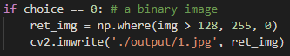
3. a histogram  
   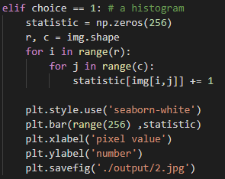
4. connected components(regions with + at centroid, bounding box)  
   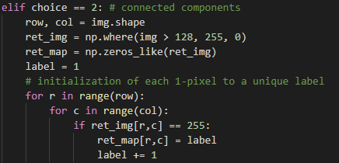  
   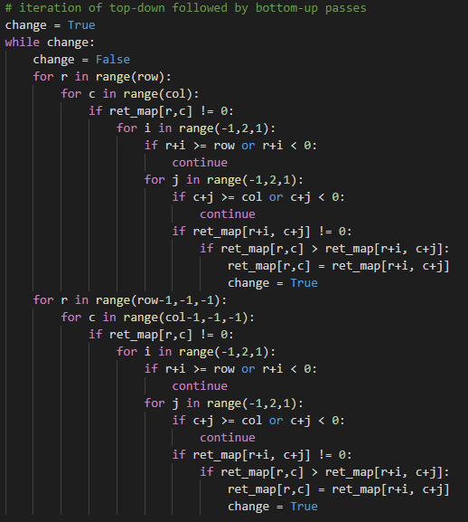  
   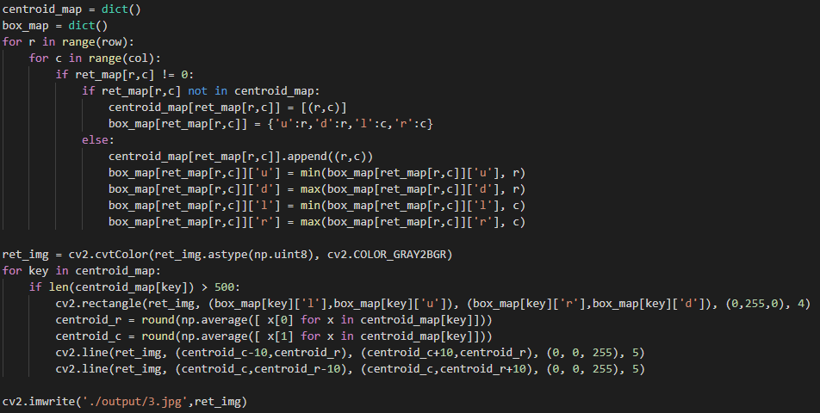
5. Results
6. a binary image (threshold at 128)

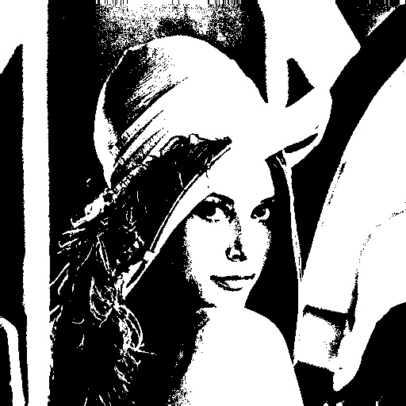

1. a histogram

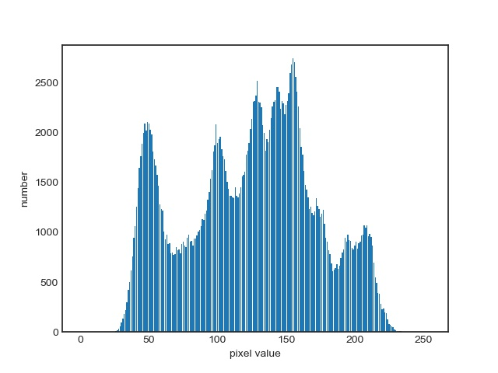

1. connected components(regions with + at centroid, bounding box)

