1. Problem Statement

* Write a program to generate images and histograms:

(a) original image and its histogram

(b) image with intensity divided by 3 and its histogram

(c) image after applying histogram equalization to (b) and its histogram

1. Programming Tools

* Programming language: Python 3.8.5
* Library: Numpy 1.19.1, OpenCV 4.0.1, matplotlib 3.3.1

1. Problem-Solving Process
2. original image and its histogram  
   宣告一個256維的numpy array，用來統計圖片pixel value的個數，在使用matplotlib中的bar()畫出histogram，並用cv2.imwrite()輸出圖片。  
   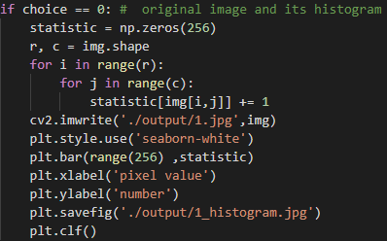
3. image with intensity divided by 3 and its histogram  
   將圖片的每個pixel value除以三後無條件捨去，再藉由a小題的方式畫出histogram，並用cv2.imwrite()輸出圖片。  
   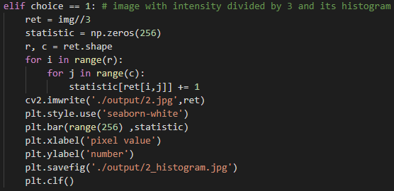
4. image after applying histogram equalization to (b) and its histogram  
   使用b小題的結果，並使numpy中的cumsum()對統計資料進行累加，取出cdf_min與cdf_max後，再對圖片的每個pixel做histogram equalization，最後cv2.imwrite()輸出圖片。

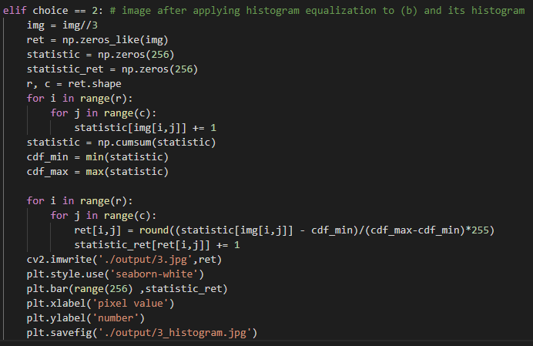

1. Results
2. original image and its histogram

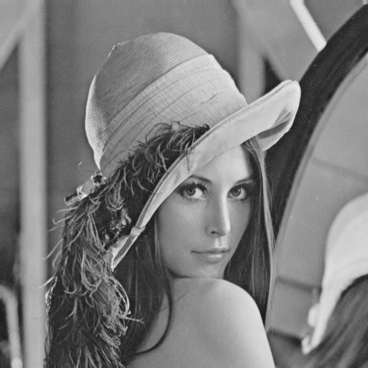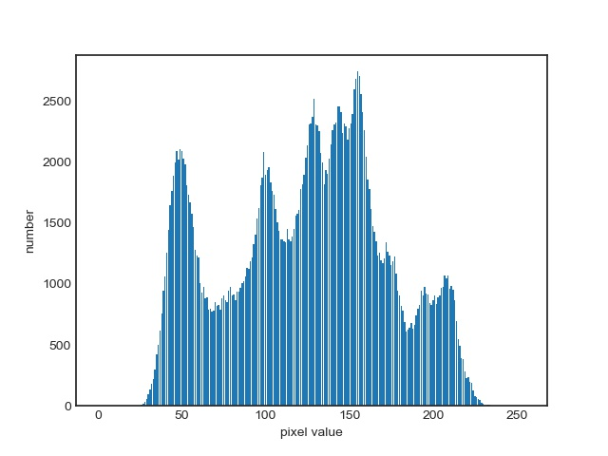

1. image with intensity divided by 3 and its histogram

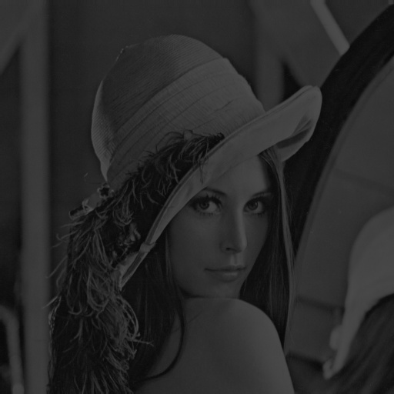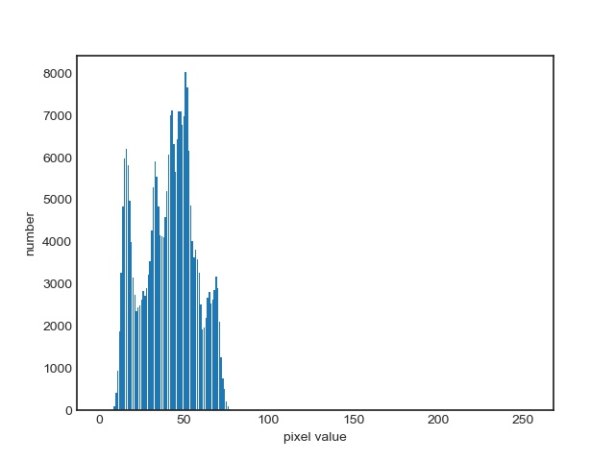

1. image after applying histogram equalization to (b) and its histogram

