1. Problem Statement

* Write a program which does thinning on a down-sampled image (lena.bmp).

1. Programming Tools

* Programming language: Python 3.8.5
* Library: Numpy 1.19.1, OpenCV 4.0.1

1. Problem-Solving Process

使用cv2.imread(‘lena.bmp’,0)讀取灰階影像，之後對影像作binarize再做down sampling得到(64,64)的img，之後對影像作以下動作：  
step1. 對img作Yokoi Operator [4 connectivity]  
step2. 由step1結果作Pair Relationship Operator

Step3. 由step2結果與原先img作Connected Shrink Operator

Step4. 比較與原先img是否有差異，有的話回到step1，沒有的話輸出影像  
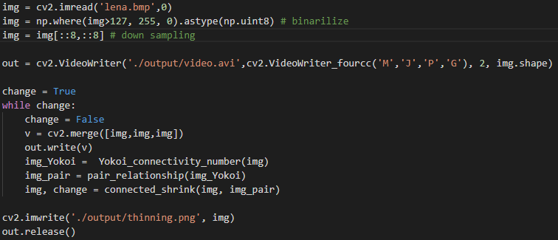  
以下為Pair Relationship Operator 與 Connected Shrink Operator程式碼。  
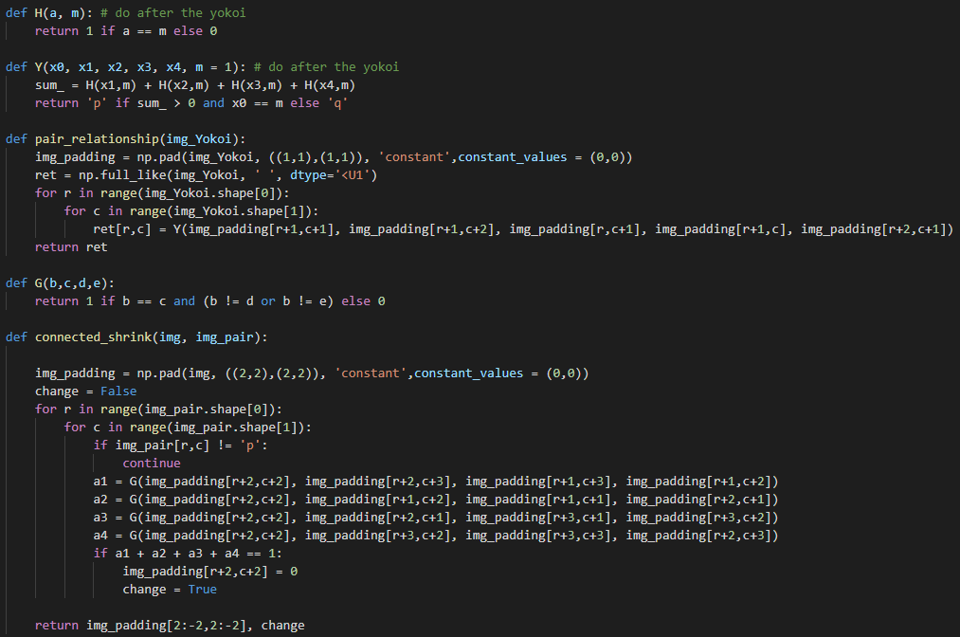

1. Results  
     
   zip檔裡面有完整的動圖。

