Implementation Traceability Matrix

Name: _______________
Project Title: Trade Flow - Wholesale Retail Management System

System Design Diagrams
The following diagrams provide visual references for the system architecture, data model, and key process flows used throughout the implementation.
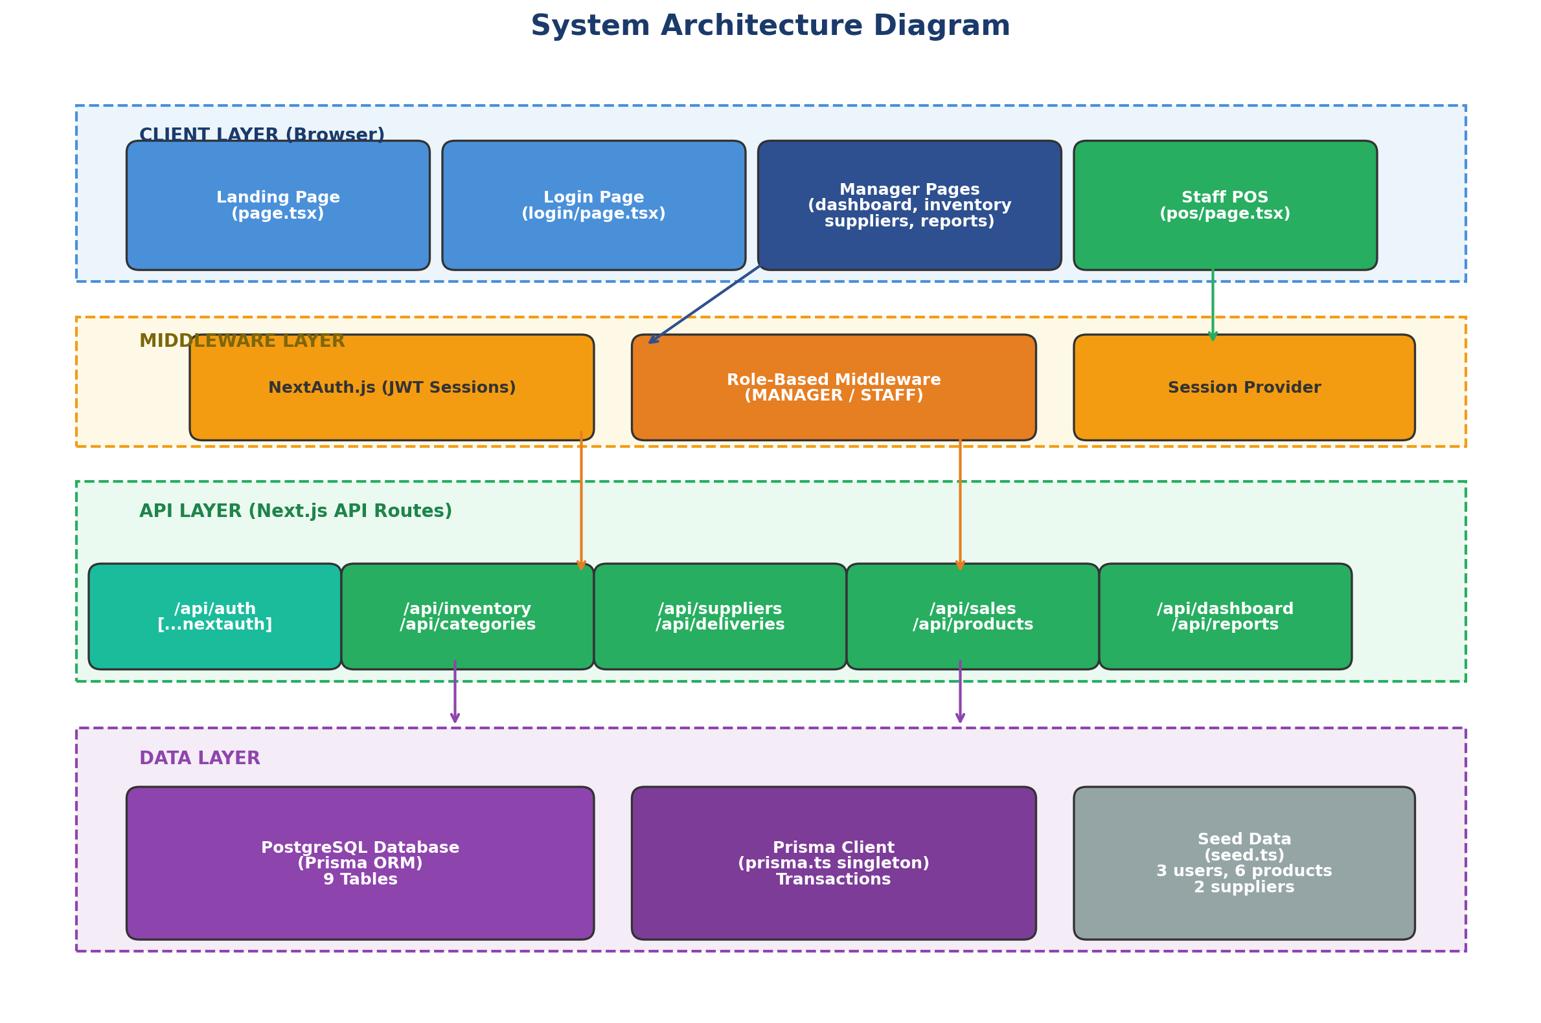
Figure 1: System Architecture Diagram
Shows the four-layer architecture: Client (React pages), Middleware (NextAuth + role guards), API (Next.js routes), and Data (PostgreSQL + Prisma).

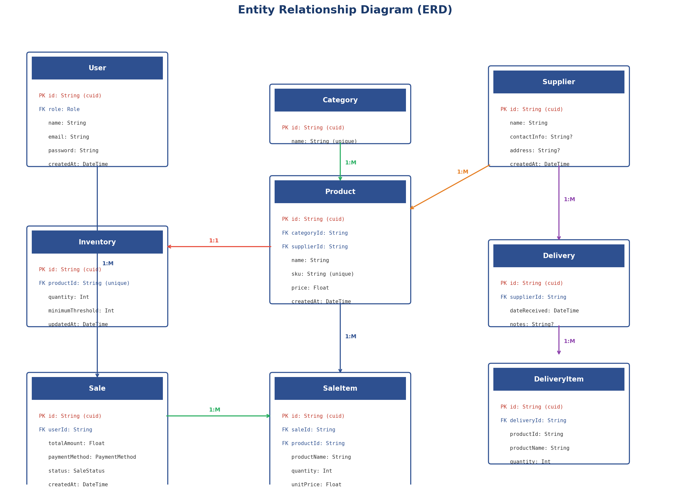
Figure 2: Entity Relationship Diagram (ERD)
Shows all 9 database entities and their relationships: User, Category, Supplier, Product, Inventory, Delivery, DeliveryItem, Sale, and SaleItem.

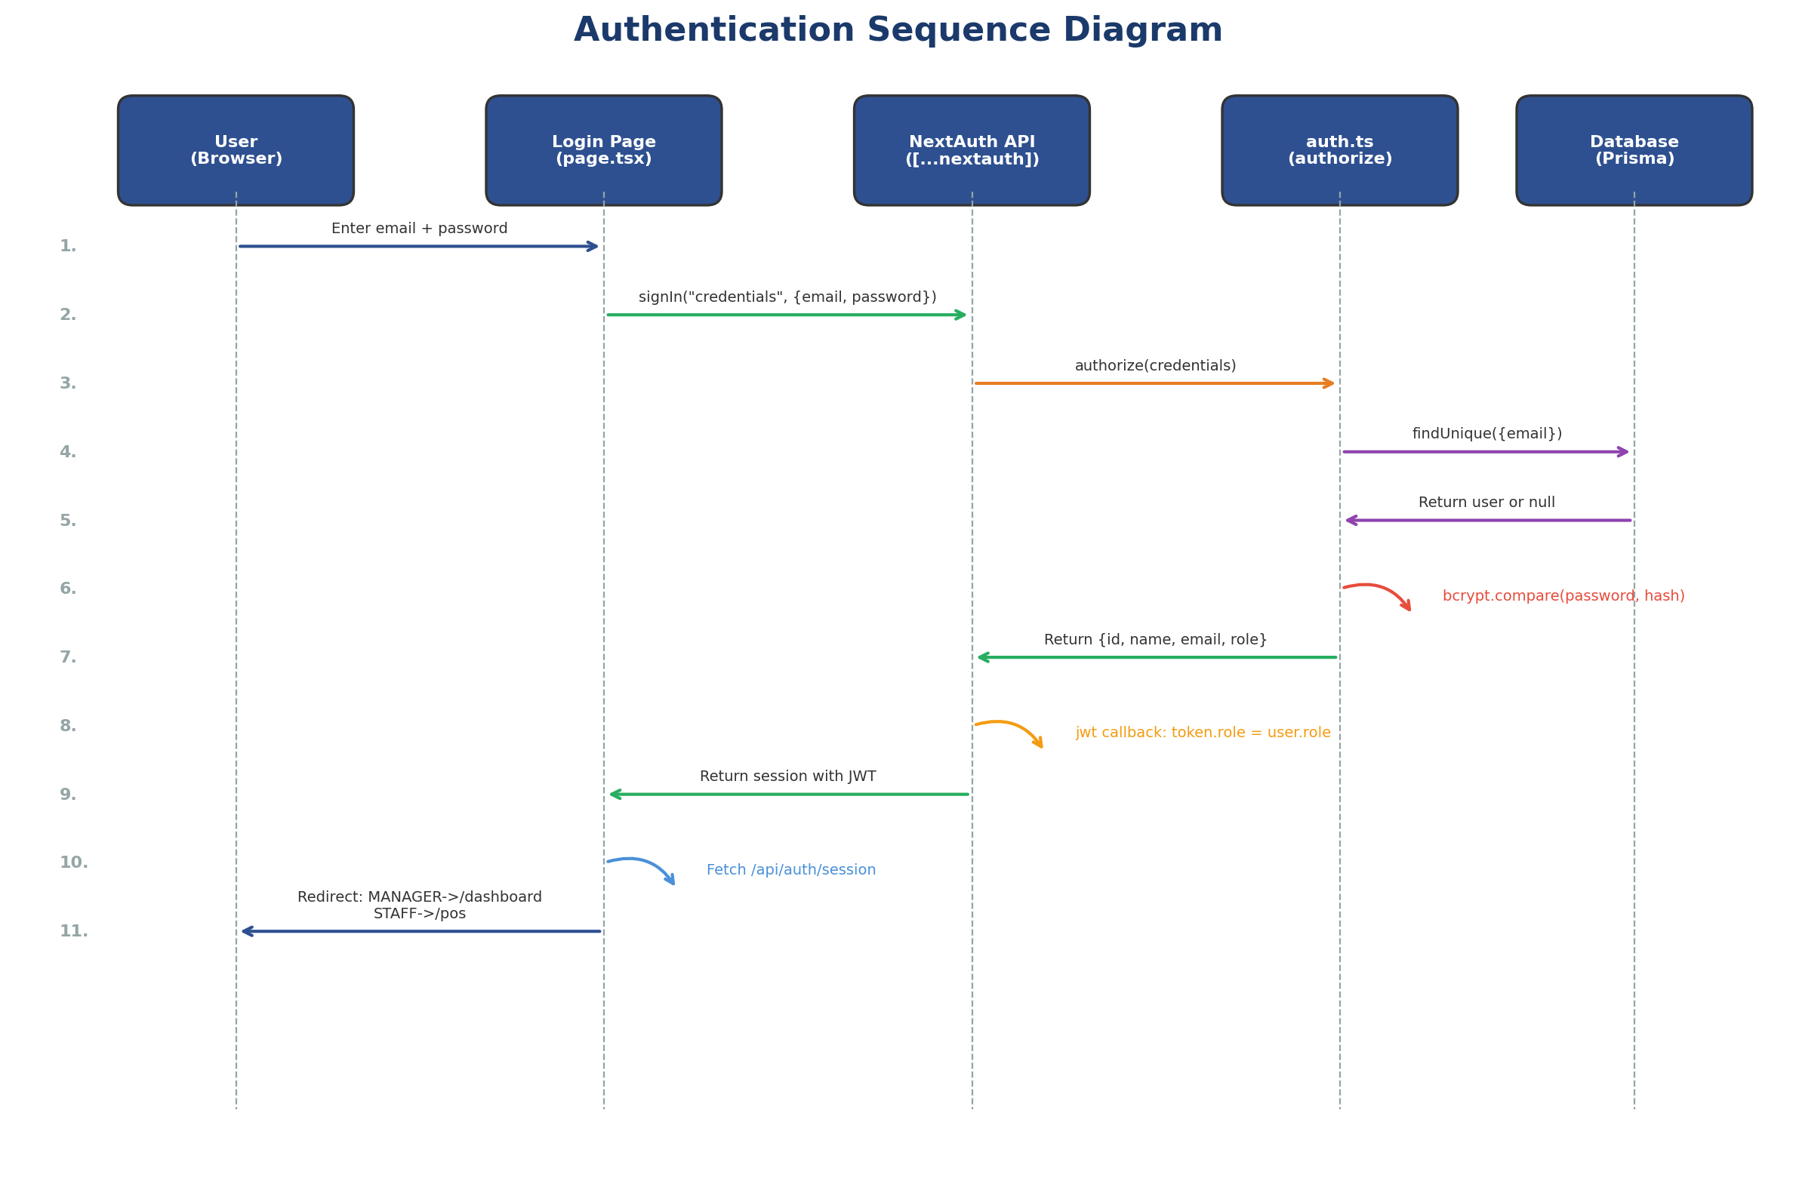
Figure 3: Authentication Sequence Diagram
Shows the login flow from user input through NextAuth credentials provider, bcrypt password verification, JWT token generation, and role-based redirect.

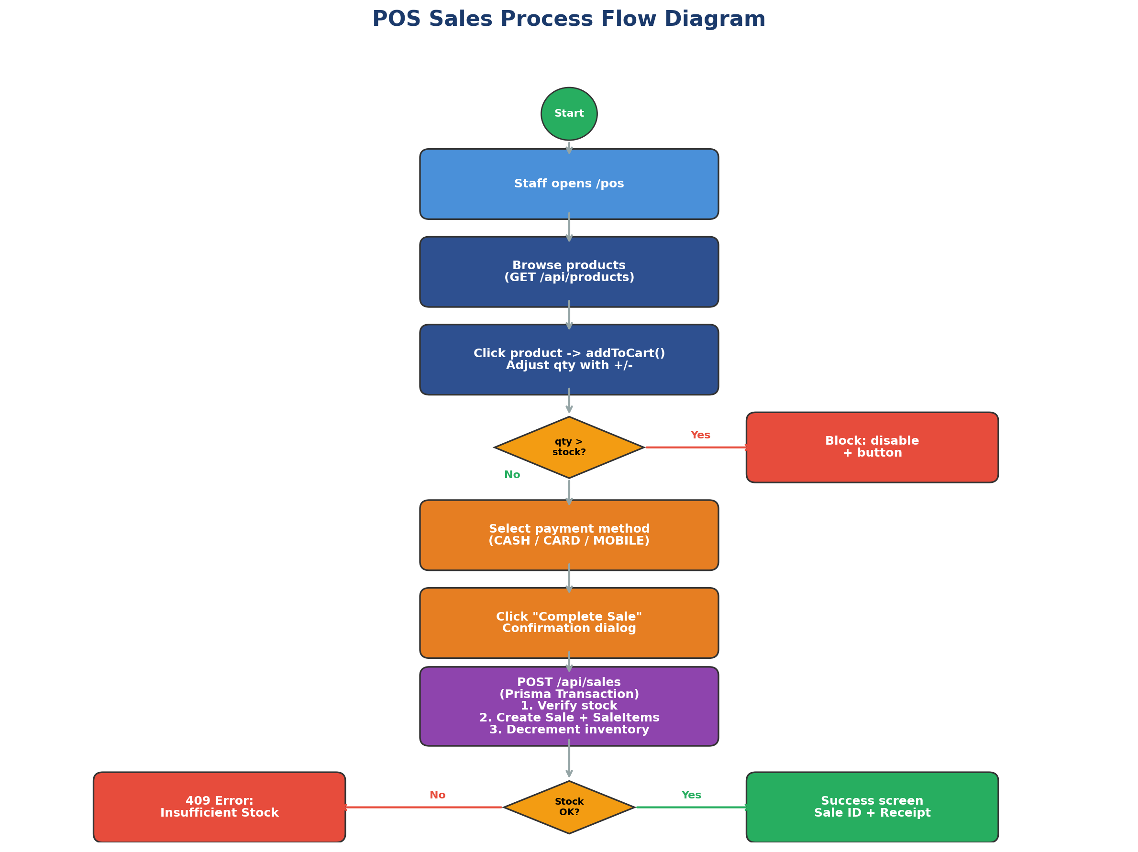
Figure 4: POS Sales Process Flow
Shows the complete point-of-sale workflow: product browsing, cart management, stock validation, payment selection, and the Prisma transaction that creates the sale and decrements inventory.

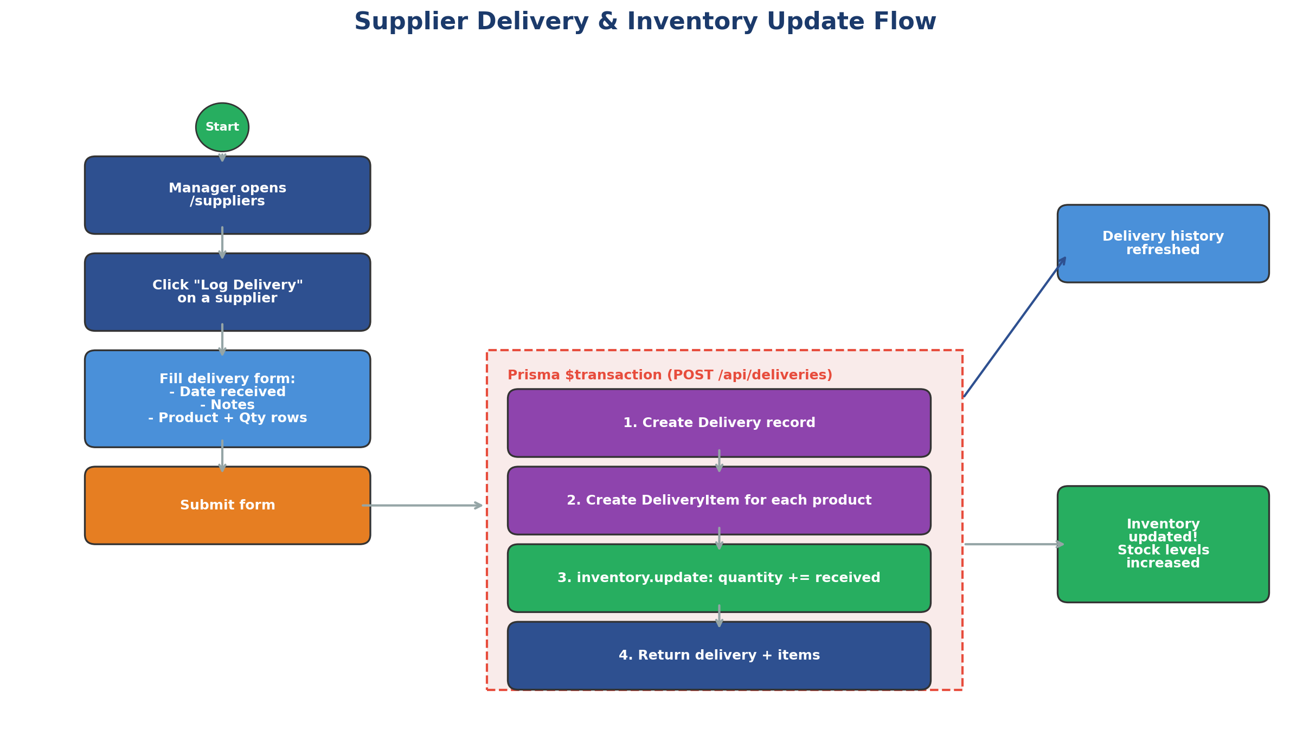
Figure 5: Supplier Delivery & Inventory Update Flow
Shows how logging a delivery triggers a Prisma transaction that creates delivery records and automatically increments inventory quantities.

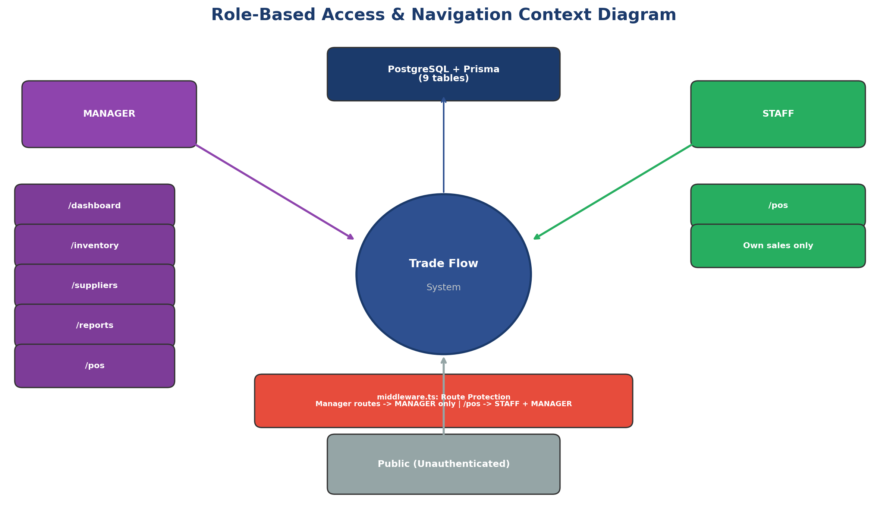
Figure 6: Role-Based Access Context Diagram
Shows how Manager and Staff roles map to different pages, with middleware enforcing route protection.

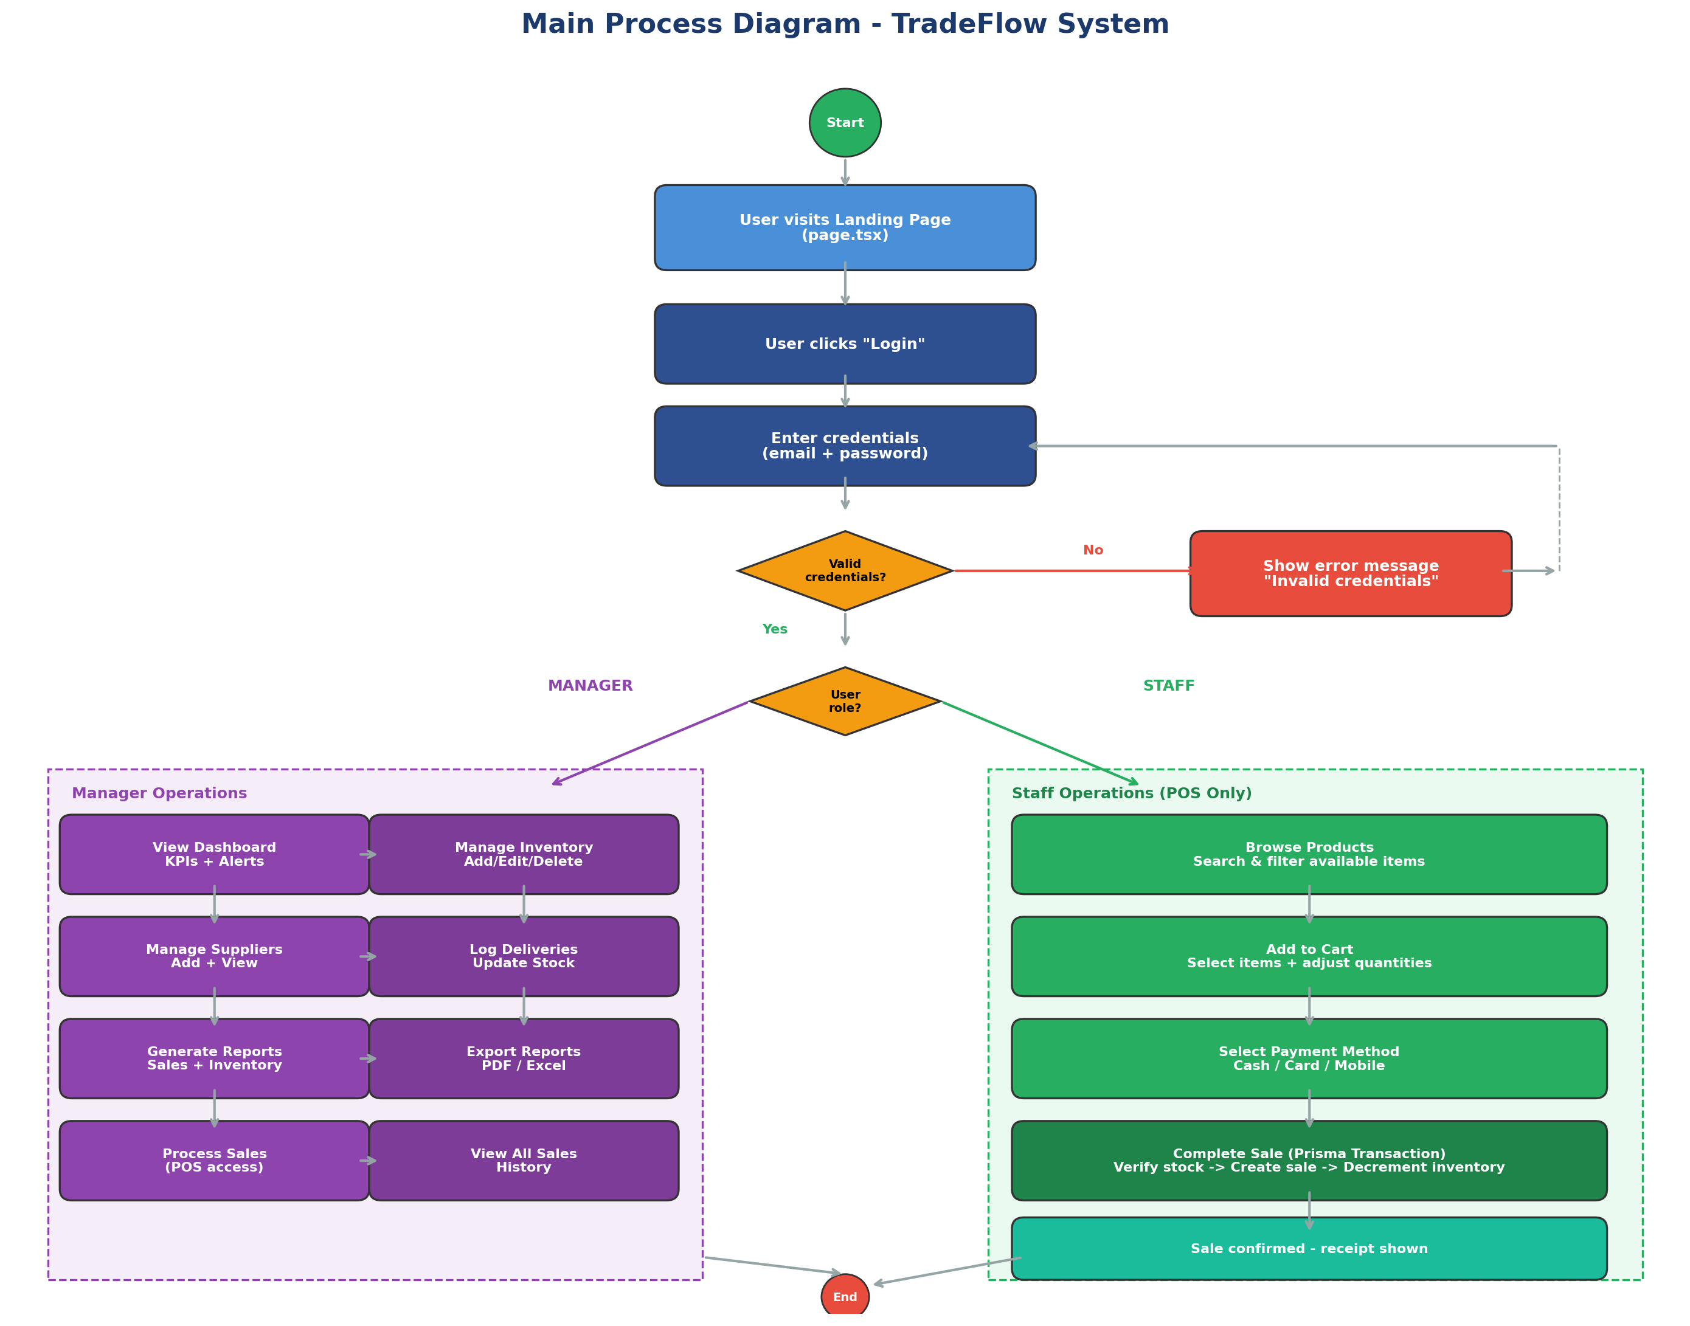
Figure 7: Main Process Diagram
Shows the end-to-end system workflow from user entry through authentication, role-based routing, and all major operations available to Manager and Staff users including inventory management, supplier deliveries, POS sales, reporting, and dashboard analytics.

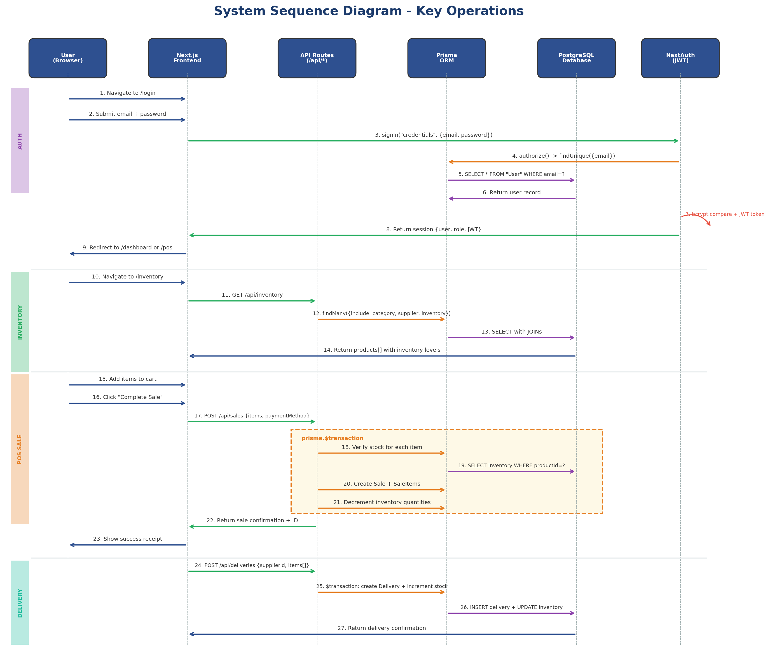
Figure 8: System Sequence Diagram
Shows the detailed interaction sequence between all system components (Browser, Frontend, API Routes, Prisma ORM, PostgreSQL, NextAuth) across four key operations: authentication, inventory retrieval, POS sale transaction, and supplier delivery processing.

Section 1: Module/Component Traceability
Component Name | Design Reference | Implementation File(s) | Status
Frontend UI | Architecture Diagram (Fig. 1) | src/app/layout.tsx, src/components/, src/app/page.tsx | Complete
Backend API | Architecture Diagram (Fig. 1) | src/app/api/ (inventory, sales, suppliers, deliveries, dashboard, reports, products, categories) | Complete
Database | ERD Diagram (Fig. 2) | prisma/schema.prisma, prisma/migrations/ | Complete
Authentication | Sequence Diagram (Fig. 3) | src/lib/auth.ts, src/app/api/auth/[...nextauth]/route.ts, src/middleware.ts, src/app/(auth)/login/page.tsx | Complete
Inventory Module | Architecture Diagram (Fig. 1) | src/app/api/inventory/route.ts, src/app/api/inventory/[id]/route.ts, src/app/(manager)/inventory/page.tsx | Complete
Supplier Module | Delivery Flow (Fig. 5) | src/app/api/suppliers/route.ts, src/app/api/deliveries/route.ts, src/app/(manager)/suppliers/page.tsx | Complete
POS / Sales Module | Sales Flow (Fig. 4) | src/app/api/sales/route.ts, src/app/api/products/route.ts, src/app/(staff)/pos/page.tsx | Complete
Dashboard Module | Context Diagram (Fig. 6) | src/app/api/dashboard/route.ts, src/app/(manager)/dashboard/page.tsx | Complete
Reporting Module | Context Diagram (Fig. 6) | src/app/api/reports/sales/route.ts, src/app/api/reports/inventory/route.ts, src/app/(manager)/reports/page.tsx | Complete

Section 2: Function Traceability
Function Name | Component | Design Reference | File: Line Number | Status
authorize() | Authentication | Sequence Diagram (Fig. 3) | src/lib/auth.ts:14-31 | Complete
handleSubmit() (login) | Authentication | Sequence Diagram (Fig. 3) | src/app/(auth)/login/page.tsx:14-41 | Complete
middleware() | Authentication | Context Diagram (Fig. 6) | src/middleware.ts:4-23 | Complete
GET /api/inventory | Inventory | Architecture (Fig. 1) | src/app/api/inventory/route.ts:6-22 | Complete
POST /api/inventory | Inventory | Architecture (Fig. 1) | src/app/api/inventory/route.ts:24-73 | Complete
PUT /api/inventory/[id] | Inventory | Architecture (Fig. 1) | src/app/api/inventory/[id]/route.ts:6-58 | Complete
DELETE /api/inventory/[id] | Inventory | Constraints (sale items) | src/app/api/inventory/[id]/route.ts:60-98 | Complete
POST /api/sales | POS / Sales | Sales Flow (Fig. 4) | src/app/api/sales/route.ts:36-108 | Complete
checkStock() | POS / Sales | Sales Flow (Fig. 4) | src/app/api/sales/route.ts:51-58 | Complete
handleCheckout() | POS / Sales | Sales Flow (Fig. 4) | src/app/(staff)/pos/page.tsx:108-143 | Complete
addToCart() | POS / Sales | Sales Flow (Fig. 4) | src/app/(staff)/pos/page.tsx:63-86 | Complete
GET /api/suppliers | Suppliers | Delivery Flow (Fig. 5) | src/app/api/suppliers/route.ts:6-20 | Complete
POST /api/deliveries | Suppliers | Delivery Flow (Fig. 5) | src/app/api/deliveries/route.ts:6-53 | Complete
GET /api/dashboard | Dashboard | Context Diagram (Fig. 6) | src/app/api/dashboard/route.ts:6-62 | Complete
exportPDF() | Reporting | Context Diagram (Fig. 6) | src/app/(manager)/reports/page.tsx:60-103 | Complete
exportExcel() | Reporting | Context Diagram (Fig. 6) | src/app/(manager)/reports/page.tsx:105-152 | Complete
fetchReport() | Reporting | Context Diagram (Fig. 6) | src/app/(manager)/reports/page.tsx:37-54 | Complete
generateSku() | Inventory | Architecture (Fig. 1) | src/app/(manager)/inventory/page.tsx:359-364 | Complete
seed() | Database | ERD (Fig. 2) | prisma/seed.ts:6-162 | Complete

Section 3: Database Table Traceability
Table Name | Design Reference (ERD) | Implementation File | Status
User | ERD - User Entity (Fig. 2) | prisma/schema.prisma:26-34 | Created
Category | ERD - Category Entity (Fig. 2) | prisma/schema.prisma:36-40 | Created
Supplier | ERD - Supplier Entity (Fig. 2) | prisma/schema.prisma:42-50 | Created
Product | ERD - Product Entity (Fig. 2) | prisma/schema.prisma:52-64 | Created
Inventory | ERD - Inventory Entity (Fig. 2) | prisma/schema.prisma:66-73 | Created
Delivery | ERD - Delivery Entity (Fig. 2) | prisma/schema.prisma:75-82 | Created
DeliveryItem | ERD - DeliveryItem Entity (Fig. 2) | prisma/schema.prisma:84-91 | Created
Sale | ERD - Sale Entity (Fig. 2) | prisma/schema.prisma:93-102 | Created
SaleItem | ERD - SaleItem Entity (Fig. 2) | prisma/schema.prisma:104-113 | Created

Section 4: UI Screen Traceability
Screen Name | Design Reference | Implementation File | Status
Landing Page | Context Diagram (Fig. 6) | src/app/page.tsx | Done
Login Screen | Sequence Diagram (Fig. 3) | src/app/(auth)/login/page.tsx | Done
Manager Dashboard | Context Diagram (Fig. 6) | src/app/(manager)/dashboard/page.tsx | Done
Inventory Screen | Architecture (Fig. 1) | src/app/(manager)/inventory/page.tsx | Done
Suppliers Screen | Delivery Flow (Fig. 5) | src/app/(manager)/suppliers/page.tsx | Done
Reports Screen | Context Diagram (Fig. 6) | src/app/(manager)/reports/page.tsx | Done
POS Screen | Sales Flow (Fig. 4) | src/app/(staff)/pos/page.tsx | Done
Manager Layout (Sidebar + Navbar) | Architecture (Fig. 1) | src/app/(manager)/layout.tsx, src/components/layout/Sidebar.tsx, src/components/layout/Navbar.tsx | Done

