BIA Business and Information Systems Architecture
MGMT-6134-(31)-25F Capstone Project

HEARTLINK: Heart rate Tracking and Analyst
Milestone 3

Professor Vinnie Moraes

Name – Student ID | Email
Guan, Ivan – 1289006 (Captain) | y_guan251701@fanshaweonline.ca
Diden, Gbubemi - 1205960 | g_diden@fanshaweonline.ca
Dinh, Patrick - 1260577 | n_dinh240521@fanshaweonline.ca

Version 1.0 | Nov 4, 2025

Index
• Milestone Summary 3
1. System Architecture 5
2. Entity Relationship Diagram 7
3. Data Dictionary 8
3.1 Hardware Layer Data Dictionary 8
3.2 Front-End Layer Data Dictionary 10
3.3 Cloud Layer Data Dictionary 13
4. Embedded Services and Third-Party Integrations 16
4.1 ESP-IDF 16
4.2 Google Cloud Pub/Sub 17
4.3 Google Cloud Storage & Google Big Query 17
4.4 Firebase Authentication 18
4.5 Looker Studio 18
4.6 Google Cloud Run 18
5. Updated UI and UX Prototypes 20
5.1 Hardware Prototype 20
5.2 Front-end Prototype 21
6. Draft of Testcases 28
6.1 Test Methodologies 28
6.2 Test Categories 29
7. Draft of Deployment Diagram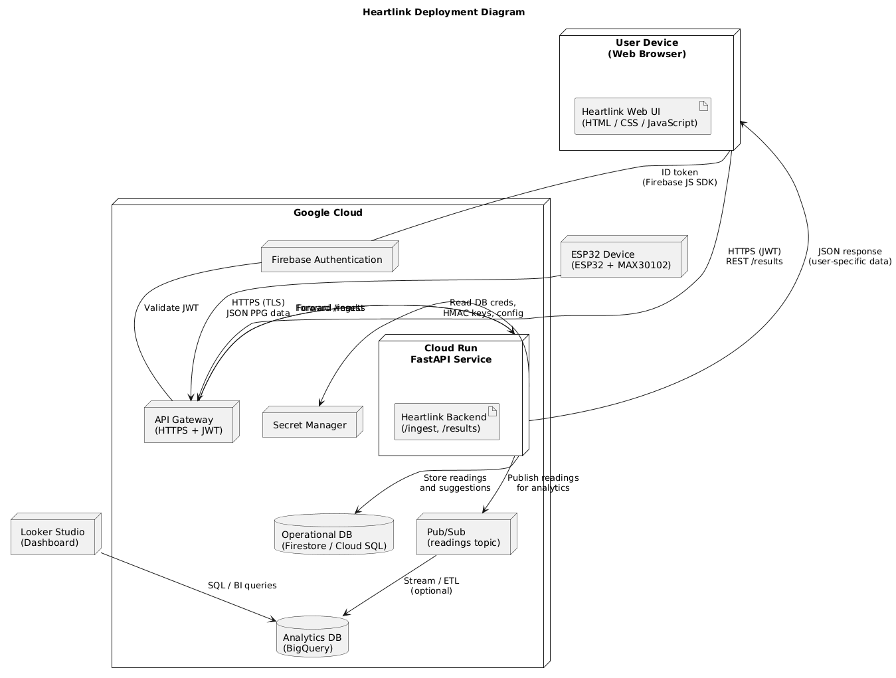 31
8. References 33

Milestone Summary
Milestone 3 primarily concentrated on enhancing the technical framework and refining the detailed design of the Heartlink project. During this stage, the team developed a comprehensive system architecture document that mapped out the interactions among all system components, ensuring the overall design was both cohesive and scalable.
A physical data model, represented through an Entity–Relationship (ER) diagram, was created to detail the structure and relationships within the database. The data dictionary was revised to clearly define each data element, maintaining uniformity and clarity across the development team.
This milestone also introduced updated UI/UX prototypes that incorporated feedback from earlier stages to improve user interaction and design flow. Furthermore, draft API documentation was produced, specifying endpoints and interaction patterns required for the app’s core functionality. Preliminary test cases were outlined to ensure broad coverage during quality assurance, and an initial deployment diagram was created to illustrate the physical infrastructure—covering the GitHub repository, CI/CD accounts, and supporting services.
Together, these deliverables established a strong foundation for a scalable, efficient, and well-documented system, ready to move into full development and deployment.
Event | Description | Start date | Due date | Status
Milestone 1 | Planning & Requirements | 2025-09-03 | 2025-09-29 | Completed
Milestone 2 & 3 | System Design | 2025-09-30 | 2025-10-10 | Completed
Milestone 4 | Development | 2025-10-09 | 2025-10-31 | Processing
Milestone 4 | Testing & Validation | 2025-10-31 | 2025-11-19 | Processing
Final | Finalization & Reporting | 2025-11-19 | 2025-12-05 | Not Started
Table 1: Milestone summary and status

System Architecture
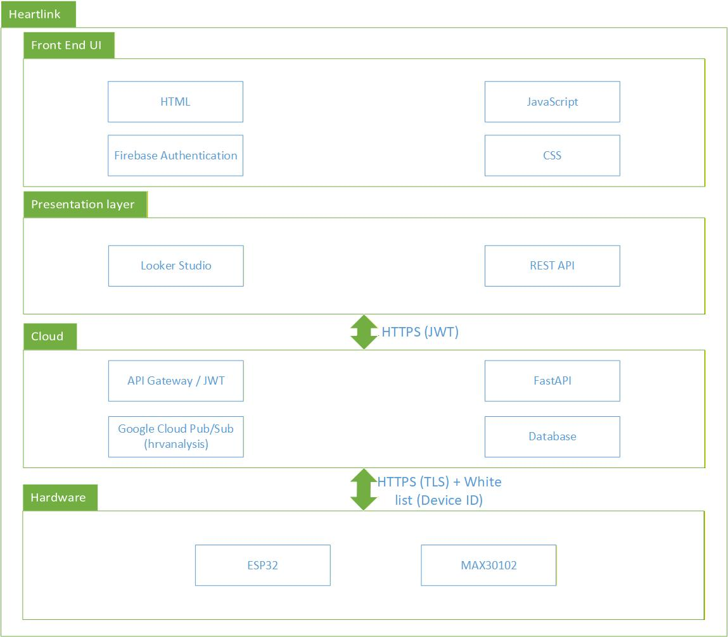
Figure 1: System Architecture

The Heartlink system is built as a secure IoT-cloud health monitoring platform.
- At the Hardware layer, the MAX30102 sensor captures photoplethysmography (PPG) signals, which are processed by the ESP32 microcontroller using the ESP-IDF framework. The ESP32 securely sends data to the cloud via HTTPS (TLS) with device whitelisting for authentication.
- In the Cloud layer, data flows through the API Gateway using JWT-based authentication before being handled by FastAPI services. Processed data and results are published via Google Cloud Pub/Sub, stored in the database, and used for HRV analysis.
- The Presentation layer provides data visualization through Looker Studio and a REST API, offering analytics dashboards and enabling the front-end to access processed health insights.
- Finally, the Front-End UI—built with HTML, CSS, and JavaScript—integrates Firebase Authentication for secure user access, allowing users to view personalized results and interact with the system through an intuitive web interface.

Entity Relationship Diagram
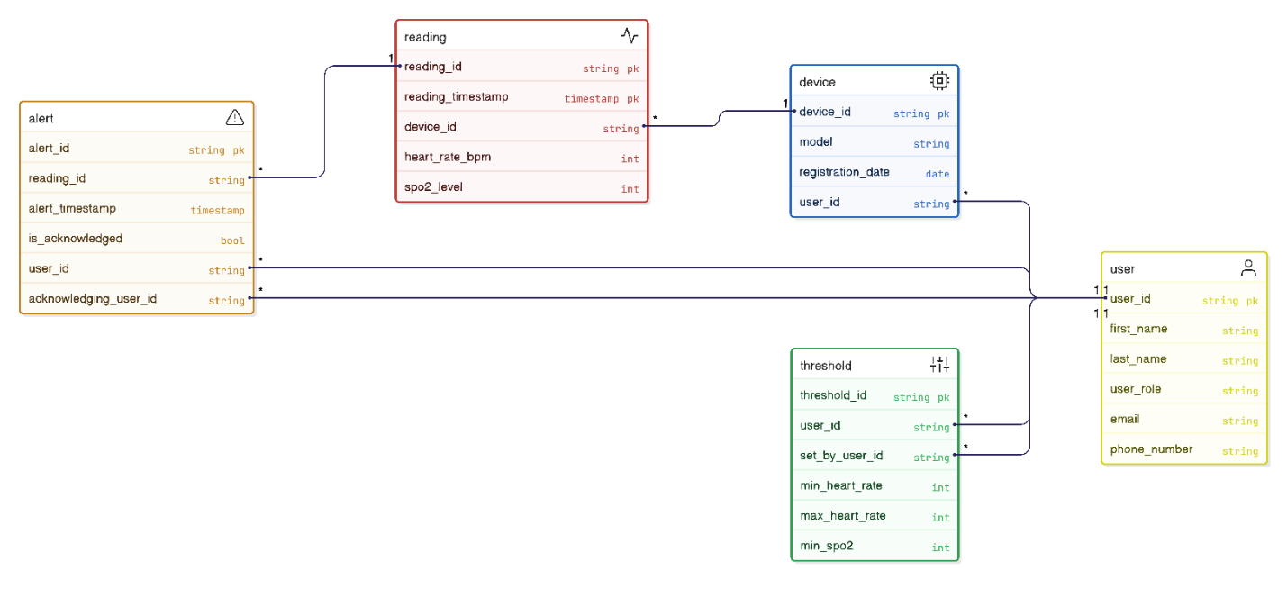
Figure 2: Entity Relationship Diagram
The Heartlink database consists of five main entities: User, Device, Reading, Threshold, and Alert. Each device is registered to a user and records heart rate and SpO₂ readings. These readings are stored with timestamps and linked to potential alerts when abnormal values are detected. Users can define personalized thresholds for heart rate and oxygen levels, and acknowledge alerts through the system.
This relational design ensures data integrity, traceability, and scalability across all components of the IoT-based health monitoring system.

Data Dictionary

Hardware Layer Data Dictionary

Physical/I²C & GPIO configuration
Varibles | Type | Unit/Format | Description
i2cPort | enum (esp-idf) | - | I²C controller used for MAX30102.
i2cSdaPin | gpio_num_t | - | SDA GPIO for MAX30102.
i2cSclPin | gpio_num_t | - | SCL GPIO for MAX30102.
i2cMasterFreqHz | uint32_t | Hz | I²C bus frequency.
max30102Addr | uint8_t | 7-bit addr | I²C address of MAX30102.
max30102IntPin | gpio_num_t | - | GPIO for MAX30102 active-low interrupt.
Table 2: Data Dictionary of Hardware Layer (Physical/I²C & GPIO configuration)

Sensor operating mode & LED drive
Varibles | Type | Unit/Format | Description
mode | sensorMode | - | Current measurement mode.
ledCurrentRed | uint8_t | ~mA per datasheet | Red LED current register (REG_LED2_PA).
ledCurrentIr | uint8_t | ~mA per datasheet | IR LED current register (REG_LED1_PA).
fifoConfig | uint8_t | bitfield | FIFO config written during init.
Table 3: Data Dictionary of Hardware Layer (Sensor operating mode & LED drive)

Sampling & pulse width enums
Varibles | Type | Unit/Format | Description
sampleRate | max30102SampleRate | sps | SpO₂/PPG sample rate selection.
pulseWidth | max30102PulseWidth | μs | LED pulse width / ADC resolution.
Table 4: Data Dictionary of Hardware Layer (Sampling & pulse width enums)

Interrupt status & masks
Varibles | Type | Unit/Format | Description
intStatus1 | uint8_t | bitmask | INT_STATUS_1 (read-to-clear).
intStatus2 | uint8_t | bitmask | INT_STATUS_2 (read-to-clear).
intMaskDataReady | const uint8_t | - | Data-ready flag in INT_STATUS_1.
intMaskFifoAlmostFull | const uint8_t | - | FIFO almost full.
intMaskAlcOvf | const uint8_t | - | Ambient light overflow.
intMaskProximity | const uint8_t | - | Proximity threshold event.
Table 5: Data Dictionary of Hardware Layer (Interrupt status & masks)

Sample payload
Varibles | Type | Unit/Format | Description
red | uint32_t | raw ADC counts | 18-bit RED PPG sample assembled from FIFO
ir | uint32_t | raw ADC counts | 18-bit IR PPG sample assembled from FIFO.
Table 6: Data Dictionary of Hardware Layer (Sample payload)

Front-End Layer Data Dictionary

User Interface Data
Varibles | Type | Description
screen_name | string | Identifies the current view (e.g., Dashboard, Settings, History).
deviceId | enum | Determines layout appearance (light/dark modes).
redAdc | int | Tracks the active UI route.
Table 7: Data Dictionary of User Interface

Vital Signs Data
Varibles | Type | Description
heart_rate | string | Representing BPM (beats per minute).
spo2_level (optional) | float | Blood oxygen saturation percentage.
timestamp | string/date time | The time of recording.
Table 8: Data Dictionary of Vital Signs Data

Device and Connectivity Data
Varibles | Type | Description
device_id | string | Unique identifier for the ESP32 unit.
connection_status | enum | Indicates the strength of the signal.
last_sync_time | string/date time | The time of the last synchronous.
Table 9: Data Dictionary of Device and Connectivity Data

Alert and Notification Data
Varibles | Type | Description
alert_message | string | Display the alert messages to users.
Table 10: Data Dictionary of Hardware Laye

User and Settings Data
Varibles | Type | Description
user_id | string | Unique identifier for the user.
preferred_units | enum | Choose the display unit (e.g. BPM).
notifications_enabled | bool | Turn on/off the notifications.
cloud_sync_enabled | bool | Boolean flags synchronized to the cloud.
Language/locale | string | String for regional formatting.
theme_preference | enum | Choose the theme (e.g. Light, Dark, System).
Table 11: Data Dictionary of User and Settings Data

Historical and Trend Data
Varibles | Type | Description
history_records | Arrays of heart_rate, spo2_level and timestamp | Arrays of heart_rate, spo2_level and timestamp.
date_range_filter | string | The range of date.
chart_data | Arrays for graph plotting | Arrays for graph plotting.
Table 12: Data Dictionary of Historical and Trend Data

Cloud Layer Data Dictionary

User Entity
Attribute Name | Data Type | Key Type | Description | note
User_ID | STRING | PK | Unique identifier for any actor | Assigned UUID.
First_Name | STRING |  | User's first name. | Required.
Last_Name | STRING |  | User's last name. | Required.
User_Role | STRING |  | The actor's role in the system. | Enum : "Admin".
Email | STRING | Unique | User's primary contact and login. | Must be unique.
Phone_Number | STRING |  | User's mobile number for notifications.
Table 13: Data Dictionary of User Entity

Device Entity
Attribute Name | Data Type | Key Type | Description | note
Device_ID | STRING | PK | Unique identifier for the physical IoT device. | Unique per hardware unit.
Patient_User_ID | STRING | FK | The ID of the patient to whom the device is assigned. | Links to USER.User_ID.
Model | STRING |  | Hardware model of the monitoring unit. | e.g., "ESP32/MAX30102".
Registration_Date | TIMESTAMP |  | The date the device was first activated.
Table 14: Data Dictionary of Device Entity

Reading Entity (time-series Data)
Attribute Name | Data Type | Key Type | Description | note
Reading_ID | STRING | PK | Unique identifier | Generated UUID.
Device_ID | STRING | FK | The device that generated this measurement. | Links to DEVICE.Device_ID.
Reading_Timestamp | TIMESTAMP | PK | The exact time the measurement was taken (UTC). | Crucial for ordering and partition key.
Heart_Rate_BPM | INTEGER |  | The calculated heart rate in beats per minute. | Expected range: 30 - 250.
SpO2_Level | FLOAT |  | The calculated blood oxygen saturation level. | Expected range: 80.0 - 100.0.
Table 15: Data Dictionary of Reading Entity

Threshold Entity
Attribute Name | Data Type | Key Type | Description | note
Threshold_ID | STRING | PK | Unique identifier for this set of patient thresholds.
Patient_User_ID | STRING | PK, FK | The patient this threshold applies to. | Links to USER.User_ID.
Min_Heart_Rate | INTEGER |  | Minimum acceptable Heart Rate (BPM).
Max_Heart_Rate | INTEGER |  | Maximum acceptable Heart Rate (BPM).
Min_SpO2 | FLOAT |  | Minimum acceptable SpO2 level.
Set_By_User_ID | STRING | FK | The Doctor/User who configured this threshold set. | Links to USER.User_ID.
Table 16: Data Dictionary of Threshold Entity

Alert Entity (Event Data)
Attribute Name | Data Type | Key Type | Description | note
Alert_ID | STRING | PK | Unique identifier for a triggered alert instance.
Reading_ID | STRING | FK | The specific reading that triggered this alert. | Links to READING.Reading_ID.
Patient_User_ID | STRING | FK | The patient who triggered the alert. | Links to USER.User_ID.
Alert_Timestamp | TIMESTAMP |  | The time the system recognized the alert condition.
Type | STRING |  | The condition that caused the alert. | Enum: "HR_High", "HR_Low", "SpO2_Low".
Is_Acknowledged | BOOLEAN |  | Flag if a professional has closed the alert. | Default: FALSE.
Acknowledging_User_ID | STRING | FK | The ID of the User who closed the alert. | Links to USER.User_ID. (Nullable if not acknowledged).
Table 17: Data Dictionary of Alert Entity

Embedded Services and Third-Party Integrations

ESP-IDF
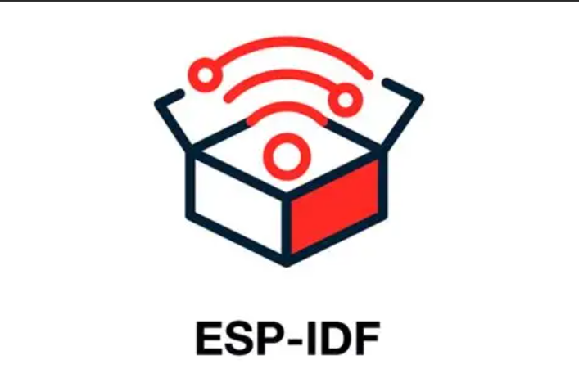
Figure 3: ESP-IDF
ESP-IDF serves as the foundation for the embedded layer, enabling the ESP32 to collect sensor data from the MAX30102 through I²C communication, process the signals in real time, and securely transmit the results to the cloud over Wi-Fi (HTTPS/TLS). It also integrates FreeRTOS, allowing efficient multitasking and real-time handling of asynchronous sensor readings and network operations.

Google Cloud Pub/Sub

Figure 4: Google Cloud Pub/Sub
Google Cloud Pub/Sub streams our incoming sensor data, providing reliable, scalable message queuing between devices and cloud processing pipeline.

Google Cloud Storage & Google Big Query

Figure 5: Google Cloud Storage

Figure 6: Google Big Query
Use Cloud Storage for raw data (files), and BigQuery for structured, time-stamped heart rate entries. BigQuery is ideal for querying large datasets efficiently and powers downstream analytics.

Firebase Authentication

Figure 7: Firebase
Firebase Authentication creates secure user accounts, protects access to data, and supports privacy requirements for health data access.

Looker Studio

Figure 8: Looker Studio
Looker Studio builds interactive dashboards, displaying heart rate trends, historical reports, and real-time alerts for users.

Google Cloud Run

Figure 9: Google Cloud Run
Google Cloud Run help to providing a secure, scalable, and flexible platform to deploy our web-based dashboard, API, and backend data processing.

Updated UI and UX Prototypes

Hardware Prototype
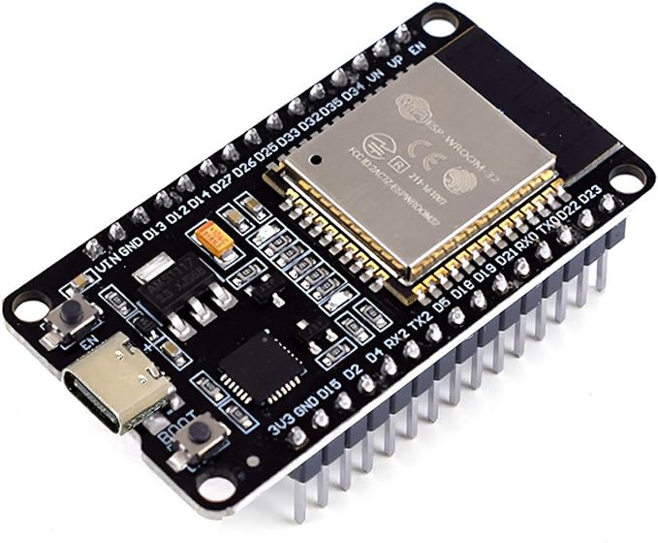
Figure 10:ESP32
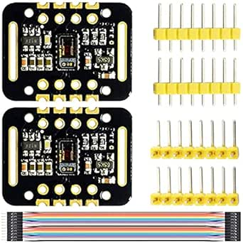
Figure 11:MAX30102 and Cables

Front-end Prototype
https://www.figma.com/make/rU63BB8kvgExZDKW5ixYQa/Wearable-Health-Monitor?node-id=0-1&t=g6IvCl59lmOZ5bmX-1
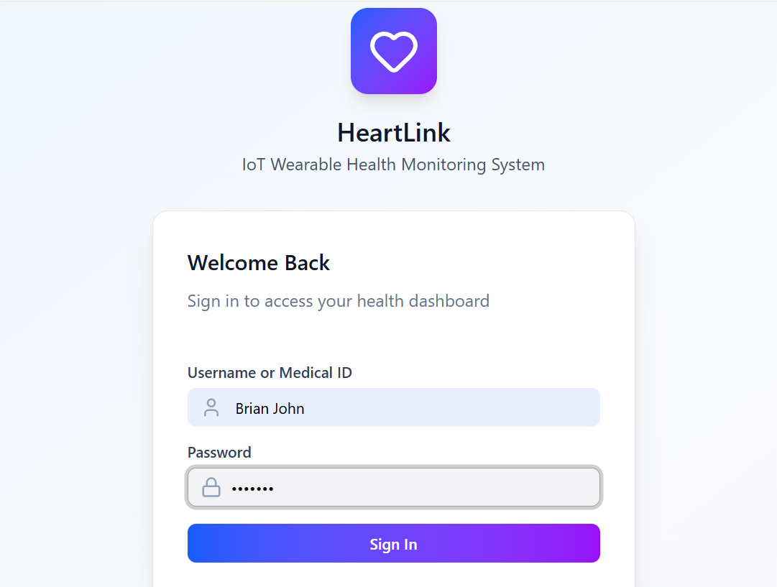
Figure 12: Login
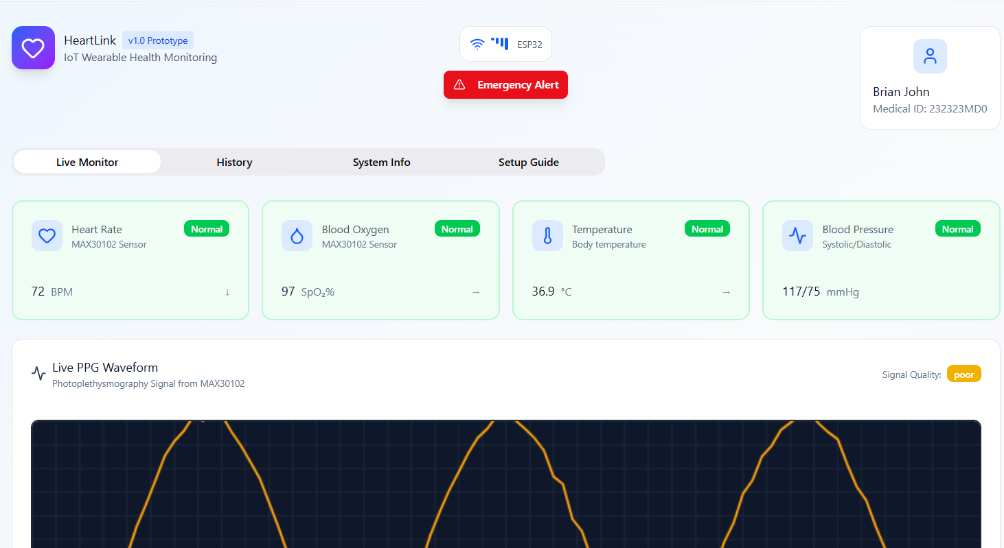
Figure 13: User Dashboard

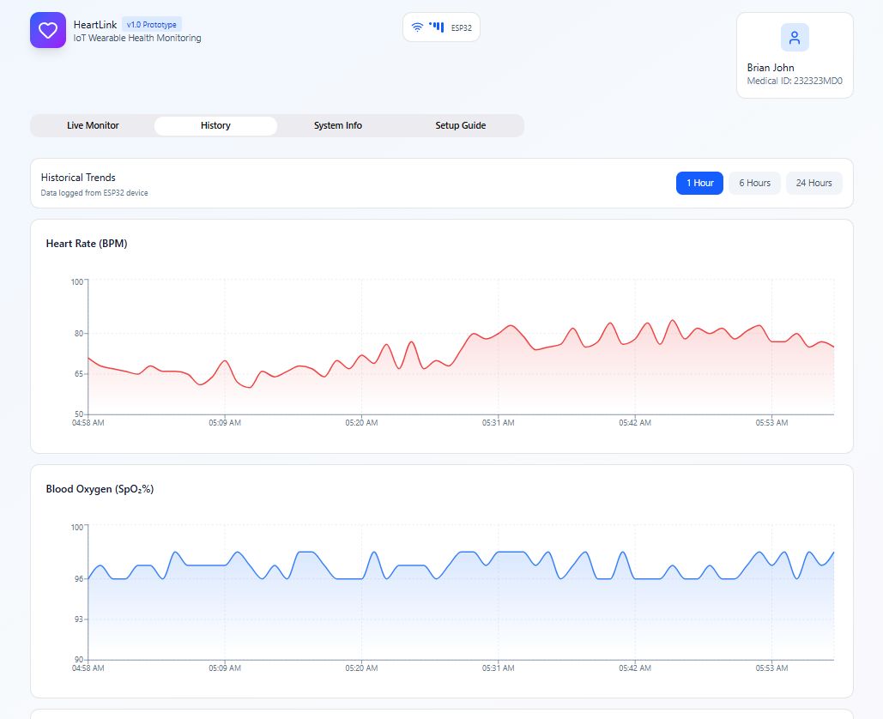
Figure 14: History

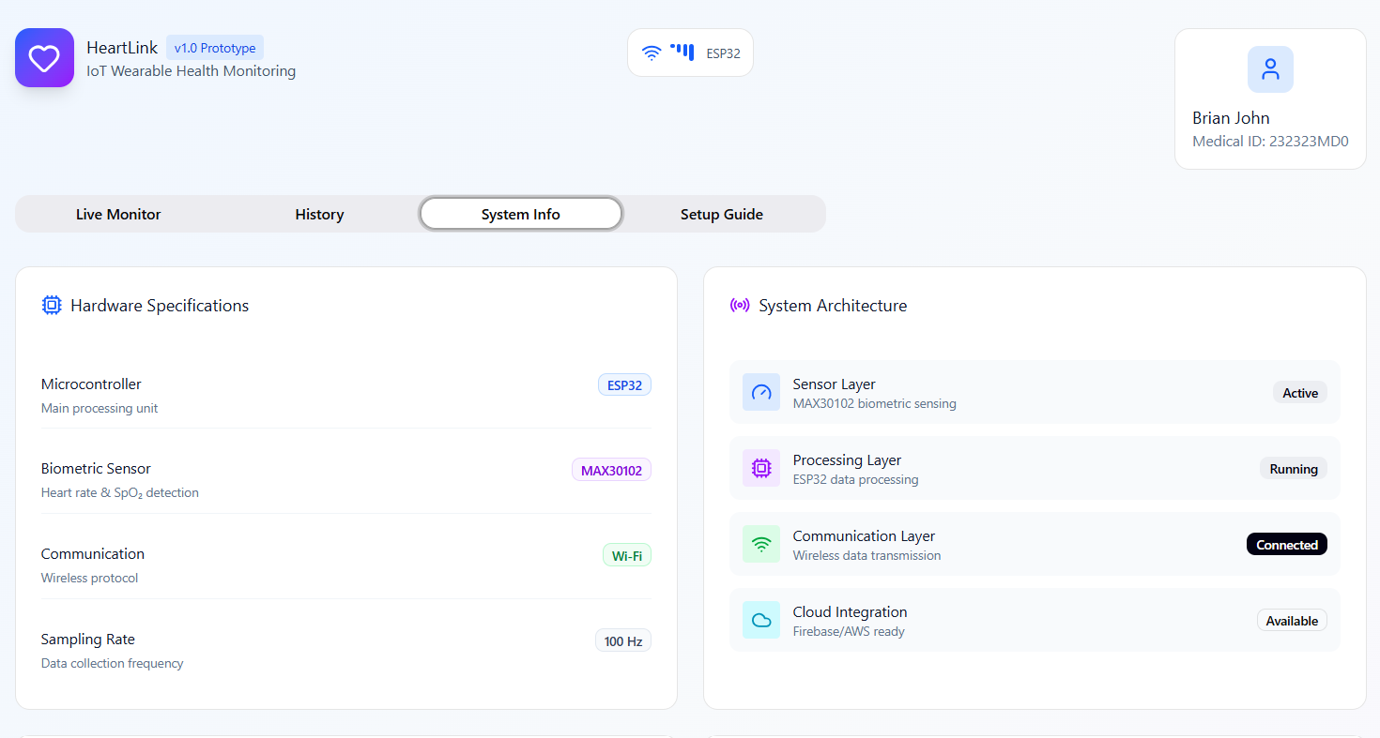
Figure 15: System Info

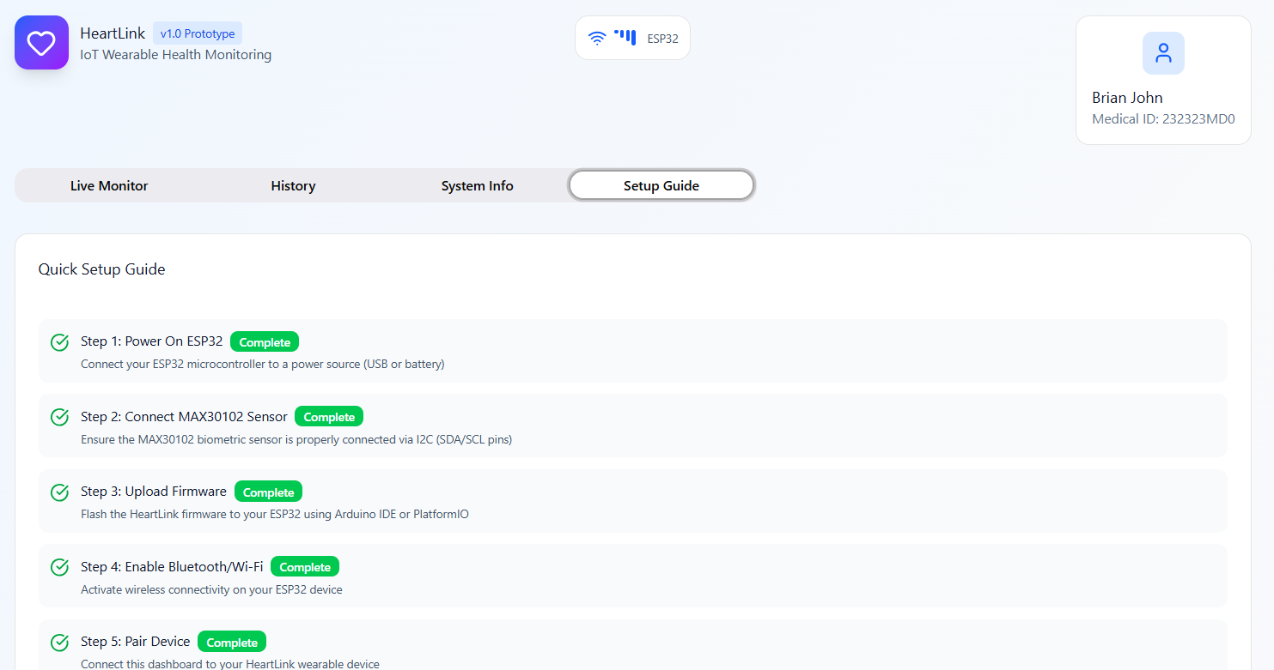
Figure 16: Set Up Guide

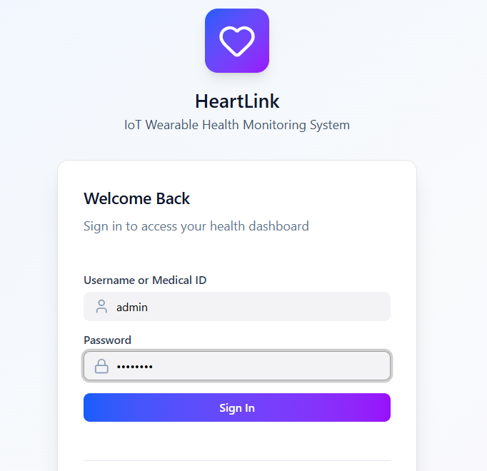
Figure 17: Admin Login

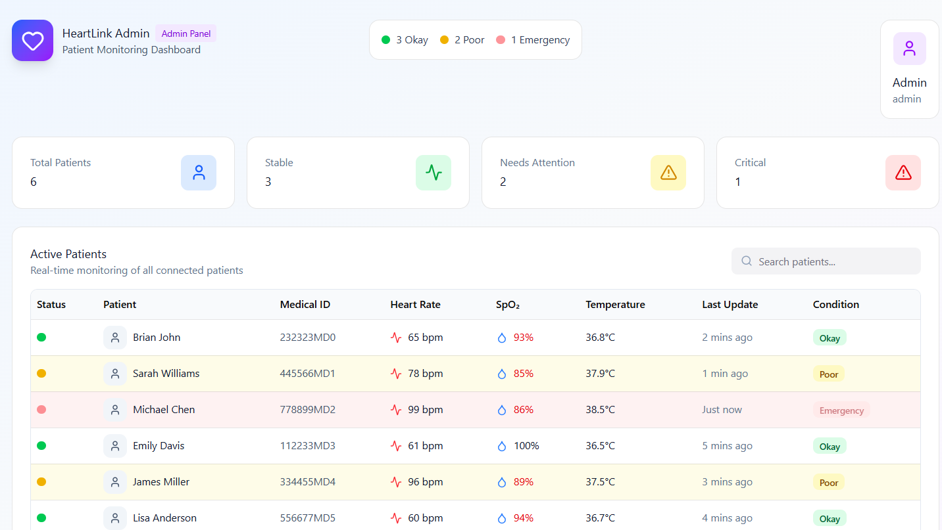
Figure 18: Admin Dashboard

Draft of Testcases
In this milestone, we prepared a comprehensive draft of the test case framework for the Heartlink project to assess its stability, correctness, and overall reliability. The draft outlines how the testing effort will be organized, including scenario classifications (such as valid input, invalid input, and boundary input) as well as functional categories covering user interactions, hardware operations, cloud communication, and system integration. By defining these structures early, we establish a clear and methodical approach for identifying potential issues and validating essential functionalities under various operating conditions. This draft focuses on the classification and organization of test cases rather than listing individual test case details. It will serve as the foundation for detailed test development and refinement in upcoming stages.

Test Methodologies

Equivalence Partitioning
Equivalence Partitioning is a test design technique that divides input data into partitions of equivalent values. Each partition represents a group of inputs that should be treated similarly by the system. Instead of testing every possible input, a representative value from each partition is selected. This reduces the total number of test cases while still ensuring broad coverage. It is especially useful for validating input fields, sensor data ranges, configuration settings, and user-provided values.

Boundary Value Analysis
Boundary Value Analysis focuses on testing the values at the edges of valid and invalid input ranges. Since systems often fail at boundaries, these tests help uncover off-by-one errors, data overflow issues, and edge-case sensor behavior. For the Heartlink project, boundary tests are particularly relevant for validating physiological data thresholds (e.g., minimum/maximum PPG values, timestamp limits, buffer capacities) and configuration parameters (e.g., session duration limits).

End-to-End Testing
End-to-End Testing verifies that the complete workflow of the system functions correctly from start to finish. It validates interactions across all layers—device sampling, Wi-Fi communication, cloud processing, backend APIs, and frontend display. These tests ensure that real-world user scenarios behave as expected and confirm that data flows reliably through the entire system without interruption.

Test Categories

Functional Test Cases
Functional tests ensure that each feature of the system behaves according to the defined requirements. These include verifying sensor initialization, sampling accuracy, data uploading, cloud processing, user authentication, and correct UI rendering. Each functional test validates that the system performs a specific action correctly based on given inputs.

Non-Functional Test Cases
Non-functional tests evaluate system qualities such as performance, reliability, usability, and security. Examples include measuring data upload latency, validating the responsiveness of the frontend interface, assessing cloud scalability, and ensuring secure HTTPS/TLS communication. These tests confirm that the system meets quality expectations beyond core functionality.

Integration Tests
Integration tests focus on verifying interactions between different modules. In this project, this includes testing the communication between the hardware driver and interface layer, the Wi-Fi module and cloud ingestion APIs, and the backend pipeline connecting Cloud Run, Pub/Sub, BigQuery, and Looker Studio. These tests help identify mismatches at interfaces and ensure modules work together smoothly.

System Tests
System tests evaluate the entire Heartlink solution as a complete unit. These tests confirm that all components—ESP32 hardware, network layer, cloud backend, database, and frontend—operate cohesively under realistic conditions. System tests validate overall workflow correctness, ensuring the project meets the intended design and technical objectives.

Error & Exception Tests
These tests evaluate how the system behaves under abnormal or unexpected conditions. They include invalid input tests, sensor failure simulations, Wi-Fi disconnection scenarios, cloud request failures, and corrupted data payloads. The goal is to ensure the system handles errors gracefully by providing appropriate recovery steps, fallback operations, or user feedback.

User Acceptance Tests
User Acceptance Tests (UAT) ensure that the overall system meets the expectations of end users and stakeholders. These tests validate usability, readability of data visualizations, reliability of device operation, and overall user workflow. UAT confirms that the final system is intuitive and satisfies the project's real-world goals.

Draft of Deployment Diagram
Figure 18: Draft of Deployment Diagram
The deployment diagram illustrates how the major components of the HeartLink system are deployed across hardware, cloud infrastructure, and presentation layers. At the device layer, the ESP32 microcontroller collects physiological data from the MAX30102 sensor and transmits the processed readings securely to Google Cloud using HTTPS. The cloud layer hosts the system’s backend services using Google Cloud Run, which receives sensor data, performs processing, and stores both raw and structured records in Cloud Storage and BigQuery.
Google Cloud Pub/Sub facilitates asynchronous communication by buffering incoming messages and ensuring reliable delivery to backend services, even during high-traffic periods. Sensitive configuration values, such as API keys or endpoint tokens, are securely stored in Secret Manager to prevent exposure in the application code. Firebase Authentication provides user identity verification for front-end access.
The presentation layer uses Looker Studio to visualize processed physiological metrics retrieved directly from BigQuery. Users interact with the system through a web interface (HTML, CSS, JavaScript), while the dashboard offers real-time and historical analytics without requiring a custom rendering engine. This architecture ensures clear separation of responsibilities, scalability, and secure data flow from the embedded hardware to user-facing analytics.

References
MAX30102. (n.d.). https://www.analog.com/media/en/technical-documentation/data-sheets/max30102.pdf
Instructables. (2023, June 3). Guide to Using MAX30102 Heart Rate and Oxygen Sensor With Arduino. Instructables. https://www.instructables.com/Guide-to-Using-MAX30102-Heart-Rate-and-Oxygen-Sens/?utm_source=chatgpt.com
‌SmartDraw. (2019). SmartDraw - Create Flowcharts, Floor Plans, and Other Diagrams on Any Device. Smartdraw.com. https://www.smartdraw.com/
‌Espressif Documentation. (2025). Espressif.com. https://documentation.espressif.com/esp32_datasheet_cn.pdf
‌Figma. (2021). Figma. Figma. https://www.figma.com/community
‌(2025). Fanshaweonline.ca. https://www.fanshaweonline.ca/d2l/le/content/2001609/viewContent/17909532/View
All APIs and references. (2025). Google Cloud. https://cloud.google.com/pubsub/docs/apis
Node.js client library. (n.d.). Google Cloud. https://cloud.google.com/nodejs/docs/reference/iot/latest
APIs and reference. (2025). Google Cloud. https://cloud.google.com/bigquery/docs/reference
‌Welcome to Looker Studio! (2025). Google Cloud. https://cloud.google.com/looker/docs/studio
‌GeeksforGeeks. (2022, July 20). Software Testing Boundary Value Analysis vs Equivalence Partitioning. GeeksforGeeks. https://www.geeksforgeeks.org/software-testing/software-testing-boundary-value-analysis-vs-equivalence-partitioning/
‌BVA & EP Testing: Key Methods of Black box testing - Ficode. (2023, September 14). Ficode Technologies Limited. https://www.ficode.com/blog/boundary-value-analysis-bva-and-equivalence-partitioning-ep-testing
‌Pittet, S. (n.d.). The different types of testing in Software. Atlassian. https://www.atlassian.com/continuous-delivery/software-testing/types-of-software-testing
Doshi, K. (2023, March 22). Types of Software Testing : Learn with Examples. BrowserStack. https://www.browserstack.com/guide/types-of-testing
Team, A. (2024, September 19). What is Functional Testing? Types and Example (Full Guide). AI-Powered End-To-End Testing | Applitools. https://applitools.com/blog/functional-testing-guide/?utm_source=chatgpt.com
‌Mozilla. (n.d.). Web security. MDN Web Docs. https://developer.mozilla.org/en-US/docs/Web/Security

