# Exercises: Client Side Rendering

Problems for exercises and homework for the ["JavaScript Applications" course @ SoftUni.](https://softuni.bg/trainings/4228/js-applications-october-2023)

**Working with Remote Data**

For the solution of some of the following tasks, you will need to use an up-to-date version of the **local REST service**, provided in the lesson’s resources archive. You can [read the documentation here](https://github.com/softuni-practice-server/softuni-practice-server).

Each exercise must have package.json file with the following parameters:

**"test": "mocha tests",**

**"start": "http-server -a localhost -p 3000 -P http://localhost:3000? -c-1"**

Look package.json in previous lecture for example.

## List Towns

You are given an **input field** with a **button**. In the input field you should enter **elements** **separated** by comma and whitespace ("**,** "). Your task is to create a simple **template** that defines a **list** of towns. Each **town** comes from the **input** field. The list should be **rendered** inside the element with Id "**root**".

### Screenshots

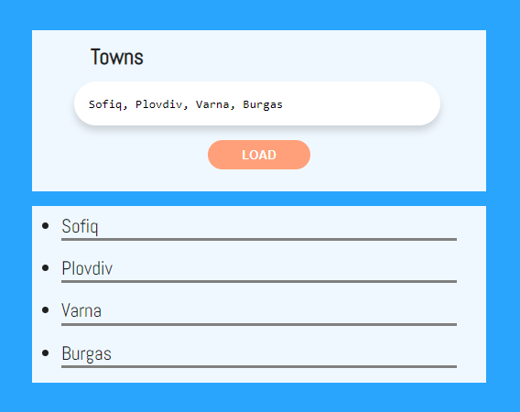

This is how the HTML should look like with the rendered template:

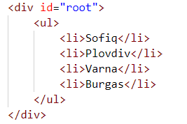

## HTTP Status Cats

We all love cats. They are also a fun way to learn all the HTTP status codes.

Your task is to create a **template** to represent an **HTTP** **cat card**. After you have **created** the template, **render** all the cats into the section with **id "**allCats**"**. Note that there should be a **nested** <ul> inside the section.

An **HTTP** **cat** has an id**,** statusCode**,** statusMessageandimageLocation. The cats are **seeded** using the **function** from the JS **file** named **"**catSeeder.js**"** – import this file as a module.

Each card block has a **button** that **reveals** its status code. You should **toggle** the button and change its text from "Showstatuscode" to "Hidestatuscode".

See the file example.html for an example of how the rendered HTML should look like.

### Screenshots

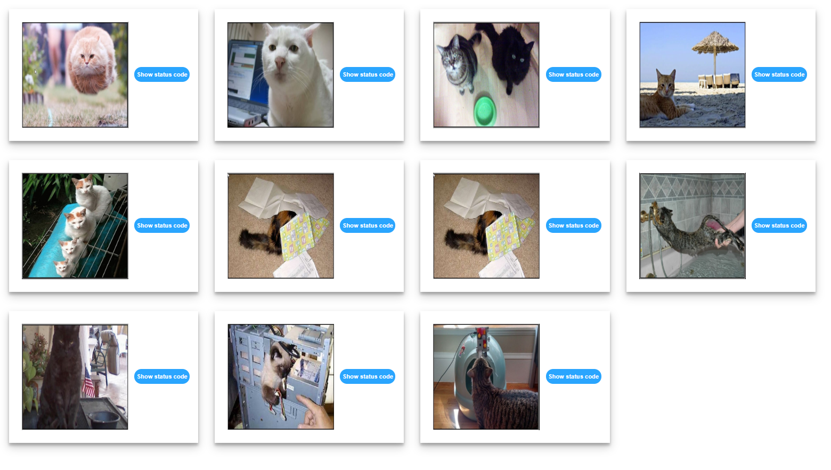

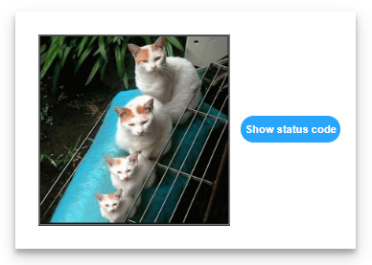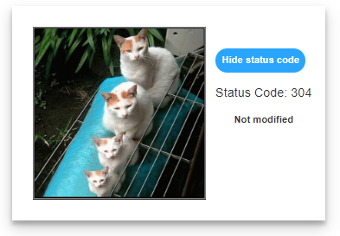

## Search in List

An HTML page holds a **list** of towns, a **search** box and a [Search] button. Create a template for a list, containing all towns, that can be easily updated when the user performs a search. The list should be rendered inside the <div> element with **id "towns"**. Load the values from the file **towns.js**, which you can import as a module.

Implement the search function to **apply class "active"** to the items from the list which include the text from the **search** box. Also print the number of items the current search **matches** in the format **"<matches> matches found"**. The search should be **case-sensitive**.

See the file example.html for an example of how the rendered HTML should look like.

### Screenshots

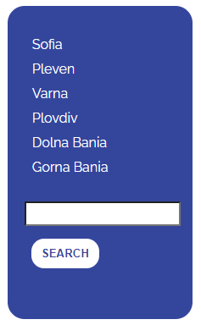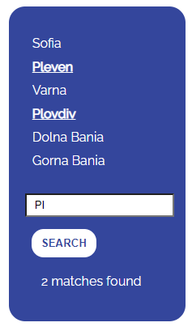

## Fill Dropdown

Create functionality that **loads list items** from a remote service and displays them inside a **drop-down** menu. The user should also be able to **add new items** to the service by entering them in the **input** field on the page and submitting the form. Create a **template** for the **drop-down list** and the **items** inside it that can be **easily updated** with new entries.

When the program starts, the data should be automatically retrieved from the server via GET request from URL http://localhost:3030/jsonstore/advanced/dropdown and rendered as <option> items inside the <select> with **id "menu"**. Upon form submission, send a **POST** request to the same URL and if it is successful, update the list of options with the newly created item.

Each item has a property text entered by the user and _id, which is generated by the server. When creating the HTML elements, use the _id as option **value** and text as option **textContent**.

**Example**

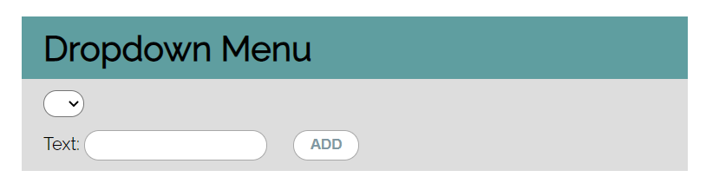

This is how the rendered HTML should look like:  
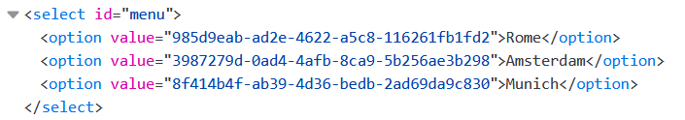

## Table – Search Engine

Write a function that **searches** in a **table** by given input. Create a **template** for a **table row**, which can be **easily updated** with class values when the user performs a search. Load the data from the following URL with a GET request: **http://localhost:3030/jsonstore/advanced/table**

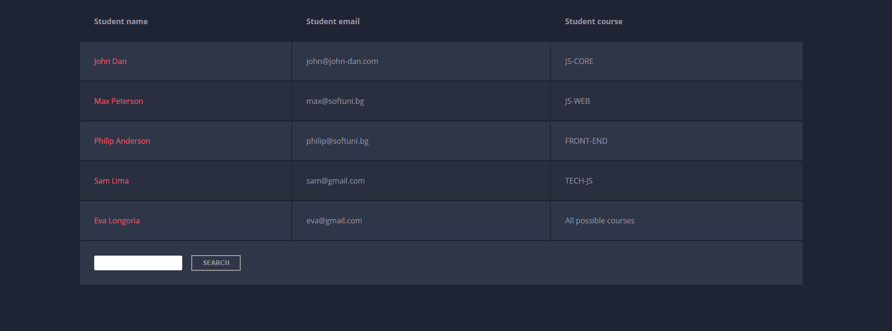

When the "**Search**" **button** is **clicked**, go through all cells in the table body and check if the given input is **included** anywhere. The search should be **case-insensitive**.

If any of the rows contains the submitted string, add a select class to that row. Note that more than one row may contain the given string. If there is no match **nothing** should be highlighted.

**Note:** After every search, **clear** **the input field** and **remove** **all already selected classes** (if any) from the previous search, in order for the **new search** to contain only the **new result**.

See the file example.html for an example of how the rendered HTML should look like.

### Example

For instance, if we try to find **eva:**

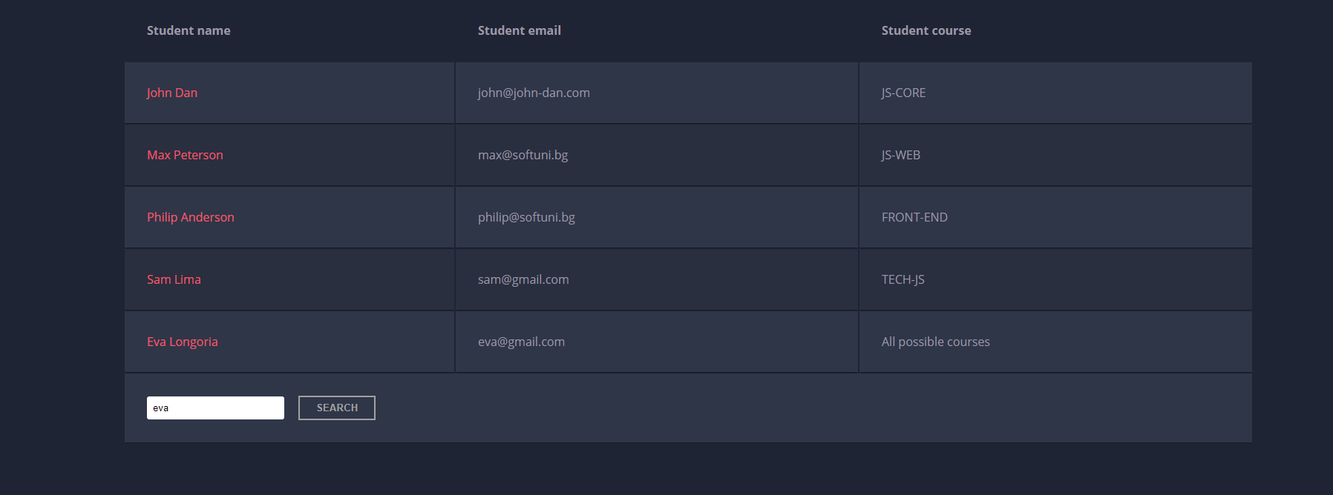

The result should be:

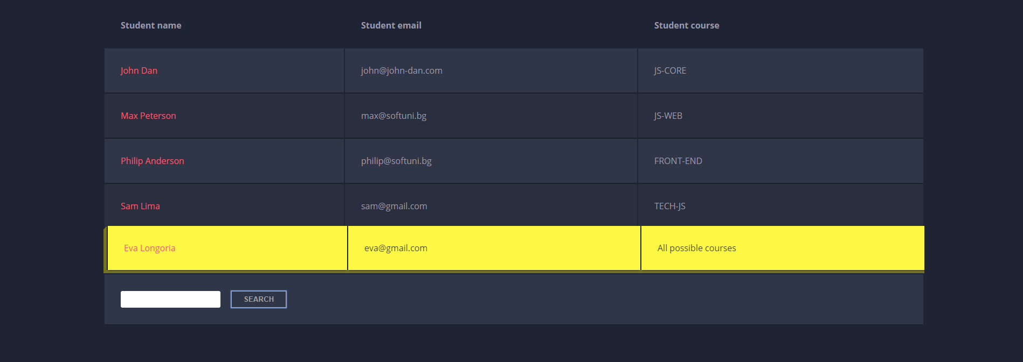

If we try to find all students who have email addresses in **softuni** domain, the expected result should be:

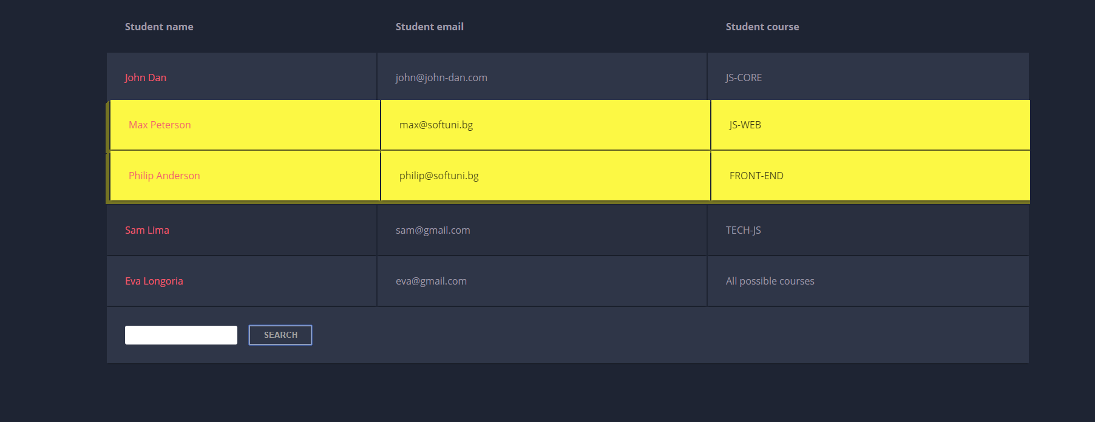

## Book Library

Create **templates** for **all items** on the page, as you see fit. See the file example.html for an example of how the rendered HTML may look like. You are free to add attributes that would help you implement the required functionality.

### Get All Books

First task is to "**GET**" all books when the button "Load All Books" is clicked. To consume the data from the API, send a request to the **following URL**: **http://localhost:3030/jsonstore/collections/books**

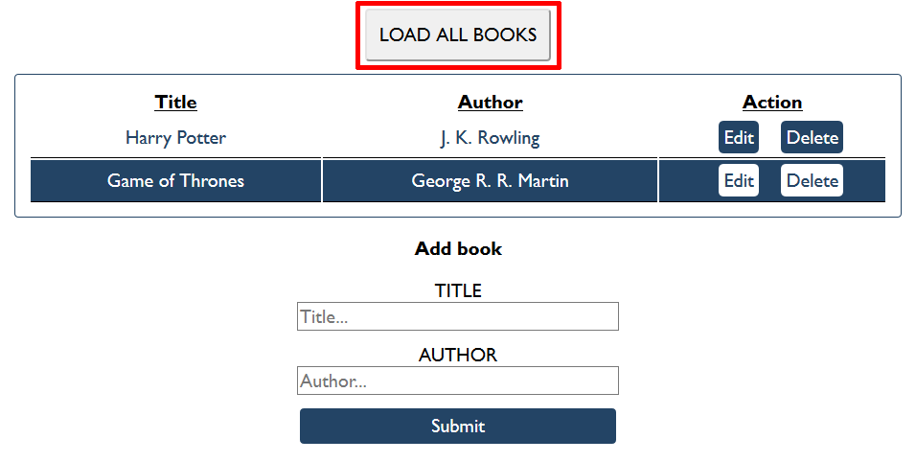

### Create Book

Initially, the form with **id "add-form"** should be displayed. Write functionality to create a new book, when the submit button is clicked. Before sending the request be sure the fields are not empty (make validation of the input). To **create** a book, you must send a "**POST**" request and the JSON body should be in the **following** format:

{

"author": "New Author",

"title": "New Title"

}

### Get Book

Send a "GET" request to the following url:

**http://localhost:3030/jsonstore/collections/books/:id**

### Update Book

By clicking the edit button of a book, display the form with **id "edit-form"** and populate its fields with the information from the selected book:

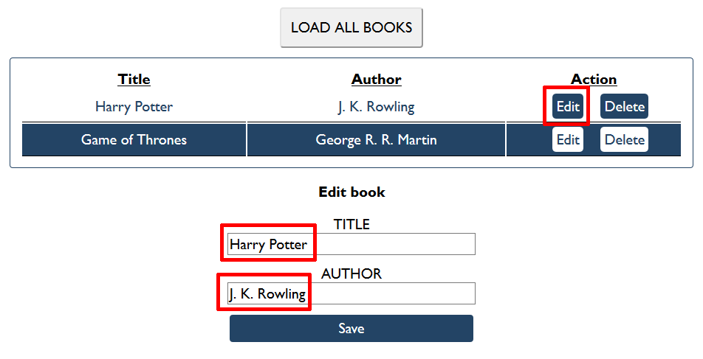

The HTTP command "**PUT**" **modifies** an existing HTTP **resource**. The URL is:

**http://localhost:3030/jsonstore/collections/books/:id**

The JSON body should be in the **following** format:

{

"author": "Changed Author",

"title": "Changed Title"

}

## Submitting Your Solution

Place in a **ZIP** file the content of the given resources including your solution. Exclude the node_modules folder if there is one. Upload the archive to Judge.

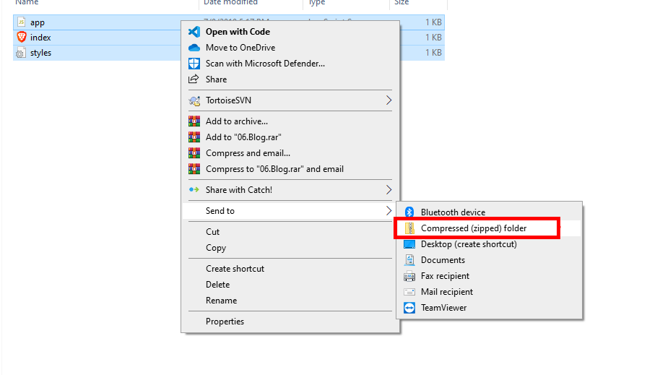

Картина, която съдържа текст

Описанието е генерирано автоматично

Картина, която съдържа текст

Описанието е генерирано автоматично