

Coursework report
Algorithms and Data structures (SET09117)
Ivan ROGER (40285021)

Introduction
Problem summary including any limitations of your solution.

Abstract

Method
Description of the experiment that you conducted.
How did you select the instances to be examined.

Experiments

Dataset selection
I selected multiple data sets for my tests. I started with a small one to be able to follow easily what the program was doing. So that if I did an error in the code it was easier to see it.
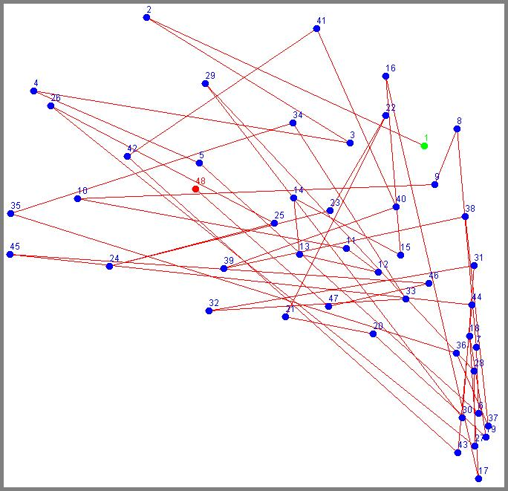
Illustration 1: Small dataset
My first dataset was composed of 48 cities (cf Illustration 1).
I also used bigger dataset afterwards to test the speed of my algorithms. To do so I used problems with gradually increasing number of cities, I began with 120 and 152, and I am now working with 4461 cities.
For some algorithms the way cities are placed can also influence on the result. I have remarked this with the file a280.tsp

Results
Tables and charts that show the performance of your solution (how long does it take to run your algorithm).
Demonstration that your solution is valid.
Demonstration of the quality of your solution (what is the cost).

Nearest Neighbour
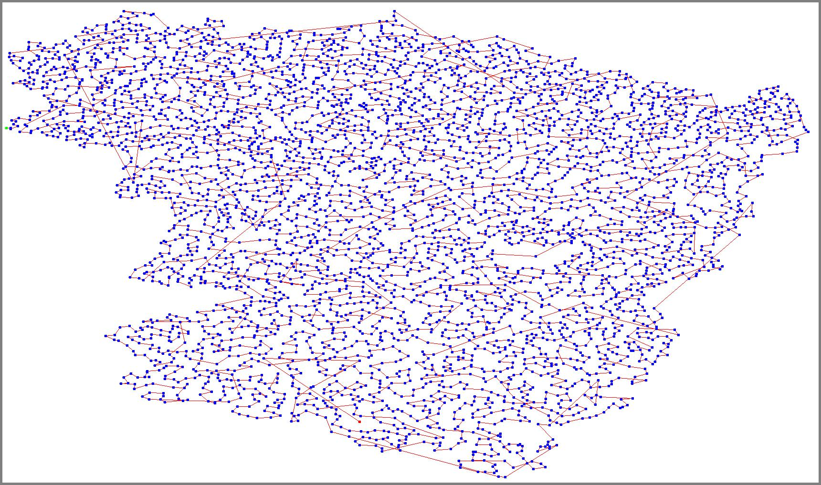
Illustration 2: Nearest Neighbour on fnl4461

Intersection solving

Two Opt
> --- RESULT ---
> Time: 7838962.27595
> Length: 296196.9237859189
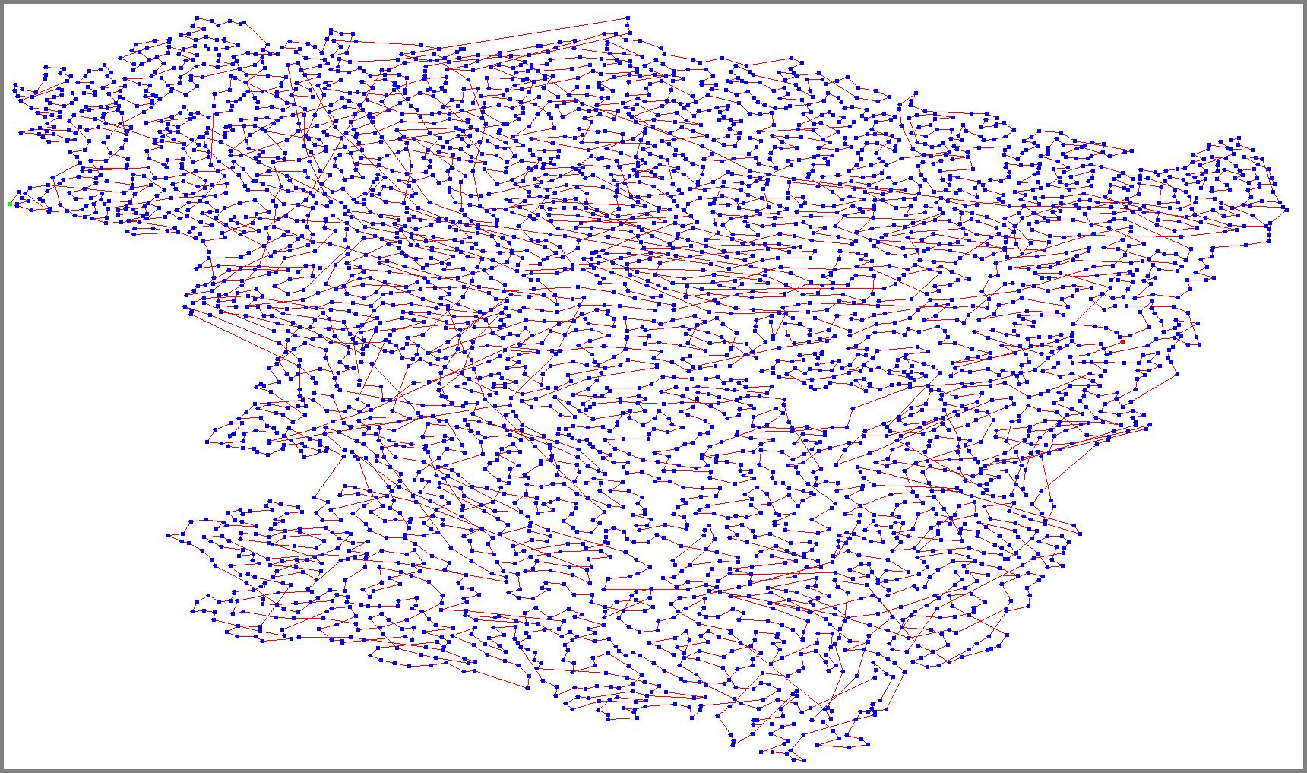
Illustration 3: Two Opt after Nearest Neighbour on fnl4461

Conclusions
Summary of your results.
Reflection on your performance on this assessment.

Summary

Performance analysis

Appendix

Source: Nearest Neighbour
ArrayList<City> res = new ArrayList<>();

City currentCity = cities.get(0);
cities.remove(0);
res.add(currentCity);

while (!cities.isEmpty()) {
// Because we are forced to give an initial value
double distance = Float.MAX_VALUE;
City closest = currentCity;
for (City p : cities) {
if (currentCity.distance(p) < distance) {
closest = p;
distance = currentCity.distance(p);
}
}
cities.remove(closest);
res.add(closest);
currentCity = closest;
}

return res;

Source: Solve Intersections
ArrayList<City> res = (ArrayList<City>) cities.clone();

boolean intersectFound;
do {
intersectFound = false;
// Loop through all cities (except the first)
for (int i=1; i<res.size()-1; i++) {
City startA = res.get(i);
City endA = res.get(i+1);
// Create a line to represent the edge
Line2D lineA = new Line2D.Float(startA, endA);

// Loop through all cities
for (int j=1; j<res.size()-1; j++) {
// if it's the previous, same, or next skip.
if (Math.abs(i-j)<2) continue;

City startB = res.get(j);
City endB = res.get(j+1);
// Create a line to represent the edge
Line2D lineB = new Line2D.Float(startB, endB);

// If the two edge intersects
if (lineA.intersectsLine(lineB)) {
// Update the loop flag
intersectFound = true;

// Swap the nodes
res = TwoOpt.swapOpt(res, i, j);

// Update data for the next loop
startA = res.get(i);
endA = res.get(i+1);
lineA = new Line2D.Float(startA, endA);
}
}
}
} while (intersectFound);

return res;

Source: Two Opt
ArrayList<City> res = (ArrayList<City>) cities.clone();

// Variable to store the best route length found.
double best_dist = TSPLib.routeLength(res);
// Flag to continue looping when we made an improvement
boolean improvementMade;
do {
improvementMade = false;
// Loop through each cities
for (int i=1; i<res.size()-1; i++) {
// Loop through cities following the current one
for (int j=i+1; j<res.size()-1; j++) {
// Get the new route and it's length
ArrayList<City> new_route = swapOpt(res, i, j);
double new_dist = TSPLib.routeLength(new_route);

// Test if it's an improvement
if (new_dist<best_dist) {
// Then keep it, update variables
res = new_route;
best_dist = new_dist;
improvementMade = true;
}
}
}
} while (improvementMade);

return res;

Function: TwoOpt.swapOpt(in, i, j)
ArrayList<City> out = (ArrayList<City>) in.clone();

City tmp = out.get(i);
out.set(i, out.get(j));
out.set(j, tmp);

return out;

