1. Implemented SVD decomposition using predefined functions in Mathematica and produced glorious compressed Milko

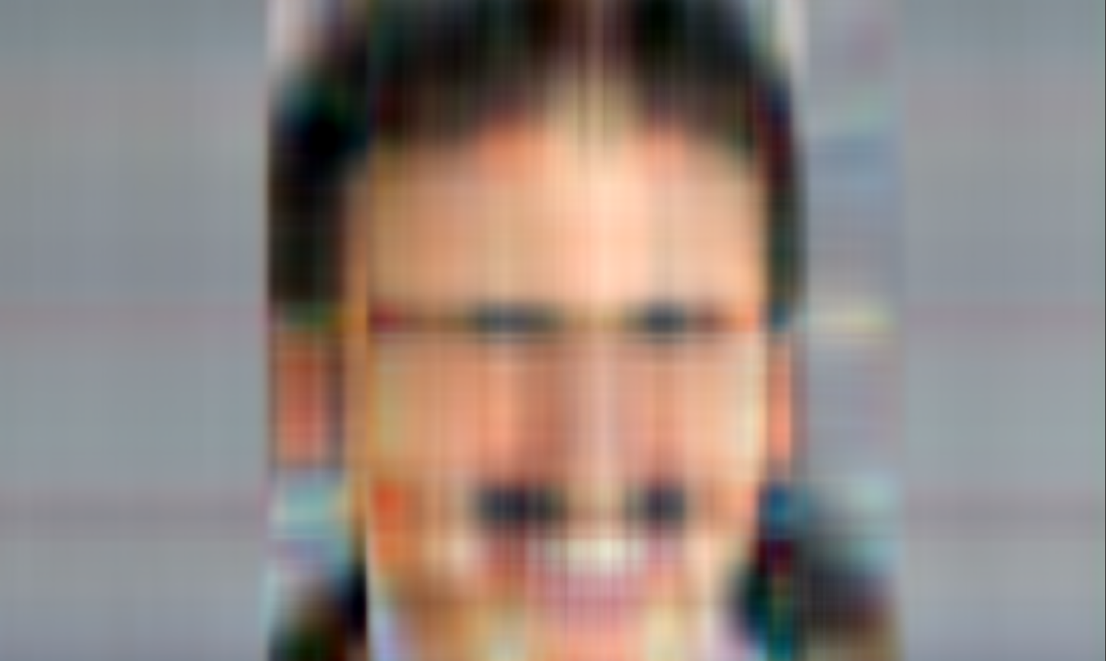

1. Experimented to see if the singular values for the different rgb channels of an image can be substantially different. And it turns out they can!

This is the plot of the singular values per rgb channel for the following image:

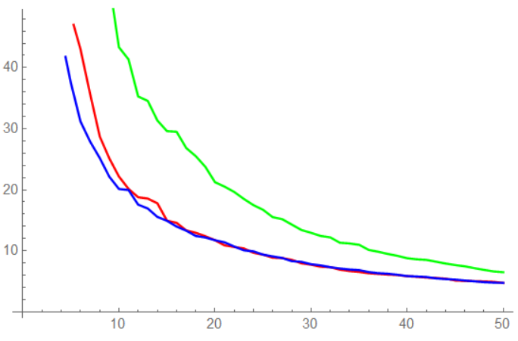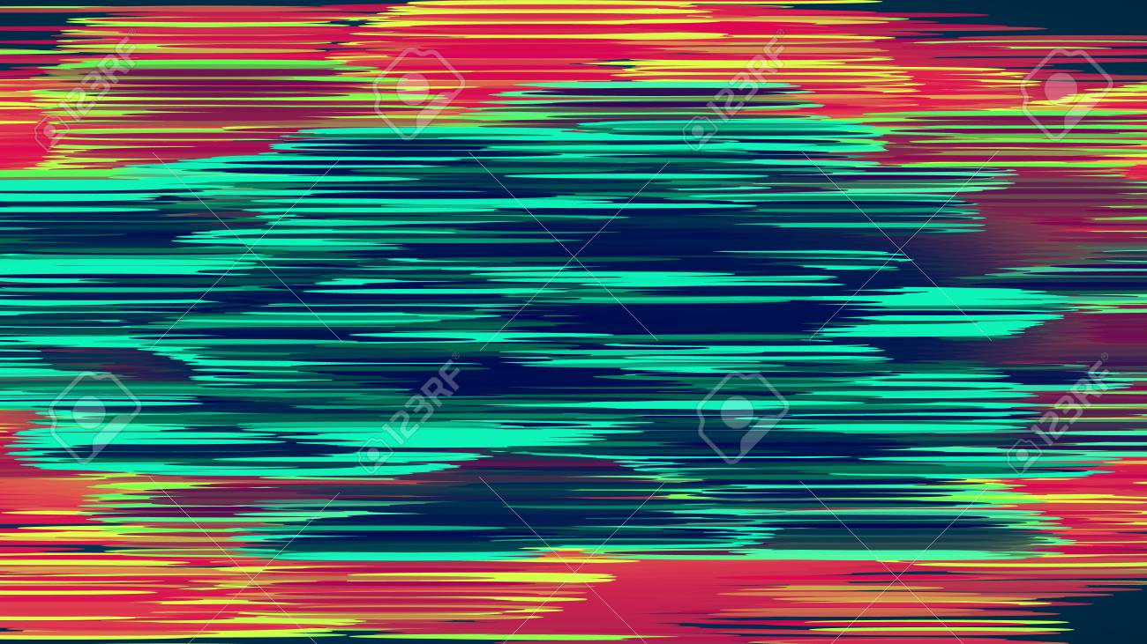

1. Improved the implementation of SVD so that the matrices are stored not as
   1. An m\*m matrix + m\*n matrix + n\*n matrix

But rather when given a cutoff threshold t:

* 1. A t\*m matrix + t vector + n\*t matrix
  2. We then reconstructed the original image from this compressed representation