**UNIT 6 TEST**

**Subject: English**

**Year: Seventh grade (7th)**

**Name: ___________________________________________**

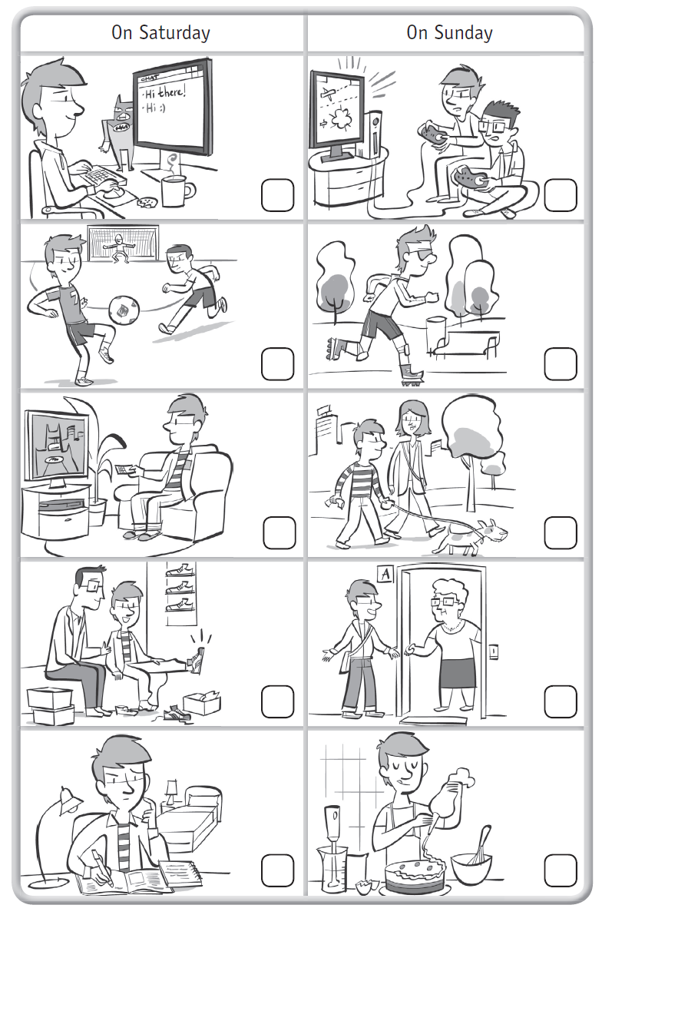**1 Listen and put the pictures in order.**

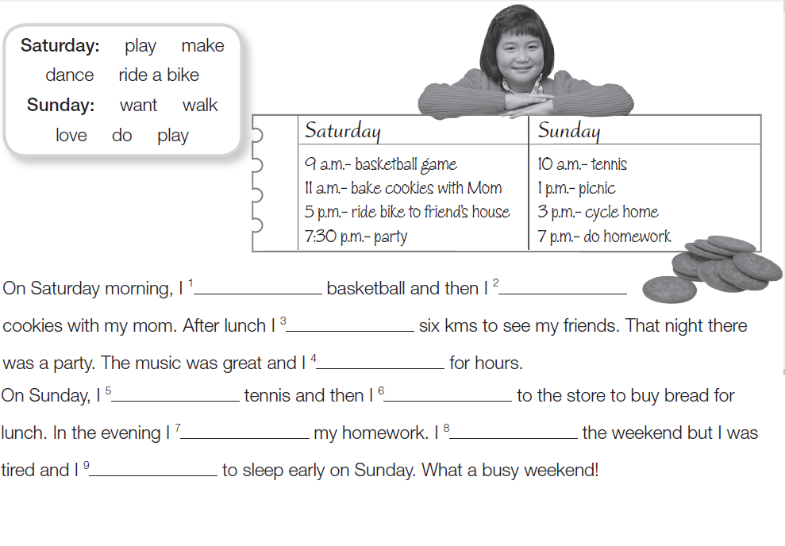**2 Look at Lucy’s diary and complete. Use the correct tense.**

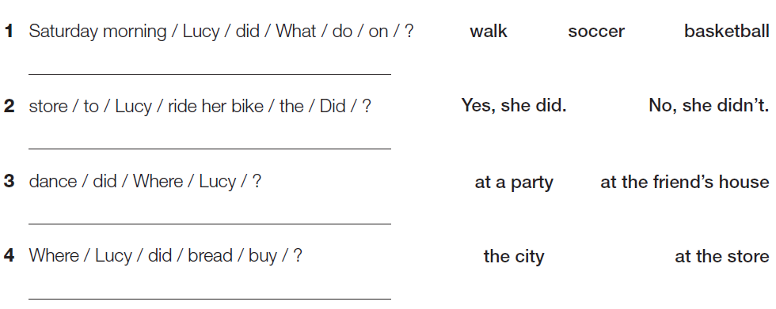**3 Unscramble and write the questions about Lucy’s weekend. Circle the answers.**

**4 Now write about you. What did you do last weekend?**

**On the weekend ………………………………………………………………………………………………………………………....**

**…………………………………………………………………………………………………………………………………………………….**