I implemented LQR method and Kalman filter on a line follower.

The robot is composed of two wheels and a row of sensors at the front. The distance between sensors and the center of two wheels is $R$. The robot is moving forward at a constant speed $v$. The angular velocity $ω$ is the input of the system to make sure that the robot follows the line. The sensor can measure the distance away from the line, and the measured value $z$ is the output of the system. $y$ is the distance between the line and the center of two wheels. $θ$ is the angle between the moving directions and the line.

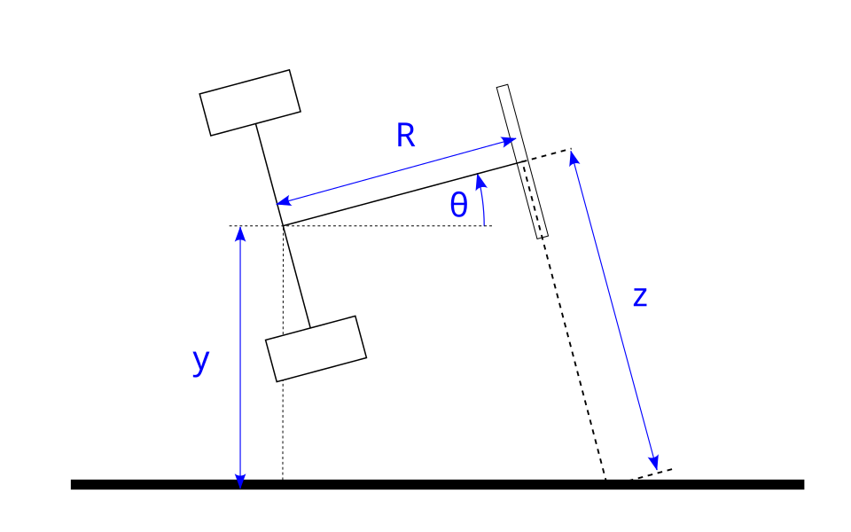

It can be seen that $\dot{y}=v\sin{θ}$ and $z=R\tan{θ}+y\sec{θ}$

I design the state to be $\left[\begin{matrix}y \\ θ\end{matrix}\right]$, the state space model can be linearized at

$y=θ=0$. Therefore,

$$\frac{d}{dt}\left[\begin{matrix}y \\ θ\end{matrix}\right]=\left[\begin{matrix}0 & v \\ 0 & 0\end{matrix}\right]\left[\begin{matrix}y \\ θ\end{matrix}\right]+\left[\begin{matrix}0 \\ 1\end{matrix}\right]ω$$

$$z=\left[\begin{matrix}1 & R\end{matrix}\right]\left[\begin{matrix}y \\ θ\end{matrix}\right]$$

This system is controllable and observable.

Because the sensor value is discrete, the variance of output is

$$\frac{1}{12}*{\left(the interval between sensors\right)}^{2}$$

Based on simulation, this method works great on following a straight line.

Interestingly, it works on following a curve under certain conditions.

When calculating the LQR gain, the weighted matrix $QW$ for the state which is a 2\*2 matrix. The weight matrix $RW$ for input is float value. If the weight for $θ$ is smaller or $RW$ is smaller, the robot will rotate more aggressively to follow the line, and therefore it can follow a sharper curve. On the other hand. The optimal weight for $y$ in $QW$ depends on $R$. If $R$ decrease, the weight for $y$ needs to be increased. Also, the upper bound for $v$ is determined by the width of sensors. When $v$ increases, it required wider range of distribution of sensors so that robot can correct the direction in time. The feedback frequency could be as low as 100Hz under some conditions.