Paolo Yshmael C. Trinidad

Hands-On Case Studies in JavaScript (Module1-3)

Case Study 1: Student Grade Management System Scenario
You are tasked to build a simple Grade Management System using JavaScript. The system should:

- Ask the user for the student’s name, age, and course.
- Ask for 3 grades and store them in an array.
- Compute the average grade.
- Classify the student’s status:
  - "Passed" if average ≥ 75
  - "Failed" if average < 75
- Display the student’s info, grades, average, and status using alert() or console.log().

Instructions

- Create an index.html and link a main.js file.
- In main.js, implement the Grade Management System.
- Test your program with different grades.

Expected Output (Example)
Student Information:
Name: Juan Dela Cruz Age: 20
Course: IT Grades: 80, 85, 90
Average: 85.00 Status: Passed

Learning Outcomes

- Using variables and objects for student info.
- Using arrays for storing grades.
- Loops for grade processing.
- Conditionals for status classification.
- Dialogs for user interaction.

Case Study 2: Simple ATM Simulation

You are tasked to create a Simple ATM Program using JavaScript. The ATM should:
- Ask the user to enter an initial balance.
- Display a menu of options: Deposit, Withdraw, Check Balance, Exit.
- Perform the transaction based on user choice.
- Prevent withdrawal if the amount is greater than the balance.
- Continue showing the menu until the user chooses Exit.

Instructions

- Create an index.html and link a main.js file.
- Implement the ATM program in main.js.
- Test your program with different transactions.

Expected Output (Example)

You deposited 500. New balance: 1500
You withdrew 300. New balance: 1200 Your current balance is: 1200
Thank you for using the ATM. Goodbye!

Learning Outcomes

  - Loops (do...while) to create a repeating menu.
  - Conditionals for menu logic.
  - Arithmetic operations for transactions.
  - Validation for sufficient funds.
  - Dialogs (prompt, alert) for user interaction.

OUTPUTS:

Case Study 1:
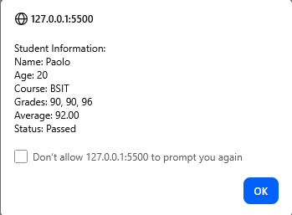

Case Study 2:
