Federal State Budgetary Educational Institution

higher education

Ufa University of Science and Technology

Department of Computational Mathematics and Cybernetics

Laboratory work No.2

“Methodology of object-oriented modeling”

Made by: Kozlov I.A.

Group number: PRO 234

Checked by: Rizvanov D.A.

Ufa 2023

**The purpose of the laboratory work:** Acquaintance with the basic elements of defining, representing, designing and modeling software systems using the UML language.

**Tasks:**

1. Consider the material on object-oriented modeling (https://www.uml-diagrams.org/index-examples.html)

2. Consider OO modeling tools (https://coderlessons.com/tutorials/kompiuternoe-programmirovanie/uchebnik-uml/13-luchshie-instrumenty-uml)

3. Decide on diagrams from the family of UML models:

a. at the stage of creating a conceptual model of an automated system (according to laboratory work 1),

b. at the stage of creating a logical model of an automated system (according to laboratory work 1).

4. Select one of the modeling tools (for example, Free UML Drawing Tool | by Warren Lynch | Medium)

5. Develop UML models for the implementation of an automated system, taking into account paragraph 3 of the assignment.

6. Develop a general block diagram of the algorithm for automated reading, processing and writing the processed data to the database (designate the stages of data processing as blocks of subroutines, if the processing algorithm has already been selected, then detail each processing subroutine with a separate block diagram).

7. Connect the repository on GitHub and download the developed documentation or code (see guidelines below).

8. Write a report. The report should include a set of static and dynamic models.

**Description of the work:**

In my lab work, I used the Visual Paradigm UML modeling tool. I also decided on the right types of diagrams: a use-case diagram and an interaction diagram. I use the first type of diagrams to display the functionality of the software system, and the second type to display the interaction between the parts of the system.

Use-case diagrams for clients and owners (with devs):

*Use-case diagram for Client*

*Use-case diagram for Devs*

To show connections between elements, we use the Interaction Overview diagram:

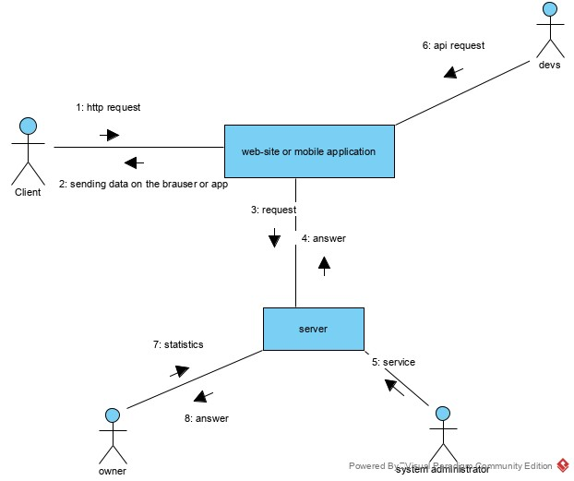

*Interactions between elements*

These diagrams show the functionality and connections between the elements of the software system. In order to display the automation of the system, we will use a flowchart:

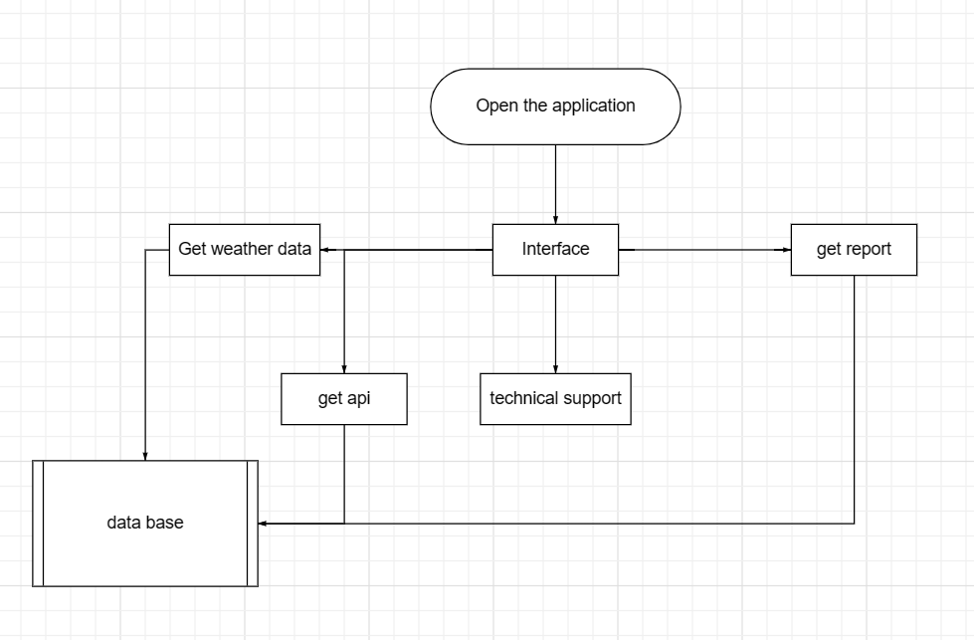

**Conclusion:** I took one of the first steps in software design (software system modeling). It helps to understand how my software will work.

Github: