**Release Notes & User Manual**

Personal Finance Management App

Group Name: B7

Chu Chun Yin 1155194319 [1155194319@link.cuhk.edu.hk](mailto:1155194319@link.cuhk.edu.hk)

Ko Kam San 1155194979 [1155194979@link.cuhk.edu.hk](mailto:1155194979@link.cuhk.edu.hk)

Lai Tsz Hin 1155194965 [1155194965@link.cuhk.edu.hk](mailto:1155194965@link.cuhk.edu.hk)

Chan Yiu Cheung 1155193060 [1155193060@link.cuhk.edu.hk](mailto:1155193060@link.cuhk.edu.hk)

Instructor: Dr. Lam Tak Kei

Course: CSCI3100

Department: Computer Science and Engineering

Printing Date: 9/5/2025

Contents

Release Notes 3

User Manual 4

1. Introduction 4

2. Getting Start 4

3. Navigation Overview 4

4. Features Explanation 6

# Release Notes

1. Version Number: 1.0

2. Release Date: 13-05-2025

3. New Feature:

* Add the create new transaction button on every pages
* Add the create new category button on Categories pages
* Add transaction pages
* Add categories pages
* Add daily bar chart
* Add logout side effect
* Add emoji and color to categories

4. Bug fixed

* Fixed number and text formatting
* Fixed the react to auth error
* Fixed invalid account summary cache
* Fixed tweak components

5. Future Plans

* Add group sharing feature

# User Manual

## 1. Introduction

The purpose of this Personal Finance Management Web Application is assisting users to take control of their finance, whether they are budgeting for personal expenses, saving for future goals, or managing investments.

## 2. Getting Start

The First-time users enter the Personal Finance Management Web Application. Users need to register an account for the web app. The process of registering accounts requires the users to input their email address, full name, password, and license key. After successfully registering accounts, users can login to the web app by inputting the email address and password. 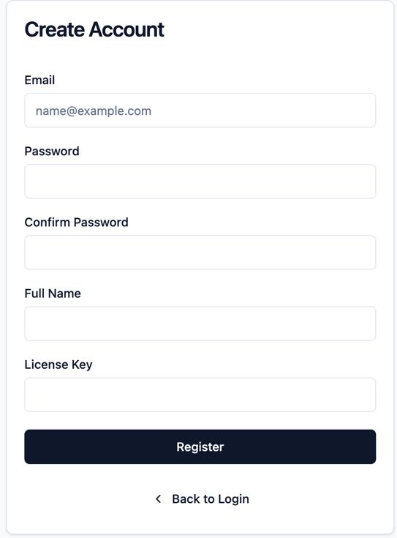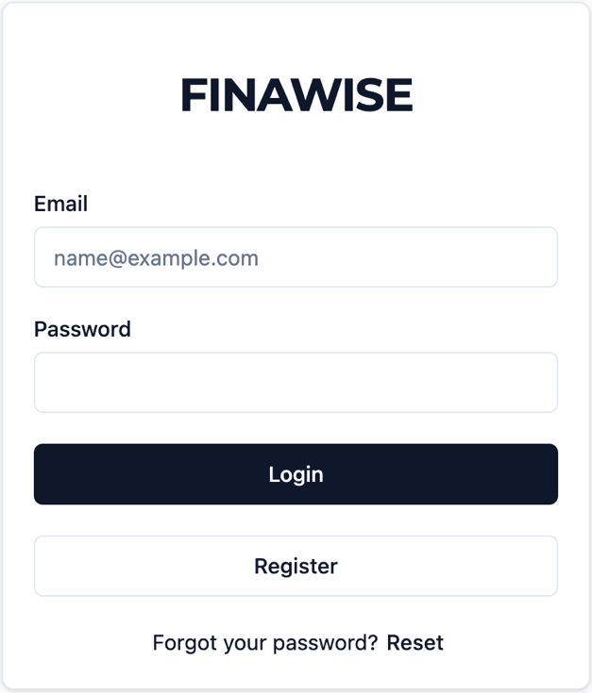

## 3. Navigation Overview

On the left-hand side, users can click on the Dashboard, transactions, budgets, categories. Users enter the Dashboard on the main page as default. Users can have the overview of their total balance, income, expense, and Daily Average. Below, users can know the recent transactions, categorized breakdown, daily balance, and budget plan.

On the Transactions page, users can view and manage their all transactions. User can check their budget on the Budgets page. The categories pages can check users’ transaction categories.

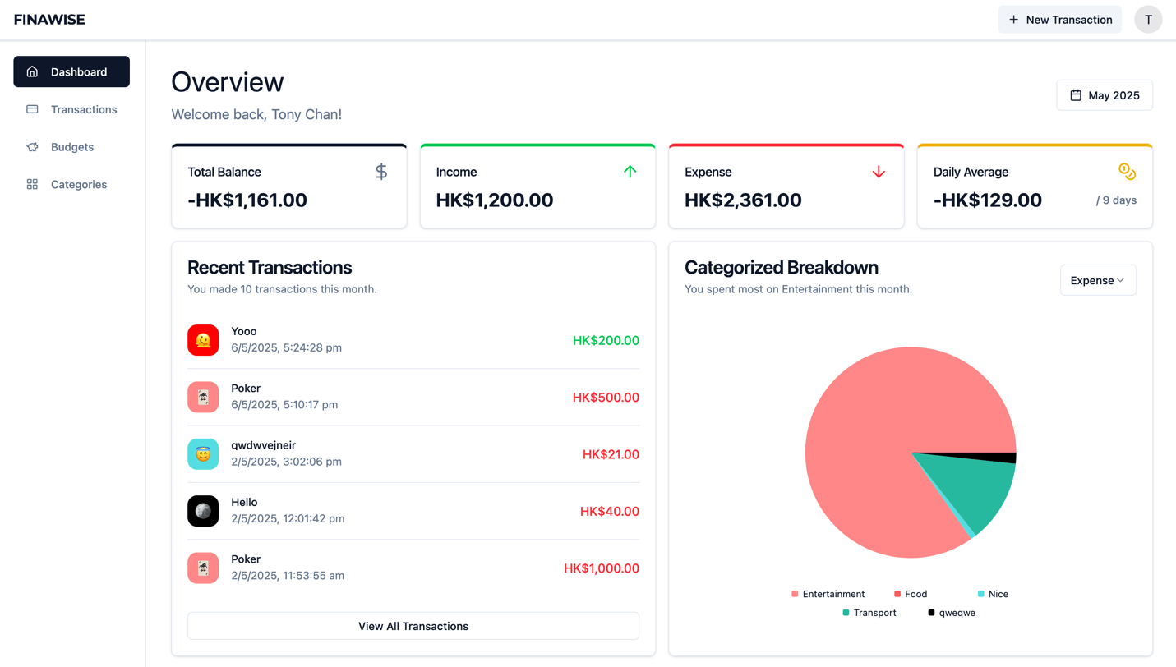 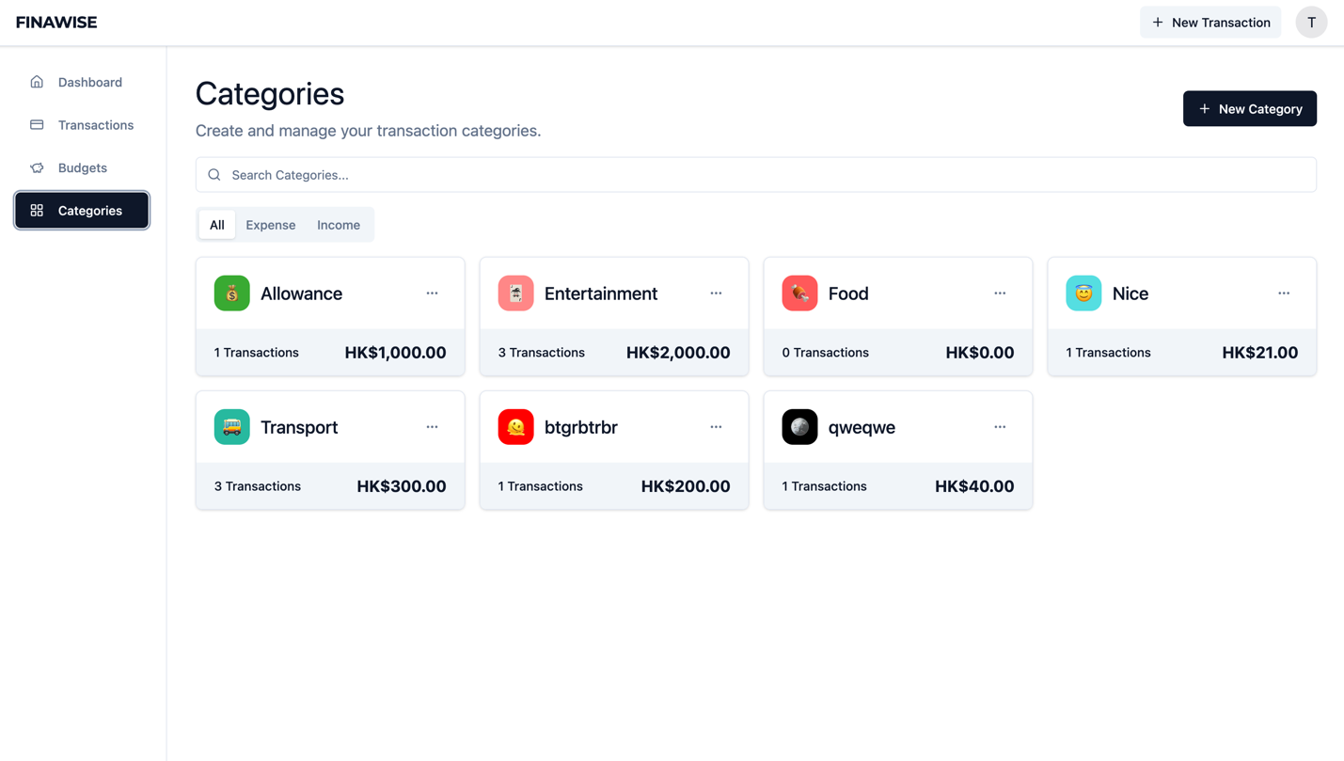

## 4. Features Explanation

User can click the + New Transaction button at every pages. There are some options on the +New Transactions to let users choose. User can change the amount to increase or decrease. Then, user also can have two type, expense and income. User can select the categories which the transaction is. Title will be the name of the transaction. Finally, users can select the date time.

After adding the transactions, users can edit or delete the categories by click the … button.

Users can export data of the transaction by click the export transaction button on the Transactions page.

Users can add new categories by click the +New Category button on the Categories pages. Then users can input the name and select the type which is expense or income. User also can choose color and emoji to the category.

User can export the transaction record by clicking the Export Data. All transactions record will be stored into a JSON format.

After adding the categories, users can edit or delete the categories by click the … button.

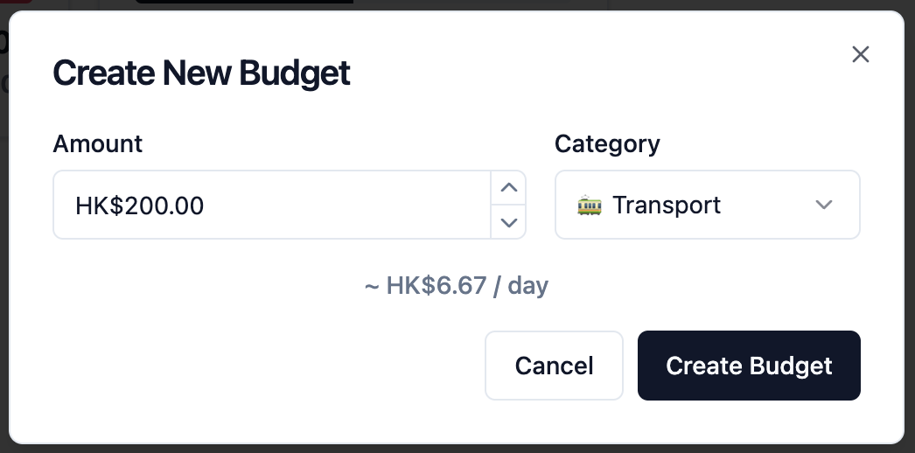

User can add a budget limit to each Category with a specific amount.

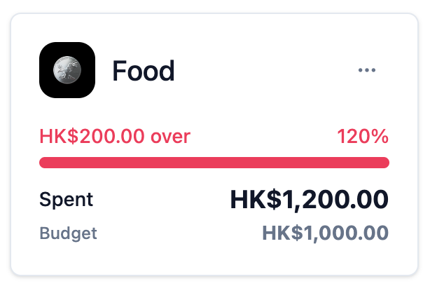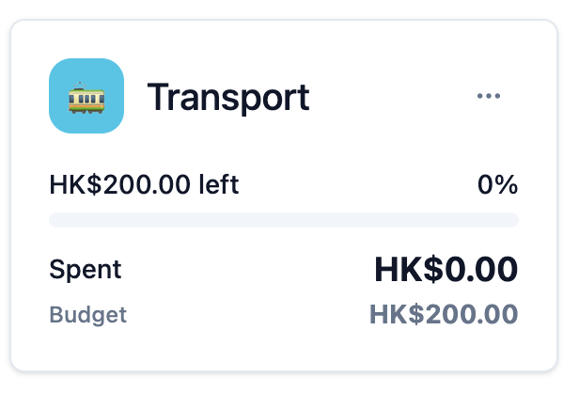

The budget page will show the proportion of spending in each Category.