Министерство науки и высшего образования Российской Федерации

Федеральное государственное бюджетное

Образовательное учреждение высшего образования

«Уфимский университет науки и технологий»

Факультет информатики и робототехники

Кафедра Информатики

Отчет по лабораторной работе № 3

на тему: «Управление камерой и освещение в OpenGL»

Выполнил:

Студент группы ПРО-233Б Ермолов И О

Проверил:

канд. техн. наук В.А. Котельников

Уфа - 2023

**Цель работы**

Изучение управления камерой и освещения в OpenGL.

**Задание**

Выполнить 14-21 уроки по OpenGL <https://triplepointfive.github.io/ogltutor/>

**Ход работы**

1. В уроках 14-15 я научился управлять перемещением камеры с помощью клавиатуры и мыши.

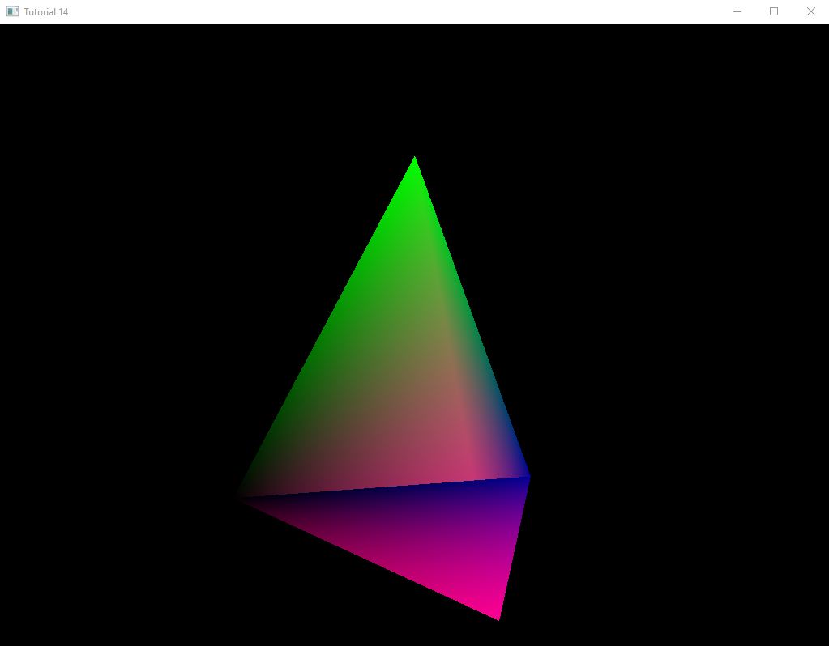

Рисунок 1. Движения камеры стрелками и мышью.

1. В 16 уроке я изучил способ наложения текстур на 3-D объекты в OpenGL с помощью библиотеки Magick.

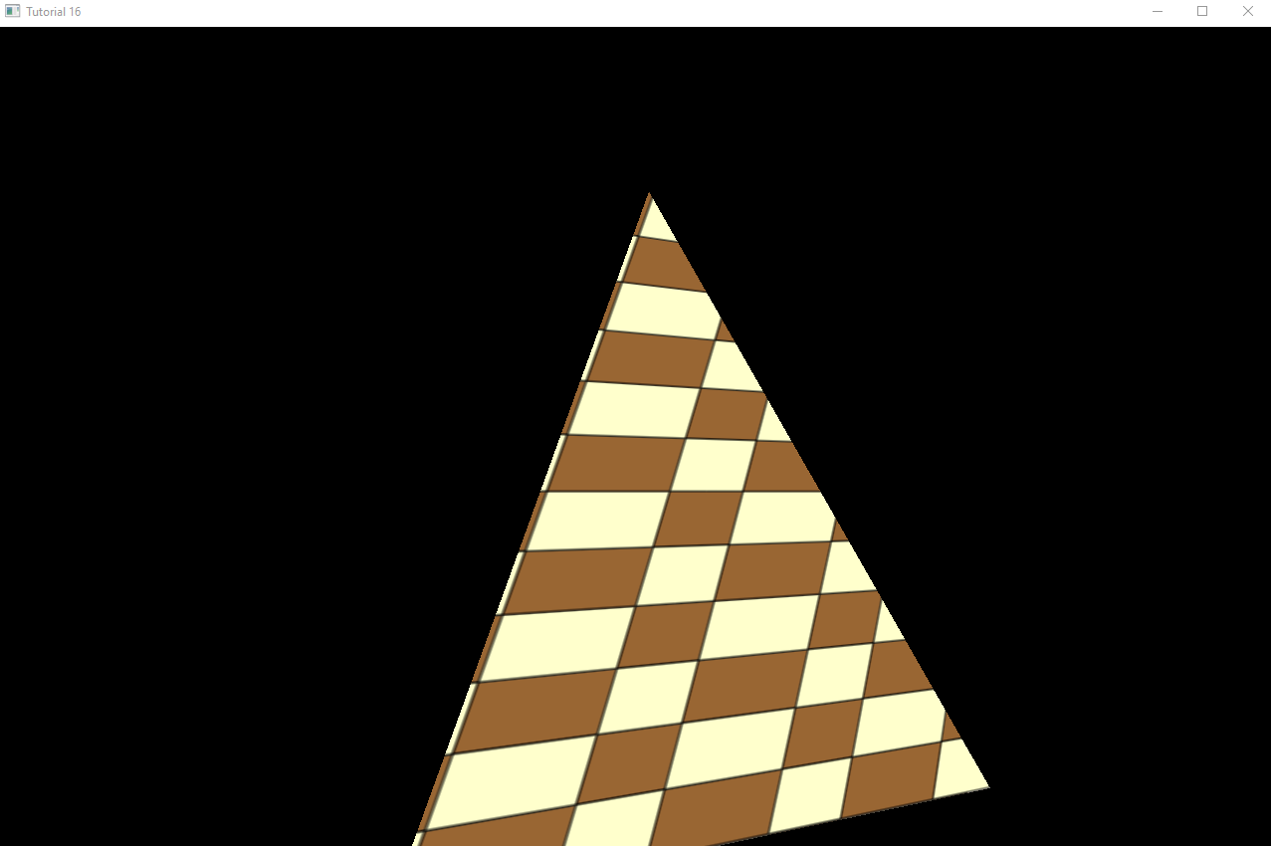

Рисунок 2. Наложение текстур.

1. В уроках 17-19 я изучил основные виды моделей освещения

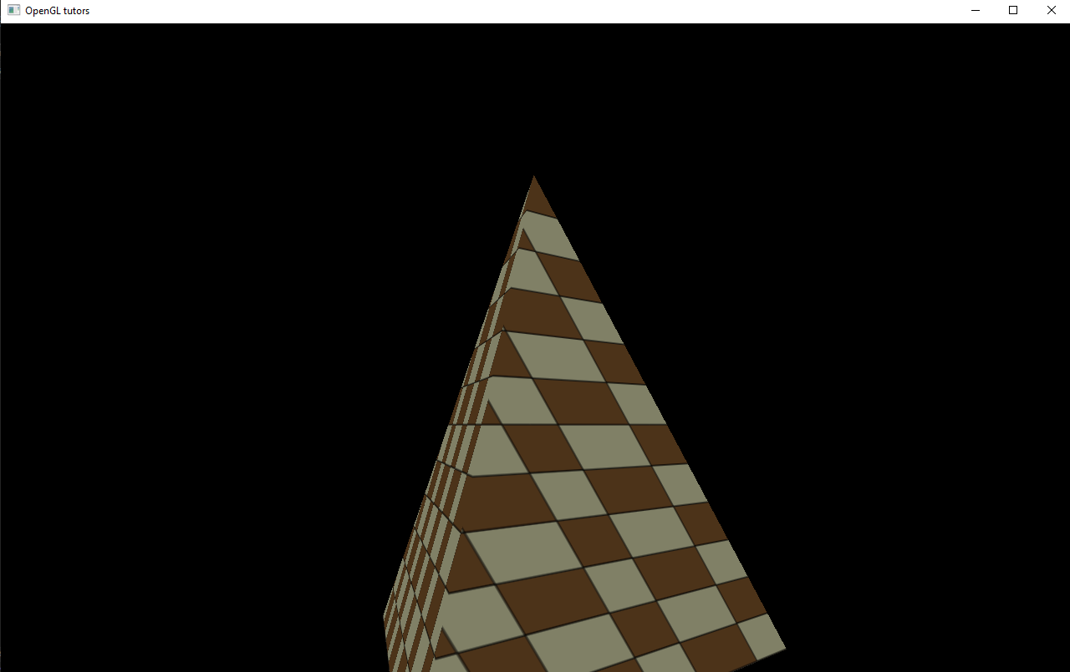

Рисунок 3. Фоновое освещение.

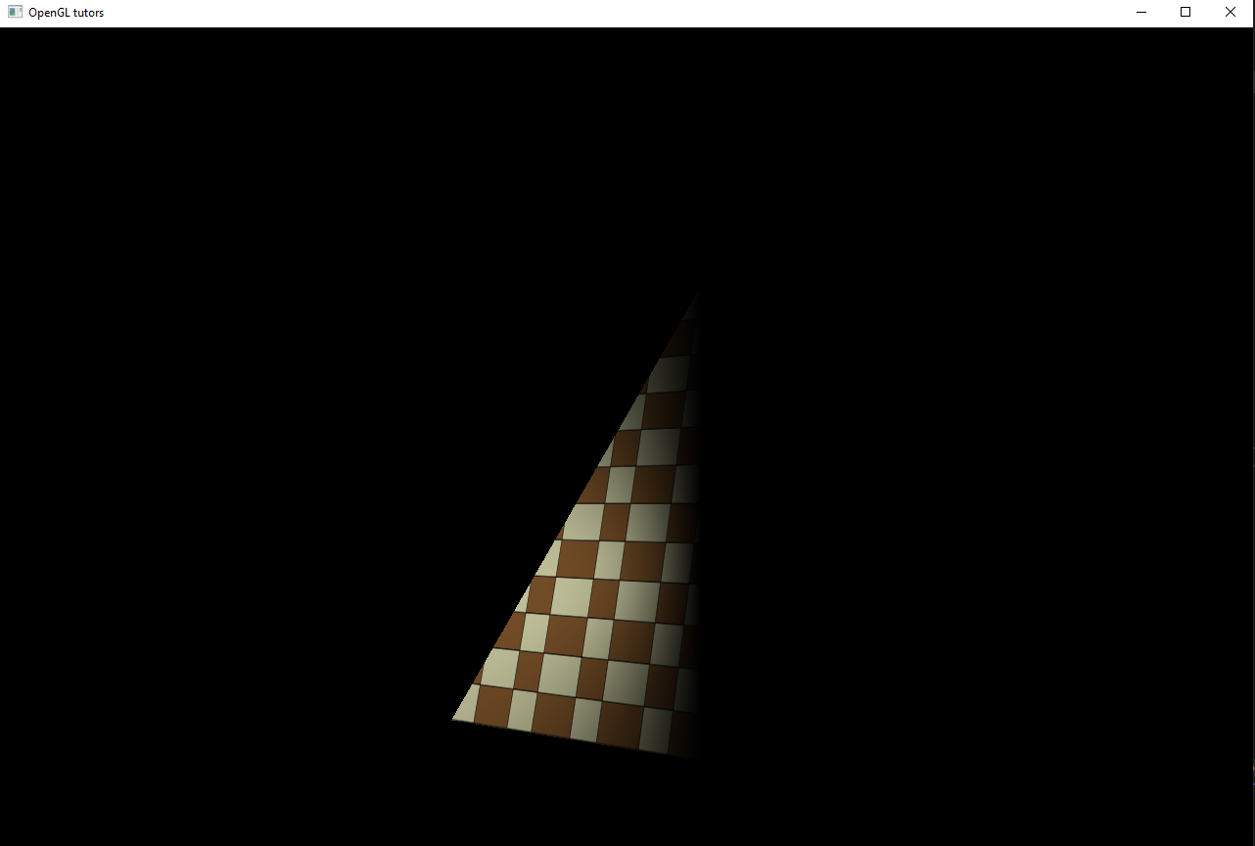

Рисунок 4. Рассеяное освещение.

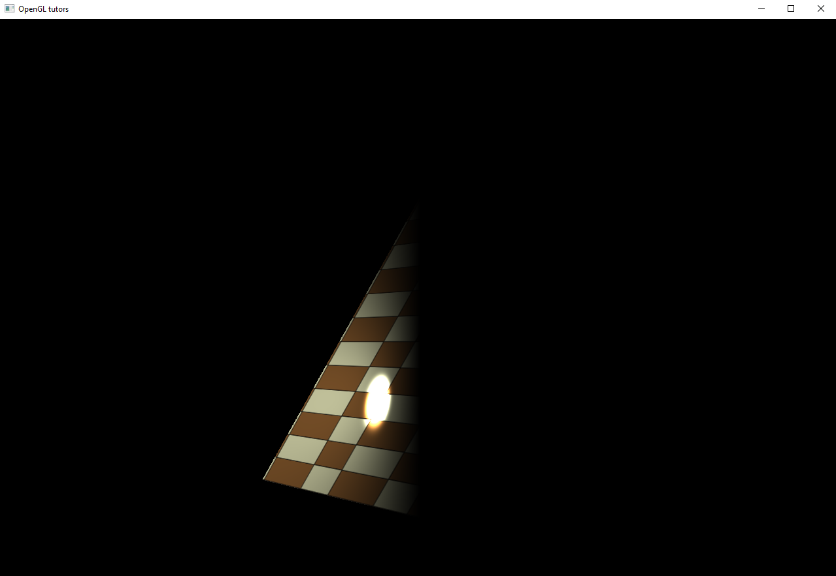

Рисунок 5. Отраженный свет.

1. В уроках 21-22 я изучил способ создания точечных источников света и прожектора.

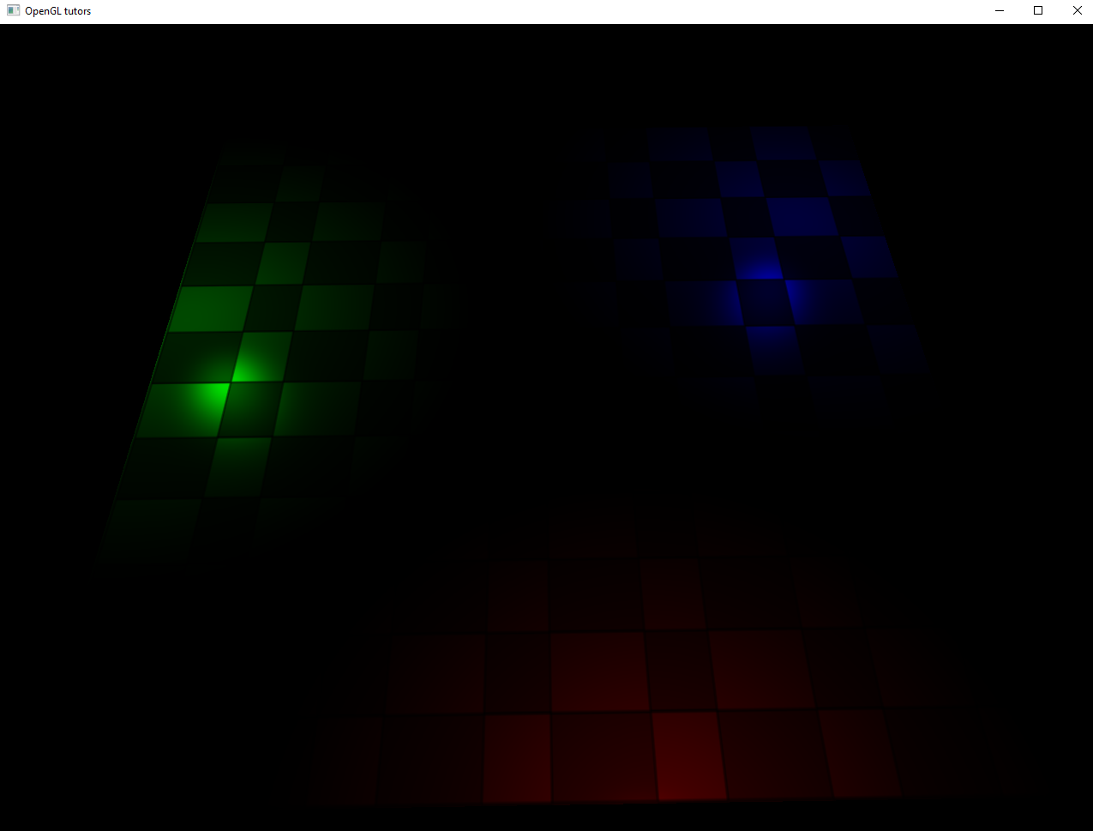

Рисунок 6. Точечные источники света.

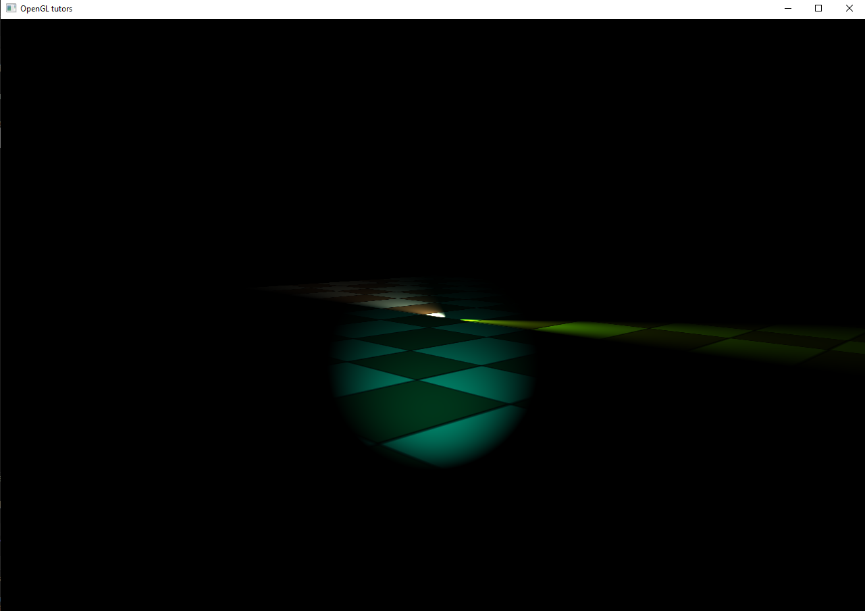

Рисунок 7. Прожекторы.

**Выводы к работе**

При выполнении данной лабораторной работы я познакомился со способами управления камерой и способами освещения. Полный код программ по ссылке: [https://github.com/Ivan122727/EKG/tree/master/LW3](https://github.com/VerVyle/LW_ECG/tree/master/LW3)

**Приложение 1**

**callbacks.h**

#ifndef CALLBACKS_H

#define CALLBACKS_H

class ICallbacks

{

public:

virtual void SpecialKeyboardCB(int Key, int x, int y) = 0;

virtual void KeyboardCB(unsigned char Key, int x, int y) = 0;

virtual void PassiveMouseCB(int x, int y) = 0;

virtual void RenderSceneCB() = 0;

virtual void IdleCB() = 0;

};

#endif /* CALLBACKS_H */

**camera.cpp**

#include <GL/freeglut.h>

#include "camera.h"

const static float STEP_SCALE = 0.1f;

const static int MARGIN = 10;

Camera::Camera(int WindowWidth, int WindowHeight)

{

m_windowWidth = WindowWidth;

m_windowHeight = WindowHeight;

m_pos = Vector3f(0.0f, 0.0f, 0.0f);

m_target = Vector3f(0.0f, 0.0f, 1.0f);

m_target.Normalize();

m_up = Vector3f(0.0f, 1.0f, 0.0f);

Init();

}

Camera::Camera(int WindowWidth, int WindowHeight, const Vector3f& Pos, const Vector3f& Target, const Vector3f& Up)

{

m_windowWidth = WindowWidth;

m_windowHeight = WindowHeight;

m_pos = Pos;

m_target = Target;

m_target.Normalize();

m_up = Up;

m_up.Normalize();

Init();

}

void Camera::Init()

{

Vector3f HTarget(m_target.x, 0.0, m_target.z);

HTarget.Normalize();

if (HTarget.z >= 0.0f)

{

if (HTarget.x >= 0.0f)

{

m_AngleH = 360.0f - ToDegree(asin(HTarget.z));

}

else

{

m_AngleH = 180.0f + ToDegree(asin(HTarget.z));

}

}

else

{

if (HTarget.x >= 0.0f)

{

m_AngleH = ToDegree(asin(-HTarget.z));

}

else

{

m_AngleH = 90.0f + ToDegree(asin(-HTarget.z));

}

}

m_AngleV = -ToDegree(asin(m_target.y));

m_mousePos.x = m_windowWidth / 2;

m_mousePos.y = m_windowHeight / 2;

glutWarpPointer(m_mousePos.x, m_mousePos.y);

}

bool Camera::OnKeyboard(int Key)

{

bool Ret = false;

switch (Key) {

case GLUT_KEY_UP:

{

m_pos += (m_target * STEP_SCALE);

Ret = true;

}

break;

case GLUT_KEY_DOWN:

{

m_pos -= (m_target * STEP_SCALE);

Ret = true;

}

break;

case GLUT_KEY_LEFT:

{

Vector3f Left = m_target.Cross(m_up);

Left.Normalize();

Left *= STEP_SCALE;

m_pos += Left;

Ret = true;

}

break;

case GLUT_KEY_RIGHT:

{

Vector3f Right = m_up.Cross(m_target);

Right.Normalize();

Right *= STEP_SCALE;

m_pos += Right;

Ret = true;

}

break;

}

return Ret;

}

void Camera::OnMouse(int x, int y)

{

if (( x == m_mousePos.x)&&(y == m_mousePos.y)) return;

const int DeltaX = x - m_mousePos.x;

const int DeltaY = y - m_mousePos.y;

m_AngleH += (float)DeltaX / 20.0f;

m_AngleV += (float)DeltaY / 20.0f;

Update();

glutWarpPointer(m_mousePos.x, m_mousePos.y);

}

void Camera::OnRender()

{

bool ShouldUpdate = false;

if (ShouldUpdate) {

Update();

}

}

void Camera::Update()

{

const Vector3f Vaxis(0.0f, 1.0f, 0.0f);

// Rotate the view vector by the horizontal angle around the vertical axis

Vector3f View(1.0f, 0.0f, 0.0f);

View.Rotate(m_AngleH, Vaxis);

View.Normalize();

// Rotate the view vector by the vertical angle around the horizontal axis

Vector3f Haxis = Vaxis.Cross(View);

Haxis.Normalize();

View.Rotate(m_AngleV, Haxis);

m_target = View;

m_target.Normalize();

m_up = m_target.Cross(Haxis);

m_up.Normalize();

}

**camera.h**

#ifndef CAMERA_H

#define CAMERA_H

#include "math_3d.h"

class Camera

{

public:

Camera(int WindowWidth, int WindowHeight);

Camera(int WindowWidth, int WindowHeight, const Vector3f& Pos, const Vector3f& Target, const Vector3f& Up);

bool OnKeyboard(int Key);

void OnMouse(int x, int y);

void OnRender();

const Vector3f& GetPos() const

{

return m_pos;

}

const Vector3f& GetTarget() const

{

return m_target;

}

const Vector3f& GetUp() const

{

return m_up;

}

private:

void Init();

void Update();

Vector3f m_pos;

Vector3f m_target;

Vector3f m_up;

int m_windowWidth;

int m_windowHeight;

float m_AngleH;

float m_AngleV;

Vector2i m_mousePos;

};

#endif /* CAMERA_H */

**glut_backend.cpp**

#include <stdio.h>

#include <GL/glew.h>

#include <GL/freeglut.h>

#include "glut_backend.h"

static ICallbacks* s_pCallbacks = NULL;

static void SpecialKeyboardCB(int Key, int x, int y){

s_pCallbacks->SpecialKeyboardCB(Key, x, y);

}

static void KeyboardCB(unsigned char Key, int x, int y){

s_pCallbacks->KeyboardCB(Key, x, y);

}

static void PassiveMouseCB(int x, int y){

s_pCallbacks->PassiveMouseCB(x, y);

}

static void RenderSceneCB(){

s_pCallbacks->RenderSceneCB();

}

static void IdleCB(){

s_pCallbacks->IdleCB();

}

static void InitCallbacks(){

glutDisplayFunc(RenderSceneCB);

glutIdleFunc(IdleCB);

glutSpecialFunc(SpecialKeyboardCB);

glutPassiveMotionFunc(PassiveMouseCB);

glutKeyboardFunc(KeyboardCB);

}

void GLUTBackendInit(int argc, char** argv){

glutInit(&argc, argv);

glutInitDisplayMode(GLUT_DOUBLE|GLUT_RGBA);

glutSetOption(GLUT_ACTION_ON_WINDOW_CLOSE, GLUT_ACTION_GLUTMAINLOOP_RETURNS);

}

bool GLUTBackendCreateWindow(unsigned int Width, unsigned int Height, unsigned int bpp, bool isFullScreen, const char* pTitle){

if (isFullScreen){

char ModeString[64] = {0};

snprintf(ModeString, sizeof(ModeString), "%dx%d@%d", Width, Height, bpp);

glutGameModeString(ModeString);

glutEnterGameMode();

}

else {

glutInitWindowSize(Width, Height);

glutCreateWindow(pTitle);

}

GLenum res = glewInit();

if (res != GLEW_OK){

fprintf(stderr, "Error: '%s'\n", glewGetErrorString(res));

return false;

}

return true;

}

void GLUTBackendRun(ICallbacks* pCallbacks){

if (!pCallbacks){

fprintf(stderr, "%s : callbacks not specified!\n", __FUNCTION__);

return;

}

glClearColor(0.0f, 0.0f, 0.0f, 0.0f);

glFrontFace(GL_CW);

glCullFace(GL_BACK);

glEnable(GL_CULL_FACE);

s_pCallbacks = pCallbacks;

InitCallbacks();

glutMainLoop();

}

**glut_backend.h**

#ifndef GLUT_BACKEND_H

#define GLUT_BACKEND_H

#include "callbacks.h"

void GLUTBackendInit(int argc, char** argv);

bool GLUTBackendCreateWindow(unsigned int Width, unsigned int Height, unsigned int bpp, bool isFullScreen, const char* pTitle);

void GLUTBackendRun(ICallbacks* pCallbacks);

#endif /* GLUT_BACKEND_H */

**lighting_technique.cpp**

#include <limits.h>

#include <string.h>

#include "lighting_technique.h"

#include "util.h"

static const char* pVS = " \n\

#version 330 \n\

\n\

layout (location = 0) in vec3 Position; \n\

layout (location = 1) in vec2 TexCoord; \n\

layout (location = 2) in vec3 Normal; \n\

\n\

uniform mat4 gWVP; \n\

uniform mat4 gWorld; \n\

\n\

out vec2 TexCoord0; \n\

out vec3 Normal0; \n\

out vec3 WorldPos0; \n\

\n\

void main() \n\

{ \n\

gl_Position = gWVP * vec4(Position, 1.0); \n\

TexCoord0 = TexCoord; \n\

Normal0 = (gWorld * vec4(Normal, 0.0)).xyz; \n\

WorldPos0 = (gWorld * vec4(Position, 1.0)).xyz; \n\

}";

static const char* pFS = " \n\

#version 330 \n\

\n\

const int MAX_POINT_LIGHTS = 2; \n\

const int MAX_SPOT_LIGHTS = 2; \n\

\n\

in vec2 TexCoord0; \n\

in vec3 Normal0; \n\

in vec3 WorldPos0; \n\

\n\

out vec4 FragColor; \n\

\n\

struct BaseLight \n\

{ \n\

vec3 Color; \n\

float AmbientIntensity; \n\

float DiffuseIntensity; \n\

}; \n\

\n\

struct DirectionalLight \n\

{ \n\

BaseLight Base; \n\

vec3 Direction; \n\

}; \n\

\n\

struct Attenuation \n\

{ \n\

float Constant; \n\

float Linear; \n\

float Exp; \n\

}; \n\

\n\

struct PointLight \n\

{ \n\

BaseLight Base; \n\

vec3 Position; \n\

Attenuation Atten; \n\

}; \n\

\n\

struct SpotLight \n\

{ \n\

PointLight Base; \n\

vec3 Direction; \n\

float Cutoff; \n\

}; \n\

\n\

uniform int gNumPointLights; \n\

uniform int gNumSpotLights; \n\

uniform DirectionalLight gDirectionalLight; \n\

uniform PointLight gPointLights[MAX_POINT_LIGHTS]; \n\

uniform SpotLight gSpotLights[MAX_SPOT_LIGHTS]; \n\

uniform sampler2D gSampler; \n\

uniform vec3 gEyeWorldPos; \n\

uniform float gMatSpecularIntensity; \n\

uniform float gSpecularPower; \n\

\n\

vec4 CalcLightInternal(BaseLight Light, vec3 LightDirection, vec3 Normal) \n\

{ \n\

vec4 AmbientColor = vec4(Light.Color, 1.0f) * Light.AmbientIntensity; \n\

float DiffuseFactor = dot(Normal, -LightDirection); \n\

\n\

vec4 DiffuseColor = vec4(0, 0, 0, 0); \n\

vec4 SpecularColor = vec4(0, 0, 0, 0); \n\

\n\

if (DiffuseFactor > 0) { \n\

DiffuseColor = vec4(Light.Color, 1.0f) * Light.DiffuseIntensity * DiffuseFactor; \n\

\n\

vec3 VertexToEye = normalize(gEyeWorldPos - WorldPos0); \n\

vec3 LightReflect = normalize(reflect(LightDirection, Normal)); \n\

float SpecularFactor = dot(VertexToEye, LightReflect); \n\

SpecularFactor = pow(SpecularFactor, gSpecularPower); \n\

if (SpecularFactor > 0) { \n\

SpecularColor = vec4(Light.Color, 1.0f) * \n\

gMatSpecularIntensity * SpecularFactor; \n\

} \n\

} \n\

\n\

return (AmbientColor + DiffuseColor + SpecularColor); \n\

} \n\

\n\

vec4 CalcDirectionalLight(vec3 Normal) \n\

{ \n\

return CalcLightInternal(gDirectionalLight.Base, gDirectionalLight.Direction, Normal); \n\

} \n\

\n\

vec4 CalcPointLight( PointLight l, vec3 Normal) \n\

{ \n\

vec3 LightDirection = WorldPos0 - l.Position; \n\

float Distance = length(LightDirection); \n\

LightDirection = normalize(LightDirection); \n\

\n\

vec4 Color = CalcLightInternal(l.Base, LightDirection, Normal); \n\

float Attenuation = l.Atten.Constant + \n\

l.Atten.Linear * Distance + \n\

l.Atten.Exp * Distance * Distance; \n\

\n\

return Color / Attenuation; \n\

} \n\

\n\

vec4 CalcSpotLight( SpotLight l, vec3 Normal) \n\

{ \n\

vec3 LightToPixel = normalize(WorldPos0 - l.Base.Position); \n\

float SpotFactor = dot(LightToPixel, l.Direction); \n\

\n\

if (SpotFactor > l.Cutoff) { \n\

vec4 Color = CalcPointLight(l.Base, Normal); \n\

return Color * (1.0 - (1.0 - SpotFactor) * 1.0/(1.0 - l.Cutoff)); \n\

} \n\

else { \n\

return vec4(0,0,0,0); \n\

} \n\

} \n\

\n\

void main() \n\

{ \n\

vec3 Normal = normalize(Normal0); \n\

vec4 TotalLight = CalcDirectionalLight(Normal); \n\

\n\

for (int i = 0 ; i < gNumPointLights ; i++) { \n\

TotalLight += CalcPointLight(gPointLights[i], Normal); \n\

} \n\

\n\

for (int i = 0 ; i < gNumSpotLights ; i++) { \n\

TotalLight += CalcSpotLight(gSpotLights[i], Normal); \n\

} \n\

\n\

FragColor = texture2D(gSampler, TexCoord0.xy) * TotalLight; \n\

}";

LightingTechnique::LightingTechnique()

{

}

bool LightingTechnique::Init()

{

if (!Technique::Init()) {

return false;

}

if (!AddShader(GL_VERTEX_SHADER, pVS)) {

return false;

}

if (!AddShader(GL_FRAGMENT_SHADER, pFS)) {

return false;

}

if (!Finalize()) {

return false;

}

m_WVPLocation = GetUniformLocation("gWVP");

m_WorldMatrixLocation = GetUniformLocation("gWorld");

m_samplerLocation = GetUniformLocation("gSampler");

m_eyeWorldPosLocation = GetUniformLocation("gEyeWorldPos");

m_dirLightLocation.Color = GetUniformLocation("gDirectionalLight.Base.Color");

m_dirLightLocation.AmbientIntensity = GetUniformLocation("gDirectionalLight.Base.AmbientIntensity");

m_dirLightLocation.Direction = GetUniformLocation("gDirectionalLight.Direction");

m_dirLightLocation.DiffuseIntensity = GetUniformLocation("gDirectionalLight.Base.DiffuseIntensity");

m_matSpecularIntensityLocation = GetUniformLocation("gMatSpecularIntensity");

m_matSpecularPowerLocation = GetUniformLocation("gSpecularPower");

m_numPointLightsLocation = GetUniformLocation("gNumPointLights");

m_numSpotLightsLocation = GetUniformLocation("gNumSpotLights");

if (m_dirLightLocation.AmbientIntensity == INVALID_UNIFORM_LOCATION ||

m_WVPLocation == INVALID_UNIFORM_LOCATION ||

m_WorldMatrixLocation == INVALID_UNIFORM_LOCATION ||

m_samplerLocation == INVALID_UNIFORM_LOCATION ||

m_eyeWorldPosLocation == INVALID_UNIFORM_LOCATION ||

m_dirLightLocation.Color == INVALID_UNIFORM_LOCATION ||

m_dirLightLocation.DiffuseIntensity == INVALID_UNIFORM_LOCATION ||

m_dirLightLocation.Direction == INVALID_UNIFORM_LOCATION ||

m_matSpecularIntensityLocation == INVALID_UNIFORM_LOCATION ||

m_matSpecularPowerLocation == INVALID_UNIFORM_LOCATION ||

m_numPointLightsLocation == INVALID_UNIFORM_LOCATION ||

m_numSpotLightsLocation == INVALID_UNIFORM_LOCATION) {

return false;

}

for (unsigned int i = 0 ; i < ARRAY_SIZE_IN_ELEMENTS(m_pointLightsLocation) ; i++) {

char Name[128];

memset(Name, 0, sizeof(Name));

snprintf(Name, sizeof(Name), "gPointLights[%d].Base.Color", i);

m_pointLightsLocation[i].Color = GetUniformLocation(Name);

snprintf(Name, sizeof(Name), "gPointLights[%d].Base.AmbientIntensity", i);

m_pointLightsLocation[i].AmbientIntensity = GetUniformLocation(Name);

snprintf(Name, sizeof(Name), "gPointLights[%d].Position", i);

m_pointLightsLocation[i].Position = GetUniformLocation(Name);

snprintf(Name, sizeof(Name), "gPointLights[%d].Base.DiffuseIntensity", i);

m_pointLightsLocation[i].DiffuseIntensity = GetUniformLocation(Name);

snprintf(Name, sizeof(Name), "gPointLights[%d].Atten.Constant", i);

m_pointLightsLocation[i].Atten.Constant = GetUniformLocation(Name);

snprintf(Name, sizeof(Name), "gPointLights[%d].Atten.Linear", i);

m_pointLightsLocation[i].Atten.Linear = GetUniformLocation(Name);

snprintf(Name, sizeof(Name), "gPointLights[%d].Atten.Exp", i);

m_pointLightsLocation[i].Atten.Exp = GetUniformLocation(Name);

if (m_pointLightsLocation[i].Color == INVALID_UNIFORM_LOCATION ||

m_pointLightsLocation[i].AmbientIntensity == INVALID_UNIFORM_LOCATION ||

m_pointLightsLocation[i].Position == INVALID_UNIFORM_LOCATION ||

m_pointLightsLocation[i].DiffuseIntensity == INVALID_UNIFORM_LOCATION ||

m_pointLightsLocation[i].Atten.Constant == INVALID_UNIFORM_LOCATION ||

m_pointLightsLocation[i].Atten.Linear == INVALID_UNIFORM_LOCATION ||

m_pointLightsLocation[i].Atten.Exp == INVALID_UNIFORM_LOCATION) {

return false;

}

}

for (unsigned int i = 0 ; i < ARRAY_SIZE_IN_ELEMENTS(m_spotLightsLocation) ; i++) {

char Name[128];

memset(Name, 0, sizeof(Name));

snprintf(Name, sizeof(Name), "gSpotLights[%d].Base.Base.Color", i);

m_spotLightsLocation[i].Color = GetUniformLocation(Name);

snprintf(Name, sizeof(Name), "gSpotLights[%d].Base.Base.AmbientIntensity", i);

m_spotLightsLocation[i].AmbientIntensity = GetUniformLocation(Name);

snprintf(Name, sizeof(Name), "gSpotLights[%d].Base.Position", i);

m_spotLightsLocation[i].Position = GetUniformLocation(Name);

snprintf(Name, sizeof(Name), "gSpotLights[%d].Direction", i);

m_spotLightsLocation[i].Direction = GetUniformLocation(Name);

snprintf(Name, sizeof(Name), "gSpotLights[%d].Cutoff", i);

m_spotLightsLocation[i].Cutoff = GetUniformLocation(Name);

snprintf(Name, sizeof(Name), "gSpotLights[%d].Base.Base.DiffuseIntensity", i);

m_spotLightsLocation[i].DiffuseIntensity = GetUniformLocation(Name);

snprintf(Name, sizeof(Name), "gSpotLights[%d].Base.Atten.Constant", i);

m_spotLightsLocation[i].Atten.Constant = GetUniformLocation(Name);

snprintf(Name, sizeof(Name), "gSpotLights[%d].Base.Atten.Linear", i);

m_spotLightsLocation[i].Atten.Linear = GetUniformLocation(Name);

snprintf(Name, sizeof(Name), "gSpotLights[%d].Base.Atten.Exp", i);

m_spotLightsLocation[i].Atten.Exp = GetUniformLocation(Name);

if (m_spotLightsLocation[i].Color == INVALID_UNIFORM_LOCATION ||

m_spotLightsLocation[i].AmbientIntensity == INVALID_UNIFORM_LOCATION ||

m_spotLightsLocation[i].Position == INVALID_UNIFORM_LOCATION ||

m_spotLightsLocation[i].Direction == INVALID_UNIFORM_LOCATION ||

m_spotLightsLocation[i].Cutoff == INVALID_UNIFORM_LOCATION ||

m_spotLightsLocation[i].DiffuseIntensity == INVALID_UNIFORM_LOCATION ||

m_spotLightsLocation[i].Atten.Constant == INVALID_UNIFORM_LOCATION ||

m_spotLightsLocation[i].Atten.Linear == INVALID_UNIFORM_LOCATION ||

m_spotLightsLocation[i].Atten.Exp == INVALID_UNIFORM_LOCATION) {

return false;

}

}

return true;

}

void LightingTechnique::SetWVP(const Matrix4f& WVP)

{

glUniformMatrix4fv(m_WVPLocation, 1, GL_TRUE, (const GLfloat*)WVP.m);

}

void LightingTechnique::SetWorldMatrix(const Matrix4f& WorldInverse)

{

glUniformMatrix4fv(m_WorldMatrixLocation, 1, GL_TRUE, (const GLfloat*)WorldInverse.m);

}

void LightingTechnique::SetTextureUnit(unsigned int TextureUnit)

{

glUniform1i(m_samplerLocation, TextureUnit);

}

void LightingTechnique::SetDirectionalLight(const DirectionalLight& Light)

{

glUniform3f(m_dirLightLocation.Color, Light.Color.x, Light.Color.y, Light.Color.z);

glUniform1f(m_dirLightLocation.AmbientIntensity, Light.AmbientIntensity);

Vector3f Direction = Light.Direction;

Direction.Normalize();

glUniform3f(m_dirLightLocation.Direction, Direction.x, Direction.y, Direction.z);

glUniform1f(m_dirLightLocation.DiffuseIntensity, Light.DiffuseIntensity);

}

void LightingTechnique::SetEyeWorldPos(const Vector3f& EyeWorldPos)

{

glUniform3f(m_eyeWorldPosLocation, EyeWorldPos.x, EyeWorldPos.y, EyeWorldPos.z);

}

void LightingTechnique::SetMatSpecularIntensity(float Intensity)

{

glUniform1f(m_matSpecularIntensityLocation, Intensity);

}

void LightingTechnique::SetMatSpecularPower(float Power)

{

glUniform1f(m_matSpecularPowerLocation, Power);

}

void LightingTechnique::SetPointLights(unsigned int NumLights, const PointLight* pLights)

{

glUniform1i(m_numPointLightsLocation, NumLights);

for (unsigned int i = 0 ; i < NumLights ; i++) {

glUniform3f(m_pointLightsLocation[i].Color, pLights[i].Color.x, pLights[i].Color.y, pLights[i].Color.z);

glUniform1f(m_pointLightsLocation[i].AmbientIntensity, pLights[i].AmbientIntensity);

glUniform1f(m_pointLightsLocation[i].DiffuseIntensity, pLights[i].DiffuseIntensity);

glUniform3f(m_pointLightsLocation[i].Position, pLights[i].Position.x, pLights[i].Position.y, pLights[i].Position.z);

glUniform1f(m_pointLightsLocation[i].Atten.Constant, pLights[i].Attenuation.Constant);

glUniform1f(m_pointLightsLocation[i].Atten.Linear, pLights[i].Attenuation.Linear);

glUniform1f(m_pointLightsLocation[i].Atten.Exp, pLights[i].Attenuation.Exp);

}

}

void LightingTechnique::SetSpotLights(unsigned int NumLights, const SpotLight* pLights)

{

glUniform1i(m_numSpotLightsLocation, NumLights);

for (unsigned int i = 0 ; i < NumLights ; i++) {

glUniform3f(m_spotLightsLocation[i].Color, pLights[i].Color.x, pLights[i].Color.y, pLights[i].Color.z);

glUniform1f(m_spotLightsLocation[i].AmbientIntensity, pLights[i].AmbientIntensity);

glUniform1f(m_spotLightsLocation[i].DiffuseIntensity, pLights[i].DiffuseIntensity);

glUniform3f(m_spotLightsLocation[i].Position, pLights[i].Position.x, pLights[i].Position.y, pLights[i].Position.z);

Vector3f Direction = pLights[i].Direction;

Direction.Normalize();

glUniform3f(m_spotLightsLocation[i].Direction, Direction.x, Direction.y, Direction.z);

glUniform1f(m_spotLightsLocation[i].Cutoff, cosf(ToRadian(pLights[i].Cutoff)));

glUniform1f(m_spotLightsLocation[i].Atten.Constant, pLights[i].Attenuation.Constant);

glUniform1f(m_spotLightsLocation[i].Atten.Linear, pLights[i].Attenuation.Linear);

glUniform1f(m_spotLightsLocation[i].Atten.Exp, pLights[i].Attenuation.Exp);

}

}

**lighting_technique.h**

#ifndef LIGHTING_TECHNIQUE_H

#define LIGHTING_TECHNIQUE_H

#include "technique.h"

#include "math_3d.h"

struct BaseLight

{

Vector3f Color;

float AmbientIntensity;

float DiffuseIntensity;

BaseLight()

{

Color = Vector3f(0.0f, 0.0f, 0.0f);

AmbientIntensity = 0.0f;

DiffuseIntensity = 0.0f;

}

};

struct DirectionalLight : public BaseLight

{

Vector3f Direction;

DirectionalLight()

{

Direction = Vector3f(0.0f, 0.0f, 0.0f);

}

};

struct PointLight : public BaseLight

{

Vector3f Position;

struct

{

float Constant;

float Linear;

float Exp;

} Attenuation;

PointLight()

{

Position = Vector3f(0.0f, 0.0f, 0.0f);

Attenuation.Constant = 1.0f;

Attenuation.Linear = 0.0f;

Attenuation.Exp = 0.0f;

}

};

struct SpotLight : public PointLight

{

Vector3f Direction;

float Cutoff;

SpotLight()

{

Direction = Vector3f(0.0f, 0.0f, 0.0f);

Cutoff = 0.0f;

}

};

class LightingTechnique : public Technique {

public:

static const unsigned int MAX_POINT_LIGHTS = 2;

static const unsigned int MAX_SPOT_LIGHTS = 2;

LightingTechnique();

virtual bool Init();

void SetWVP(const Matrix4f& WVP);

void SetWorldMatrix(const Matrix4f& WVP);

void SetTextureUnit(unsigned int TextureUnit);

void SetDirectionalLight(const DirectionalLight& Light);

void SetPointLights(unsigned int NumLights, const PointLight* pLights);

void SetSpotLights(unsigned int NumLights, const SpotLight* pLights);

void SetEyeWorldPos(const Vector3f& EyeWorldPos);

void SetMatSpecularIntensity(float Intensity);

void SetMatSpecularPower(float Power);

private:

GLuint m_WVPLocation;

GLuint m_WorldMatrixLocation;

GLuint m_samplerLocation;

GLuint m_eyeWorldPosLocation;

GLuint m_matSpecularIntensityLocation;

GLuint m_matSpecularPowerLocation;

GLuint m_numPointLightsLocation;

GLuint m_numSpotLightsLocation;

struct {

GLuint Color;

GLuint AmbientIntensity;

GLuint DiffuseIntensity;

GLuint Direction;

} m_dirLightLocation;

struct {

GLuint Color;

GLuint AmbientIntensity;

GLuint DiffuseIntensity;

GLuint Position;

struct {

GLuint Constant;

GLuint Linear;

GLuint Exp;

} Atten;

} m_pointLightsLocation[MAX_POINT_LIGHTS];

struct {

GLuint Color;

GLuint AmbientIntensity;

GLuint DiffuseIntensity;

GLuint Position;

GLuint Direction;

GLuint Cutoff;

struct {

GLuint Constant;

GLuint Linear;

GLuint Exp;

} Atten;

} m_spotLightsLocation[MAX_SPOT_LIGHTS];

};

#endif /* LIGHTING_TECHNIQUE_H */

#ifndef LIGHTING_TECHNIQUE_H

#define LIGHTING_TECHNIQUE_H

#include "technique.h"

#include "math_3d.h"

struct BaseLight

{

Vector3f Color;

float AmbientIntensity;

float DiffuseIntensity;

BaseLight()

{

Color = Vector3f(0.0f, 0.0f, 0.0f);

AmbientIntensity = 0.0f;

DiffuseIntensity = 0.0f;

}

};

struct DirectionalLight : public BaseLight

{

Vector3f Direction;

DirectionalLight()

{

Direction = Vector3f(0.0f, 0.0f, 0.0f);

}

};

struct PointLight : public BaseLight

{

Vector3f Position;

struct

{

float Constant;

float Linear;

float Exp;

} Attenuation;

PointLight()

{

Position = Vector3f(0.0f, 0.0f, 0.0f);

Attenuation.Constant = 1.0f;

Attenuation.Linear = 0.0f;

Attenuation.Exp = 0.0f;

}

};

struct SpotLight : public PointLight

{

Vector3f Direction;

float Cutoff;

SpotLight()

{

Direction = Vector3f(0.0f, 0.0f, 0.0f);

Cutoff = 0.0f;

}

};

class LightingTechnique : public Technique {

public:

static const unsigned int MAX_POINT_LIGHTS = 2;

static const unsigned int MAX_SPOT_LIGHTS = 2;

LightingTechnique();

virtual bool Init();

void SetWVP(const Matrix4f& WVP);

void SetWorldMatrix(const Matrix4f& WVP);

void SetTextureUnit(unsigned int TextureUnit);

void SetDirectionalLight(const DirectionalLight& Light);

void SetPointLights(unsigned int NumLights, const PointLight* pLights);

void SetSpotLights(unsigned int NumLights, const SpotLight* pLights);

void SetEyeWorldPos(const Vector3f& EyeWorldPos);

void SetMatSpecularIntensity(float Intensity);

void SetMatSpecularPower(float Power);

private:

GLuint m_WVPLocation;

GLuint m_WorldMatrixLocation;

GLuint m_samplerLocation;

GLuint m_eyeWorldPosLocation;

GLuint m_matSpecularIntensityLocation;

GLuint m_matSpecularPowerLocation;

GLuint m_numPointLightsLocation;

GLuint m_numSpotLightsLocation;

struct {

GLuint Color;

GLuint AmbientIntensity;

GLuint DiffuseIntensity;

GLuint Direction;

} m_dirLightLocation;

struct {

GLuint Color;

GLuint AmbientIntensity;

GLuint DiffuseIntensity;

GLuint Position;

struct {

GLuint Constant;

GLuint Linear;

GLuint Exp;

} Atten;

} m_pointLightsLocation[MAX_POINT_LIGHTS];

struct {

GLuint Color;

GLuint AmbientIntensity;

GLuint DiffuseIntensity;

GLuint Position;

GLuint Direction;

GLuint Cutoff;

struct {

GLuint Constant;

GLuint Linear;

GLuint Exp;

} Atten;

} m_spotLightsLocation[MAX_SPOT_LIGHTS];

};

#endif /* LIGHTING_TECHNIQUE_H */

**main.cpp**

#include <math.h>

#include <GL/glew.h>

#include <GL/freeglut.h>

#include "pipeline.h"

#include "camera.h"

#include "texture.h"

#include "lighting_technique.h"

#include "glut_backend.h"

#include "util.h"

#define WINDOW_WIDTH 1280

#define WINDOW_HEIGHT 1024

struct Vertex

{

Vector3f m_pos;

Vector2f m_tex;

Vector3f m_normal;

Vertex() {}

Vertex(Vector3f pos, Vector2f tex)

{

m_pos = pos;

m_tex = tex;

m_normal = Vector3f(0.0f, 0.0f, 0.0f);

}

};

class Main : public ICallbacks

{

public:

Main()

{

m_pGameCamera = NULL;

m_pTexture = NULL;

m_pEffect = NULL;

m_scale = 0.0f;

m_directionalLight.Color = Vector3f(1.0f, 1.0f, 1.0f);

m_directionalLight.AmbientIntensity = 0.0f;

m_directionalLight.DiffuseIntensity = 0.0f;

m_directionalLight.Direction = Vector3f(1.0f, 0.0f, 0.0f);

}

~Main()

{

delete m_pEffect;

delete m_pGameCamera;

delete m_pTexture;

}

bool Init()

{

Vector3f Pos(-10.0f, 0.0f, -10.0f);

Vector3f Target(1.0f, 0.0f, 1.0f);

Vector3f Up(0.0, 1.0f, 0.0f);

m_pGameCamera = new Camera(WINDOW_WIDTH, WINDOW_HEIGHT, Pos, Target, Up);

unsigned int Indices[] = { 0, 2, 1,

0, 3, 2};

CreateIndexBuffer(Indices, sizeof(Indices));

CreateVertexBuffer(Indices, ARRAY_SIZE_IN_ELEMENTS(Indices));

m_pEffect = new LightingTechnique();

if (!m_pEffect->Init())

{

printf("Error initializing the lighting technique\n");

return false;

}

m_pEffect->Enable();

m_pEffect->SetTextureUnit(0);

m_pTexture = new Texture(GL_TEXTURE_2D, "../Content/test.png");

if (!m_pTexture->Load()) {

return false;

}

return true;

}

void Run()

{

GLUTBackendRun(this);

}

virtual void RenderSceneCB()

{

m_pGameCamera->OnRender();

glClear(GL_COLOR_BUFFER_BIT);

m_scale += 0.001f;

SpotLight sl[2];

sl[0].DiffuseIntensity = 15.0f;

sl[0].Color = Vector3f(0.5f, 1.0f, 0.0f);

sl[0].Position = Vector3f(-0.0f, -1.9f, -0.0f);

sl[0].Direction = Vector3f(sinf(m_scale), 0.0f, cosf(m_scale));

sl[0].Attenuation.Linear = 0.1f;

sl[0].Cutoff = 20.0f;

sl[1].DiffuseIntensity = 10.0f;

sl[1].Color = Vector3f(0.0f, 1.0f, 1.0f);

sl[1].Position = m_pGameCamera->GetPos();

sl[1].Direction = m_pGameCamera->GetTarget();

sl[1].Attenuation.Linear = 0.5f;

sl[1].Cutoff = 10.0f;

m_pEffect->SetSpotLights(2, sl);

Pipeline p;

p.Rotate(0.0f, 0.0f, 0.0f);

p.WorldPos(0.0f, 0.0f, 1.0f);

p.SetCamera(m_pGameCamera->GetPos(), m_pGameCamera->GetTarget(), m_pGameCamera->GetUp());

p.SetPerspectiveProj(60.0f, WINDOW_WIDTH, WINDOW_HEIGHT, 0.1f, 100.0f);

m_pEffect->SetWVP(p.GetWVPTrans());

const Matrix4f& WorldTransformation = p.GetWorldTrans();

m_pEffect->SetWorldMatrix(WorldTransformation);

m_pEffect->SetDirectionalLight(m_directionalLight);

m_pEffect->SetEyeWorldPos(m_pGameCamera->GetPos());

m_pEffect->SetMatSpecularIntensity(1.0f);

m_pEffect->SetMatSpecularPower(32);

glEnableVertexAttribArray(0);

glEnableVertexAttribArray(1);

glEnableVertexAttribArray(2);

glBindBuffer(GL_ARRAY_BUFFER, m_VBO);

glVertexAttribPointer(0, 3, GL_FLOAT, GL_FALSE, sizeof(Vertex), 0);

glVertexAttribPointer(1, 2, GL_FLOAT, GL_FALSE, sizeof(Vertex), (const GLvoid*)12);

glVertexAttribPointer(2, 3, GL_FLOAT, GL_FALSE, sizeof(Vertex), (const GLvoid*)20);

glBindBuffer(GL_ELEMENT_ARRAY_BUFFER, m_IBO);

m_pTexture->Bind(GL_TEXTURE0);

glDrawElements(GL_TRIANGLES, 6, GL_UNSIGNED_INT, 0);

glDisableVertexAttribArray(0);

glDisableVertexAttribArray(1);

glDisableVertexAttribArray(2);

glutSwapBuffers();

}

virtual void IdleCB()

{

RenderSceneCB();

}

virtual void SpecialKeyboardCB(int Key, int x, int y)

{

m_pGameCamera->OnKeyboard(Key);

}

virtual void KeyboardCB(unsigned char Key, int x, int y)

{

switch (Key) {

case 'q':

glutLeaveMainLoop();

break;

case 'a':

m_directionalLight.AmbientIntensity += 0.05f;

break;

case 's':

m_directionalLight.AmbientIntensity -= 0.05f;

break;

case 'z':

m_directionalLight.DiffuseIntensity += 0.05f;

break;

case 'x':

m_directionalLight.DiffuseIntensity -= 0.05f;

break;

}

}

virtual void PassiveMouseCB(int x, int y)

{

m_pGameCamera->OnMouse(x, y);

}

private:

void CalcNormals(const unsigned int* pIndices, unsigned int IndexCount,

Vertex* pVertices, unsigned int VertexCount){

for (unsigned int i = 0; i < IndexCount; i +=3 ){

unsigned int Index0 = pIndices[i];

unsigned int Index1 = pIndices[i + 1];

unsigned int Index2 = pIndices[i + 2];

Vector3f v1 = pVertices[Index1].m_pos - pVertices[Index0].m_pos;

Vector3f v2 = pVertices[Index2].m_pos - pVertices[Index0].m_pos;

Vector3f Normal = v1.Cross(v2);

Normal.Normalize();

pVertices[Index0].m_normal += Normal;

pVertices[Index1].m_normal += Normal;

pVertices[Index2].m_normal += Normal;

}

for (unsigned int i = 0; i < VertexCount; i++){

pVertices[i].m_normal.Normalize();

}

}

void CreateVertexBuffer(const unsigned int* pIndices, unsigned int IndexCount)

{

Vertex Vertices[4] = { Vertex(Vector3f(-10.0f, -2.0f, -10.0f), Vector2f(0.0f, 0.0f)),

Vertex(Vector3f(10.0f, -2.0f, -10.0f), Vector2f(1.0f, 0.0f)),

Vertex(Vector3f(10.0f, -2.0f, 10.0f), Vector2f(1.0f, 1.0f)),

Vertex(Vector3f(-10.0f, -2.0f, 10.0f), Vector2f(0.0f, 1.0f))};

unsigned int VertexCount = ARRAY_SIZE_IN_ELEMENTS(Vertices);

CalcNormals(pIndices, IndexCount, Vertices, VertexCount);

glGenBuffers(1, &m_VBO);

glBindBuffer(GL_ARRAY_BUFFER, m_VBO);

glBufferData(GL_ARRAY_BUFFER, sizeof(Vertices), Vertices, GL_STATIC_DRAW);

}

void CreateIndexBuffer(const unsigned int* pIndices, unsigned int SizeInBytes)

{

glGenBuffers(1, &m_IBO);

glBindBuffer(GL_ELEMENT_ARRAY_BUFFER, m_IBO);

glBufferData(GL_ELEMENT_ARRAY_BUFFER, SizeInBytes, pIndices, GL_STATIC_DRAW);

}

GLuint m_VBO;

GLuint m_IBO;

LightingTechnique* m_pEffect;

Texture* m_pTexture;

Camera* m_pGameCamera;

float m_scale;

DirectionalLight m_directionalLight;

};

int main(int argc, char** argv) {

Magick::InitializeMagick(*argv);

GLUTBackendInit(argc, argv);

if (!GLUTBackendCreateWindow(WINDOW_WIDTH, WINDOW_HEIGHT, 32, false, "OpenGL tutors")) {

return 1;

}

Main* pApp = new Main();

if (!pApp->Init()) {

return 1;

}

pApp->Run();

delete pApp;

return 0;

}

**math_3d.h**

#ifndef MATH_3D_H

#define MATH_3D_H

#include <stdio.h>

#include <math.h>

#include <corecrt_math_defines.h>

#define ToRadian(x) ((x) * M_PI / 180.0f)

#define ToDegree(x) ((x) * 180.0f / M_PI)

struct Vector2i

{

int x;

int y;

};

struct Vector2f

{

float x;

float y;

Vector2f()

{

}

Vector2f(float _x, float _y)

{

x = _x;

y = _y;

}

};

struct Vector3f

{

float x;

float y;

float z;

Vector3f()

{

}

Vector3f(float _x, float _y, float _z)

{

x = _x;

y = _y;

z = _z;

}

Vector3f& operator+=(const Vector3f& r)

{

x += r.x;

y += r.y;

z += r.z;

return *this;

}

Vector3f& operator-=(const Vector3f& r)

{

x -= r.x;

y -= r.y;

z -= r.z;

return *this;

}

Vector3f& operator*=(float f)

{

x *= f;

y *= f;

z *= f;

return *this;

}

Vector3f Cross(const Vector3f& v) const;

Vector3f& Normalize();

void Rotate(float Angle, const Vector3f& Axis);

void Print() const

{

printf("(%.02f, %.02f, %.02f", x, y, z);

}

};

inline Vector3f operator+(const Vector3f& l, const Vector3f& r)

{

Vector3f Ret(l.x + r.x,

l.y + r.y,

l.z + r.z);

return Ret;

}

inline Vector3f operator-(const Vector3f& l, const Vector3f& r)

{

Vector3f Ret(l.x - r.x,

l.y - r.y,

l.z - r.z);

return Ret;

}

inline Vector3f operator*(const Vector3f& l, float f)

{

Vector3f Ret(l.x * f,

l.y * f,

l.z * f);

return Ret;

}

class Matrix4f

{

public:

float m[4][4];

Matrix4f()

{

}

inline void InitIdentity()

{

m[0][0] = 1.0f; m[0][1] = 0.0f; m[0][2] = 0.0f; m[0][3] = 0.0f;

m[1][0] = 0.0f; m[1][1] = 1.0f; m[1][2] = 0.0f; m[1][3] = 0.0f;

m[2][0] = 0.0f; m[2][1] = 0.0f; m[2][2] = 1.0f; m[2][3] = 0.0f;

m[3][0] = 0.0f; m[3][1] = 0.0f; m[3][2] = 0.0f; m[3][3] = 1.0f;

}

inline Matrix4f operator*(const Matrix4f& Right) const

{

Matrix4f Ret;

for (unsigned int i = 0 ; i < 4 ; i++) {

for (unsigned int j = 0 ; j < 4 ; j++) {

Ret.m[i][j] = m[i][0] * Right.m[0][j] +

m[i][1] * Right.m[1][j] +

m[i][2] * Right.m[2][j] +

m[i][3] * Right.m[3][j];

}

}

return Ret;

}

void InitScaleTransform(float ScaleX, float ScaleY, float ScaleZ);

void InitRotateTransform(float RotateX, float RotateY, float RotateZ);

void InitTranslationTransform(float x, float y, float z);

void InitCameraTransform(const Vector3f& Target, const Vector3f& Up);

void InitPersProjTransform(float FOV, float Width, float Height, float zNear, float zFar);

};

struct Quaternion

{

float x, y, z, w;

Quaternion(float _x, float _y, float _z, float _w);

void Normalize();

Quaternion Conjugate();

};

Quaternion operator*(const Quaternion& l, const Quaternion& r);

Quaternion operator*(const Quaternion& q, const Vector3f& v);

#endif /* MATH_3D_H */

**math_3d.cpp**

#include "math_3d.h"

Vector3f Vector3f::Cross(const Vector3f& v) const

{

const float _x = y * v.z - z * v.y;

const float _y = z * v.x - x * v.z;

const float _z = x * v.y - y * v.x;

return Vector3f(_x, _y, _z);

}

Vector3f& Vector3f::Normalize()

{

const float Length = sqrtf(x * x + y * y + z * z);

x /= Length;

y /= Length;

z /= Length;

return *this;

}

void Vector3f::Rotate(float Angle, const Vector3f& Axe)

{

const float SinHalfAngle = sinf(ToRadian(Angle/2));

const float CosHalfAngle = cosf(ToRadian(Angle/2));

const float Rx = Axe.x * SinHalfAngle;

const float Ry = Axe.y * SinHalfAngle;

const float Rz = Axe.z * SinHalfAngle;

const float Rw = CosHalfAngle;

Quaternion RotationQ(Rx, Ry, Rz, Rw);

Quaternion ConjugateQ = RotationQ.Conjugate();

// ConjugateQ.Normalize();

Quaternion W = RotationQ * (*this) * ConjugateQ;

x = W.x;

y = W.y;

z = W.z;

}

void Matrix4f::InitScaleTransform(float ScaleX, float ScaleY, float ScaleZ)

{

m[0][0] = ScaleX; m[0][1] = 0.0f; m[0][2] = 0.0f; m[0][3] = 0.0f;

m[1][0] = 0.0f; m[1][1] = ScaleY; m[1][2] = 0.0f; m[1][3] = 0.0f;

m[2][0] = 0.0f; m[2][1] = 0.0f; m[2][2] = ScaleZ; m[2][3] = 0.0f;

m[3][0] = 0.0f; m[3][1] = 0.0f; m[3][2] = 0.0f; m[3][3] = 1.0f;

}

void Matrix4f::InitRotateTransform(float RotateX, float RotateY, float RotateZ)

{

Matrix4f rx, ry, rz;

const float x = ToRadian(RotateX);

const float y = ToRadian(RotateY);

const float z = ToRadian(RotateZ);

rx.m[0][0] = 1.0f; rx.m[0][1] = 0.0f ; rx.m[0][2] = 0.0f ; rx.m[0][3] = 0.0f;

rx.m[1][0] = 0.0f; rx.m[1][1] = cosf(x); rx.m[1][2] = -sinf(x); rx.m[1][3] = 0.0f;

rx.m[2][0] = 0.0f; rx.m[2][1] = sinf(x); rx.m[2][2] = cosf(x) ; rx.m[2][3] = 0.0f;

rx.m[3][0] = 0.0f; rx.m[3][1] = 0.0f ; rx.m[3][2] = 0.0f ; rx.m[3][3] = 1.0f;

ry.m[0][0] = cosf(y); ry.m[0][1] = 0.0f; ry.m[0][2] = -sinf(y); ry.m[0][3] = 0.0f;

ry.m[1][0] = 0.0f ; ry.m[1][1] = 1.0f; ry.m[1][2] = 0.0f ; ry.m[1][3] = 0.0f;

ry.m[2][0] = sinf(y); ry.m[2][1] = 0.0f; ry.m[2][2] = cosf(y) ; ry.m[2][3] = 0.0f;

ry.m[3][0] = 0.0f ; ry.m[3][1] = 0.0f; ry.m[3][2] = 0.0f ; ry.m[3][3] = 1.0f;

rz.m[0][0] = cosf(z); rz.m[0][1] = -sinf(z); rz.m[0][2] = 0.0f; rz.m[0][3] = 0.0f;

rz.m[1][0] = sinf(z); rz.m[1][1] = cosf(z) ; rz.m[1][2] = 0.0f; rz.m[1][3] = 0.0f;

rz.m[2][0] = 0.0f ; rz.m[2][1] = 0.0f ; rz.m[2][2] = 1.0f; rz.m[2][3] = 0.0f;

rz.m[3][0] = 0.0f ; rz.m[3][1] = 0.0f ; rz.m[3][2] = 0.0f; rz.m[3][3] = 1.0f;

*this = rz * ry * rx;

}

void Matrix4f::InitTranslationTransform(float x, float y, float z)

{

m[0][0] = 1.0f; m[0][1] = 0.0f; m[0][2] = 0.0f; m[0][3] = x;

m[1][0] = 0.0f; m[1][1] = 1.0f; m[1][2] = 0.0f; m[1][3] = y;

m[2][0] = 0.0f; m[2][1] = 0.0f; m[2][2] = 1.0f; m[2][3] = z;

m[3][0] = 0.0f; m[3][1] = 0.0f; m[3][2] = 0.0f; m[3][3] = 1.0f;

}

void Matrix4f::InitCameraTransform(const Vector3f& Target, const Vector3f& Up)

{

Vector3f N = Target;

N.Normalize();

Vector3f U = Up;

U.Normalize();

U = U.Cross(N);

Vector3f V = N.Cross(U);

m[0][0] = U.x; m[0][1] = U.y; m[0][2] = U.z; m[0][3] = 0.0f;

m[1][0] = V.x; m[1][1] = V.y; m[1][2] = V.z; m[1][3] = 0.0f;

m[2][0] = N.x; m[2][1] = N.y; m[2][2] = N.z; m[2][3] = 0.0f;

m[3][0] = 0.0f; m[3][1] = 0.0f; m[3][2] = 0.0f; m[3][3] = 1.0f;

}

void Matrix4f::InitPersProjTransform(float FOV, float Width, float Height, float zNear, float zFar)

{

const float ar = Width / Height;

const float zRange = zNear - zFar;

const float tanHalfFOV = tanf(ToRadian(FOV / 2.0f));

m[0][0] = 1.0f/(tanHalfFOV * ar); m[0][1] = 0.0f; m[0][2] = 0.0f; m[0][3] = 0.0;

m[1][0] = 0.0f; m[1][1] = 1.0f/tanHalfFOV; m[1][2] = 0.0f; m[1][3] = 0.0;

m[2][0] = 0.0f; m[2][1] = 0.0f; m[2][2] = (-zNear -zFar)/zRange ; m[2][3] = 2.0f * zFar*zNear/zRange;

m[3][0] = 0.0f; m[3][1] = 0.0f; m[3][2] = 1.0f; m[3][3] = 0.0;

}

Quaternion::Quaternion(float _x, float _y, float _z, float _w)

{

x = _x;

y = _y;

z = _z;

w = _w;

}

void Quaternion::Normalize()

{

float Length = sqrtf(x * x + y * y + z * z + w * w);

x /= Length;

y /= Length;

z /= Length;

w /= Length;

}

Quaternion Quaternion::Conjugate()

{

Quaternion ret(-x, -y, -z, w);

return ret;

}

Quaternion operator*(const Quaternion& l, const Quaternion& r)

{

const float w = (l.w * r.w) - (l.x * r.x) - (l.y * r.y) - (l.z * r.z);

const float x = (l.x * r.w) + (l.w * r.x) + (l.y * r.z) - (l.z * r.y);

const float y = (l.y * r.w) + (l.w * r.y) + (l.z * r.x) - (l.x * r.z);

const float z = (l.z * r.w) + (l.w * r.z) + (l.x * r.y) - (l.y * r.x);

Quaternion ret(x, y, z, w);

return ret;

}

Quaternion operator*(const Quaternion& q, const Vector3f& v)

{

const float w = - (q.x * v.x) - (q.y * v.y) - (q.z * v.z);

const float x = (q.w * v.x) + (q.y * v.z) - (q.z * v.y);

const float y = (q.w * v.y) + (q.z * v.x) - (q.x * v.z);

const float z = (q.w * v.z) + (q.x * v.y) - (q.y * v.x);

Quaternion ret(x, y, z, w);

return ret;

}

**pipeline.cpp**

#include "pipeline.h"

const Matrix4f& Pipeline::GetWorldTrans()

{

Matrix4f ScaleTrans, RotateTrans, TranslationTrans;

ScaleTrans.InitScaleTransform(m_scale.x, m_scale.y, m_scale.z);

RotateTrans.InitRotateTransform(m_rotateInfo.x, m_rotateInfo.y, m_rotateInfo.z);

TranslationTrans.InitTranslationTransform(m_worldPos.x, m_worldPos.y, m_worldPos.z);

m_WorldTransformation = TranslationTrans * RotateTrans * ScaleTrans;

return m_WorldTransformation;

}

const Matrix4f& Pipeline::GetWVPTrans()

{

GetWorldTrans();

Matrix4f CameraTranslationTrans, CameraRotateTrans, PersProjTrans;

CameraTranslationTrans.InitTranslationTransform(-m_camera.Pos.x, -m_camera.Pos.y, -m_camera.Pos.z);

CameraRotateTrans.InitCameraTransform(m_camera.Target, m_camera.Up);

PersProjTrans.InitPersProjTransform(m_persProj.FOV, m_persProj.Width, m_persProj.Height, m_persProj.zNear, m_persProj.zFar);

m_WVPtransformation = PersProjTrans * CameraRotateTrans * CameraTranslationTrans * m_WorldTransformation;

return m_WVPtransformation;

}

**pipeline.h**

#ifndef PIPELINE_H

#define PIPELINE_H

#include "math_3d.h"

class Pipeline

{

public:

Pipeline()

{

m_scale = Vector3f(1.0f, 1.0f, 1.0f);

m_worldPos = Vector3f(0.0f, 0.0f, 0.0f);

m_rotateInfo = Vector3f(0.0f, 0.0f, 0.0f);

}

void Scale(float ScaleX, float ScaleY, float ScaleZ)

{

m_scale.x = ScaleX;

m_scale.y = ScaleY;

m_scale.z = ScaleZ;

}

void WorldPos(float x, float y, float z)

{

m_worldPos.x = x;

m_worldPos.y = y;

m_worldPos.z = z;

}

void Rotate(float RotateX, float RotateY, float RotateZ)

{

m_rotateInfo.x = RotateX;

m_rotateInfo.y = RotateY;

m_rotateInfo.z = RotateZ;

}

void SetPerspectiveProj(float FOV, float Width, float Height, float zNear, float zFar)

{

m_persProj.FOV = FOV;

m_persProj.Width = Width;

m_persProj.Height = Height;

m_persProj.zNear = zNear;

m_persProj.zFar = zFar;

}

void SetCamera(const Vector3f& Pos, const Vector3f& Target, const Vector3f& Up)

{

m_camera.Pos = Pos;

m_camera.Target = Target;

m_camera.Up = Up;

}

const Matrix4f& GetWVPTrans();

const Matrix4f& GetWorldTrans();

private:

Vector3f m_scale;

Vector3f m_worldPos;

Vector3f m_rotateInfo;

struct {

float FOV;

float Width;

float Height;

float zNear;

float zFar;

} m_persProj;

struct {

Vector3f Pos;

Vector3f Target;

Vector3f Up;

} m_camera;

Matrix4f m_WVPtransformation;

Matrix4f m_WorldTransformation;

};

#endif /* PIPELINE_H */

**technique.h**

#ifndef TEXHNIQUE_H

#define TEXHNIQUE_H

#include <GL/glew.h>

#include <list>

#define INVALID_UNIFORM_LOCATION 0xFFFFFFFF

class Technique

{

public:

Technique();

~Technique();

virtual bool Init();

void Enable();

protected:

bool AddShader(GLenum ShaderType, const char* pShaderText);

bool Finalize();

GLint GetUniformLocation(const char* pUniformName);

private:

GLuint m_shaderProg;

typedef std::list<GLuint> ShaderObjList;

ShaderObjList m_shaderObjList;

};

#endif /* TEXHNIQUE_H */

**texture.cpp**

#include <iostream>

#include "texture.h"

Texture::Texture(GLenum TextureTarget, const std::string& FileName)

{

m_textureTarget = TextureTarget;

m_fileName = FileName;

m_pImage = NULL;

}

bool Texture::Load()

{

try {

m_pImage = new Magick::Image(m_fileName);

m_pImage->write(&m_blob, "RGBA");

}

catch (Magick::Error& Error) {

std::cout << "Error loading texture '" << m_fileName << "': " << Error.what() << std::endl;

return false;

}

glGenTextures(1, &m_textureObj);

glBindTexture(m_textureTarget, m_textureObj);

glTexImage2D(m_textureTarget, 0, GL_RGB, m_pImage->columns(), m_pImage->rows(), -0.5, GL_RGBA, GL_UNSIGNED_BYTE, m_blob.data());

glTexParameterf(m_textureTarget, GL_TEXTURE_MIN_FILTER, GL_LINEAR);

glTexParameterf(m_textureTarget, GL_TEXTURE_MAG_FILTER, GL_LINEAR);

return true;

}

void Texture::Bind(GLenum TextureUnit)

{

glActiveTexture(TextureUnit);

glBindTexture(m_textureTarget, m_textureObj);

}

**technique.cpp**

#include <stdio.h>

#include <string.h>

#include "technique.h"

Technique::Technique(){

m_shaderProg = 0;

}

Technique::~Technique(){

for (ShaderObjList::iterator it = m_shaderObjList.begin(); it != m_shaderObjList.end(); it++){

glDeleteShader(*it);

}

if (m_shaderProg != 0){

glDeleteProgram(m_shaderProg);

m_shaderProg = 0;

}

}

bool Technique::Init(){

m_shaderProg = glCreateProgram();

if (m_shaderProg == 0){

fprintf(stderr, "Error creating shader program\n");

return false;

}

return true;

}

//Используем этот метод для добавления шейдеров в программу. Когда заканчиваем - вызываем finalize()

bool Technique::AddShader(GLenum ShaderType, const char* pShaderText){

GLuint ShaderObj = glCreateShader(ShaderType);

if (ShaderObj == 0){

fprintf(stderr, "Error creating shader type %d\n", ShaderType);

return false;

}

// Сохраним объект шейдера - он будет удален в декструкторе

m_shaderObjList.push_back(ShaderObj);

const GLchar* p[1];

p[0] = pShaderText;

GLint Lengths[1];

Lengths[0] = strlen(pShaderText);

glShaderSource(ShaderObj, 1, p, Lengths);

glCompileShader(ShaderObj);

GLint success;

glGetShaderiv(ShaderObj, GL_COMPILE_STATUS, &success);

if (!success){

GLchar InfoLog[1024];

glGetShaderInfoLog(ShaderObj, 1024, NULL, InfoLog);

fprintf(stderr, "Error compiling shader type %d: '%s'\n", ShaderType, InfoLog);

return false;

}

glAttachShader(m_shaderProg, ShaderObj);

return true;

}

// После добавления всех шейдеров в программу вызываем эту функцию

// для линковки и проверки программу на ошибки

bool Technique::Finalize(){

GLint Success = 0;

GLchar ErrorLog[1024] = {0};

glLinkProgram(m_shaderProg);

glGetProgramiv(m_shaderProg, GL_LINK_STATUS, &Success);

if (Success == 0){

glGetProgramInfoLog(m_shaderProg, sizeof(ErrorLog), NULL, ErrorLog);

fprintf(stderr, "Error linking shader program: '%s'\n", ErrorLog);

return false;

}

glValidateProgram(m_shaderProg);

glGetProgramiv(m_shaderProg, GL_VALIDATE_STATUS, &Success);

if (Success == 0){

glGetProgramInfoLog(m_shaderProg, sizeof(ErrorLog), NULL, ErrorLog);

fprintf(stderr, "Invalid shader program: '%s'\n", ErrorLog);

return false;

}

// Удаляем промежуточные объекты шейдеров, которые были добавлены в программу

for (ShaderObjList::iterator it = m_shaderObjList.begin(); it != m_shaderObjList.end(); it++){

glDeleteShader(*it);

}

m_shaderObjList.clear();

return true;

}

void Technique::Enable(){

glUseProgram(m_shaderProg);

}

GLint Technique::GetUniformLocation(const char* pUniformName){

GLint Location = glGetUniformLocation(m_shaderProg, pUniformName);

if (Location == 0xFFFFFFFF){

fprintf(stderr, "Warning! Unable to get the location of uniform '%s'\n", pUniformName);

}

return Location;

}

**texture.h**

#ifndef TEXTURE_H

#define TEXTURE_H

#include <string>

#include <GL/glew.h>

#include <Magick++.h>

class Texture

{

public:

Texture(GLenum TextureTarget, const std::string& FileName);

bool Load();

void Bind(GLenum TextureUnit);

private:

std::string m_fileName;

GLenum m_textureTarget;

GLuint m_textureObj;

Magick::Image* m_pImage;

Magick::Blob m_blob;

};

#endif /* TEXTURE_H */

**util.h**

#ifndef UTIL_H

#define UTIL_H

#define ARRAY_SIZE_IN_ELEMENTS(a) (sizeof(a)/sizeof(a[0]))

#endif /* UTIL_H */