Министерство науки и высшего образования Российской Федерации

Федеральное государственное бюджетное

Образовательное учреждение высшего образования

«Уфимский университет науки и технологий»

Факультет информатики и робототехники

Кафедра Информатики

Отчет по лабораторной работе № 4

на тему: «Работа с тенями, скайбокс и карта нормалей в OpenGL»

Выполнил:

Студент группы ПРО-233Б Ермолов И О

Проверил:

канд. техн. наук В.А. Котельников

Уфа - 2023

**Цель работы**

Изучение работы с тенями, скайбокс и карта нормалей в OpenGL.

**Задание**

Выполнить 23-26 уроки по OpenGL <https://triplepointfive.github.io/ogltutor/>

**Ход работы**

1. В уроках 23-24 я научился загружать модели через Assimp и работать с тенями загруженных моделей.

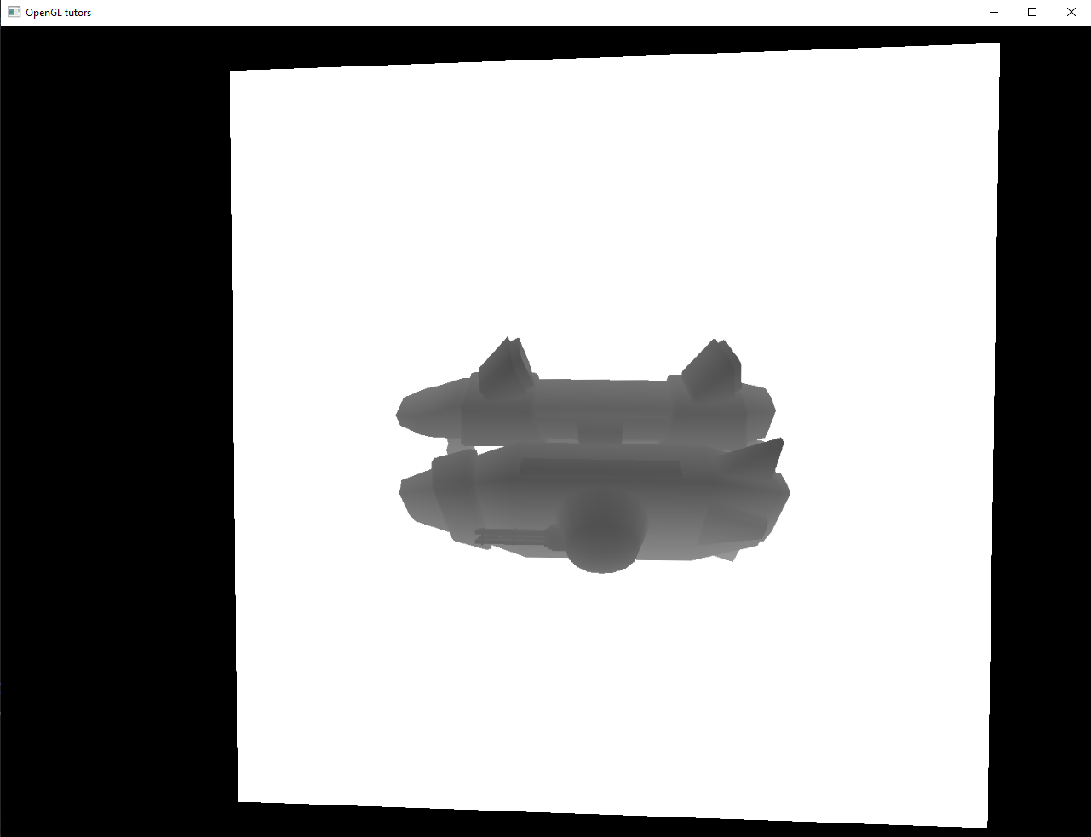

Рисунок 1. Загруженная модель с картой теней.

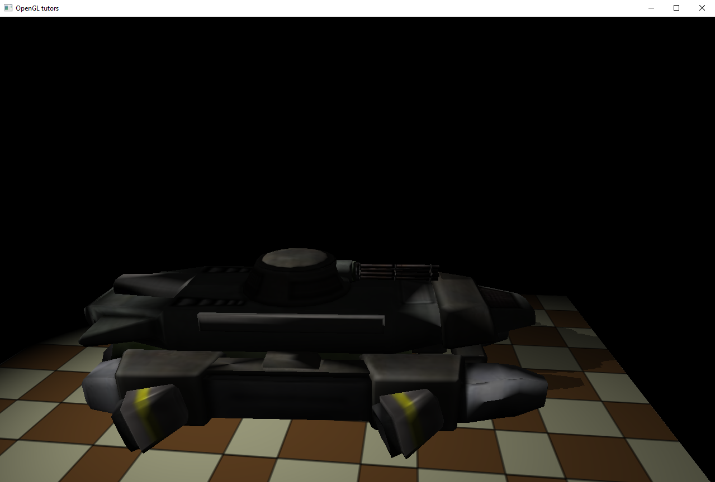

Рисунок 2. Другая загруженная модель с картой теней.

1. В 25 уроке я изучил назначение, определение и способ создания скайбокса.

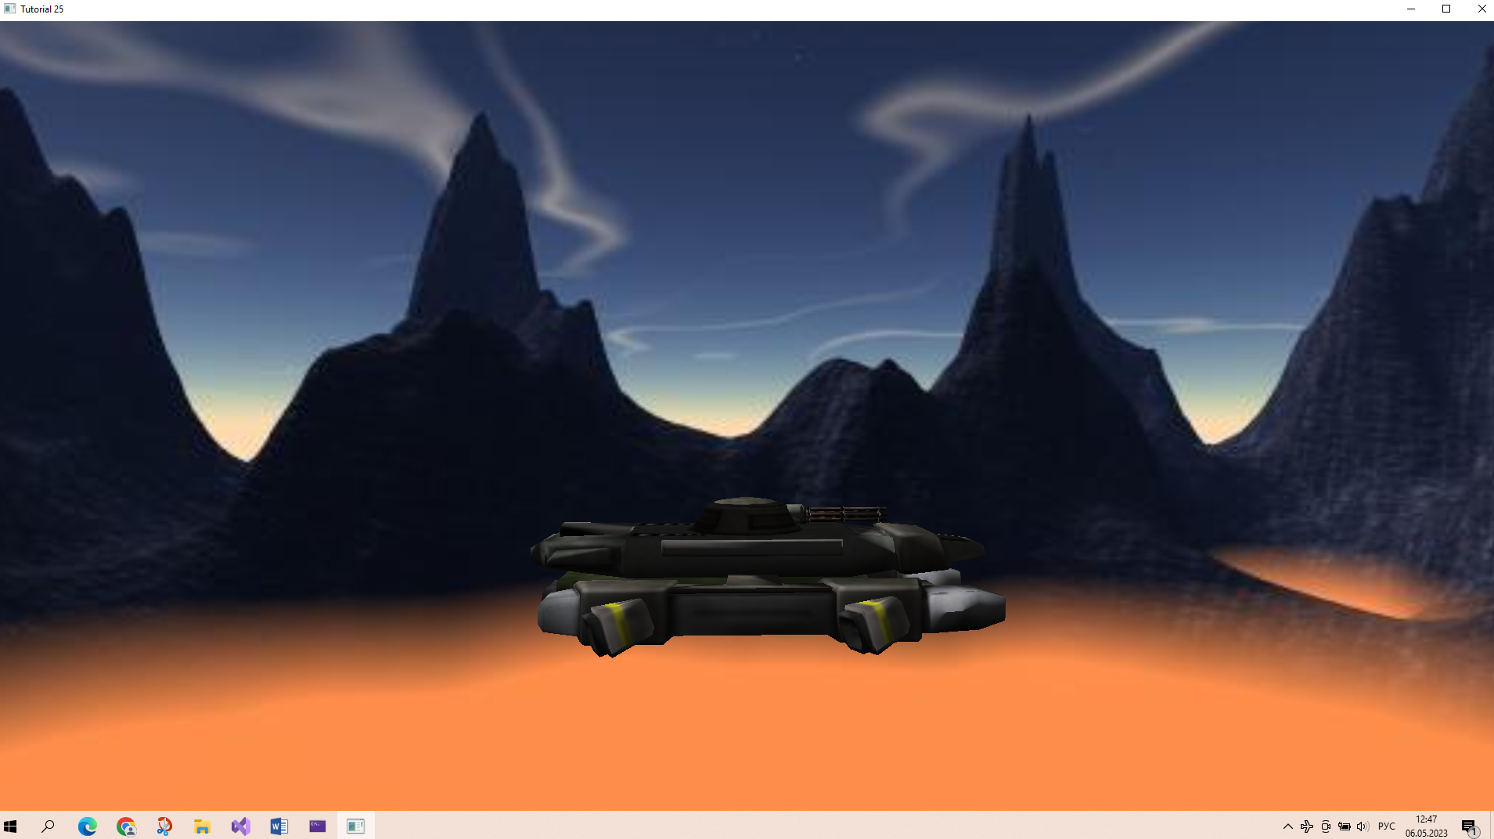

Рисунок 3. Модель в окружении скайбокса.

1. В урокe 26 я изучил назначение и способ создание карты нормалей.

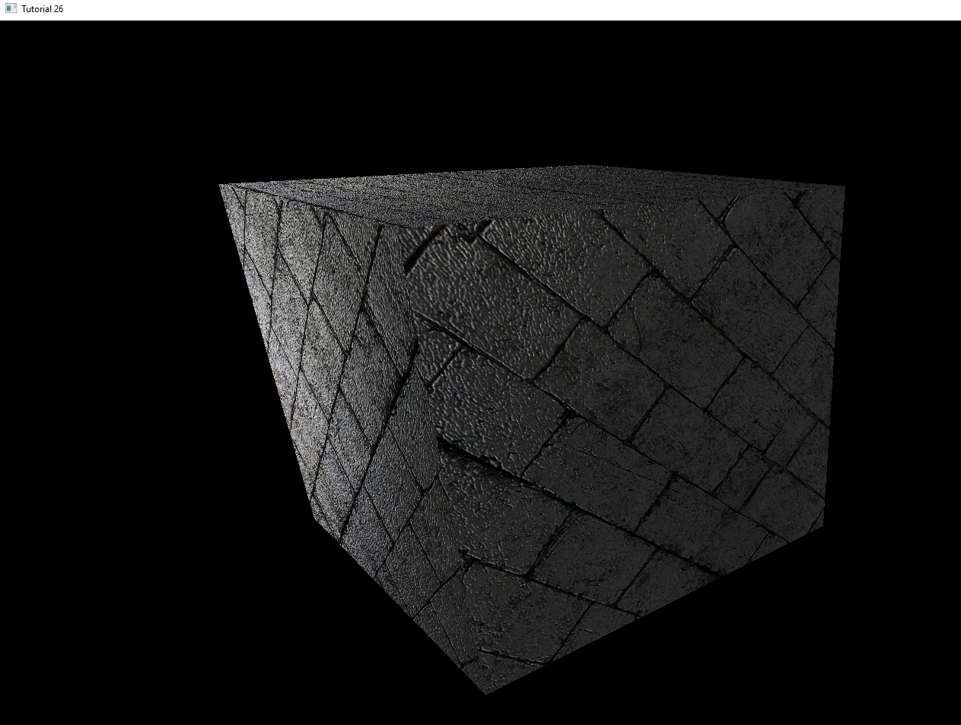

Рисунок 4. Модель с картой нормалей.

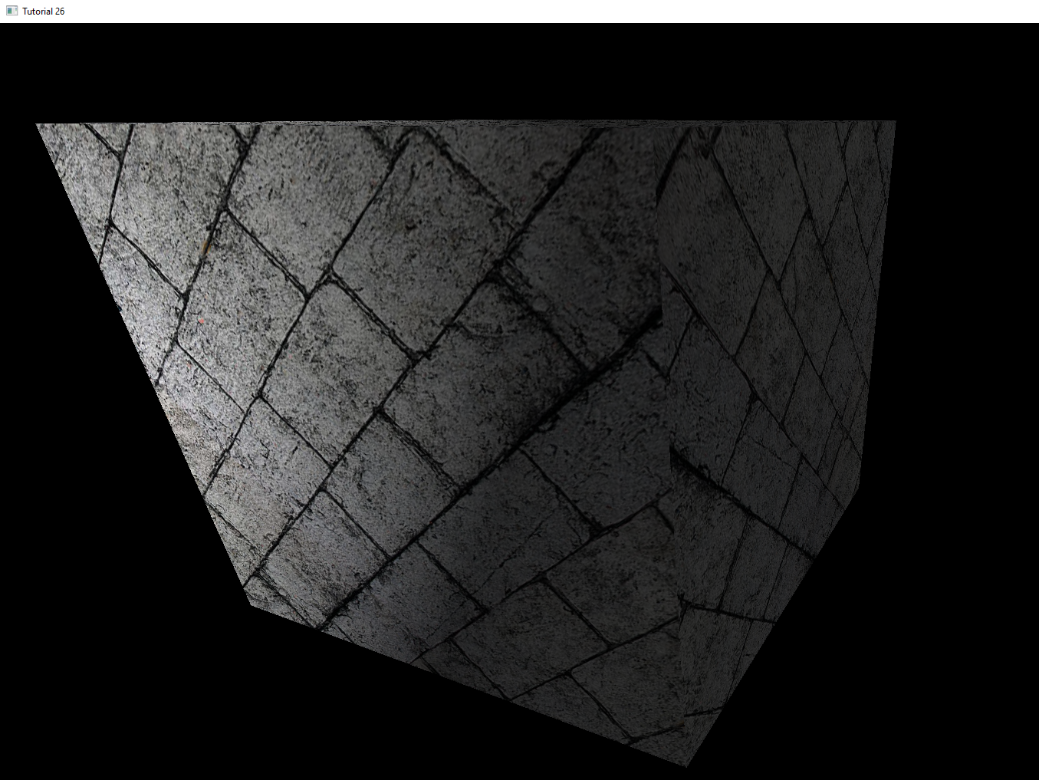

Рисунок 5. Модель без карты нормалей.

**Выводы к работе**

При выполнении данной лабораторной работы я познакомился с загрузкой моделей в OpenGL, способами создания теней, а так же со скайбоксом. Полный код программ по ссылке: [https://github.com/Ivan122727/EKG/tree/master/LW4](https://github.com/VerVyle/LW_ECG/tree/master/LW4)

**Приложение 1**

**main.cpp (task26)**

#include <math.h>

#include <GL/glew.h>

#include <GL/freeglut.h>

#include "engine_common.h"

#include "util.h"

#include "pipeline.h"

#include "camera.h"

#include "texture.h"

#include "lighting_technique.h"

#include "glut_backend.h"

#include "mesh.h"

#define WINDOW_WIDTH 1920

#define WINDOW_HEIGHT 1200

class Tutorial26 : public ICallbacks

{

public:

Tutorial26()

{

m_pLightingTechnique = NULL;

m_pGameCamera = NULL;

m_pSphereMesh = NULL;

m_scale = 0.0f;

m_pTexture = NULL;

m_pNormalMap = NULL;

m_pTrivialNormalMap = NULL;

m_dirLight.AmbientIntensity = 0.2f;

m_dirLight.DiffuseIntensity = 0.8f;

m_dirLight.Color = Vector3f(1.0f, 1.0f, 1.0f);

m_dirLight.Direction = Vector3f(1.0f, 0.0f, 0.0f);

m_persProjInfo.FOV = 60.0f;

m_persProjInfo.Height = WINDOW_HEIGHT;

m_persProjInfo.Width = WINDOW_WIDTH;

m_persProjInfo.zNear = 0.01f;

m_persProjInfo.zFar = 100.0f;

m_bumpMapEnabled = true;

}

~Tutorial26()

{

SAFE_DELETE(m_pLightingTechnique);

SAFE_DELETE(m_pGameCamera);

SAFE_DELETE(m_pSphereMesh);

SAFE_DELETE(m_pTexture);

SAFE_DELETE(m_pNormalMap);

SAFE_DELETE(m_pTrivialNormalMap);

}

bool Init()

{

Vector3f Pos(0.5f, 1.025f, 0.25f);

Vector3f Target(0.0f, -0.5f, 1.0f);

Vector3f Up(0.0, 1.0f, 0.0f);

m_pGameCamera = new Camera(WINDOW_WIDTH, WINDOW_HEIGHT, Pos, Target, Up);

m_pLightingTechnique = new LightingTechnique();

if (!m_pLightingTechnique->Init()) {

printf("Error initializing the lighting technique\n");

return false;

}

m_pLightingTechnique->Enable();

m_pLightingTechnique->SetDirectionalLight(m_dirLight);

m_pLightingTechnique->SetColorTextureUnit(0);

m_pLightingTechnique->SetNormalMapTextureUnit(2);

m_pSphereMesh = new Mesh();

if (!m_pSphereMesh->LoadMesh("../Content/box.obj")) {

return false;

}

m_pTexture = new Texture(GL_TEXTURE_2D, "../Content/bricks.jpg");

if (!m_pTexture->Load()) {

return false;

}

m_pTexture->Bind(COLOR_TEXTURE_UNIT);

m_pNormalMap = new Texture(GL_TEXTURE_2D, "../Content/normal_map.jpg");

if (!m_pNormalMap->Load()) {

return false;

}

m_pTrivialNormalMap = new Texture(GL_TEXTURE_2D, "../Content/normal_up.jpg");

if (!m_pTrivialNormalMap->Load()) {

return false;

}

return true;

}

void Run()

{

GLUTBackendRun(this);

}

virtual void RenderSceneCB()

{

m_pGameCamera->OnRender();

m_scale += 0.01f;

glClear(GL_COLOR_BUFFER_BIT | GL_DEPTH_BUFFER_BIT);

m_pLightingTechnique->Enable();

Pipeline p;

p.Rotate(0.0f, m_scale, 0.0f);

p.WorldPos(sinf(m_scale), 0.0f, 3.0f);

p.SetCamera(m_pGameCamera->GetPos(), m_pGameCamera->GetTarget(), m_pGameCamera->GetUp());

p.SetPerspectiveProj(m_persProjInfo);

m_pTexture->Bind(COLOR_TEXTURE_UNIT);

if (m_bumpMapEnabled)

{

m_pNormalMap->Bind(NORMAL_TEXTURE_UNIT);

}

else

{

m_pTrivialNormalMap->Bind(NORMAL_TEXTURE_UNIT);

}

m_pLightingTechnique->SetWVP(p.GetWVPTrans());

m_pLightingTechnique->SetWorldMatrix(p.GetWorldTrans());

m_pSphereMesh->Render();

glutSwapBuffers();

}

virtual void IdleCB()

{

RenderSceneCB();

}

virtual void SpecialKeyboardCB(int Key, int x, int y)

{

m_pGameCamera->OnKeyboard(Key);

}

virtual void KeyboardCB(unsigned char Key, int x, int y)

{

switch (Key) {

case 'q':

glutLeaveMainLoop();

break;

case 'b':

m_bumpMapEnabled = !m_bumpMapEnabled;

break;

}

}

virtual void PassiveMouseCB(int x, int y)

{

m_pGameCamera->OnMouse(x, y);

}

private:

LightingTechnique* m_pLightingTechnique;

Camera* m_pGameCamera;

float m_scale;

DirectionalLight m_dirLight;

Mesh* m_pSphereMesh;

Texture* m_pTexture;

Texture* m_pNormalMap;

Texture* m_pTrivialNormalMap;

PersProjInfo m_persProjInfo;

bool m_bumpMapEnabled;

};

int main(int argc, char** argv)

{

Magick::InitializeMagick(*argv);

GLUTBackendInit(argc, argv);

if (!GLUTBackendCreateWindow(WINDOW_WIDTH, WINDOW_HEIGHT, 32, false, "Tutorial 26")) {

return 1;

}

Tutorial26* pApp = new Tutorial26();

if (!pApp->Init()) {

return 1;

}

pApp->Run();

delete pApp;

return 0;

}

**main.cpp (task25)**

#include <math.h>

#include <GL/glew.h>

#include <GL/freeglut.h>

#include "util.h"

#include "pipeline.h"

#include "camera.h"

#include "texture.h"

#include "lighting_technique.h"

#include "glut_backend.h"

#include "mesh.h"

#include "skybox.h"

#define WINDOW_WIDTH 1920

#define WINDOW_HEIGHT 1200

class Main : public ICallbacks

{

public:

Main()

{

m_pLightingTechnique = NULL;

m_pGameCamera = NULL;

m_pTankMesh = NULL;

m_scale = 0.0f;

m_pSkyBox = NULL;

m_dirLight.AmbientIntensity = 0.2f;

m_dirLight.DiffuseIntensity = 0.8f;

m_dirLight.Color = Vector3f(1.0f, 1.0f, 1.0f);

m_dirLight.Direction = Vector3f(1.0f, -1.0f, 0.0f);

m_persProjInfo.FOV = 60.0f;

m_persProjInfo.Height = WINDOW_HEIGHT;

m_persProjInfo.Width = WINDOW_WIDTH;

m_persProjInfo.zNear = 1.0f;

m_persProjInfo.zFar = 100.0f;

}

virtual ~Main()

{

SAFE_DELETE(m_pLightingTechnique);

SAFE_DELETE(m_pGameCamera);

SAFE_DELETE(m_pTankMesh);

SAFE_DELETE(m_pSkyBox);

}

bool Init()

{

Vector3f Pos(0.0f, 1.0f, -20.0f);

Vector3f Target(0.0f, 0.0f, 1.0f);

Vector3f Up(0.0, 1.0f, 0.0f);

m_pGameCamera = new Camera(WINDOW_WIDTH, WINDOW_HEIGHT, Pos, Target, Up);

m_pLightingTechnique = new LightingTechnique();

if (!m_pLightingTechnique->Init()) {

printf("Error initializing the lighting technique\n");

return false;

}

m_pLightingTechnique->Enable();

m_pLightingTechnique->SetDirectionalLight(m_dirLight);

m_pLightingTechnique->SetTextureUnit(0);

m_pTankMesh = new Mesh();

if (!m_pTankMesh->LoadMesh("../Content/phoenix_ugv.md2")) {

return false;

}

m_pSkyBox = new SkyBox(m_pGameCamera, m_persProjInfo);

if (!m_pSkyBox->Init(".",

"../Content/sp3right.jpg",

"../Content/sp3left.jpg",

"../Content/sp3top.jpg",

"../Content/sp3bot.jpg",

"../Content/sp3front.jpg",

"../Content/sp3back.jpg")) {

return false;

}

return true;

}

void Run()

{

GLUTBackendRun(this);

}

virtual void RenderSceneCB()

{

m_pGameCamera->OnRender();

m_scale += 0.05f;

glClear(GL_COLOR_BUFFER_BIT | GL_DEPTH_BUFFER_BIT);

m_pLightingTechnique->Enable();

Pipeline p;

p.Scale(0.1f, 0.1f, 0.1f);

p.Rotate(0.0f, m_scale, 0.0f);

p.WorldPos(0.0f, -5.0f, 3.0f);

p.SetCamera(m_pGameCamera->GetPos(), m_pGameCamera->GetTarget(), m_pGameCamera->GetUp());

p.SetPerspectiveProj(m_persProjInfo);

m_pLightingTechnique->SetWVP(p.GetWVPTrans());

m_pLightingTechnique->SetWorldMatrix(p.GetWorldTrans());

m_pTankMesh->Render();

m_pSkyBox->Render();

glutSwapBuffers();

}

virtual void IdleCB()

{

RenderSceneCB();

}

virtual void SpecialKeyboardCB(int Key, int x, int y)

{

m_pGameCamera->OnKeyboard(Key);

}

virtual void KeyboardCB(unsigned char Key, int x, int y)

{

switch (Key) {

case 'q':

glutLeaveMainLoop();

break;

}

}

virtual void PassiveMouseCB(int x, int y)

{

m_pGameCamera->OnMouse(x, y);

}

private:

LightingTechnique* m_pLightingTechnique;

Camera* m_pGameCamera;

float m_scale;

DirectionalLight m_dirLight;

Mesh* m_pTankMesh;

SkyBox* m_pSkyBox;

PersProjInfo m_persProjInfo;

};

int main(int argc, char** argv)

{

Magick::InitializeMagick(*argv);

GLUTBackendInit(argc, argv);

if (!GLUTBackendCreateWindow(WINDOW_WIDTH, WINDOW_HEIGHT, 32, false, "Tutorial 25")) {

return 1;

}

Main* pApp = new Main();

if (!pApp->Init()) {

return 1;

}

pApp->Run();

delete pApp;

return 0;

}

**main.cpp (task24)**

#include <math.h>

#include <GL/glew.h>

#include <GL/freeglut.h>

#include "pipeline.h"

#include "camera.h"

#include "texture.h"

#include "lighting_technique.h"

#include "glut_backend.h"

#include "util.h"

#include "mesh.h"

#include "shadow_map_fbo.h"

#include "shadow_map_technique.h"

#define WINDOW_WIDTH 1280

#define WINDOW_HEIGHT 1024

class Main : public ICallbacks

{

public:

Main()

{

m_pLightingEffect = NULL;

m_pShadowMapEffect = NULL;

m_pGameCamera = NULL;

m_pMesh = NULL;

m_pQuad = NULL;

m_scale = 0.0f;

m_pGroundTex = NULL;

m_spotLight.AmbientIntensity = 0.1f;

m_spotLight.DiffuseIntensity = 0.9f;

m_spotLight.Color = Vector3f(1.0f, 1.0f, 1.0f);

m_spotLight.Attenuation.Linear = 0.01f;

m_spotLight.Position = Vector3f(-20.0, 20.0, 1.0f);

m_spotLight.Direction = Vector3f(1.0f, -1.0f, 0.0f);

m_spotLight.Cutoff = 20.0f;

}

virtual ~Main()

{

SAFE_DELETE(m_pLightingEffect);

SAFE_DELETE(m_pShadowMapEffect);

SAFE_DELETE(m_pGameCamera);

SAFE_DELETE(m_pMesh);

SAFE_DELETE(m_pQuad);

SAFE_DELETE(m_pGroundTex);

}

bool Init()

{

Vector3f Pos(3.0f, 8.0f, -10.0f);

Vector3f Target(0.0f, -0.2f, 1.0f);

Vector3f Up(0.0, 1.0f, 0.0f);

if (!m_shadowMapFBO.Init(WINDOW_WIDTH, WINDOW_HEIGHT)) {

return false;

}

m_pGameCamera = new Camera(WINDOW_WIDTH, WINDOW_HEIGHT, Pos, Target, Up);

m_pLightingEffect = new LightingTechnique();

if (!m_pLightingEffect->Init()) {

printf("Error initializing the lighting technique\n");

return false;

}

m_pLightingEffect->Enable();

m_pLightingEffect->SetSpotLights(1, &m_spotLight);

m_pLightingEffect->SetTextureUnit(0);

m_pLightingEffect->SetShadowMapTextureUnit(1);

m_pShadowMapEffect = new ShadowMapTechnique();

if (!m_pShadowMapEffect->Init()) {

printf("Error initializing the shadow map technique\n");

return false;

}

m_pQuad = new Mesh();

if (!m_pQuad->LoadMesh("../Content/quad.obj")) {

return false;

}

m_pGroundTex = new Texture(GL_TEXTURE_2D, "../Content/test.png");

if (!m_pGroundTex->Load()) {

return false;

}

m_pMesh = new Mesh();

return m_pMesh->LoadMesh("../Content/phoenix_ugv.md2");

}

void Run()

{

GLUTBackendRun(this);

}

virtual void RenderSceneCB()

{

m_pGameCamera->OnRender();

m_scale += 0.5f;

ShadowMapPass();

RenderPass();

glutSwapBuffers();

}

virtual void ShadowMapPass()

{

m_shadowMapFBO.BindForWriting();

glClear(GL_DEPTH_BUFFER_BIT);

m_pShadowMapEffect->Enable();

Pipeline p;

p.Scale(0.1f, 0.1f, 0.1f);

p.Rotate(0.0f, m_scale, 0.0f);

p.WorldPos(0.0f, 0.0f, 5.0f);

p.SetCamera(m_spotLight.Position, m_spotLight.Direction, Vector3f(0.0f, 1.0f, 0.0f));

p.SetPerspectiveProj(60.0f, WINDOW_WIDTH, WINDOW_HEIGHT, 1.0f, 50.0f);

m_pShadowMapEffect->SetWVP(p.GetWVPTrans());

m_pMesh->Render();

glBindFramebuffer(GL_FRAMEBUFFER, 0);

}

virtual void RenderPass()

{

glClear(GL_COLOR_BUFFER_BIT | GL_DEPTH_BUFFER_BIT);

m_pLightingEffect->Enable();

m_shadowMapFBO.BindForReading(GL_TEXTURE1);

Pipeline p;

p.SetPerspectiveProj(60.0f, WINDOW_WIDTH, WINDOW_HEIGHT, 1.0f, 50.0f);

p.Scale(10.0f, 10.0f, 10.0f);

p.WorldPos(0.0f, 0.0f, 1.0f);

p.Rotate(90.0f, 0.0f, 0.0f);

p.SetCamera(m_pGameCamera->GetPos(), m_pGameCamera->GetTarget(), m_pGameCamera->GetUp());

m_pLightingEffect->SetWVP(p.GetWVPTrans());

m_pLightingEffect->SetWorldMatrix(p.GetWorldTrans());

p.SetCamera(m_spotLight.Position, m_spotLight.Direction, Vector3f(0.0f, 1.0f, 0.0f));

m_pLightingEffect->SetLightWVP(p.GetWVPTrans());

m_pLightingEffect->SetEyeWorldPos(m_pGameCamera->GetPos());

m_pGroundTex->Bind(GL_TEXTURE0);

m_pQuad->Render();

p.Scale(0.1f, 0.1f, 0.1f);

p.Rotate(0.0f, m_scale, 0.0f);

p.WorldPos(0.0f, 0.0f, 3.0f);

p.SetCamera(m_pGameCamera->GetPos(), m_pGameCamera->GetTarget(), m_pGameCamera->GetUp());

m_pLightingEffect->SetWVP(p.GetWVPTrans());

m_pLightingEffect->SetWorldMatrix(p.GetWorldTrans());

p.SetCamera(m_spotLight.Position, m_spotLight.Direction, Vector3f(0.0f, 1.0f, 0.0f));

m_pLightingEffect->SetLightWVP(p.GetWVPTrans());

m_pMesh->Render();

}

virtual void IdleCB()

{

RenderSceneCB();

}

virtual void SpecialKeyboardCB(int Key, int x, int y)

{

m_pGameCamera->OnKeyboard(Key);

}

virtual void KeyboardCB(unsigned char Key, int x, int y)

{

switch (Key) {

case 'q':

glutLeaveMainLoop();

break;

}

}

virtual void PassiveMouseCB(int x, int y)

{

m_pGameCamera->OnMouse(x, y);

}

private:

LightingTechnique* m_pLightingEffect;

ShadowMapTechnique* m_pShadowMapEffect;

Camera* m_pGameCamera;

float m_scale;

SpotLight m_spotLight;

Mesh* m_pMesh;

Mesh* m_pQuad;

ShadowMapFBO m_shadowMapFBO;

Texture* m_pGroundTex;

};

int main(int argc, char** argv)

{

Magick::InitializeMagick(*argv);

GLUTBackendInit(argc, argv);

if (!GLUTBackendCreateWindow(WINDOW_WIDTH, WINDOW_HEIGHT, 32, false, "OpenGL tutors")) {

return 1;

}

Main* pApp = new Main();

if (!pApp->Init()) {

return 1;

}

pApp->Run();

delete pApp;

return 0;

}

**main.cpp (task23)**

#include <math.h>

#include <GL/glew.h>

#include <GL/freeglut.h>

#include "pipeline.h"

#include "camera.h"

#include "texture.h"

#include "lighting_technique.h"

#include "glut_backend.h"

#include "util.h"

#include "mesh.h"

#include "shadow_map_fbo.h"

#include "shadow_map_technique.h"

#define WINDOW_WIDTH 1280

#define WINDOW_HEIGHT 1024

class Main : public ICallbacks

{

public:

Main()

{

m_pEffect = NULL;

m_pShadowMapTech = NULL;

m_pGameCamera = NULL;

m_pMesh = NULL;

m_pQuad = NULL;

m_scale = 0.0f;

m_spotLight.AmbientIntensity = 0.0f;

m_spotLight.DiffuseIntensity = 0.9f;

m_spotLight.Color = Vector3f(1.0f, 1.0f, 1.0f);

m_spotLight.Attenuation.Linear = 0.01f;

m_spotLight.Position = Vector3f(-20.0, 20.0, 5.0f);

m_spotLight.Direction = Vector3f(1.0f, -1.0f, 0.0f);

m_spotLight.Cutoff = 20.0f;

}

virtual ~Main()

{

SAFE_DELETE(m_pEffect);

SAFE_DELETE(m_pShadowMapTech);

SAFE_DELETE(m_pGameCamera);

SAFE_DELETE(m_pMesh);

SAFE_DELETE(m_pQuad);

}

bool Init()

{

if (!m_shadowMapFBO.Init(WINDOW_WIDTH, WINDOW_HEIGHT)) {

return false;

}

m_pGameCamera = new Camera(WINDOW_WIDTH, WINDOW_HEIGHT);

m_pEffect = new LightingTechnique();

if (!m_pEffect->Init()) {

printf("Error initializing the lighting technique\n");

return false;

}

m_pShadowMapTech = new ShadowMapTechnique();

if (!m_pShadowMapTech->Init()) {

printf("Error initializing the shadow map technique\n");

return false;

}

m_pShadowMapTech->Enable();

m_pQuad = new Mesh();

if (!m_pQuad->LoadMesh("../Content/quad.obj")) {

return false;

}

m_pMesh = new Mesh();

return m_pMesh->LoadMesh("../Content/phoenix_ugv.md2");

}

void Run()

{

GLUTBackendRun(this);

}

virtual void RenderSceneCB()

{

m_pGameCamera->OnRender();

m_scale += 0.05f;

ShadowMapPass();

RenderPass();

glutSwapBuffers();

}

virtual void ShadowMapPass()

{

m_shadowMapFBO.BindForWriting();

glClear(GL_DEPTH_BUFFER_BIT);

Pipeline p;

p.Scale(0.2f, 0.2f, 0.2f);

p.Rotate(0.0f, m_scale, 0.0f);

p.WorldPos(0.0f, 0.0f, 5.0f);

p.SetCamera(m_spotLight.Position, m_spotLight.Direction, Vector3f(0.0f, 1.0f, 0.0f));

p.SetPerspectiveProj(60.0f, WINDOW_WIDTH, WINDOW_HEIGHT, 1.0f, 50.0f);

m_pShadowMapTech->SetWVP(p.GetWVPTrans());

m_pMesh->Render();

glBindFramebuffer(GL_FRAMEBUFFER, 0);

}

virtual void RenderPass()

{

glClear(GL_COLOR_BUFFER_BIT | GL_DEPTH_BUFFER_BIT);

m_pShadowMapTech->SetTextureUnit(0);

m_shadowMapFBO.BindForReading(GL_TEXTURE0);

Pipeline p;

p.Scale(5.0f, 5.0f, 5.0f);

p.WorldPos(0.0f, 0.0f, 10.0f);

p.SetCamera(m_pGameCamera->GetPos(), m_pGameCamera->GetTarget(), m_pGameCamera->GetUp());

p.SetPerspectiveProj(60.0f, WINDOW_WIDTH, WINDOW_HEIGHT, 1.0f, 50.0f);

m_pShadowMapTech->SetWVP(p.GetWVPTrans());

m_pQuad->Render();

}

virtual void IdleCB()

{

RenderSceneCB();

}

virtual void SpecialKeyboardCB(int Key, int x, int y)

{

m_pGameCamera->OnKeyboard(Key);

}

virtual void KeyboardCB(unsigned char Key, int x, int y)

{

switch (Key) {

case 'q':

glutLeaveMainLoop();

break;

}

}

virtual void PassiveMouseCB(int x, int y)

{

m_pGameCamera->OnMouse(x, y);

}

private:

LightingTechnique* m_pEffect;

ShadowMapTechnique* m_pShadowMapTech;

Camera* m_pGameCamera;

float m_scale;

SpotLight m_spotLight;

Mesh* m_pMesh;

Mesh* m_pQuad;

ShadowMapFBO m_shadowMapFBO;

};

int main(int argc, char** argv)

{

Magick::InitializeMagick(*argv);

GLUTBackendInit(argc, argv);

if (!GLUTBackendCreateWindow(WINDOW_WIDTH, WINDOW_HEIGHT, 32, false, "OpenGL tutors")) {

return 1;

}

Main* pApp = new Main();

if (!pApp->Init()) {

return 1;

}

pApp->Run();

delete pApp;

return 0;

}