Министерство науки и высшего образования Российской Федерации

Федеральное государственное бюджетное

Образовательное учреждение высшего образования

«Уфимский университет науки и технологий»

Факультет информатики и робототехники

Кафедра Информатики

Отчет по лабораторной работе № 5

на тему: «Геометрический шейдер, частицы, vertex, deferred shading в OpenGL»

Выполнил:

Студент группы ПРО-233Б Ермолов И О

Проверил:

канд. техн. наук В.А. Котельников

Уфа - 2023

**Цель работы**

Изучение работы с геометрическим шейдером, частицами , Vertex, Deferred shading в OpenGL.

З**адание**

Выполнить 27, 28, 32, 33 уроки по OpenGL <https://triplepointfive.github.io/ogltutor/>

**Ход работы**

1. В урокe 27 я научился создавать billboard и работать с геометрическим шейдером.

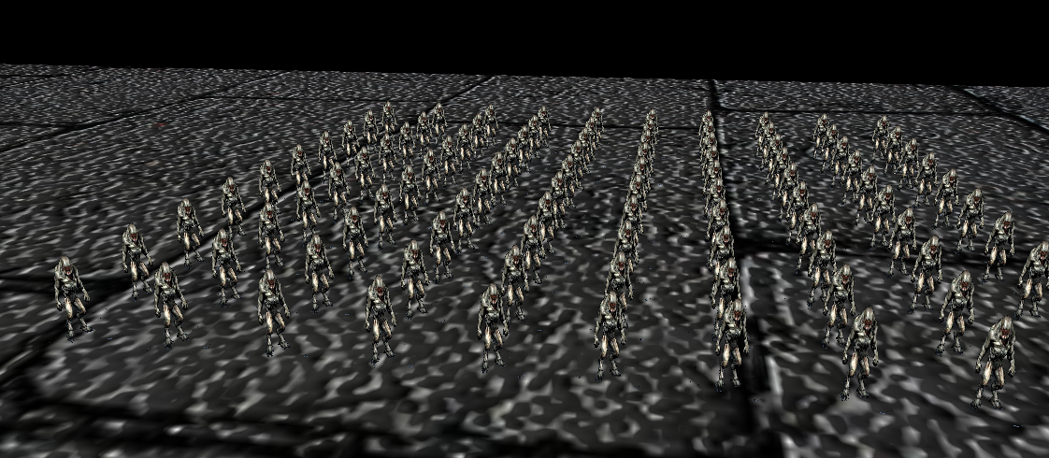

Рисунок 1. Billboard моделей.

1. В 28 уроке я изучил способ создания частиц в OpenGL.

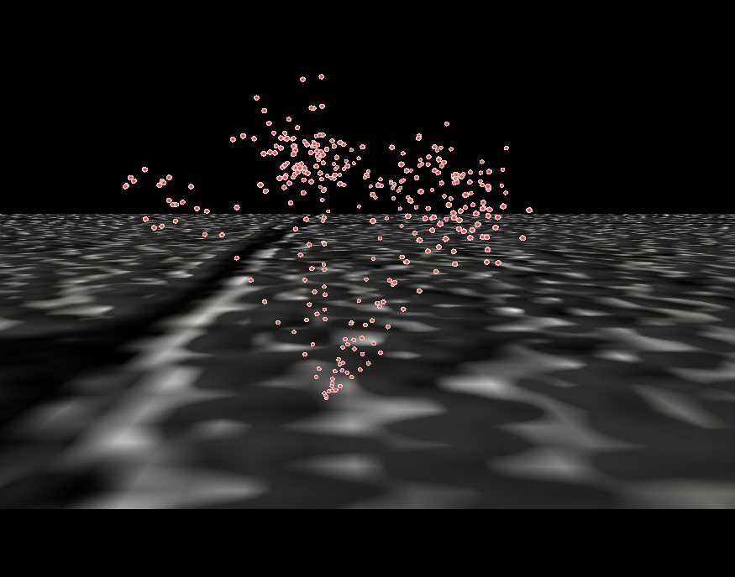

Рисунок 2. Система простых частиц.

1. В урокe 32 я изучил способ работы с Vertex Array Object (или VAO).

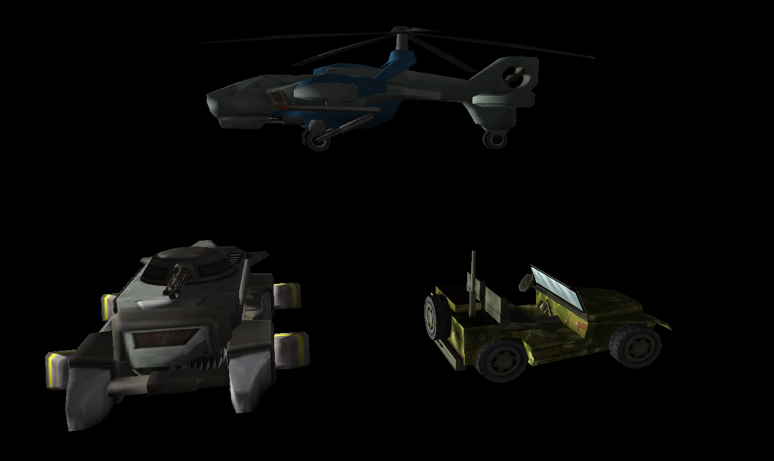

Рисунок 3. Использование VAO.

1. В уроке 33 я научился работать с дублирующим рендерингом.

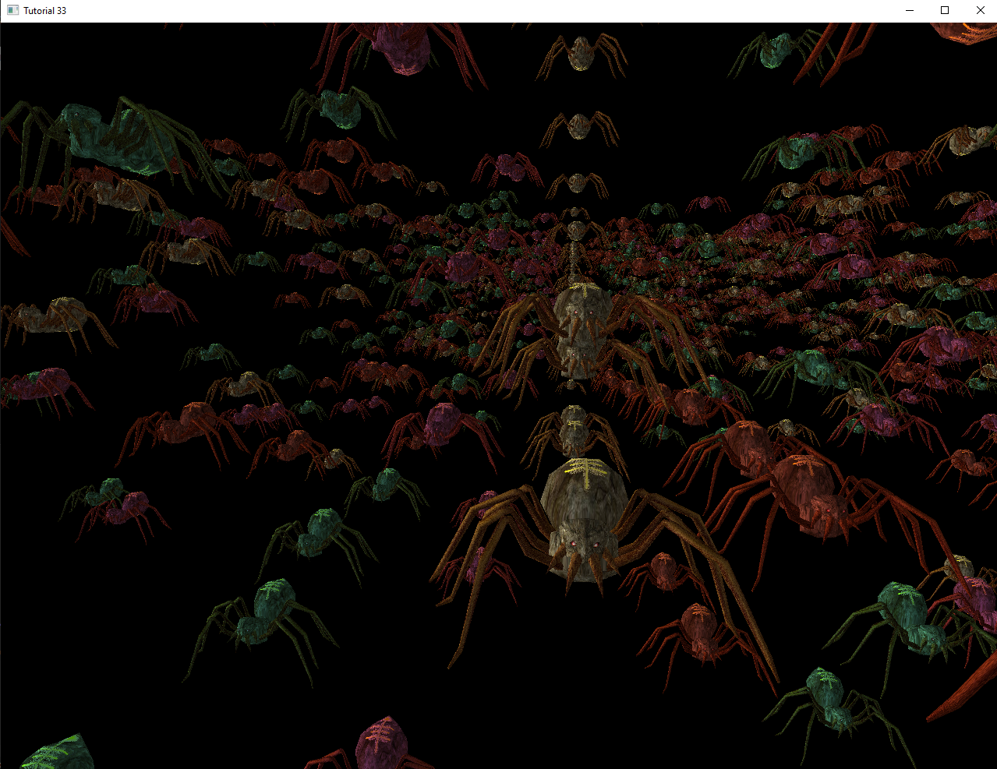

Рисунок 4. Повторяющиеся модели с дублирующим рендерингом.

**Выводы к работе**

При выполнении данной лабораторной работы я познакомился с геометрическим шейдером, частицами , Vertex, Deferred shading в OpenGL. Полный код программ по ссылке: [https://github.com/Ivan122727/EKG/tree/master/LW5](https://github.com/VerVyle/LW_ECG/tree/master/LW5)

**Приложение 1**

**main.cpp (task33)**

#include <math.h>

#include <GL/glew.h>

#include <GL/freeglut.h>

#include "engine_common.h"

#include "util.h"

#include "pipeline.h"

#include "camera.h"

#include "texture.h"

#include "lighting_technique.h"

#include "glut_backend.h"

#include "mesh.h"

#ifdef FREETYPE

#include "freetypeGL.h"

#endif

#define WINDOW_WIDTH 1280

#define WINDOW_HEIGHT 1024

#define NUM_ROWS 50

#define NUM_COLS 20

#define NUM_INSTANCES NUM_ROWS * NUM_COLS

class Tutorial33 : public ICallbacks

{

public:

Tutorial33()

{

m_pGameCamera = NULL;

m_pEffect = NULL;

m_scale = 0.0f;

m_directionalLight.Color = Vector3f(1.0f, 1.0f, 1.0f);

m_directionalLight.AmbientIntensity = 0.55f;

m_directionalLight.DiffuseIntensity = 0.9f;

m_directionalLight.Direction = Vector3f(1.0f, 0.0, 0.0);

m_persProjInfo.FOV = 60.0f;

m_persProjInfo.Height = WINDOW_HEIGHT;

m_persProjInfo.Width = WINDOW_WIDTH;

m_persProjInfo.zNear = 1.0f;

m_persProjInfo.zFar = 100.0f;

m_pMesh = NULL;

m_frameCount = 0;

m_fps = 0.0f;

}

~Tutorial33()

{

SAFE_DELETE(m_pEffect);

SAFE_DELETE(m_pGameCamera);

SAFE_DELETE(m_pMesh);

}

bool Init()

{

Vector3f Pos(7.0f, 3.0f, 0.0f);

Vector3f Target(0.0f, -0.2f, 1.0f);

Vector3f Up(0.0, 1.0f, 0.0f);

m_pGameCamera = new Camera(WINDOW_WIDTH, WINDOW_HEIGHT, Pos, Target, Up);

m_pEffect = new LightingTechnique();

if (!m_pEffect->Init()) {

printf("Error initializing the lighting technique\n");

return false;

}

m_pEffect->Enable();

m_pEffect->SetColorTextureUnit(COLOR_TEXTURE_UNIT_INDEX);

m_pEffect->SetDirectionalLight(m_directionalLight);

m_pEffect->SetMatSpecularIntensity(0.0f);

m_pEffect->SetMatSpecularPower(0);

m_pEffect->SetColor(0, Vector4f(1.0f, 0.5f, 0.5f, 0.0f));

m_pEffect->SetColor(1, Vector4f(0.5f, 1.0f, 1.0f, 0.0f));

m_pEffect->SetColor(2, Vector4f(1.0f, 0.5f, 1.0f, 0.0f));

m_pEffect->SetColor(3, Vector4f(1.0f, 1.0f, 1.0f, 0.0f));

m_pMesh = new Mesh();

if (!m_pMesh->LoadMesh("../Content/spider.obj")) {

return false;

}

#ifdef FREETYPE

if (!m_fontRenderer.InitFontRenderer()) {

return false;

}

#endif

m_time = glutGet(GLUT_ELAPSED_TIME);

CalcPositions();

return true;

}

void Run()

{

GLUTBackendRun(this);

}

virtual void RenderSceneCB()

{

CalcFPS();

m_scale += 0.005f;

m_pGameCamera->OnRender();

glClear(GL_COLOR_BUFFER_BIT | GL_DEPTH_BUFFER_BIT);

m_pEffect->Enable();

m_pEffect->SetEyeWorldPos(m_pGameCamera->GetPos());

Pipeline p;

p.SetCamera(m_pGameCamera->GetPos(), m_pGameCamera->GetTarget(), m_pGameCamera->GetUp());

p.SetPerspectiveProj(m_persProjInfo);

p.Rotate(0.0f, 90.0f, 0.0f);

p.Scale(0.005f, 0.005f, 0.005f);

Matrix4f WVPMatrics[NUM_INSTANCES];

Matrix4f WorldMatrices[NUM_INSTANCES];

for (unsigned int i = 0 ; i < NUM_INSTANCES ; i++) {

Vector3f Pos(m_positions[i]);

Pos.y += sinf(m_scale) * m_velocity[i];

p.WorldPos(Pos);

WVPMatrics[i] = p.GetWVPTrans().Transpose();

WorldMatrices[i] = p.GetWorldTrans().Transpose();

}

m_pMesh->Render(NUM_INSTANCES, WVPMatrics, WorldMatrices);

RenderFPS();

glutSwapBuffers();

}

virtual void IdleCB()

{

RenderSceneCB();

}

virtual void SpecialKeyboardCB(int Key, int x, int y)

{

m_pGameCamera->OnKeyboard(Key);

}

virtual void KeyboardCB(unsigned char Key, int x, int y)

{

switch (Key) {

case 'q':

glutLeaveMainLoop();

break;

}

}

virtual void PassiveMouseCB(int x, int y)

{

m_pGameCamera->OnMouse(x, y);

}

virtual void MouseCB(int Button, int State, int x, int y)

{

}

private:

void CalcFPS()

{

m_frameCount++;

int time = glutGet( GLUT_ELAPSED_TIME );

if (time - m_time > 1000) {

m_fps = (float)m_frameCount * 1000.0f / (time - m_time);

m_time = time;

m_frameCount = 0;

}

}

void RenderFPS()

{

char text[32];

SNPRINTF(text, sizeof(text), "FPS: %.2f", m_fps);

#ifdef FREETYPE

m_fontRenderer.RenderText(10, 10, text);

#endif

}

void CalcPositions()

{

for (unsigned int i = 0; i < NUM_ROWS ; i++) {

for (unsigned int j = 0 ; j < NUM_COLS ; j++) {

unsigned int Index = i * NUM_COLS + j;

m_positions[Index].x = (float)j;

m_positions[Index].y = RandomFloat() * 5.0f;

m_positions[Index].z = (float)i;

m_velocity[Index] = RandomFloat();

if (i & 1) {

m_velocity[Index] *= (-1.0f);

}

}

}

}

LightingTechnique* m_pEffect;

Camera* m_pGameCamera;

float m_scale;

DirectionalLight m_directionalLight;

Mesh* m_pMesh;

PersProjInfo m_persProjInfo;

#ifdef FREETYPE

FontRenderer m_fontRenderer;

#endif

int m_time;

int m_frameCount;

float m_fps;

Vector3f m_positions[NUM_INSTANCES];

float m_velocity[NUM_INSTANCES];

};

int main(int argc, char** argv)

{

Magick::InitializeMagick(*argv);

GLUTBackendInit(argc, argv);

if (!GLUTBackendCreateWindow(WINDOW_WIDTH, WINDOW_HEIGHT, 32, false, "Tutorial 33")) {

return 1;

}

SRANDOM;

Tutorial33* pApp = new Tutorial33();

if (!pApp->Init()) {

return 1;

}

pApp->Run();

delete pApp;

return 0;

}

**main.cpp (task32)**

#include <math.h>

#include <GL/glew.h>

#include <GL/freeglut.h>

#include "engine_common.h"

#include "util.h"

#include "pipeline.h"

#include "camera.h"

#include "texture.h"

#include "lighting_technique.h"

#include "glut_backend.h"

#include "mesh.h"

#define WINDOW_WIDTH 1920

#define WINDOW_HEIGHT 1200

class Tutorial32 : public ICallbacks

{

public:

Tutorial32()

{

m_pGameCamera = NULL;

m_pEffect = NULL;

m_scale = 0.0f;

m_directionalLight.Color = Vector3f(1.0f, 1.0f, 1.0f);

m_directionalLight.AmbientIntensity = 0.25f;

m_directionalLight.DiffuseIntensity = 0.9f;

m_directionalLight.Direction = Vector3f(1.0f, 0.0, 0.0);

m_persProjInfo.FOV = 60.0f;

m_persProjInfo.Height = WINDOW_HEIGHT;

m_persProjInfo.Width = WINDOW_WIDTH;

m_persProjInfo.zNear = 1.0f;

m_persProjInfo.zFar = 100.0f;

m_pMesh1 = NULL;

m_pMesh2 = NULL;

m_pMesh3 = NULL;

}

~Tutorial32()

{

SAFE_DELETE(m_pEffect);

SAFE_DELETE(m_pGameCamera);

SAFE_DELETE(m_pMesh1);

SAFE_DELETE(m_pMesh2);

SAFE_DELETE(m_pMesh3);

}

bool Init()

{

Vector3f Pos(3.0f, 7.0f, -10.0f);

Vector3f Target(0.0f, -0.2f, 1.0f);

Vector3f Up(0.0, 1.0f, 0.0f);

m_pGameCamera = new Camera(WINDOW_WIDTH, WINDOW_HEIGHT, Pos, Target, Up);

m_pEffect = new LightingTechnique();

if (!m_pEffect->Init()) {

printf("Error initializing the lighting technique\n");

return false;

}

m_pEffect->Enable();

m_pEffect->SetColorTextureUnit(COLOR_TEXTURE_UNIT_INDEX);

m_pEffect->SetDirectionalLight(m_directionalLight);

m_pEffect->SetMatSpecularIntensity(0.0f);

m_pEffect->SetMatSpecularPower(0);

m_pMesh1 = new Mesh();

if (!m_pMesh1->LoadMesh("../Content/phoenix_ugv.md2")) {

return false;

}

m_pMesh2 = new Mesh();

if (!m_pMesh2->LoadMesh("../Content/jeep.obj")) {

return false;

}

m_pMesh3 = new Mesh();

if (!m_pMesh3->LoadMesh("../Content/hheli.obj")) {

return false;

}

return true;

}

void Run()

{

GLUTBackendRun(this);

}

virtual void RenderSceneCB()

{

m_scale += 0.01f;

m_pGameCamera->OnRender();

glClear(GL_COLOR_BUFFER_BIT | GL_DEPTH_BUFFER_BIT);

m_pEffect->SetEyeWorldPos(m_pGameCamera->GetPos());

Pipeline p;

p.SetCamera(m_pGameCamera->GetPos(), m_pGameCamera->GetTarget(), m_pGameCamera->GetUp());

p.Rotate(0.0f, m_scale, 0.0f);

p.SetPerspectiveProj(m_persProjInfo);

p.Scale(0.1f, 0.1f, 0.1f);

p.WorldPos(-6.0f, -2.0f, 10.0f);

m_pEffect->SetWVP(p.GetWVPTrans());

m_pEffect->SetWorldMatrix(p.GetWorldTrans());

m_pMesh1->Render();

p.Scale(0.01f, 0.01f, 0.01f);

p.WorldPos(6.0f, -2.0f, 10.0f);

m_pEffect->SetWVP(p.GetWVPTrans());

m_pEffect->SetWorldMatrix(p.GetWorldTrans());

m_pMesh2->Render();

p.Scale(0.04f, 0.04f, 0.04f);

p.WorldPos(0.0f, 6.0f, 10.0f);

m_pEffect->SetWVP(p.GetWVPTrans());

m_pEffect->SetWorldMatrix(p.GetWorldTrans());

m_pMesh3->Render();

glutSwapBuffers();

}

virtual void IdleCB()

{

RenderSceneCB();

}

virtual void SpecialKeyboardCB(int Key, int x, int y)

{

m_pGameCamera->OnKeyboard(Key);

}

virtual void KeyboardCB(unsigned char Key, int x, int y)

{

switch (Key) {

case 'q':

glutLeaveMainLoop();

break;

}

}

virtual void PassiveMouseCB(int x, int y)

{

m_pGameCamera->OnMouse(x, y);

}

virtual void MouseCB(int Button, int State, int x, int y)

{

}

private:

LightingTechnique* m_pEffect;

Camera* m_pGameCamera;

float m_scale;

DirectionalLight m_directionalLight;

Mesh* m_pMesh1;

Mesh* m_pMesh2;

Mesh* m_pMesh3;

PersProjInfo m_persProjInfo;

};

int main(int argc, char** argv)

{

Magick::InitializeMagick(*argv);

GLUTBackendInit(argc, argv);

if (!GLUTBackendCreateWindow(WINDOW_WIDTH, WINDOW_HEIGHT, 32, false, "Tutorial 32")) {

return 1;

}

Tutorial32* pApp = new Tutorial32();

if (!pApp->Init()) {

return 1;

}

pApp->Run();

delete pApp;

return 0;

}

**main.cpp (task28)**

#include <stdlib.h>

#include <math.h>

#include <chrono>

#include <assert.h>

#include <GL/glew.h>

#include <GL/freeglut.h>

#ifdef __GNUC__

# if __GNUC_PREREQ(4,7)

#include <unistd.h>

# endif

#endif

#include "engine_common.h"

#include "util.h"

#include "pipeline.h"

#include "camera.h"

#include "texture.h"

#include "lighting_technique.h"

#include "glut_backend.h"

#include "mesh.h"

#include "particle_system.h"

#define WINDOW_WIDTH 1920

#define WINDOW_HEIGHT 1200

static long long GetCurrentTimeMillis() {

auto time = std::chrono::system_clock::now();

auto since_epoch = time.time_since_epoch();

auto millis = std::chrono::duration_cast<std::chrono::milliseconds>(since_epoch);

long long now = millis.count();

return now;

}

class Tutorial28 : public ICallbacks

{

public:

Tutorial28()

{

m_pLightingTechnique = NULL;

m_pGameCamera = NULL;

m_pGround = NULL;

m_pTexture = NULL;

m_pNormalMap = NULL;

m_dirLight.AmbientIntensity = 0.2f;

m_dirLight.DiffuseIntensity = 0.8f;

m_dirLight.Color = Vector3f(1.0f, 1.0f, 1.0f);

m_dirLight.Direction = Vector3f(1.0f, 0.0f, 0.0f);

m_persProjInfo.FOV = 60.0f;

m_persProjInfo.Height = WINDOW_HEIGHT;

m_persProjInfo.Width = WINDOW_WIDTH;

m_persProjInfo.zNear = 1.0f;

m_persProjInfo.zFar = 100.0f;

m_currentTimeMillis = GetCurrentTimeMillis();

}

~Tutorial28()

{

SAFE_DELETE(m_pLightingTechnique);

SAFE_DELETE(m_pGameCamera);

SAFE_DELETE(m_pGround);

SAFE_DELETE(m_pTexture);

SAFE_DELETE(m_pNormalMap);

}

bool Init()

{

Vector3f Pos(0.0f, 0.4f, -0.5f);

Vector3f Target(0.0f, 0.2f, 1.0f);

Vector3f Up(0.0, 1.0f, 0.0f);

m_pGameCamera = new Camera(WINDOW_WIDTH, WINDOW_HEIGHT, Pos, Target, Up);

m_pLightingTechnique = new LightingTechnique();

if (!m_pLightingTechnique->Init()) {

printf("Error initializing the lighting technique\n");

return false;

}

m_pLightingTechnique->Enable();

m_pLightingTechnique->SetDirectionalLight(m_dirLight);

m_pLightingTechnique->SetColorTextureUnit(COLOR_TEXTURE_UNIT_INDEX);

m_pLightingTechnique->SetNormalMapTextureUnit(NORMAL_TEXTURE_UNIT_INDEX);

m_pGround = new Mesh();

if (!m_pGround->LoadMesh("../Content/quad.obj")) {

return false;

}

m_pTexture = new Texture(GL_TEXTURE_2D, "../Content/bricks.jpg");

if (!m_pTexture->Load()) {

return false;

}

m_pTexture->Bind(COLOR_TEXTURE_UNIT);

m_pNormalMap = new Texture(GL_TEXTURE_2D, "../Content/normal_map.jpg");

if (!m_pNormalMap->Load()) {

return false;

}

Vector3f ParticleSystemPos = Vector3f(0.0f, 0.0f, 1.0f);

return m_particleSystem.InitParticleSystem(ParticleSystemPos);

}

void Run()

{

GLUTBackendRun(this);

}

virtual void RenderSceneCB()

{

long long TimeNowMillis = GetCurrentTimeMillis();

assert(TimeNowMillis >= m_currentTimeMillis);

unsigned int DeltaTimeMillis = (unsigned int)(TimeNowMillis - m_currentTimeMillis);

m_currentTimeMillis = TimeNowMillis;

m_pGameCamera->OnRender();

glClear(GL_COLOR_BUFFER_BIT | GL_DEPTH_BUFFER_BIT);

m_pLightingTechnique->Enable();

m_pTexture->Bind(COLOR_TEXTURE_UNIT);

m_pNormalMap->Bind(NORMAL_TEXTURE_UNIT);

Pipeline p;

p.Scale(20.0f, 20.0f, 1.0f);

p.Rotate(90.0f, 0.0, 0.0f);

p.SetCamera(m_pGameCamera->GetPos(), m_pGameCamera->GetTarget(), m_pGameCamera->GetUp());

p.SetPerspectiveProj(m_persProjInfo);

m_pLightingTechnique->SetWVP(p.GetWVPTrans());

m_pLightingTechnique->SetWorldMatrix(p.GetWorldTrans());

m_pGround->Render();

m_particleSystem.Render(DeltaTimeMillis, p.GetVPTrans(), m_pGameCamera->GetPos());

glutSwapBuffers();

}

virtual void IdleCB()

{

RenderSceneCB();

}

virtual void SpecialKeyboardCB(int Key, int x, int y)

{

m_pGameCamera->OnKeyboard(Key);

}

virtual void KeyboardCB(unsigned char Key, int x, int y)

{

switch (Key) {

case 'q':

glutLeaveMainLoop();

break;

}

}

virtual void PassiveMouseCB(int x, int y)

{

m_pGameCamera->OnMouse(x, y);

}

private:

long long m_currentTimeMillis;

LightingTechnique* m_pLightingTechnique;

Camera* m_pGameCamera;

DirectionalLight m_dirLight;

Mesh* m_pGround;

Texture* m_pTexture;

Texture* m_pNormalMap;

PersProjInfo m_persProjInfo;

ParticleSystem m_particleSystem;

};

int main(int argc, char** argv)

{

srand(time(nullptr));

Magick::InitializeMagick(*argv);

GLUTBackendInit(argc, argv);

if (!GLUTBackendCreateWindow(WINDOW_WIDTH, WINDOW_HEIGHT, 32, false, "Tutorial 28")) {

return 1;

}

Tutorial28* pApp = new Tutorial28();

if (!pApp->Init()) {

return 1;

}

pApp->Run();

delete pApp;

return 0;

}

**main.cpp (task27)**

#include <math.h>

#include <GL/glew.h>

#include <GL/freeglut.h>

#include "engine_common.h"

#include "util.h"

#include "pipeline.h"

#include "camera.h"

#include "texture.h"

#include "lighting_technique.h"

#include "glut_backend.h"

#include "mesh.h"

#include "billboard_list.h"

#define WINDOW_WIDTH 1280

#define WINDOW_HEIGHT 1024

class Tutorial27 : public ICallbacks

{

public:

Tutorial27()

{

m_pLightingTechnique = NULL;

m_pGameCamera = NULL;

m_pGround = NULL;

m_pTexture = NULL;

m_pNormalMap = NULL;

m_dirLight.AmbientIntensity = 0.2f;

m_dirLight.DiffuseIntensity = 0.8f;

m_dirLight.Color = Vector3f(1.0f, 1.0f, 1.0f);

m_dirLight.Direction = Vector3f(1.0f, 0.0f, 0.0f);

m_persProjInfo.FOV = 60.0f;

m_persProjInfo.Height = WINDOW_HEIGHT;

m_persProjInfo.Width = WINDOW_WIDTH;

m_persProjInfo.zNear = 1.0f;

m_persProjInfo.zFar = 100.0f;

}

~Tutorial27()

{

SAFE_DELETE(m_pLightingTechnique);

SAFE_DELETE(m_pGameCamera);

SAFE_DELETE(m_pGround);

SAFE_DELETE(m_pTexture);

SAFE_DELETE(m_pNormalMap);

}

bool Init()

{

Vector3f Pos(0.0f, 1.0f, -1.0f);

Vector3f Target(0.0f, -0.5f, 1.0f);

Vector3f Up(0.0, 1.0f, 0.0f);

m_pGameCamera = new Camera(WINDOW_WIDTH, WINDOW_HEIGHT, Pos, Target, Up);

m_pLightingTechnique = new LightingTechnique();

if (!m_pLightingTechnique->Init()) {

printf("Error initializing the lighting technique\n");

return false;

}

m_pLightingTechnique->Enable();

m_pLightingTechnique->SetDirectionalLight(m_dirLight);

m_pLightingTechnique->SetColorTextureUnit(0);

m_pLightingTechnique->SetNormalMapTextureUnit(2);

m_pGround = new Mesh();

if (!m_pGround->LoadMesh("../Content/quad.obj")) {

return false;

}

if (!m_billboardList.Init("../Content/monster_hellknight.png")) {

return false;

}

m_pTexture = new Texture(GL_TEXTURE_2D, "../Content/bricks.jpg");

if (!m_pTexture->Load()) {

return false;

}

m_pTexture->Bind(COLOR_TEXTURE_UNIT);

m_pNormalMap = new Texture(GL_TEXTURE_2D, "../Content/normal_map.jpg");

if (!m_pNormalMap->Load()) {

return false;

}

return true;

}

void Run()

{

GLUTBackendRun(this);

}

virtual void RenderSceneCB()

{

m_pGameCamera->OnRender();

glClear(GL_COLOR_BUFFER_BIT | GL_DEPTH_BUFFER_BIT);

m_pLightingTechnique->Enable();

m_pTexture->Bind(COLOR_TEXTURE_UNIT);

m_pNormalMap->Bind(NORMAL_TEXTURE_UNIT);

Pipeline p;

p.Scale(20.0f, 20.0f, 1.0f);

p.Rotate(90.0f, 0.0, 0.0f);

p.SetCamera(m_pGameCamera->GetPos(), m_pGameCamera->GetTarget(), m_pGameCamera->GetUp());

p.SetPerspectiveProj(m_persProjInfo);

m_pLightingTechnique->SetWVP(p.GetWVPTrans());

m_pLightingTechnique->SetWorldMatrix(p.GetWorldTrans());

m_pGround->Render();

m_billboardList.Render(p.GetVPTrans(), m_pGameCamera->GetPos());

glutSwapBuffers();

}

virtual void IdleCB()

{

RenderSceneCB();

}

virtual void SpecialKeyboardCB(int Key, int x, int y)

{

m_pGameCamera->OnKeyboard(Key);

}

virtual void KeyboardCB(unsigned char Key, int x, int y)

{

switch (Key) {

case 'q':

glutLeaveMainLoop();

break;

}

}

virtual void PassiveMouseCB(int x, int y)

{

m_pGameCamera->OnMouse(x, y);

}

private:

LightingTechnique* m_pLightingTechnique;

Camera* m_pGameCamera;

DirectionalLight m_dirLight;

Mesh* m_pGround;

Texture* m_pTexture;

Texture* m_pNormalMap;

PersProjInfo m_persProjInfo;

BillboardList m_billboardList;

};

int main(int argc, char** argv)

{

Magick::InitializeMagick(*argv);

GLUTBackendInit(argc, argv);

if (!GLUTBackendCreateWindow(WINDOW_WIDTH, WINDOW_HEIGHT, 32, false, "Tutorial 27")) {

return 1;

}

Tutorial27* pApp = new Tutorial27();

if (!pApp->Init()) {

return 1;

}

pApp->Run();

delete pApp;

return 0;

}