CUBIC CONSTRUCTION MANAGEMENT
PROJECT MANAGEMENT SYSTEM
IT Requirements & System Scoping Document

Use this image as logo of the new system.
Prepared for internal development planning
DRAFT — v0.1

PROCESS OVERVIEW
This document scopes the modules, data sources, and business logic required to build an internal construction project management system for Cubic Construction Management covering the same core functions as platforms like Procore or Contractor Foreman, tailored to how our projects run.
Each module below follows the same format: the source data/documents that feed it, a wireframe of how the screen is laid out, and the specific business rules the system needs to apply when processing that data. This mirrors how we scope AI-assisted reporting tools the goal is a shared reference between whoever designs the screens and whoever builds the logic behind them.

First Interphase:
Portfolio: where it going to show all project and from here it will be create a new project.
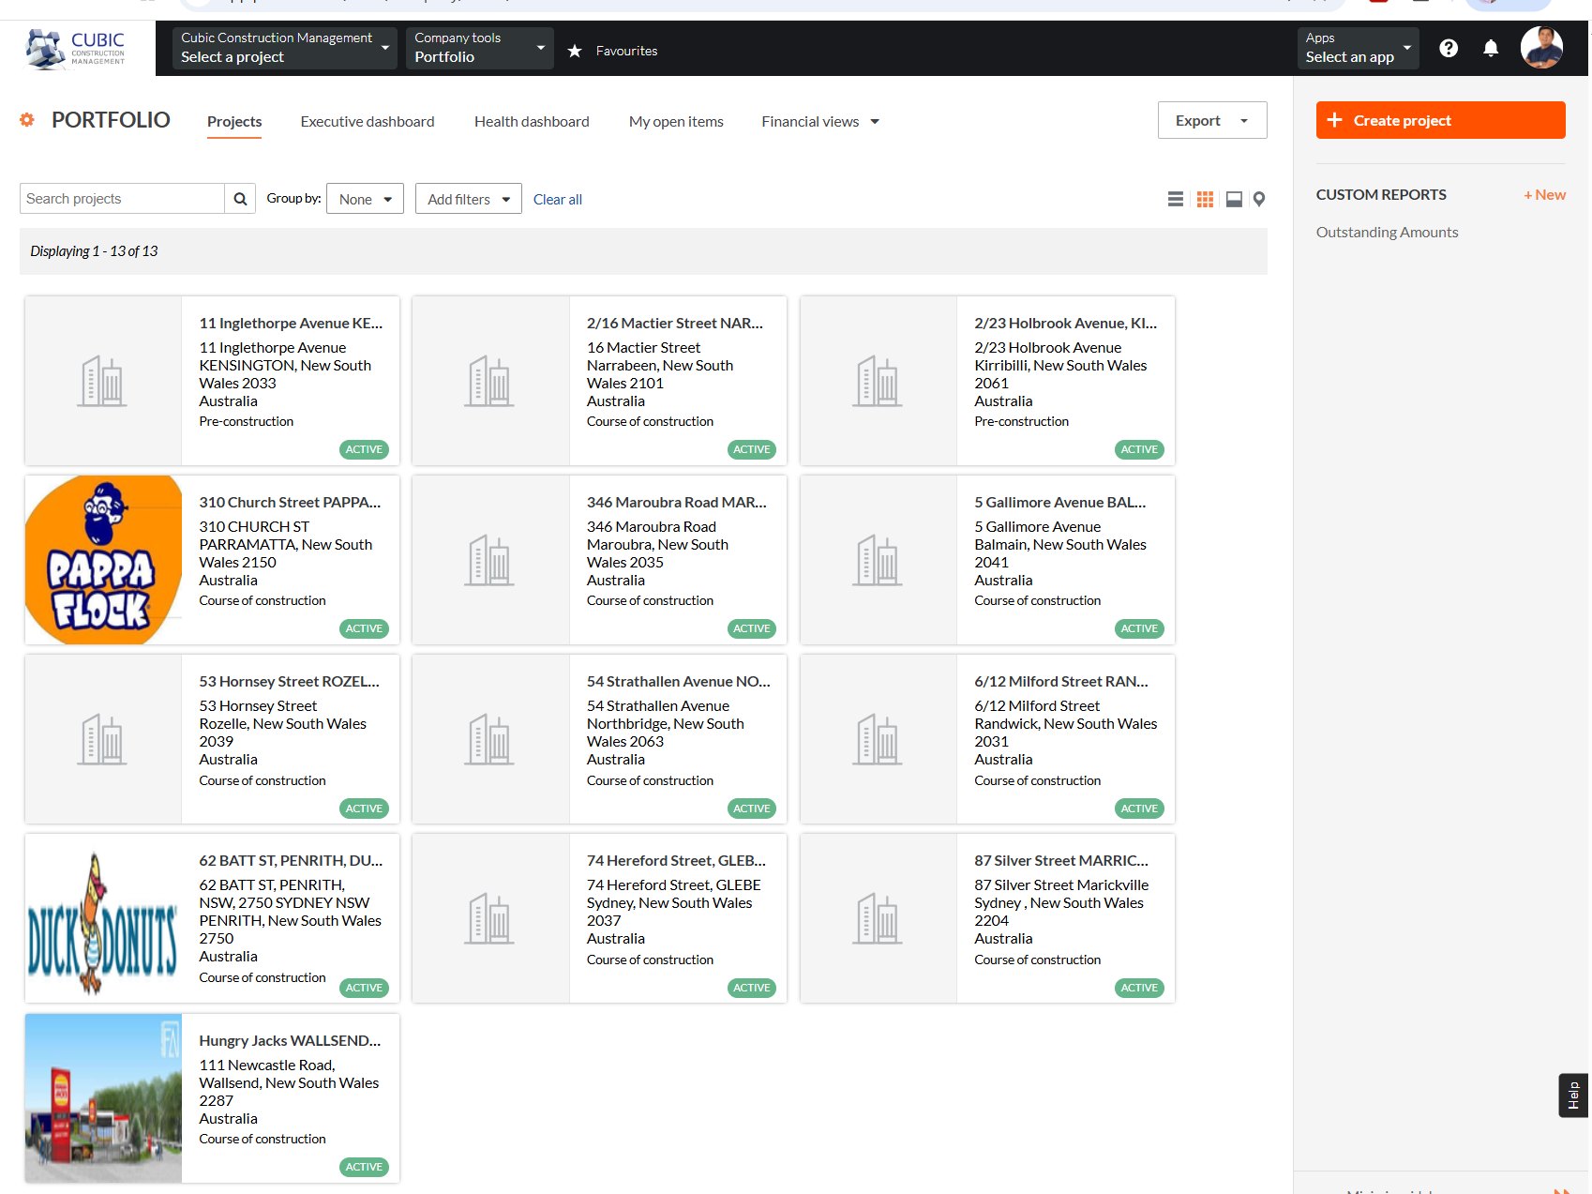

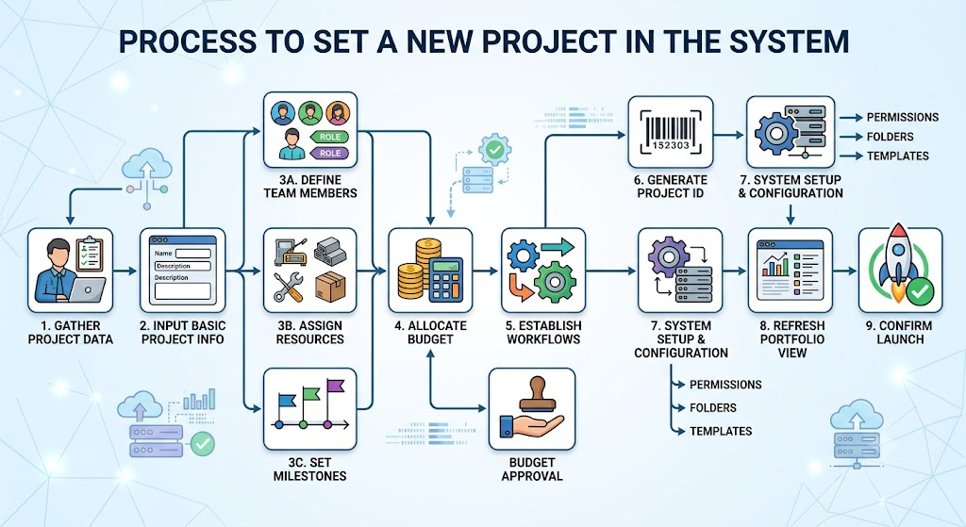
Second Interphase:
Company settings: work break down structure (where we can introduce the cost codes and description), Trades( insert trades like (concrete, plasterboard, electrical, hydraulics, etc.), unit of measurements master list, etc. Cost Codes are company-wide master data owned by this settings screen (code, description, associated Trade); the Estimate, Subcontractor & Vendor Agreement, Variation, and Report modules all reference this master list and do not create cost codes of their own. Spec Sections referenced by the Submittals module — are managed under the "specifications" tool in Tool Settings and may carry an assigned Cost Code from this same master list.
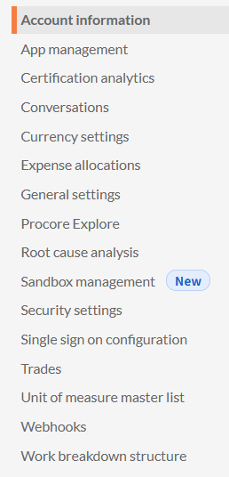

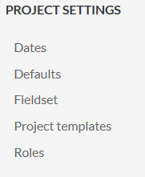
Project settings: dates, defaults, field set, project templates, roles.

Tool settings: budget, change management, contract and variations, directory, site diary, project document, drawing, progress claim, defect list, RFIs, specifications, task, etc.
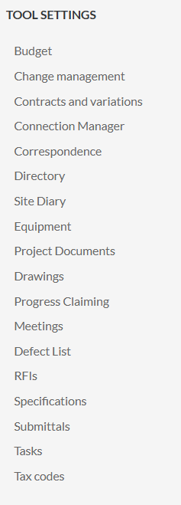
ROLES & PERMISSIONS
The roles referenced throughout this document are defined below. Role is assigned per user in Company Settings and determines module access company-wide unless a specific rule states a project-level override.
Field/Crew: assigned-project access only; read-only on financials; can create Daily Logs and Punch Items, and view (but not approve) RFIs and Submittals.
PM / Superintendent: full access to assigned projects, including approving Estimates, Invoices, Agreements, and Daily Log sign-off. Superintendent shares PM's module access but cannot approve a Variation that changes contract value (see Schedule of Values, Rule 37).
Finance: company-wide read access to budget and financial data; joint approval (with PM) on Estimates, Invoices, and Variations that change contract value.
HR: can add, edit, or deactivate Employee records in the Directory; no access to project financials or other modules.
Admin: full company-wide access, including overriding PM/Superintendent field restrictions and reassigning Assigned PM/Superintendent on an Active project.
Architect / Engineer: external reviewer role, limited to reviewing and setting status on Submittals routed to them; no access to financials, scheduling, or agreements.
Project Manager: the “PM” half of PM / Superintendent above; listed separately here because Project Manager and Superintendent are distinct positions at Cubic even though they share the same system permissions in this document.
Foreman / Superintendent: field-supervisory title equivalent to the Superintendent half of PM / Superintendent above — same system access, and cannot approve a Variation that changes contract value (Rule 37).
Site Manager: day-to-day on-site operational role, equivalent to the Superintendent access level above.
Contract Administrator: administrative support role for Subcontractor & Vendor Agreements and Variations — view/track access only under the rules as currently scoped; issuing or amending an Agreement (Rule 35), raising or approving a Variation (Rule 37), and editing the Contracts/Insurance folders (Rule 44) all remain PM/Admin/Finance-only. If the business wants this role to issue or amend directly, Rules 35, 37, and 44 would need to be revised to name it — flagged here rather than assumed.
Employee: default baseline role for any authenticated staff member without a specialized assignment — same access as Field/Crew until assigned a specific role (PM, Superintendent, Finance, HR, Admin, Contract Administrator, etc.). Not to be confused with the “Employee” Directory contact type (Rule 1), which identifies an internal staff record rather than a system permission level.
Admin/Main: the primary administrator tier — same as Admin above; named separately to distinguish from any future limited-admin tier, which is not yet scoped.
Client/Superintendent: the client's own on-site representative — view-only access to the Schedule, RFIs, and Submittals on their project, plus general Document Management folders (excluding Contracts/Insurance, which stay PM/Admin-only per Rule 44), for oversight purposes; no edit or approval rights on any module.
Student: restricted read-only access for interns/trainees, scoped to a single assigned project, for learning purposes; no edit or approval rights on any module.
Permissions matrix: V = View, E = Edit/Create, A = Approve, — = No access. “PM/Super” covers both roles except where noted — Superintendent cannot approve a Variation that changes contract value (Rule 37). Project Manager, Foreman/Superintendent, and Site Manager map onto this same "PM/Super" column (see role descriptions above); Admin/Main and Employee map onto the Admin and Field/Crew columns respectively. V* = view/track only, not an edit or approval right under current rules (see Contract Administrator above). V** = view, excluding the Contracts/Insurance folders (Rule 44).
Module | Field/Crew | PM/Super | Finance | HR | Admin | Architect/Engineer | Subcontractor | Client | Contract Administrator | Client/Superintendent | Student
Directory | V | E | V | E | E | — | — | — | V | — | —
Dashboard | V (own) | V (own) | V (co.-wide) | — | V (all) | — | — | — | — | V (own) | V (own)
Project Setup | V | E | V | — | E | — | — | — | V | V | V
Financial / Estimates | V | A | A | — | E | — | — | — | V | — | —
Subcontractor & Vendor Agreements | — | E | V | — | E | — | E (via link)* | — | V* | — | —
Schedule of Values / Variations | E (raise) | A** | A | — | E | — | — | — | V* | V | —
Document Management | E (general)*** | E | V | — | E | V (drawings) | — | — | V* | V** | V**
Daily Logs | E | A | — | — | E | — | — | — | — | — | —
RFIs | E | A | — | — | E | A | — | — | — | V | V
Submittals | E | A | — | — | E | A | E (via PM/Crew)**** | — | — | V | V
Punch List | E | A | — | — | E | — | — | — | — | V | V
Reporting | V | V | V | — | V | — | — | — | V | — | —
* Subcontractor has no system login; access is limited to the one-time shareable link (Rule 30) to view and e-sign their own Agreement.
** Only PM (not Superintendent) and Finance can approve a Variation that changes contract value (Rule 37); Superintendent is limited to raising a request, same as Field/Crew.
*** Field/Crew can upload to general project folders but not Contracts/Insurance, which are PM/Admin-restricted (Rule 44).
**** Subcontractors/suppliers provide shop drawings and product data to Field/Crew or PM for upload; they do not upload directly (no system login).
SLA & ESCALATION POLICY
This model applies uniformly across every module with a Due Date, turnaround, or pending-approval state — RFIs, Submittals, Variations (Change Orders), Daily Logs, and Punch List — so overdue items behave the same way regardless of module, and the same escalation surfaces consistently for a PM or Superintendent running multiple projects at once.
Overdue flag: an item without a resolution by its Due Date/SLA is automatically flagged Overdue on its existing status; this is not a separate status.
First escalation: an item still Overdue 3 business days after its Due Date notifies the PM/Superintendent assigned to that project (by email and SMS) and appears in an Escalated filter on the Dashboard (Module 01).
Second escalation: an item still Overdue 7 business days after its Due Date additionally notifies Admin, company-wide (by email and SMS).
Project scoping: escalation notifications and the Escalated filter always scope to the item's project, consistent with Dashboard visibility rules (see Roles & Permissions) — a PM/Superintendent sees escalations only for their assigned projects; Admin sees escalations across all projects.
INTEGRATIONS
Cubic CMS is a standalone, closed system for internal project management; it does not expose a general public API. External parties (Subcontractors/Vendors, Architect/Engineer reviewers, and Clients where relevant) interact only through the specific approval actions already scoped elsewhere in this document — e-signing a Subcontractor & Vendor Agreement (Rule 30) and, in a future revision, approving an Estimate — not through open system access.
Accounting/ERP: the system must be linkable to Xero and other relevant accounting platforms, so Committed costs, Invoices, and Budget data (Reporting, Module 09) can sync with the company's books; the specific fields and sync direction are to be defined in a future revision.
Schedule files (Module 08): MPP/MPX/XER/XML/PPX files are brought in as a one-time or periodic file transfer from MS Project or Primavera P6 by default; a live two-way sync is preferred if feasible, to be confirmed during technical scoping.
E-signature (Rule 30): e-sign is native to the system, not a third-party provider (e.g. DocuSign, Adobe Sign).
NOTIFICATION ENGINE
Notifications ride on top of the status-change events already defined per module, grouped into three trigger categories:
Overdue / escalation (RFIs, Submittals, Variations, Daily Logs, Punch List): recipients and channel follow the SLA & Escalation Policy above (PM/Superintendent at 3 business days, Admin at 7, by email and SMS). Not configurable — these cannot be muted by the recipient, since they exist to surface risk.
Next-actor status change (e.g. an RFI response is logged, a Submittal returns Revise & Resubmit, an Agreement is Signed/Rejected, a Variation is Approved/Rejected): notifies the party who needs to act next or was waiting on the outcome, by email and in-app notification. Configurable — a user may mute the in-app notification, but the email is always sent.
Record-level flags (e.g. a Directory contact's Insurance/License goes Expired, Rule 6): notifies the PM/Admin on the affected project, by email and in-app notification. Configurable, same as next-actor notifications above.
Channel, recipient, and configurability defaults above are for technical scoping and should be confirmed — in particular whether push notifications are needed alongside email/SMS/in-app.
MOBILE & OFFLINE BEHAVIOUR
Daily Logs, Punch List (including photo capture), and field-crew Schedule updates (Rule 68) must remain usable with poor or no site connectivity; other modules are mobile-responsive but do not require offline support.
Offline entries queue locally on the device and sync automatically once connectivity returns; a queued entry is visibly marked Pending Sync until it lands, so field users can confirm nothing was lost.
Conflicting edits to the same record made offline by two users are resolved by most-recent-timestamp-wins on sync; the losing edit is not discarded but retained in a conflict log visible to the assigned PM/Admin, so no resolution happens silently. This is a default policy — confirm during technical scoping whether a stricter rule (e.g. manual merge) is preferred for Punch List status specifically, since last-write-wins could overwrite a same-day update from another Trade Responsible.
Photo capture (Daily Logs, Punch List) queues and uploads in the background once connectivity returns, rather than blocking entry submission.
FINANCIAL / COST MANAGEMENT STRUCTURE
Budget, Contracts, Change Orders, and Invoicing/Payment Claims are modelled across separate modules rather than one combined “Budget” screen: Budget and Invoicing/Payment Claims live in Financial (Module 03) and roll up in Reporting (Module 09); the prime/Head Contract is captured in Project Setup (Module 02 — Contract Value/Type/upload); subcontracts are captured in Subcontractor & Vendor Agreements; and Change Orders (Variations) have their own approval chain in Schedule of Values (Module 04, Rules 36–41).
Gap: unlike Subcontracts (Rule 35) and Variations (Rule 37), the Head Contract itself has no dedicated approval chain or status lifecycle beyond “uploading a signed contract flags the project Active” (Rule 16). Confirm whether the business needs one (e.g. an internal contract review/sign-off step before upload) before this goes to development.
PERFORMANCE & SCALABILITY
Cubic CMS is sized for medium-scale operation: 10–50 active projects and 25–100 users company-wide at any time, with room to grow. Key screens (Dashboard, RFI/Submittal/Punch List logs) should load within 3 seconds under that load; the Document Management file-content search (Module 05) should return results within 5 seconds. These are default targets for technical scoping and should be validated once infrastructure is selected.
Closed and Cancelled projects (Rule 17) remain fully queryable rather than moving to a separate archive tier, so historical project data stays available for reporting and audit purposes as project count grows.
File uploads (drawings, contracts, insurance certificates, punch-item photos) are capped at a default size limit to be confirmed during technical scoping; this document assumes typical construction-document sizes (drawings, PDFs) rather than large media files.
DATA RESIDENCY
All Cubic CMS data — project, financial, and employee/Directory records — must be hosted within Australia; this is a hard data-sovereignty requirement, not a preference, and applies uniformly across modules with no exception for personal data (Directory/HR) versus project/financial data.
BACKUP & RECOVERY
The system requires near-zero downtime and frequent backups (several times per day), given multiple projects operate concurrently. Document Management's version history (Rule 42) covers file-level recovery only and is not a substitute for full system backup. Specific RPO/RTO targets are to be finalized during technical scoping, consistent with the minimal-downtime, minimal-data-loss expectation stated here.
AUDIT TRAIL
Beyond the approval- and amendment-specific logging already scoped per module (e.g. Rule 34 — Voided/Rejected reasons; Rule 35 — dated amendments; Rule 47 — Daily Log addenda; Rule 71 — Variation approval logging), the system requires a full, system-wide audit trail: every field-level change is recorded with who changed it, when, and the old and new values, across all modules, retained long-term. Access to the audit trail itself is limited to Admin (see Roles & Permissions).

DIRECTORY
SOURCE / INPUT: Client records, employee records, subcontractor/vendor register

Directory — List View
[ Contact Type filter: Client / Employee / Contractor / Subcontractor / Vendor ]
[ Name ] [ Company ] [ Role/Trade ] [ Phone ] [ Email ] [ Address ]
[ Linked Projects — auto-populated ] [ Insurance/License expiry ] [ Status: Active / Inactive ]
[ Add New Contact ] [ Search/filter bar ]

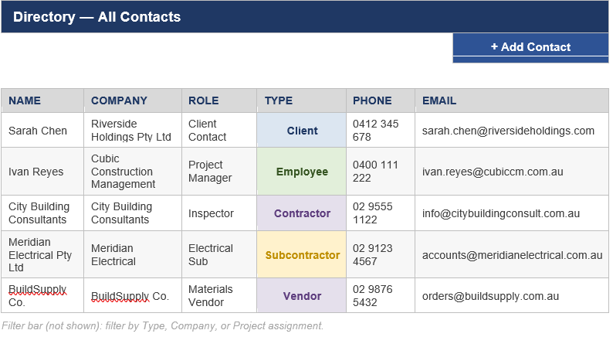

Wireframe shown is a structural mockup with sample data for illustration
BUSINESS RULES / LOGIC
- Contacts are typed as Client, Employee, Contractor, Subcontractor, or Vendor — type determines what they can be assigned to (e.g. only Employees can be set as PM/Superintendent in Project Setup). "Contractor" identifies an external head contractor on jobs where Cubic is engaged as a subcontractor and is informational only; "Subcontractor" and "Vendor" are functionally identical for agreement purposes — both are selected against the same Subcontractor Name field in the Subcontractor & Vendor Agreements module, which does not currently distinguish between them by separate fields or workflow.
- Adding a Subcontractor or Vendor here makes them selectable from a dropdown in the Subcontractor & Vendor Agreements module, instead of re-typing their name and email each time.
- Directory is company-wide by default; contacts can be tagged to one or more specific projects to control who appears on that project's team list.
- Employee entries sync from company HR/user records; Client, Contractor, Subcontractor, and Vendor entries are added manually or imported from won bids.
- Removing a contact from the Directory does not delete their history on past RFIs, submittals, or agreements — it only prevents new assignments going forward.
- A contact whose Insurance/License expiry date has passed is automatically flagged Expired on their Directory record; the system blocks selecting them on new Subcontractor & Vendor Agreements until a current certificate is uploaded (existing signed agreements are unaffected).
- Setting a contact to Inactive hides them from new assignment dropdowns but preserves their history and does not delete the record; only Company Admins can permanently delete a contact, and only if they have no linked history.
- Adding, editing, or deactivating a Directory contact requires Admin or HR role for Employee records, and Admin or PM role for Client/Contractor/Subcontractor/Vendor records.
PROCESS MAP
Step / State | Decision Point | Outcome
Contact added | Type = Employee? | Yes → synced from company HR/user records · No → added manually or imported from won bids
Active contact | Insurance/License expiry date has passed? | Yes → flagged Expired, blocked from new Subcontractor & Vendor Agreements · No → remains selectable
Set Inactive | Has linked history (RFIs, Submittals, Agreements)? | Yes → record preserved, hidden from new-assignment dropdowns · No → Admin can permanently delete

Third interphase:
1. select the project. Dropdown
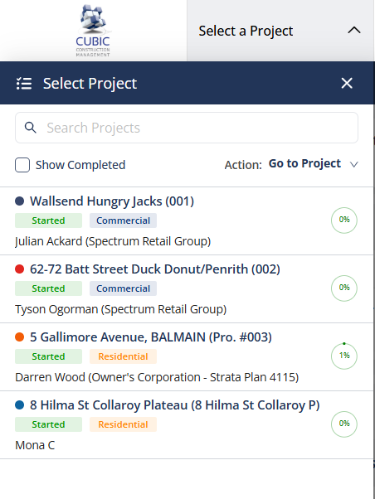
where it will be located
Core Tools: Directory, task, admin., documents, home,
Project Management: Defects list, program site diary, photos, emails, program, RFIs,
Financial Management: Head contracts, budget, commitments, variations, progress claim. "Head Contract" here is the same record captured by the Contract Value / Contract Type / signed-contract-upload fields in Project Setup (Module 02) and the "Contracts" folder in Document Management (Module 05) — it is not a separate object.
Custom Tools: Extension of time (EOT) — referenced here and in Daily Logs Rule 47 (delay-day rollups feed EOT requests), but not yet scoped as its own module; fields, workflow, and approval rules are to be defined in a future revision.

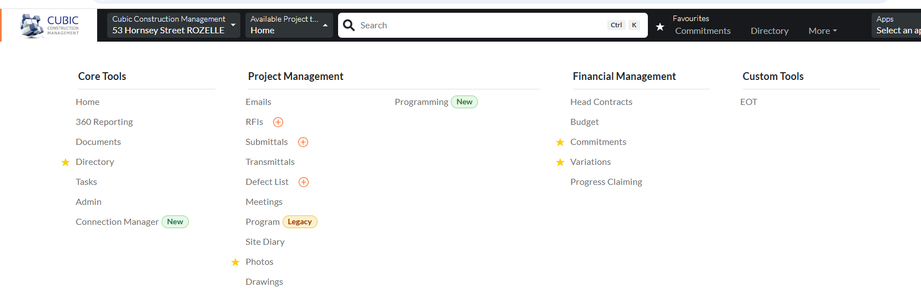

2. Once selected the project poop up several Modules:
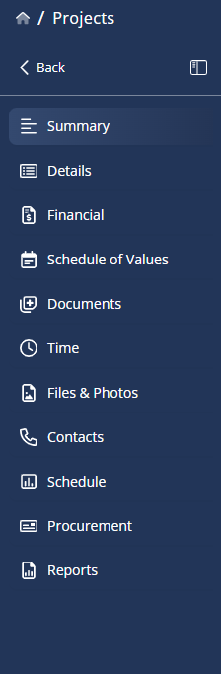
Module 01: Summary

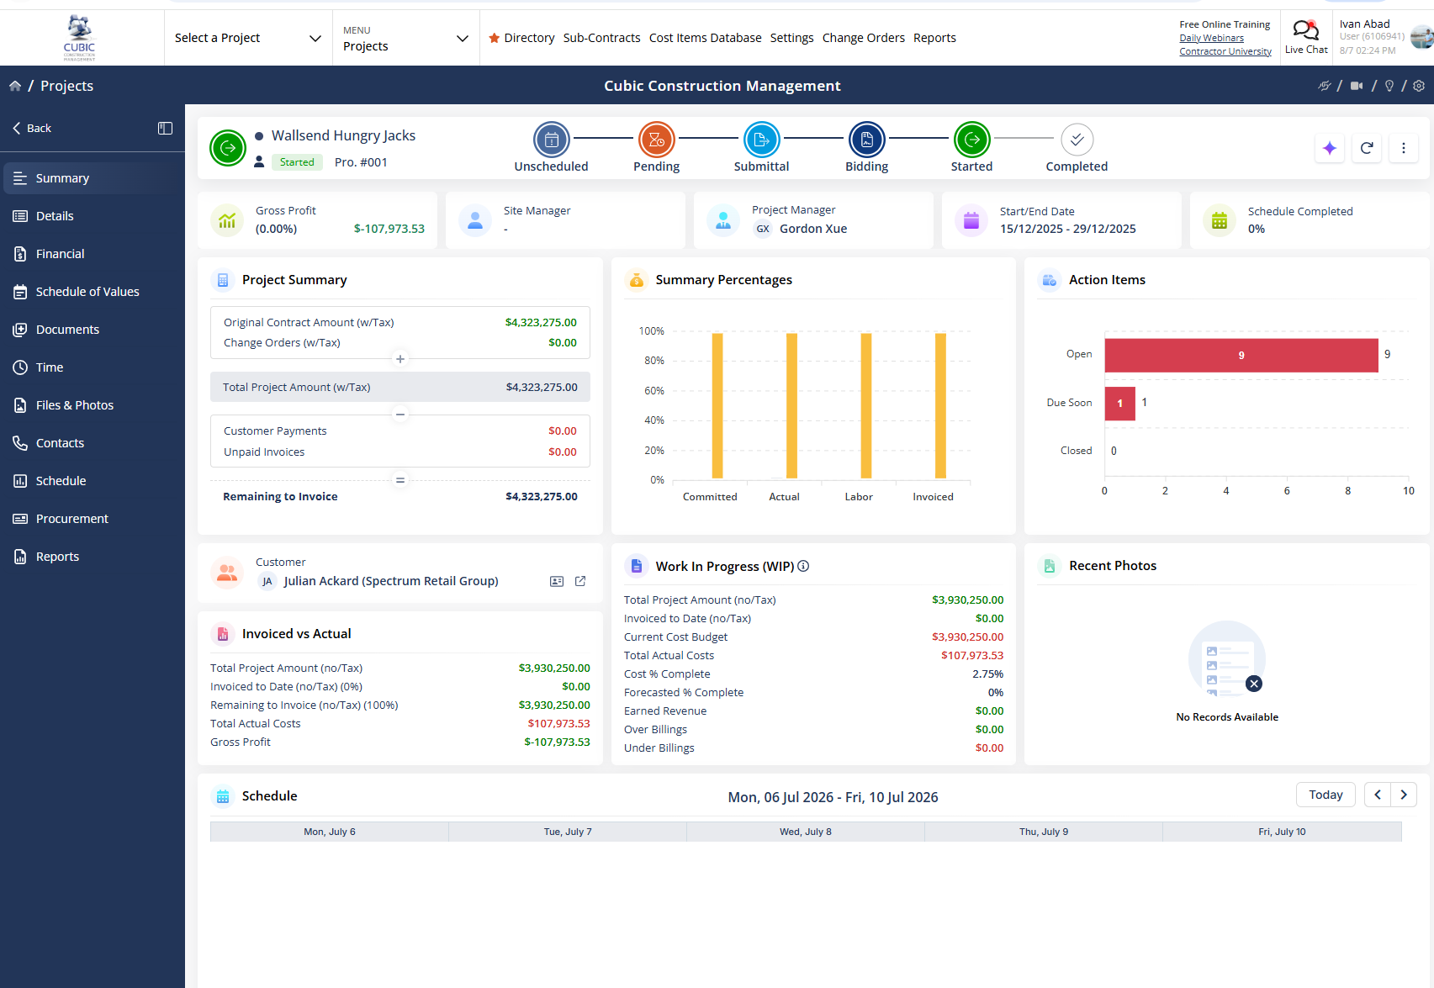
PROJECT HOME/DASHBOARD
SOURCE / INPUT: Aggregated from all active project modules (budget, schedule, RFIs, daily logs)
Dashboard — Landing View
[ Project selector dropdown ] [ Status badge: On Track / At Risk / Delayed ]
[ Budget snapshot: spent vs. total ] [ Schedule snapshot: % complete, days remaining ]
[ Open RFIs: count ] [ Open Submittals: count ] [ Open Punch Items: count ]
[ Recent activity feed — last 10 updates across all modules ]
[ Upcoming milestones (next 10 days) ]
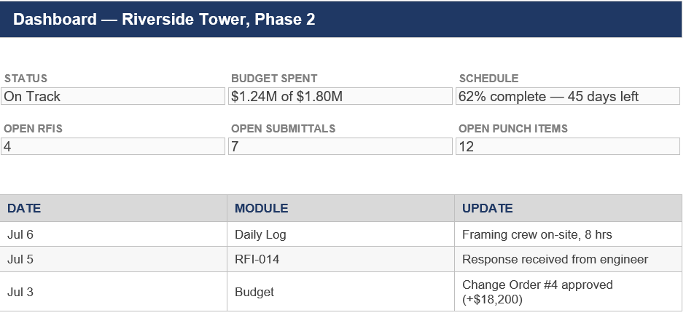
BUSINESS RULES / LOGIC
- Status badge auto-calculates from schedule variance (Delayed if any critical-path task is >5 days behind) and budget variance (At Risk if spend exceeds pace of schedule completion by >10%). If both conditions are true simultaneously, the badge shows Delayed — schedule variance takes precedence over budget variance for the headline status.
- Counts (RFIs, Submittals, Punch Items) only include items in “open” or “pending response” states.
- Activity feed pulls the most recent timestamped change from every module, sorted descending.
- Users only see projects they are assigned to, unless granted admin/company-wide visibility.
- Visibility roles are: Field/Crew (their assigned project only, read-only on financials), PM/Superintendent (full access to their assigned projects), Finance (budget/financial data company-wide, read-only elsewhere), Admin (full company-wide access) — see Roles & Permissions for the complete role list, including HR and Architect/Engineer.
PROCESS MAP
Step / State | Decision Point | Outcome
Status badge recalculated | Any critical-path task >5 days behind? | Yes → Delayed · No → check budget variance
Not Delayed | Spend exceeds pace of schedule completion by >10%? | Yes → At Risk · No → On Track
Both conditions true simultaneously | — | Badge shows Delayed — schedule variance takes precedence over budget variance

Module 02: Details
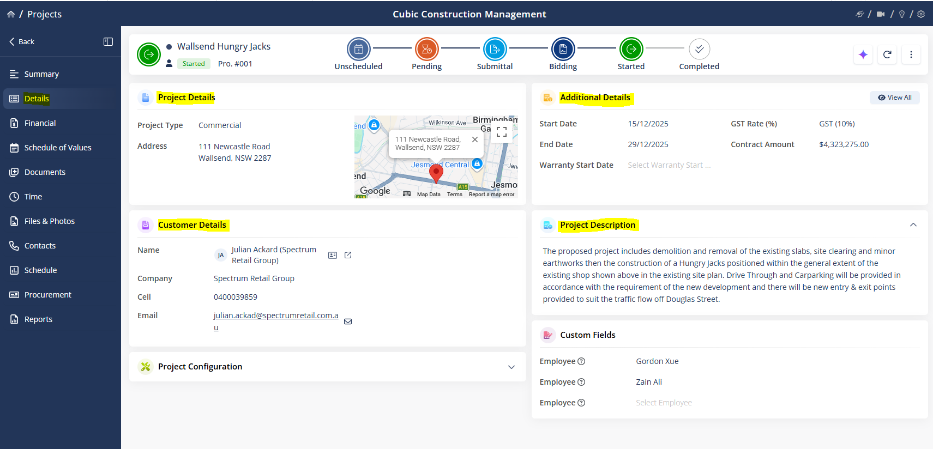

See below other example
SOURCE / INPUT: Project Contract & Scope of Work
Project Setup Form
[ Project Name ] [ Project Number ] [ Client Name ]
[ Site Address ] [ Project Type: New Build / Renovation / etc. ]
[ Start Date ] [ Target Completion Date ]
[ Contract Value ] [ Contract Type: Fixed Price / Cost Plus / T&M ]
[ Assigned PM ] [ Assigned Superintendent ] [ Team members list + add ]
[ Upload: signed contract, scope of work, permits ]
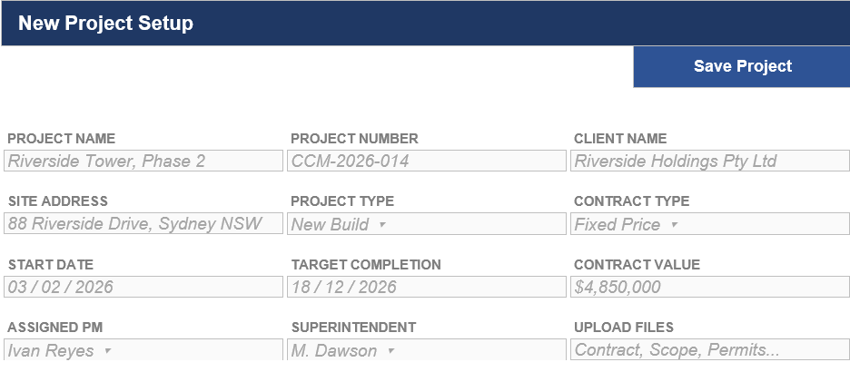
BUSINESS RULES / LOGIC
- Project Number auto-generates using a company sequence (e.g. CCM-2026-0XX) but is editable if a legacy numbering scheme applies.
- Contract Type selection changes which fields are required later in the Financials module (e.g. T&M requires hourly rate tables; Fixed Price does not; Cost Plus requires a fee structure — % fee or fixed fee — plus supporting-cost documentation on every invoice).
- Uploading a signed contract flags the project as “Active”; without one, the project remains in “Draft/Pre-construction” status.
- Full project status lifecycle: Draft/Pre-construction → Active → Substantially Complete (set automatically once all Safety-category punch items are Closed, per Punch List Rule 62) → Closed (set manually by PM/Admin once final retention is released and all documents archived). On Hold and Cancelled are available at any point before Closed, set by PM/Admin with a logged reason; a project cannot be re-opened from Closed without Admin override.
- Validation: Target Completion Date must be on or after Start Date; Contract Value must be greater than zero; Project Name, Client Name, and Contract Type are required before the project can move out of Draft.
- Once a project is Active, only Admin can change Assigned PM or Assigned Superintendent; the PM can edit other setup fields (site address, team members) but not Contract Value or Contract Type without Admin approval.
- Target Completion Date seeds the initial baseline schedule end date, editable once a full schedule is built.
PROCESS MAP
Step / State | Decision Point | Outcome
Draft/Pre-construction (created) | Signed contract uploaded? (Rule 16) | Yes → Active · No → remains Draft/Pre-construction
Active | All Safety-category punch items Closed? (Rule 17) | Yes → Substantially Complete (auto) · No → remains Active
Substantially Complete | PM/Admin releases final retention & archives documents? | Yes → Closed (manual) · No → remains Substantially Complete
Active / Substantially Complete | PM/Admin sets On Hold or Cancelled with a logged reason? | Yes → On Hold / Cancelled · No → continues normal flow
Closed (terminal) | Admin override to reopen? | Yes → returns to prior status · No → remains Closed

Module 03: Financial
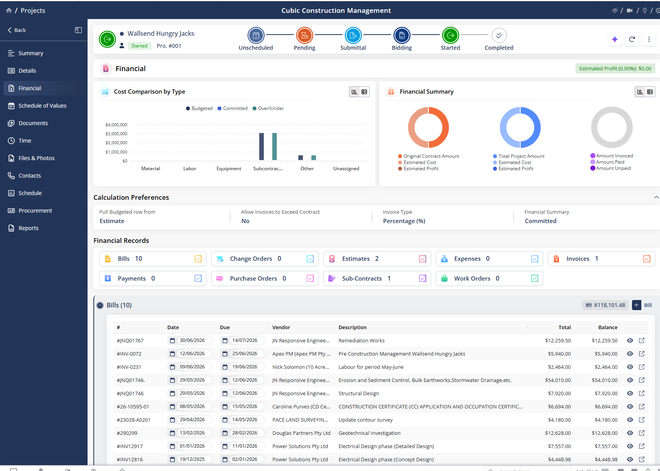
In this field we will create estimates, for the project, according to the need of each project, assigning the client, and cost code, Qty, unit cost, Unit, total tax, etc.
The flow: Create Estimate (Draft) → add estimate lines (Cost Code, Qty, Unit, Unit Cost, Tax) → every line has a Cost Code? (No → approval blocked) → submit → PM signs off? → total over delegated-authority threshold? (Yes → Finance sign-off) → Approved Estimate → convert to Schedule of Values (budget baseline) → committed costs post from signed subcontracts + Variations adjust totals → Budget live in Reportin
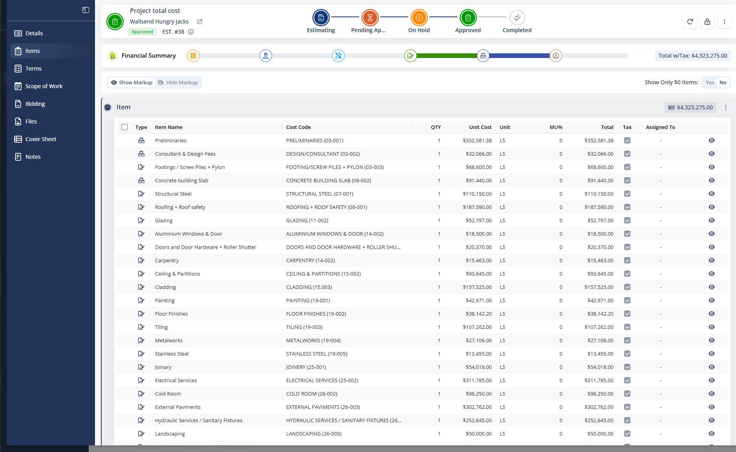

Moreover, Invoices: to sent to the client to ask for payment according to the project progress. In this point is important to have a column for percentage, to make it easier the claim columns such as: cost code, description, approved budget, progress (%) percentage, see below.
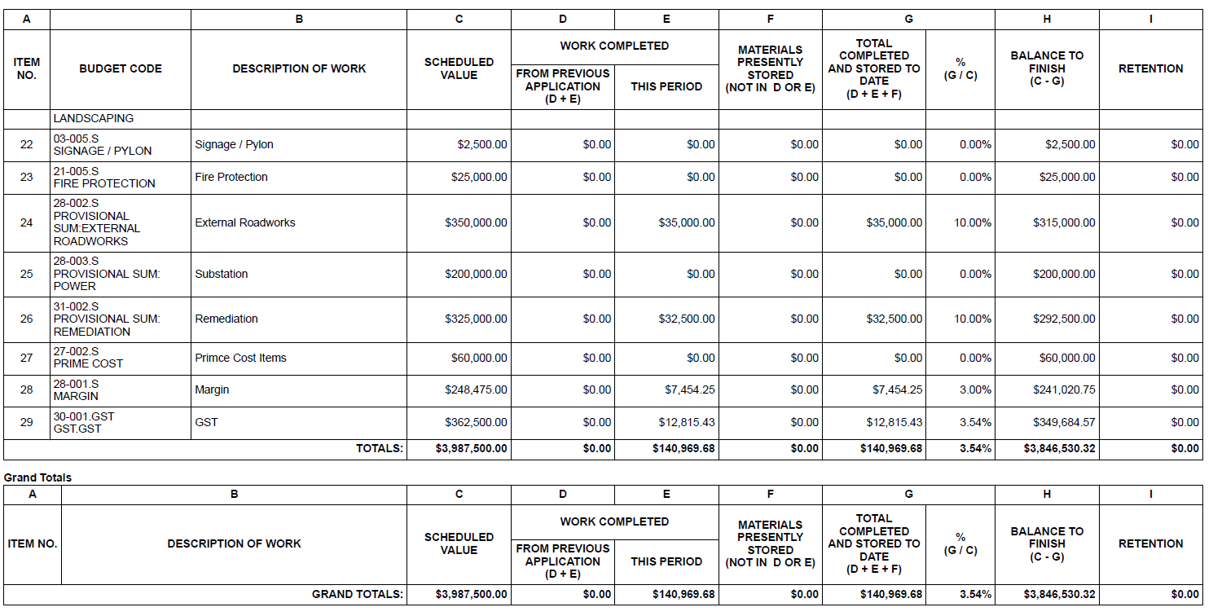
note: all values will change for each project.

Similarly Subcontract: Are created based the Trade, for example and subcontract can be made for electrical, hydraulics, concrete, steel works, etc.
BUSINESS RULES / LOGIC
- An Estimate is a Draft until approved; approval requires PM sign-off, and Finance sign-off if the total exceeds the company delegated-authority threshold. Only an Approved Estimate can be converted to a Schedule of Values (Module 04).
- Each Estimate line requires a Cost Code (from the company Work Breakdown Structure), Quantity, Unit of Measure, Unit Cost, and Tax status; the system blocks approval if any line is missing a Cost Code.
- A Progress Claim/Invoice cannot claim more than 100% complete against any cost code's approved budget, and cannot be issued until the corresponding Schedule of Values line exists.
- Issuing an Invoice to the client requires PM approval; once sent, prior claim percentages lock so the next claim can only report incremental progress from the last approved position.
- “Subcontract” in this module refers to the same record created in the Subcontractor & Vendor Agreements module — once an agreement there reaches Signed status, it appears here as a Committed cost line against its assigned cost code (see Subcontractor & Vendor Agreements, Rule 32); it is not a separate object created independently in Financials.
- Only PM and Finance roles can approve an Estimate or an Invoice for sending to the client; Field/Crew roles have read-only access to this module.
PROCESS MAP
Step / State | Decision Point | Outcome
Estimate — Draft | PM signs off? | Yes → check Finance threshold below · No → remains Draft
PM signed off | Total exceeds delegated-authority threshold? | Yes → requires Finance sign-off · No → Approved
Finance review (over threshold) | Finance signs off? | Yes → Approved · No → remains Draft
Approved Estimate | Converted to Schedule of Values? | Yes → becomes Module 04 record · No → remains an Approved Estimate, unconverted
Progress Claim/Invoice — drafted | Claim ≤ 100% of approved budget on every cost code, and Schedule of Values line exists? | Yes → can be issued (with PM approval) · No → blocked from issuing
Invoice issued | — | Prior claim % locks; next claim can only report incremental progress
PROCESS FLOW — CREATE A BUDGET FOR A NEW PROJECT

SUBCONTRACTOR & VENDOR AGREEMENTS
SOURCE / INPUT: Subcontractor bids/quotes, signed agreements, company subcontractor register

Subcontractor & Vendor Agreements — Form View
[ Subcontractor Name ] [ Issued By ] [ Date Issued ] [ Cost Code ] [ Agreement Value ] [ Retainage % (Working) ]
[ Terms & Conditions — text/template ] [ Scope of Work — text ]
[ Inclusions — list ] [ Exclusions — list ] [ Document Notes — text ]
[ Attach Quote — file upload ] [ Preview ] [ Send to Subcontractor — generates emailable agreement + quote ]
[ Tracking: Sent date, Viewed status, Signed status ]

Wireframe shown is a structural mock up with sample data for illustration
BUSINESS RULES / LOGIC
- Retainage % auto-populates from the company default but is editable per agreement; it flows into the Budget module to calculate retained amounts on each payment application.
- Agreement Status auto-updates to “Sent” once the “Send to Subcontractor” action is triggered, logging timestamp and recipient.
- Uploading a quote is mandatory before the agreement can move from “Draft” to “Sent” status.
- The “Send to Subcontractor” action generates a shareable link/PDF combining agreement details, terms, scope, and the attached quote, so the subcontractor can review and e-sign (natively, with no third-party e-signature provider) without needing system access.
- Once signed, the agreement details and terms lock from editing; changes require a logged amendment.
- Signed agreements automatically create a “Committed” line item in the Budget & Financials module against the Cost Code selected on the agreement, for the Agreement Value entered.
- Terms and conditions, Inclusions/Exclusions support a template library for one-click reuse of standard trade scopes.
- Agreement status also supports Rejected (subcontractor declines via the shareable link, logged with reason), Voided (issued in error, PM/Admin only, before signature), and Expired (retention/warranty period elapsed after Signed, set automatically from a defect-liability-period field). Rejected and Voided agreements do not post a Committed cost line.
- Only PM and Admin roles can issue an agreement or override the default Retainage %; only PM or Admin can log an amendment to a signed agreement, and each amendment is stored as a dated revision, not an overwrite, preserving the original signed terms.
PROCESS MAP
Step / State | Decision Point | Outcome
Draft | Quote uploaded, then “Send to Subcontractor” triggered? | Yes → Sent · No → remains Draft
Sent | Subcontractor e-signs via the shareable link? | Yes → Signed · No → subcontractor may Reject, or PM/Admin may Void (before signature)
Signed | Defect-liability period elapses? | Yes → Expired (auto) · No → remains Signed
Signed | PM/Admin logs an amendment? | Yes → dated revision stored, terms otherwise unchanged · No → terms stay locked as signed
Rejected / Voided | — | Terminal — no Committed cost line posted
Signed | — | Committed cost line auto-created in Budget & Financials against the agreement's Cost Code
Module 04: Schedule of values
Is linked with the estimate that we create previously. Once the estimate is approve can me convert into approve schedule of values.
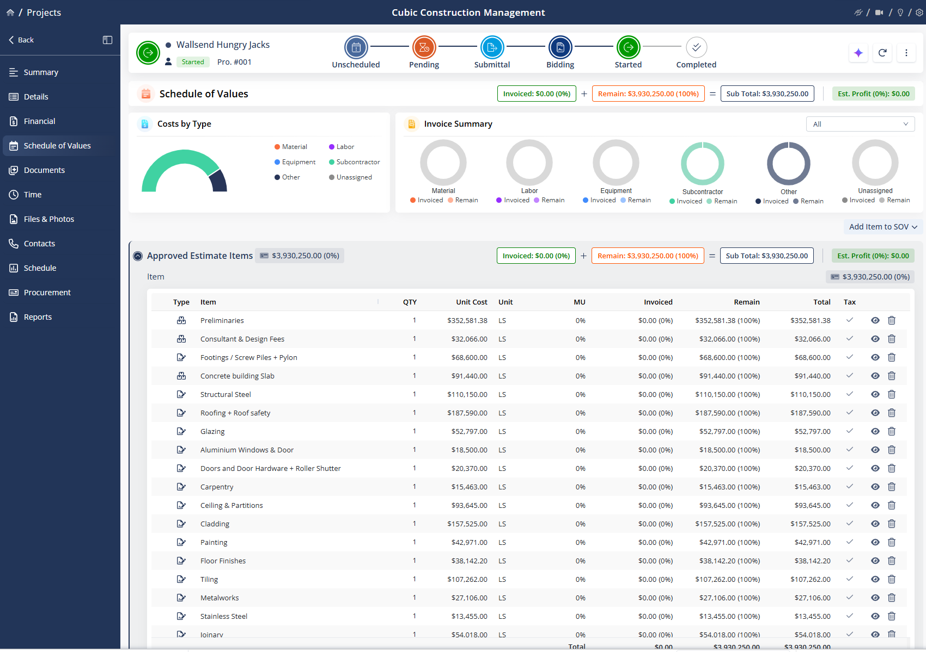

This section of the Schedule of Values holds Variations (referred to as "Change Orders" in Procore/Contractor Foreman and used interchangeably with that term elsewhere in this document). A Variation can affect the agreed contract price positively or negatively — for example, if the total main contract is $1,000,000.00 and an approved Variation of $80,000.00 is added, the new contract value becomes $1,080,000.00 AUD.
BUSINESS RULES / LOGIC
- A Variation moves through Draft → Pending Approval → Approved or Rejected. Only Approved Variations adjust the contract value and Budgeted totals (see Reporting, Rule 73); Rejected Variations are retained for audit but have no financial effect.
- Only PM and Finance roles can approve a Variation that changes contract value (see Reporting, Rule 77); Superintendent and Field/Crew roles can raise a Variation request but not approve it.
- Variations follow the SLA & Escalation Policy: a Variation must reach Approved or Rejected within 5 business days of entering Pending Approval, unless the contract specifies a different turnaround; PM and Finance jointly hold both the approve and the reject decision (Rule 37).
- Every Variation must be assigned to at least one Cost Code from the Schedule of Values before it can be submitted for approval.
- A Variation raised from an RFI (per RFIs, Rule 52) carries a link back to the source RFI for traceability.
- An approved Variation flagged with Schedule Impact must be linked to a Schedule task in Module 08 before the source RFI (if any) can be marked Closed; the project's Target Completion Date only shifts once that Schedule task is approved through the Module 08 update workflow (Rule 70).
PROCESS MAP
Step / State | Decision Point | Outcome
Draft | Cost Code assigned? | Yes → can be submitted for approval · No → blocked from submission
Submitted | PM and Finance approve? (Superintendent/Field-Crew can raise but not approve) | Yes → Approved · No → Rejected
Approved | — | Contract value and Budgeted totals adjust (rolls up to Reporting)
Rejected | — | Retained for audit; no financial effect (terminal)
Approved | Flagged with Schedule Impact? | Yes → must link to a Schedule task before the source RFI can Close · No → no schedule linkage required
Linked Schedule task | Task approved through Module 08's update workflow? | Yes → Target Completion Date shifts · No → date unchanged
Pending Approval | 5 business days elapse with no decision? | Yes → SLA & Escalation Policy triggers · No → continues awaiting approval
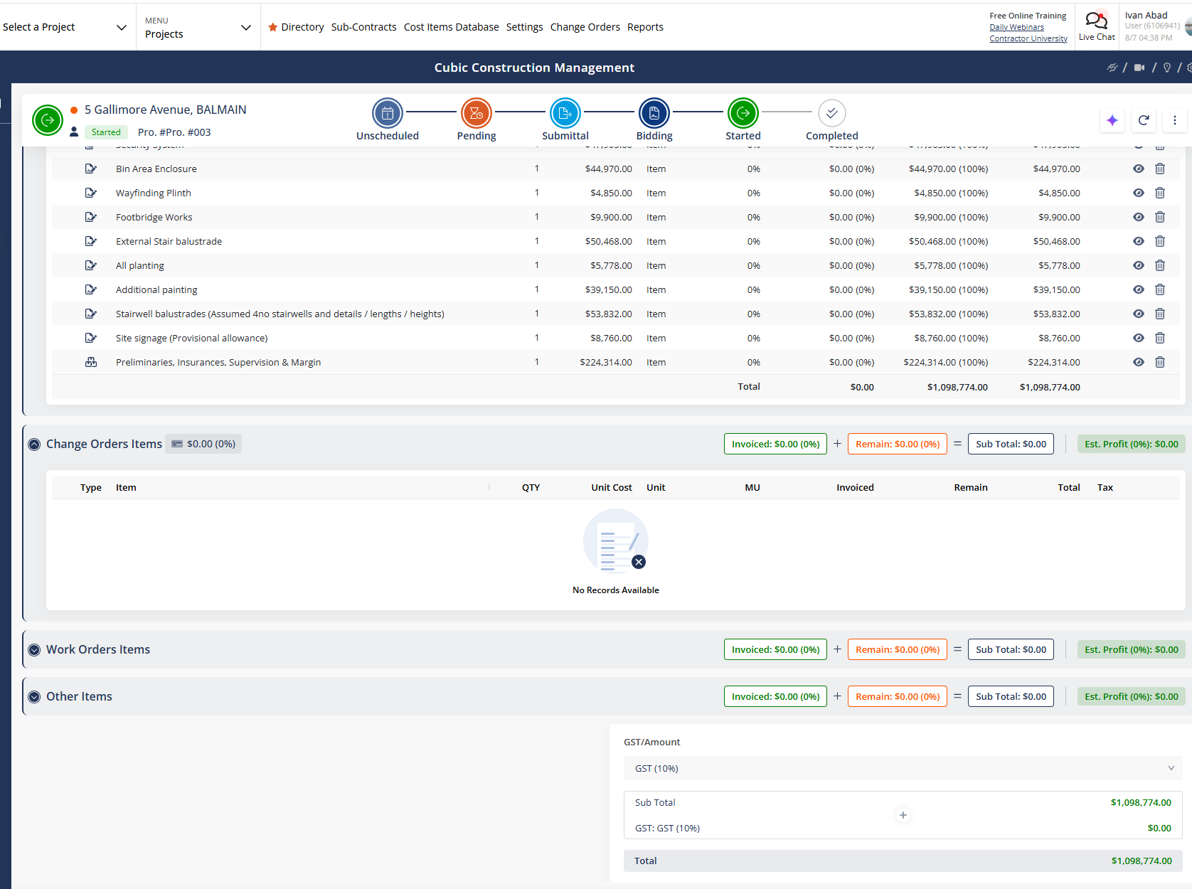

Module 05: Document Management
: will contain information such as, Daily logs, Punch lists, Request for information, see below. Incidents live in Safety & Incident Management (Module 11), not here.
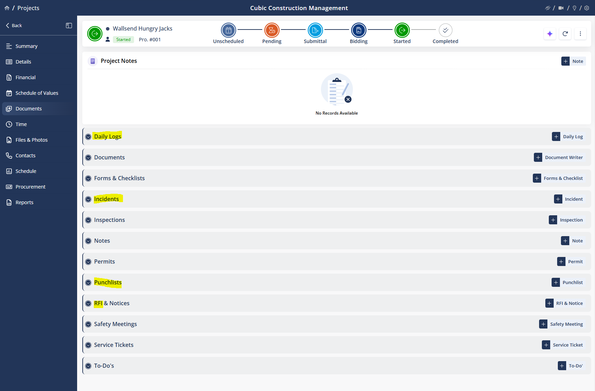

SOURCE / INPUT: Contracts, drawings, permits, insurance certificates, all uploaded project files
Document Library
[ Folder tree: Contracts / Drawings / Permits / Insurance / Submittals / Photos ]
[ File list: name, uploaded by, date, version ]
[ Version history — previous versions retained, not overwritten ]
[ Search bar — across file names and, where possible, file content ]
BUSINESS RULES / LOGIC
- Uploading a file with the same name to the same folder creates a new version rather than overwriting — all prior versions remain accessible.
- Drawing files are tagged with revision date; the system flags any drawing referenced elsewhere (e.g. in an RFI) that has since been superseded by a newer revision.
- Access to Contracts and Insurance folders can be restricted to PM/Admin roles only, separate from general project file access.
- Drawing files support version-controlled markup/redlining (annotations layered on a specific revision, not altering the underlying file) and side-by-side sheet comparison between any two revisions of the same drawing.
PROCESS MAP
Step / State | Decision Point | Outcome
File uploaded | Same name already exists in the same folder? | Yes → new version created, prior versions retained · No → stored as a new file
Drawing revision uploaded | An older revision of this drawing is referenced elsewhere (e.g. an RFI or Submittal)? | Yes → that reference is flagged as superseded · No → no flag
File access requested | File is in the Contracts or Insurance folder? | Yes → PM/Admin only · No → general project file access applies

DAILY LOGS
SOURCE / INPUT: Field entries via mobile/tablet — weather, crew, work performed, delays
Daily Log Entry
[ Date ] [ Weather: auto-pulled ] [ Temperature ]
[ Crew on site: trade, headcount ]
[ Work performed today — free text or checklist by task ]
[ Delays / Issues — reason, hours lost, photo attachment ]
[ Equipment on site ]
[ Submit → locks entry after PM sign-off ]
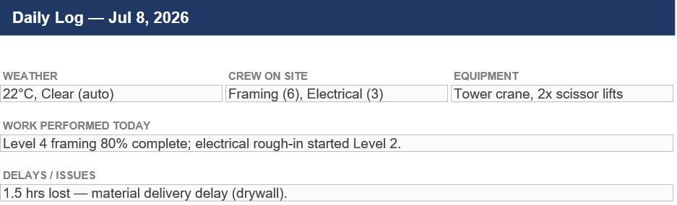
Wireframe shown is a structural mockup with sample data for illustration
BUSINESS RULES / LOGIC
- Weather auto-pulls from a weather API based on site address and log date; field user can override if inaccurate.
- Logged delay hours roll up into a project-level “weather/delay days” total, referenced automatically in schedule extension requests.
- Once a PM signs off on a daily log, it becomes read-only; corrections require a logged addendum, not an edit. PM sign-off is due within 2 business days of submission and follows the SLA & Escalation Policy if it lapses; addenda may be logged by the original field user or the PM, and are retained alongside the original entry rather than replacing it.
PROCESS MAP
Step / State | Decision Point | Outcome
Entry being filled (field/mobile) | Field user submits? | Yes → Submitted, pending PM sign-off · No → remains editable
Submitted | PM signs off within 2 business days? | Yes → Locked (read-only) · No → SLA & Escalation Policy triggers
Locked | Correction needed? | Yes → addendum logged (original entry preserved) · No → no further action

RFIs (REQUESTS FOR INFORMATION)
SOURCE / INPUT: RFIs submitted by field team, architect/engineer responses
RFI Log
[ RFI # ] [ Subject ] [ Submitted By ] [ Date Sent ] [ Due Date ] [ Status ]
RFI-014 Beam spec clarification J. Smith --/-- --/-- Open
[ Detail view: question, attached drawings, response thread, resolution ]
[ Cost/Schedule Impact flag: Yes/No, with linked Variation (Change Order) if Yes ]
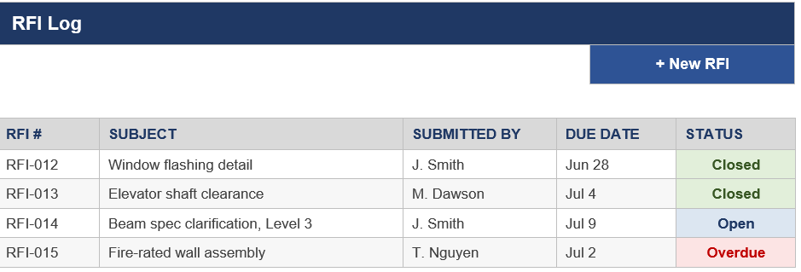
Wireframe shown is a structural mockup with sample data for illustration
BUSINESS RULES / LOGIC
- Full RFI status lifecycle: Open → Closed. Overdue is an automatic flag applied to an Open RFI once Due Date passes without a logged response (not a separate status); an RFI cannot move to Closed while Cost/Schedule Impact is marked Yes unless it is linked to a Variation or Schedule task. RFIs are submitted by Field/Crew or PM/Superintendent and are marked Closed by the PM/Superintendent once a response has been logged (or by the responding Architect/Engineer where one is assigned); Overdue RFIs follow the SLA & Escalation Policy.
- Due Date defaults to Date Sent + 7 calendar days unless the contract specifies a different RFI turnaround.
- RFI status auto-flags “Overdue” if Due Date passes with no response logged.
- If Cost/Schedule Impact is marked Yes, the RFI must be linked to a Variation (Change Order) or Schedule task before it can be marked Closed.
- Closed RFIs remain visible/searchable but are removed from the Dashboard's open count.
PROCESS MAP
Step / State | Decision Point | Outcome
Open (submitted by Field/Crew or PM/Superintendent) | Response logged by Due Date (Date Sent + 7 days, or contract turnaround)? | Yes → proceed to Cost/Schedule Impact check · No → auto-flagged Overdue, SLA & Escalation Policy triggers
Response logged | Cost/Schedule Impact marked Yes? | Yes → must be linked to a Variation or Schedule task before Closing · No → can be Closed directly
Linked to Variation/Schedule task | PM/Superintendent or responding Architect/Engineer marks Closed? | Yes → Closed · No → remains Open
Closed | — | Remains visible/searchable; removed from Dashboard's open count (terminal)
PROCESS FLOW DIAGRAM
RFI SUBMITTED
(Field/Crew or PM/Superintendent)
SUBMITTALS
↓
RESPONSE LOGGED BY DUE DATE?
(Date Sent + 7 days, or contract turnaround)
SOURCE / INPUT: Project specifications (spec sections), submittal requirements schedule, shop drawings/product data from subcontractors and suppliers
NO → AUTO-FLAGGED OVERDUE  (SLA & Escalation Policy triggers) | YES → CHECK COST/SCHEDULE IMPACT

↓ (from YES)
COST/SCHEDULE IMPACT = YES?

NO → CAN BE CLOSED DIRECTLY | YES → MUST LINK TO A VARIATION OR SCHEDULE TASK BEFORE CLOSING

↓
PM/SUPERINTENDENT OR RESPONDING ARCHITECT/ENGINEER MARKS CLOSED

↓
CLOSED
(visible/searchable, removed from Dashboard's open count)

Submittal Log
[ Submittal # ] [ Spec Section ] [ Title ] [ Submitted By ] [ Date Sent ] [ Due Date ] [ Status ]
SUB-021 Spec 03 30 00 Concrete mix design J. Smith --/-- --/-- Open
[ Detail view: description, attached shop drawings/product data, review comments, resolution ]
[ Linked Spec Section ] [ Linked Cost Code — via Spec Section's assigned Cost Code ] [ Linked Drawing, if applicable ]

Wireframe shown is a structural mockup with sample data for illustration
BUSINESS RULES / LOGIC
- Each Submittal must be linked to a Spec Section (from the project's specifications) and, where the Spec Section carries one, its assigned Cost Code — establishing the same traceability chain referenced elsewhere in this document (Submittal → Spec Section → Cost Code).
- Due Date defaults to Date Sent plus the turnaround period specified in the Spec Section (or a company default if none is specified), mirroring RFIs, Rule 50. Submittals follow the same Overdue flag and escalation path as RFIs under the SLA & Escalation Policy.
- Submittal status lifecycle: Open → Under Review → Approved / Approved as Noted / Revise & Resubmit / Rejected → Closed. Only Approved or Approved as Noted submittals can be marked Closed; Revise & Resubmit returns the submittal to Open for resubmission. The submitter (Field/Crew or the Subcontractor via the shareable record) moves a Submittal from Open to Under Review by completing submission; the assigned PM or Architect/Engineer marks it Closed once in an Approved or Approved as Noted state, and resubmits it to Open following Revise & Resubmit.
- A Submittal referencing a Drawing that has since been superseded (per Document Management, Rule 44) is automatically flagged for review.
- Closed Submittals remain visible/searchable but are removed from the Dashboard's open count, mirroring RFIs, Rule 53.
- Only PM and Architect/Engineer-role reviewers can change Submittal status to Approved, Approved as Noted, or Rejected; Field/Crew roles can create and view Submittals but not approve them.
PROCESS MAP
Step / State | Decision Point | Outcome
Open (submitted, linked to a Spec Section) | Response logged by Due Date (Spec Section turnaround, or company default)? | Yes → moves to Under Review · No → auto-flagged Overdue, SLA & Escalation Policy triggers
Under Review | PM or Architect/Engineer decides | Approved / Approved as Noted → can be Closed · Revise & Resubmit → back to Open · Rejected → terminal
Approved / Approved as Noted | PM or Architect/Engineer marks Closed? | Yes → Closed · No → remains Approved, awaiting Closed
Any state | References a Drawing that's since been superseded? | Yes → auto-flagged for review · No → no flag
Closed | — | Remains visible/searchable; removed from Dashboard's open count (terminal)

PUNCH LIST & INSPECTIONS
SOURCE / INPUT: Field inspections, closeout walkthroughs, safety checklists
Punch List
[ Item # ] [ Location ] [ Description ] [ Trade Responsible ] [ Photo ] [ Status: Open / In Progress / Ready for Review / Closed ]
[ Filter by: Trade / Location / Status ]
[ Inspection checklist templates — select by type: Safety / Quality / Pre-Closeout ]
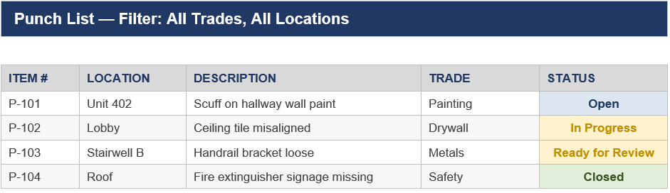
Wireframe shown is a structural mockup with sample data for illustration

BUSINESS RULES / LOGIC
- Each punch item requires at least one photo before it can be marked Closed.
- Items marked “Ready for Review” notify the assigned PM automatically; PM approval is required to move to Closed.
- Project cannot be marked “Substantially Complete” while any Safety-category punch item remains Open.
- Punch items follow the SLA & Escalation Policy against a Target Resolution Date — 10 business days from creation by default, or 5 business days for Safety-category items given the effect above on project completion. The Trade Responsible assigned to the item moves it from Open to In Progress once work begins and to Ready for Review once complete with photo evidence attached (per the photo requirement above); the assigned PM marks it Closed.
PROCESS MAP
Step / State | Decision Point | Outcome
Open (item logged) | Trade Responsible begins work within Target Resolution Date (10 business days, or 5 for Safety-category)? | Yes → In Progress · No → SLA & Escalation Policy triggers
In Progress | Work complete with photo evidence attached? | Yes → Ready for Review (PM auto-notified) · No → remains In Progress
Ready for Review | PM approves? | Yes → Closed · No → returns to In Progress
Any item, Safety category | Item still Open? | Yes → blocks project's Substantially Complete status · No → no block
Closed | — | Terminal

Module 06: Files and photos:
This sections will contain, all files related to each project, for example, in carpets: bills, Variations (Change Orders), invoices, photos, plans, purchase orders, sub-contracts.
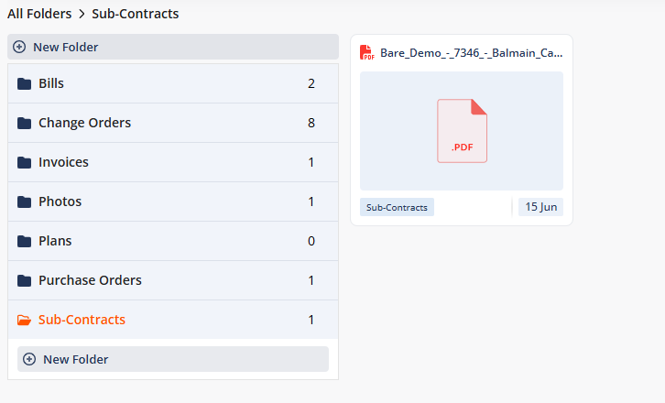

BUSINESS RULES / LOGIC
- Files and Photos is a project-scoped quick-access view of images and documents already stored under the Drawings and Photos folders in Document Management (Module 05); uploading a file here files it into the corresponding Document Management folder rather than creating a separate store.
- Purchase Orders, referenced here and in Reporting (Module 09) as a cost-commitment source alongside signed subcontracts, are not yet scoped as their own object; fields, approval workflow, and their relationship to Subcontractor & Vendor Agreements are to be defined in a future revision.
PROCESS MAP: none — Files and Photos has no branching logic of its own; it is a read-only, project-scoped view onto Document Management (Rule 63). See Document Management's process map above for the underlying file/version decision logic.
- Photos are captured with geo-tag (site location) and timestamp metadata, and are cross-linked to the record they were taken for — a Daily Log entry, a Punch List item, or an RFI — so a photo taken from within one of those modules is discoverable from Files and Photos and vice versa, rather than existing as a standalone, unlinked upload.

Module 07: Contacts:

will contain the internal contact like employees, and external like clients representative. This is a project-scoped view of the same Directory records maintained in Company Settings, filtered to contacts tagged to the current project — not a separate contact list.
PROCESS MAP: none — Contacts (Module 07) has no branching logic of its own; it is a project-scoped view onto Directory. See Directory's process map above for the underlying decision logic.
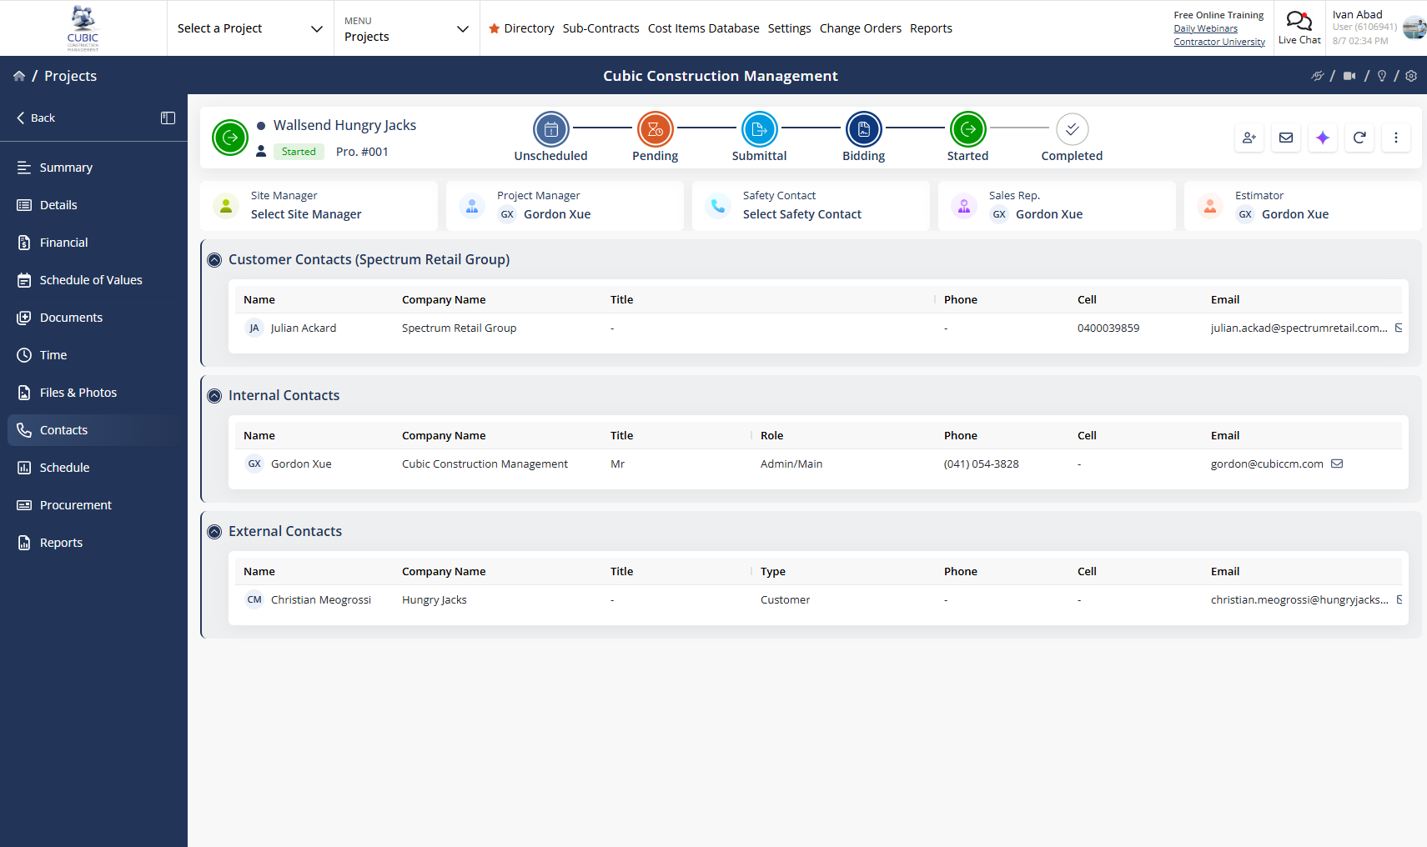

Module 08: Schedule:
this can be added by uploading a file types: MPP, MPX, XER, PP, XML, PPX
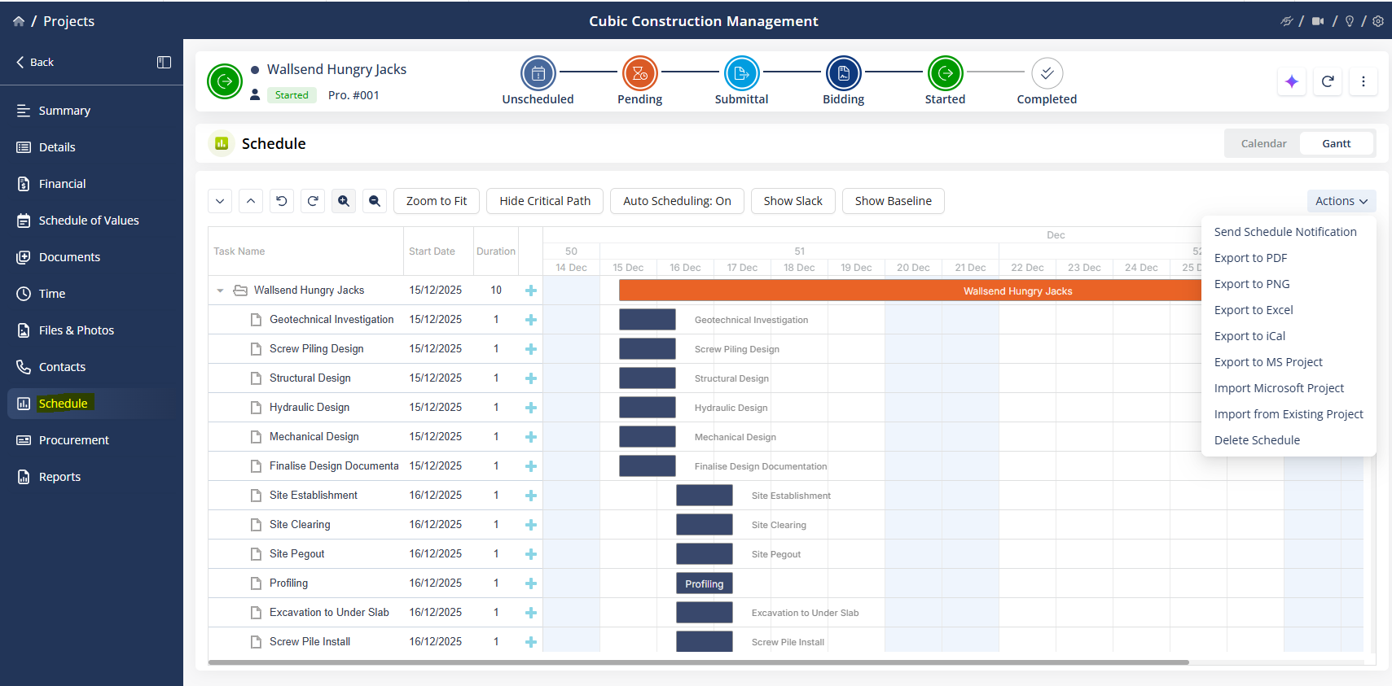

Or can be enter manually through the following instructions
SOURCE / INPUT: Construction Schedule (baseline + updates)
Schedule — Gantt View
[ Task ] [ Start ] [ End ] [ Duration ] [ % Complete ] [ Dependency ] [ Assigned Crew ]
Foundation Pour ----------->
Framing -------------->
MEP Rough-in ------------->
[ Critical path highlighted in a distinct color ]
[ Toggle: Baseline vs. Current schedule overlay ]
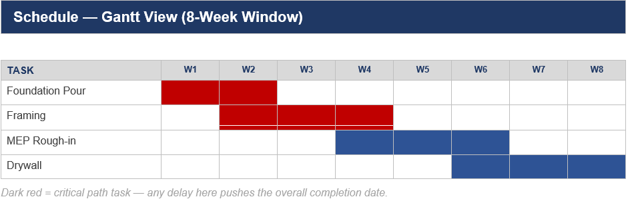
Wireframe shown is a structural mockup with sample data for illustration
BUSINESS RULES / LOGIC
- A task cannot start until all its listed dependencies reach 100% complete, unless manually overridden (with a logged reason).
- Critical path recalculates automatically whenever any task's duration or dependency changes.
- If a task's actual finish date exceeds its baseline finish date, the task is flagged and rolled up into the Dashboard's schedule variance calculation.
- Schedule updates by field crews (via mobile) require PM approval before they affect the official schedule of record. A Task may also serve as the linked resolution for a Cost/Schedule-Impact RFI (see RFIs, Rule 52); linking a Task to an RFI surfaces the RFI number on the task card for traceability.
PROCESS MAP
Step / State | Decision Point | Outcome
Task ready to start | All listed dependencies at 100% complete? | Yes → task can start · No → blocked, unless manually overridden with a logged reason
Task duration/dependency changes | — | Critical path recalculates automatically
Task finishes | Actual finish date exceeds baseline finish date? | Yes → flagged, rolls into Dashboard schedule variance · No → no flag
Field crew updates schedule via mobile | PM approves? | Yes → becomes the official schedule of record · No → update does not take effect
Task linked as resolution for a Cost/Schedule-Impact RFI | — | RFI number surfaces on the task card for traceability

Module 09: Report:
will contain the cost code, description, budgeted, committed (billed), revised budget (original + variation -/+), pending variations, Estimate at Completion (EAC), estimate cost at completion.

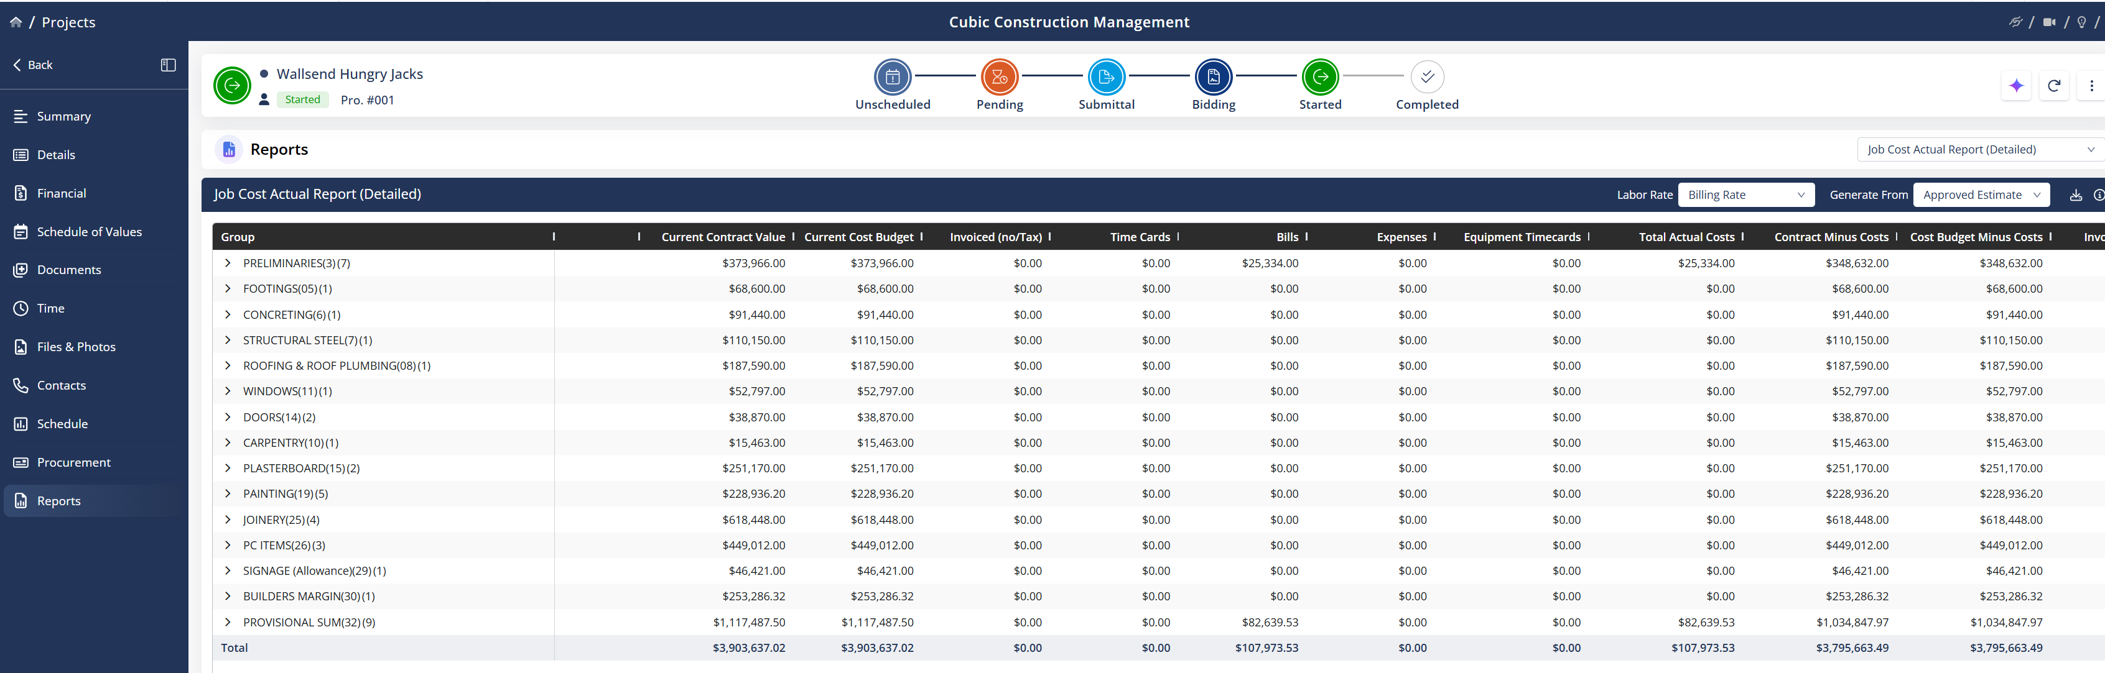

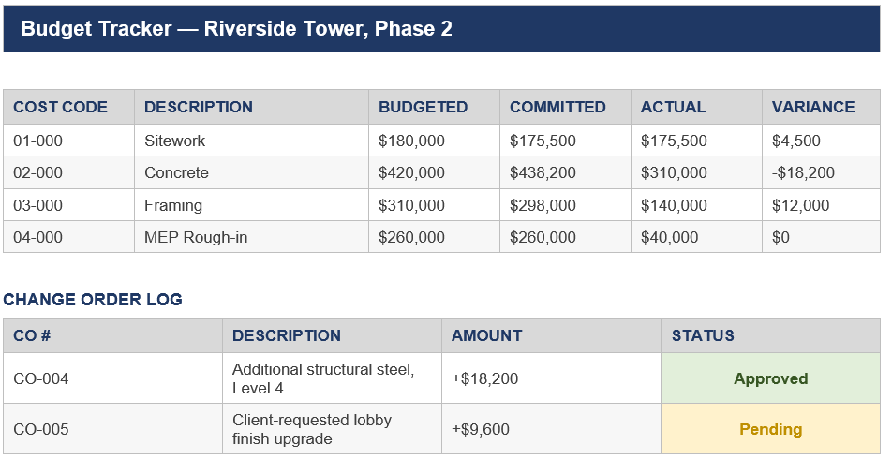
The values will change according to the selected project.

BUSINESS RULES / LOGIC
- Budgeted = original approved budget per cost code; Committed = value of signed subcontracts/POs against that code; Actual = paid invoices to date.
- Variance = Budgeted − Committed. Flag red if Variance goes negative (over budget on that code).
- Approved Variations (Change Orders) automatically adjust the Budgeted total for the affected cost code(s) and are logged with date, reason, and approver. revised budget (original + variation -/+).
- Pending Variations = Variations (Change Orders) outstanding for approval.
- Estimate at Completion (EAC) =AC+ETC, AC is the actual cost spent to date, and ETC is the estimated cost to complete the remaining work.
- Estimate to Complete: At Current Performance: Used if you expect your current cost trends to continue until the end.
Formula: ETC= ((BAC-EV)/CPI); CPI is your Cost Performance Index.
PROCESS MAP
Step / State | Decision Point | Outcome
Variance recalculated (Budgeted − Committed) | Goes negative? | Yes → flagged red (over budget on that code) · No → no flag
Variation approved elsewhere (Module 04) | — | Budgeted total for the affected cost code(s) auto-adjusts here, logged with date/reason/approver
Variation raised, not yet approved | — | Shows as Pending Variations, no effect on Budgeted total yet

- Only PM and Finance roles can approve a Variation (Change Order) that changes contract value.

Module 10: Meeting Minutes:
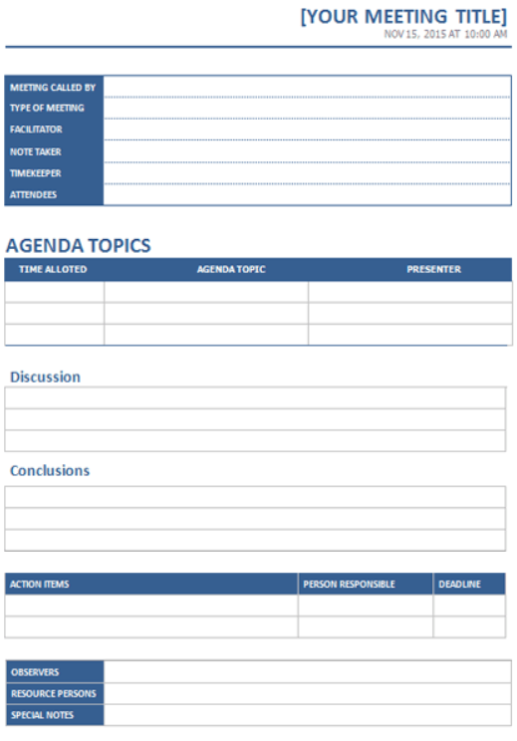
will contain site meeting records (progress meetings, pre-start meetings, minuted toolbox talks) with attendees, discussion notes, and action items.
SOURCE / INPUT: Site meeting records — progress meetings, pre-start meetings, minuted toolbox talks
Meeting Called By | [ Name ]
Type of Meeting | Progress / Pre-Start / Toolbox Talk / Other
Facilitator | [ Name ]
Note Taker | [ Name ]
Timekeeper | [ Name ]
Attendees | [ Name, Name, Name… ]
AGENDA TOPICS
Time Allotted | Agenda Topic | Presenter
[ e.g. 10 min ] | [ topic ] | [ Name ]
[ e.g. 10 min ] | [ topic ] | [ Name ]

Discussion
[ free text by agenda item ]
Conclusions
[ free text ]
Action Item | Person Responsible | Deadline
[ description ] | [ Name ] | [ dd/mm/yyyy ]

Action Item Status | Open / In Progress / Closed
Linked RFI / Punch List Item | [ RFI-### or Punch #### — optional ]

Observers | [ Name, Name… ]
Resource Persons | [ Name, Name… ]
Special Notes | [ free text ]

Wireframe shown is a structural mockup with sample data for illustration
BUSINESS RULES / LOGIC
- Each action item has an owner (an assigned Directory contact) and a Due Date; action items follow the SLA & Escalation Policy the same as other tracked items, using the action item's Due Date as its SLA.
- An action item can be promoted directly into a new RFI or Punch List item, carrying the meeting reference back for traceability (the created RFI/Punch item shows “Raised from Meeting Minutes, [date]”).
- Only the PM/Superintendent who owns the meeting, or Admin, can mark an action item Closed; other attendees can update status to In Progress.
- Meeting Minutes are visible to all roles with access to the project (per Dashboard visibility rules) but only editable by the meeting owner (PM/Superintendent) or Admin, consistent with the closed-system model in Integrations.
PROCESS MAP
Step / State | Decision Point | Outcome
Action item logged (Open) | Owner needs an RFI or Punch List item to resolve it? | Yes → promoted into a new RFI/Punch item, carrying the meeting reference back · No → stays a standalone action item
Action item in progress | Attendee updates status? | Attendee → can set In Progress · Meeting owner (PM/Superintendent) or Admin → can also set Closed
Action item Due Date passes unresolved | — | SLA & Escalation Policy triggers, using the action item's Due Date as its SLA
Closed | — | Terminal

Module 11: Safety & Incident Management:
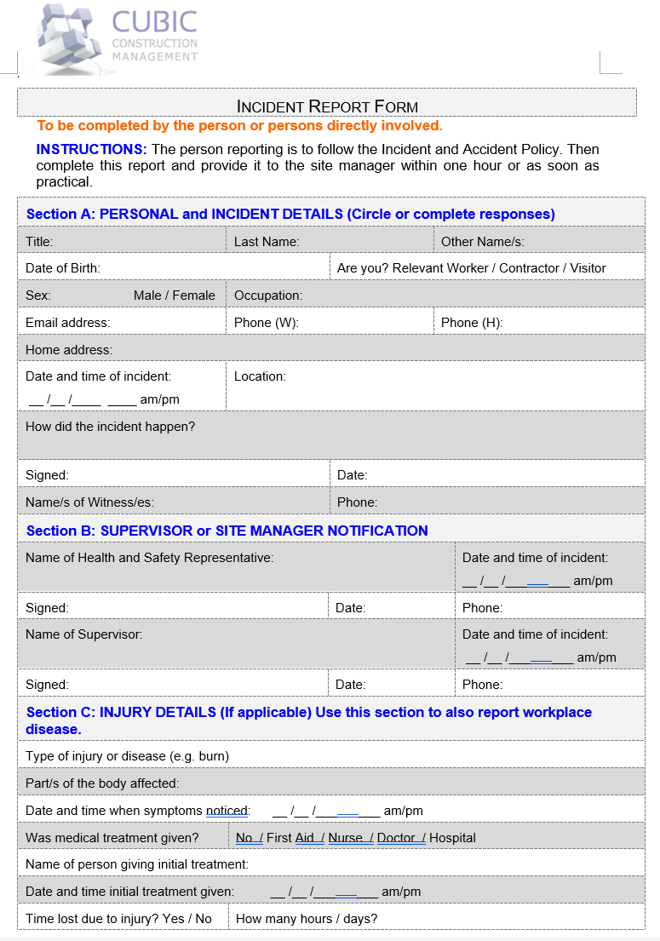
will contain toolbox talks, incident/near-miss reports, and safety inspections — this is where "Incidents" (referenced in passing under Document Management, Module 05) lives.
SOURCE / INPUT: Toolbox talk records, incident/near-miss reports, safety inspection checklists

Reporter — Title / Last Name / Other Names | [ … ] / [ … ] / [ … ]
Reporter — Type | Relevant Worker / Contractor / Visitor
Reporter — Date of Birth / Sex / Occupation | [ dd/mm/yyyy ] / M / F / [ … ]
Reporter — Email / Phone (W) / Phone (H) | [ … ] / [ … ] / [ … ]
Reporter — Home Address | [ … ]

Date / Time of Incident | [ dd/mm/yyyy ] / [ hh:mm ] am/pm
Location | [ … ]
How did the incident happen? | [ narrative ]
Witness Name(s) / Phone | [ … ] / [ … ]
Notification Sign-off (both required)
Health & Safety Representative — Name | [ … ]
Health & Safety Representative — Date/Time Notified / Signed / Phone | [ dd/mm/yyyy hh:mm ] / [ signed ] / [ … ]
Supervisor — Name | [ … ]
Supervisor — Date/Time Notified / Signed / Phone | [ dd/mm/yyyy hh:mm ] / [ signed ] / [ … ]
Injury Details (if applicable — also covers workplace disease)
Type of Injury/Disease | [ e.g. burn ]
Part(s) of Body Affected | [ … ]
Date/Time Symptoms Noticed | [ dd/mm/yyyy hh:mm ]
Medical Treatment Given | No / First Aid / Nurse / Doctor / Hospital
Person Giving Initial Treatment | [ … ]
Date/Time Treatment Given | [ dd/mm/yyyy hh:mm ]
Time Lost Due to Injury? | Yes / No
Hours / Days Lost | [ … ]
Other Record Types (Toolbox Talk / Near-Miss / Inspection)
Record Type | Toolbox Talk / Incident / Near-Miss / Inspection
Date / Time / Location | [ dd/mm/yyyy ] / [ hh:mm ] / [ site area ]
Reported By | [ Name ]
Toolbox Talk — Topic / Attendees / Acknowledgement | [ Topic ] / [ Names ] / Signed
Immediate Action Taken | [ free text ]
Inspection — Checklist Type / Findings | Safety / Quality / Pre-Closeout — [ findings ]
Corrective Actions / Due Date / Status | [ … ] / [ dd/mm/yyyy ] / Open
Notifiable Incident Flag | Yes / No

Wireframe shown is a structural mockup with sample data for illustration

BUSINESS RULES / LOGIC
- An incident marked as a Notifiable Incident (per NSW WHS Act/Regulation notifiable-incident criteria — e.g. death, serious injury or illness, or a dangerous incident) auto-escalates to Admin immediately, bypassing the standard 3/7-business-day SLA & Escalation Policy timeline, and is flagged for statutory notification. This document tracks only the internal flag, not the SafeWork NSW lodgement itself — confirm the exact criteria and lodgement workflow with your WHS/compliance advisor during technical scoping.
- Corrective actions from an Incident or Inspection follow the SLA & Escalation Policy against a PM-set Due Date, the same as a Punch List item.
- Toolbox Talk attendance is captured per attendee (from Directory) with a signed acknowledgement; a Field/Crew user cannot be marked present without their own confirmation.
- Only PM/Superintendent, Site Manager, or Admin can create an Incident/Near-Miss report or close out an Inspection's corrective actions; any role can raise a Near-Miss for their own observation.
- Incident and Inspection photos follow the same geo-tag/timestamp and cross-linking behaviour as Files and Photos (Module 06).
- Every Incident/Near-Miss report requires independent notification and sign-off from both the Health & Safety Representative and the Supervisor, each with their own timestamp and signature; the report is not complete until both are captured, matching the two-tier sign-off on the Cubic Incident Report Form.
PROCESS MAP
Step / State | Decision Point | Outcome
Incident/Near-Miss reported | — | Health & Safety Representative AND Supervisor each independently notified, sign, and timestamp
Both sign-offs captured | Meets Notifiable Incident criteria (NSW WHS Act/Regulation)? | Yes → auto-escalates to Admin immediately, bypasses standard SLA timeline, flagged for statutory notification · No → follows standard SLA & Escalation Policy
Injury involved | Time lost due to injury? | Yes → hours/days lost recorded · No → no lost-time record needed
Corrective action assigned (Incident or Inspection) | PM-set Due Date reached without closeout? | Yes → SLA & Escalation Policy triggers · No → remains on track
Project marked Substantially Complete (Project Setup, Rule 17) | Any Safety-category punch item still Open? | Yes → blocked · No → not blocked by Safety

