Student Name : Tsz Fung Kung
Student Number : 48996066
INFS 7903 – Assignment 2
Semester 2, 2025

Task 1
1.1
SELECT f.title FROM film f
JOIN film_category fc ON f.film_id = fc.film_id
JOIN category c ON fc.category_id = c.category_id
JOIN language l ON f.language_id = l.language_id
WHERE f.length < 50
AND l.name = 'English'
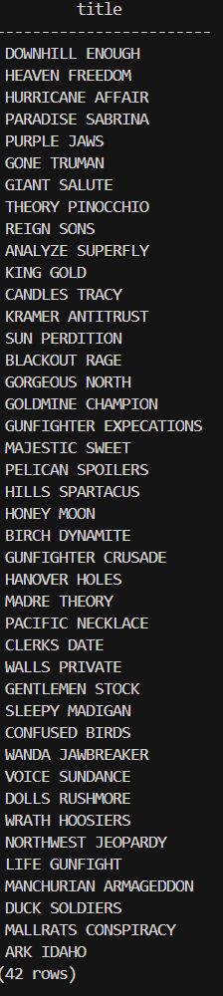
AND c.name = 'Comedy';

1.2
SELECT distinct a.actor_id, a.first_name, a.last_name
FROM actor a
JOIN film_actor fa ON a.actor_id = fa.actor_id
JOIN film f ON fa.film_id = f.film_id
JOIN film_category fc ON f.film_id = fc.film_id
JOIN category c ON fc.category_id = c.category_id
JOIN language l ON f.language_id = l.language_id
WHERE f.length < 50
AND l.name = 'English'
AND c.name = 'Comedy';
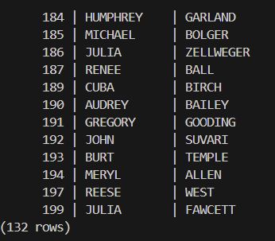

1.3
CREATE VIEW V_HR_MU_2010_ACTORS AS
SELECT distinct a.actor_id, a.first_name, a.last_name
FROM actor a
JOIN film_actor fa ON a.actor_id = fa.actor_id
JOIN film f ON fa.film_id = f.film_id
JOIN film_category fc ON f.film_id = fc.film_id
JOIN category c ON fc.category_id = c.category_id
WHERE f.rental_rate > 4
AND f.release_year = 2010
AND c.name = 'Music';
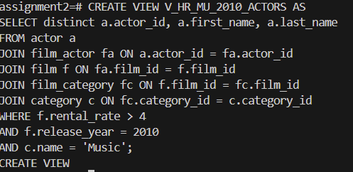

1.4
CREATE MATERIALIZED VIEW MV_HR_MU_2010_ACTORS AS
SELECT distinct a.actor_id, a.first_name, a.last_name
FROM actor a
JOIN film_actor fa ON a.actor_id = fa.actor_id
JOIN film f ON fa.film_id = f.film_id
JOIN film_category fc ON f.film_id = fc.film_id
JOIN category c ON fc.category_id = c.category_id
WHERE f.rental_rate > 4
AND f.release_year = 2010
AND c.name = 'Music';
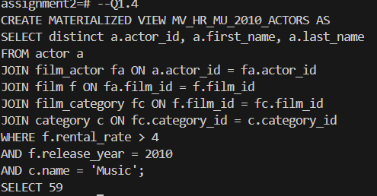

1.5
EXPLAIN ANALYZE
SELECT * FROM V_HR_MU_2010_ACTORS;
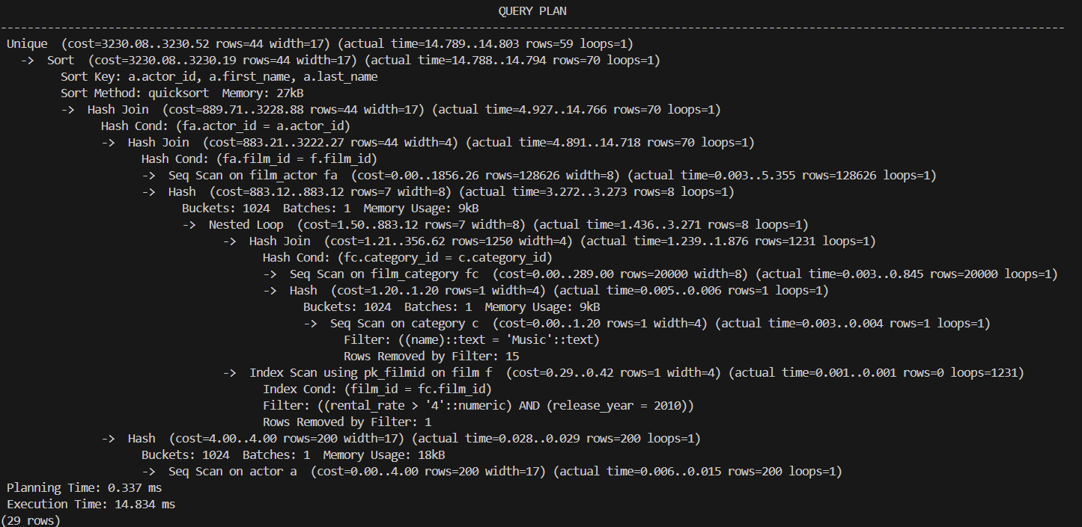
EXPLAIN ANALYZE
SELECT * FROM MV_HR_MU_2010_ACTORS;
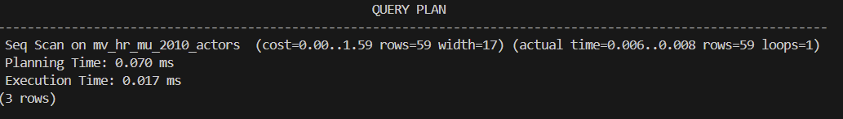
Explanation:
The materialized view improves the query efficiency by lowering the computing time and shortening the query plan.
In my runs, SELECT * FROM MV_HR_MU_2010_ACTORS had a lower computing time (~14ms vs 0.017ms) and shorter query plan (see above result)than the SELECT * FROM V_HR_MU_2010_ACTORS; , as the Virtual view query modification and recomputes the joins/aggregation over base table(whole database) while Materialized view query from a precomputed table. However, the trade-off of MV is the storage of MV table and maintenance cost when the base tables changed.

Task 2
2.1
SELECT title
FROM film
WHERE POSITION('Boat' IN description) > 0
ORDER BY title
LIMIT 10;
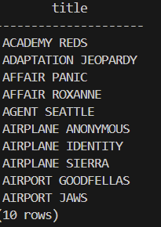
EXPLAIN ANALYZE
SELECT title
FROM film
WHERE POSITION('Boat' IN description) > 0
ORDER BY title
LIMIT 10;

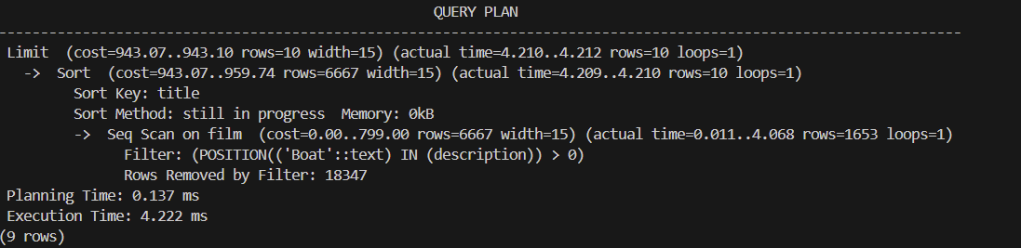

2.2
CREATE INDEX IDX_BOAT
ON film ((POSITION('Boat' IN description)));
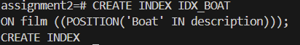

2.3
EXPLAIN ANALYZE
SELECT title
FROM film
WHERE POSITION('Boat' IN description) > 0
ORDER BY title
LIMIT 10;
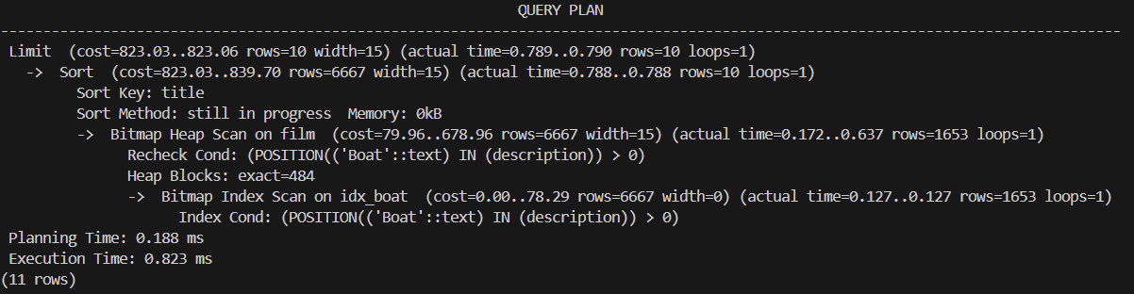

Explanation:
Yes, the idx_boat index improved query efficiency in task 2.
Before creating the idx_boat index, PostgreSQL plan was to perform a sequential scan across the entire film table, with a relatively high cost and execution time.
After creating the function-based index IDX_BOAT, the query planner used an Index Scan which can immediately locate matching rows, it can reduce both the estimated cost and actual execution time significantly.
Therefore, the pre-computed and ordered function in index did improve query efficiency. If we analyze deeper, the improvement arises because the DBMS can now leverage the indexed expression instead of evaluating the POSITION function for every row.

Task 3
3.1
(A) SQL using a GROUP BY clause:
SELECT SUM(cluster_size) AS film_count
FROM (
SELECT COUNT(*)AS cluster_size
FROM film
GROUP BY release_year, rating, special_features
HAVING COUNT(*) >=41
) temp;
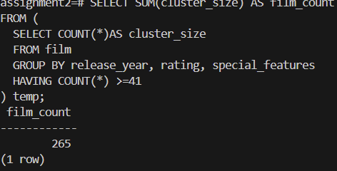

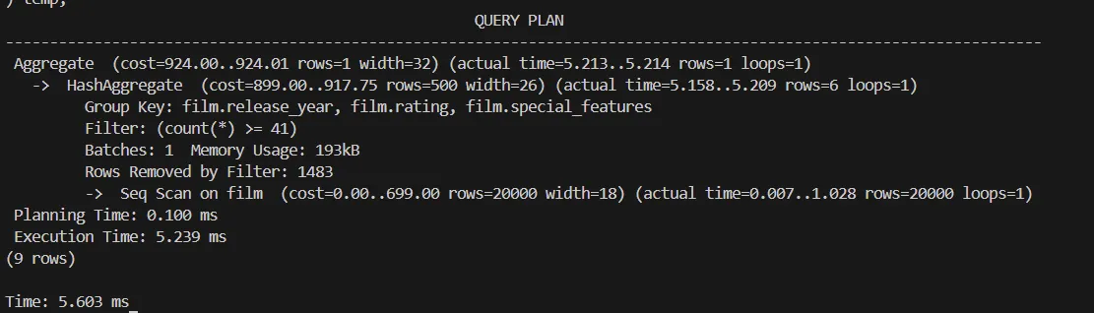

(B) SQL without using a GROUP BY clause:
SELECT COUNT (*) AS film_count
FROM film f
WHERE (
SELECT COUNT(*)
FROM film f2
WHERE f2.release_year = f.release_year
AND f2.rating = f.rating
AND f2.special_features = f.special_features
) >=41;
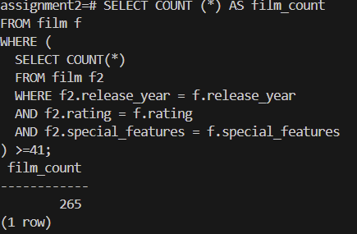
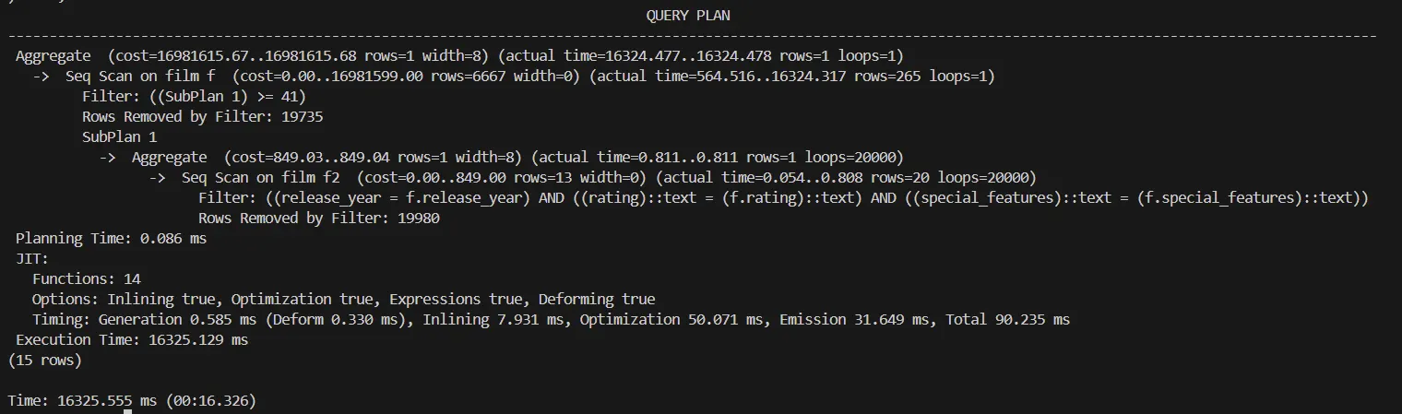

3.2
CREATE INDEX IDX_YEAR ON film (release_year);
CREATE INDEX IDX_RATE ON film (rating);
CREATE INDEX IDX_FEATURE ON film (special_features);

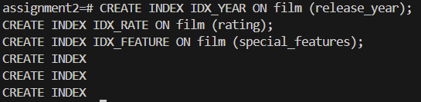

3.3
EXPLAIN ANALYZE
SELECT COUNT (*) AS film_count
FROM film f
WHERE (
SELECT COUNT(*)
FROM film f2
WHERE f2.release_year = f.release_year
AND f2.rating = f.rating
AND f2.special_features = f.special_features
) >=41;
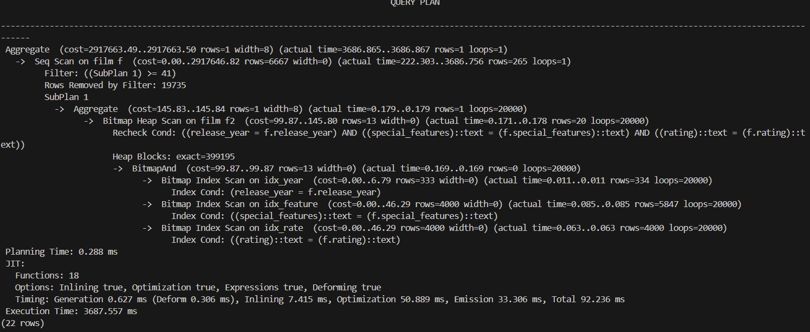

EXPLAIN ANALYZE
SELECT SUM(cluster_size) AS film_count
FROM (
SELECT COUNT(*)AS cluster_size
FROM film
GROUP BY release_year, rating, special_features
HAVING COUNT(*) >=41
) AS temp;
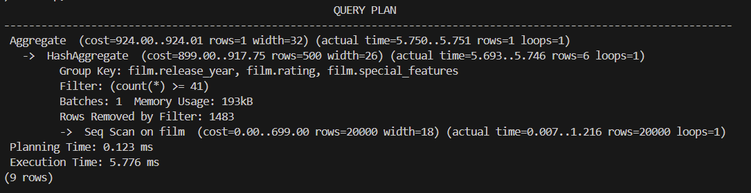

Explanation:
Before indexing, the “without group by” version is extremely slow (~16s) as the Postgres need to repeatedly scan the entire table, sort/group rows, and aggregate. While the “group by” version using a correlated subquery or window function to avoid full scanning, so it’s faster (~6 ms).
After indexing, the “without group by” version drops from ~16s to ~3s as the indexes on release_year, rating, special_features let Postgres quickly find matching groups. While the “group by” remains unchanged as it already using correlated subquery and the indexing do not have effect on it.
After comparing the time before and after indexing, the query with GROUP BY is still the most efficient way in this case compared to without GROUP BY query, as the query groups keys to aggregate efficiently before scanning. Postgres can avoid large sorts and minimize random I/O. Although the indexing helps the without GROUP BY query by locating the places of the elements, the Postgres still need to perform many repeated indexed probes and remain slower.
In my runs, the GROUP BY without indexes was slightly faster than the GROUP BY with indexes (5.6 ms vs 5.7 ms). Based on the result, I think the combination of GROUP BY + without indexes is the most efficient.

Task 4
4.1.1
(a) for film id <100
EXPLAIN ANALYZE
SELECT * FROM film WHERE film_id < 100;
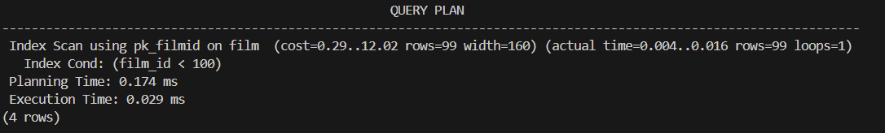

(b) for film id >=100
EXPLAIN ANALYZE
SELECT * FROM film WHERE film_id >= 100;
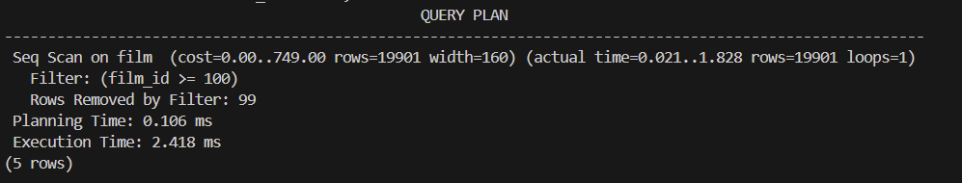

4.1.2
with sequential scans disable:
SET enable_seqscan = off;
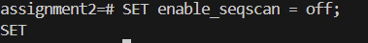
(a) for film_id <100
EXPLAIN ANALYZE
SELECT * FROM film WHERE film_id < 100;
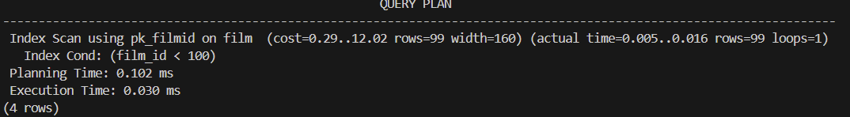
(b) for film_id >= 100
EXPLAIN ANALYZE
SELECT * FROM film WHERE film_id >= 100;
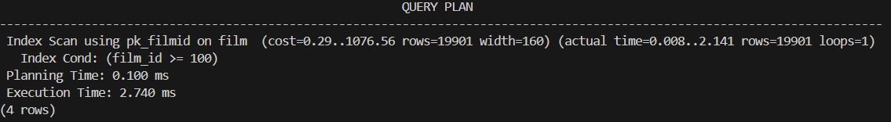

4.1.3
with sequential scans enabled and index scans disabled
SET enable_seqscan = on;
SET enable_indexscan = off;
SET enable_bitmapscan = off;
SET enable_indexonlyscan = off;
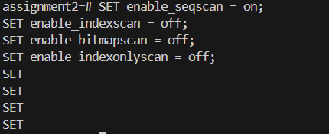
(a) for film_id <100
EXPLAIN ANALYZE
SELECT * FROM film WHERE film_id < 100;
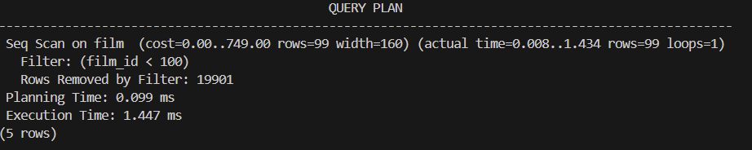

(a) for film_id >=100
EXPLAIN ANALYZE
SELECT * FROM film WHERE film_id >= 100;
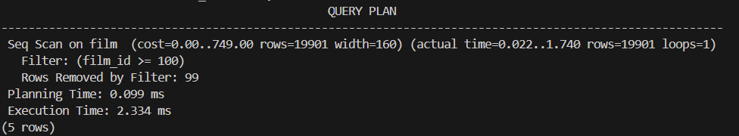

4.2
Summary of results:
Query (event_id <100) :
Default : index scan, 0.029ms
Sequential scan disabled (force index scan) : index scan, 0.030ms
Index scan disabled (force sequences scan) : seq scan, 1.447ms (slower)
Query (event_id >= 100)
Default : index scan, 2.418ms
Sequential scan disabled (force index scan) : index scan, 2.740ms (slower)
Index scan disabled (force sequences scan) : seq scan, 2.334ms (slower)

Explanation:
Event_id <100 is highly selective as the searching target is only 99, using index scan can reads only the handful of matching index entries and the few corresponding heap pages. When we force a sequences scan, the run times become much slower (0.029ms to 1.447ms) because it must read the entire table, which is more pages than necessary.
Event_id >= 100 is low selective as the searching target is the whole table minus the first 99 id, a sequential scan becomes more effective because a single linear pass is cheaper than doing thousands of random index probes plus heap fetches. Forcing index scan makes it slightly slower as the query plan shows that it did not remove the first 99 rows for scanning.
The planner’s decision reflects both selectivity (fraction of rows fetched) and I/O pattern. Index Scans minimize random I/O for highly selective predicates, while Sequential Scans exploit spatial locality and caching when most pages will be read anyway. The execution plans and times match this model: the Index Scan is optimal for the tiny result of event_id < 100, whereas the Sequential Scan is optimal for the broad range event_id ≥ 100.

