Second Advance: Interactive Design

Tito Team

“Qronociendo”

March 25 2015

Carla Serrano Pesquera A01206336

Iván Alejandro Soto Velázquez A00225851

Lilian Andrea Rosales Ramírez A01204565

1. **Analysis of the user tasks which will be covered by interactive system**

* **Form through which we got user information:** Online Surveys and personal statements videos; that helped us to determine the characteristics of the personality of our targeted user group and the features that our application should content, in order to satisfy our users needs. This also helped us to visualized the type of content, forms of interaction and type of design we will use.

Before applying the survey; we gave some feedback of the functionality and purpose of the interface, so they could had a better understanding of the task and activities, they will be performing through the interactive system.

* **Proofs:**

**Survey results**

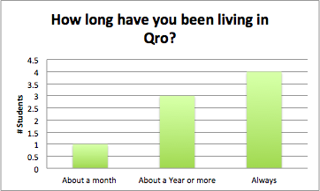

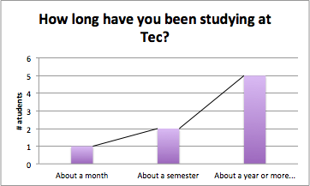

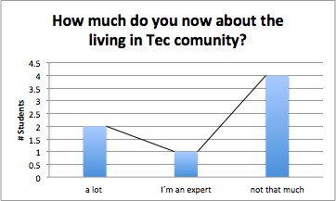

|  |
| --- |
|  |
|  |
|  |
|  |

**II. Prototype design**

This web site is the earliest version of the prototype we have so far, it shows the basic interactions that our system would have with the user, showing an example of an interaction scenario.

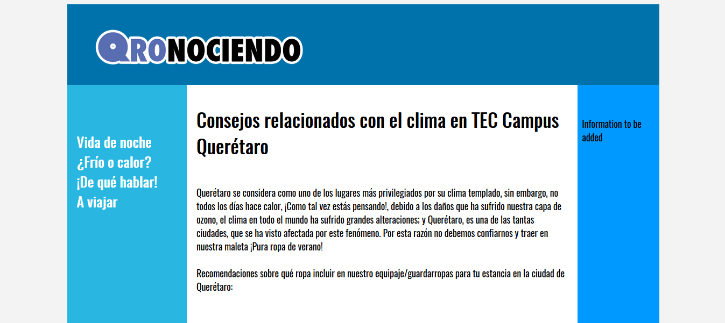

* **Information design**: the navigation system consists of a star organizational structure of the content, in which a website serves as a center and others depends on it. The type of information content is basic knowledge about Querétaro city and the living in Tec community. To get through the different information menus, the user does not have to follow a sequence, it can surf around the application in the order the user may wish.
* **Interaction design:** we selected a group of interactive components, that allow the user to communicate with the application; based on the user personal characteristics and preferences. Which consists in pop up menus organized in easy and common topics.
* **Visual design:** we consider some design principles as the proximity of the buttons that constitutes the different topics of the website, so the user can group them as a principal menu and becomes easier to separate the different areas of the web site on an easier way. We also apply the similarity principle, which consists in establishing the same appearance ; colour, shape and size, to the elements of each topic, so the user can perceive them as a part of the same object.

**III. Analysis of the implementation of the principles of interaction design in the designed system components.**

* How would you apply the following **golden rules** of interface design in Qronociendo:
  + **Strive to be consistent:** Qronociendo will be following this rule by keeping the same colours and typographies through the interface.  
    Also by keeping the same way to interact, which is by menus, articles, and everything as the user choose.
  + **Design of dialogues that lead to an end:** the website will keep this rule by leading the user through menu-> article-> home and viceversa.
  + **It is better to prevent errors:** Qronociendo will disable UI elements, the controls provided will be only as needed.
  + **Allow "undo"**: Qronociendo will always have a home botton above all articles, in case they don’t wanted that information, they can go back to index and start again.
  + **Give the control to the user:** the user will have control at every step, if the user doesn’t click at any menu nothing would happen, he chooses between the topics in order to watch only what’s interesting to him.
  + **Avoid to overload the user's memory:** the website will follow this by having a very simple interface, with no needs of instructions, just a side of menus and an intro to the site.

How you would apply the following **design principles** in your Qronociendo:

* + **Universal usability**: Qronociendo will have a very simple interface so there will be no need to separate the different types of users.
  + **Windows and menus**: menus will be essential in Qronociendo, as the user choose what he is interested in and navigates in the page with this.
  + **Icons and typography:** icons as the logo and Queretaro city pictures, will remain through the interface, as the main typography oswald stencil.
  + **Interaction devices:** will be mainly computer as it’s what is designed for, but could be used in mobile and tablets (not app).
  + **Organization and distribution:** The website will have a **star** organizational structure because you don’t need to follow any steps in order to get to what you are interested in and you can navigate to other websites from Qronociendo
  + **Widgets and controls:** Qronociendo will use widgets in order to give an easy access to the frequently used functions.
  + **Feedback and error handling:** Qronociendo will provide feedback to the user when they search for specific things. The site will not trough alert messages with red icons when an error is discovered.

**IV. Emotional aspect**

How would you apply the following **emotional aspects** in your project:

* + Positive emotions: some of Qronociendo sections will have emoticons and may be sounds, and the whole interface will be done very simple and with nice colours so the user have positive emotions while he’s in the site.
  + Frustration (how to avoid): The website will not have complex elements that could lead the user to not understand the interface.  
    We will not use threatening messages when an error is committed, we’ll provide feedback and steps to fix the error.  
    We will not use childish designs that could make the user feel stupid.
  + Persuasive technologies: Qronociendo will use the good way of persuasion by inciting the users to go out and know the city they are living in and increase movement in their lives.
  + Anthropomorphism: the site will not use this.
  + Virtual agents: the site will not use this.