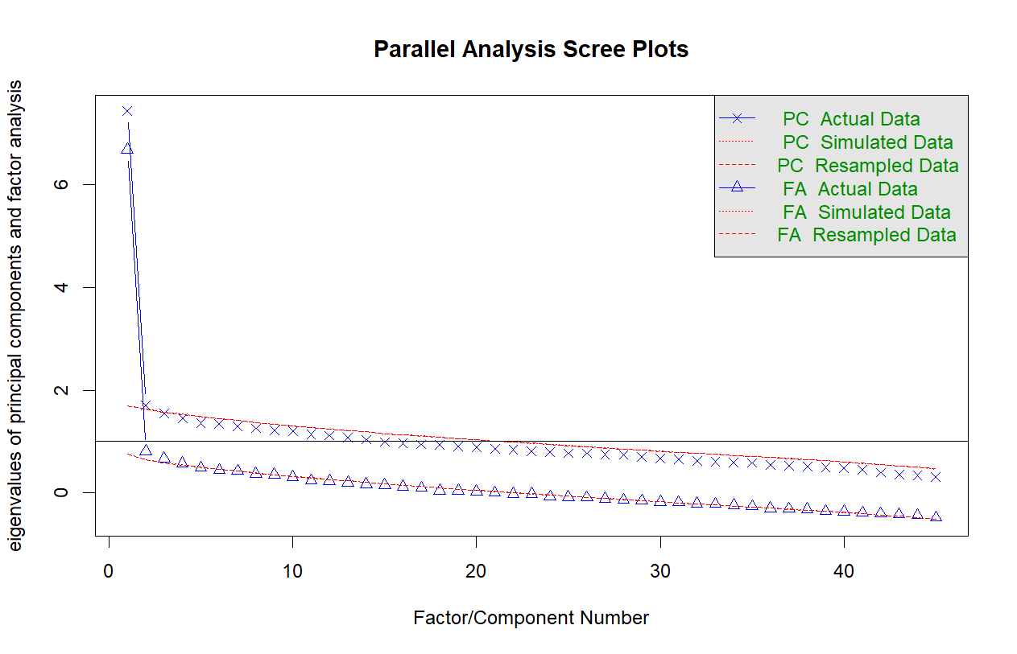

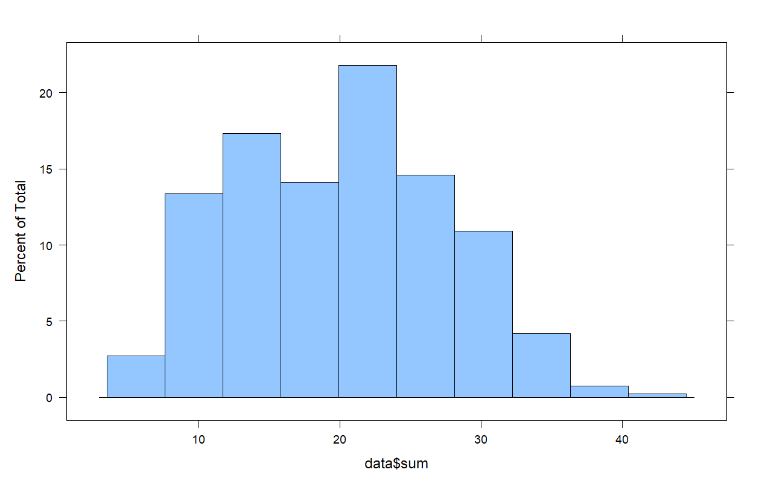

|  |  |  |  |  |  |  |  |
| --- | --- | --- | --- | --- | --- | --- | --- |
| Model | M2 | df | p | RMSEA | SRMSR | TLI | CFI |
| Initial Rasch | 2064.737 | 989 | 0.000 | 0.052 | 0.094 | 0.874 | 0.875 |
| Initial 2PL | 1186.973 | 945 | 0.000 | 0.025 | 0.047 | 0.970 | 0.972 |
| Post Rasch | 1122.893 | 594 | 0.000 | 0.047 | 0.089 | 0.929 | 0.930 |
| Post 2PL | 676.722 | 560 | 0.000 | 0.023 | 0.044 | 0.983 | 0.984 |