1. Підняти та налаштувати GitLab server

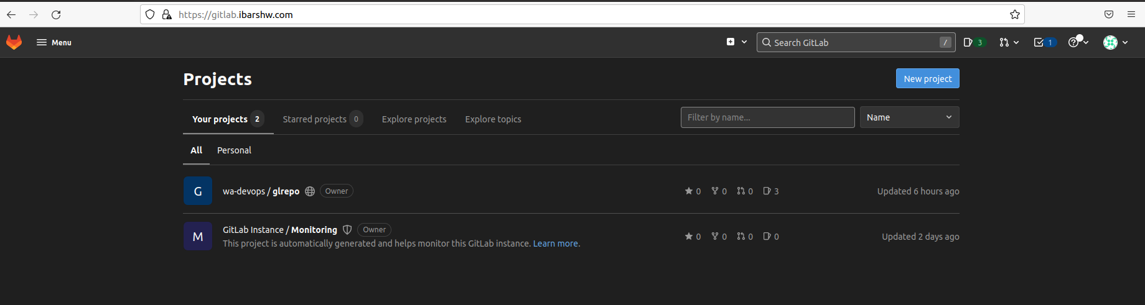

* 1. Створити групу та проект

* 1. Зробити декілька гілок

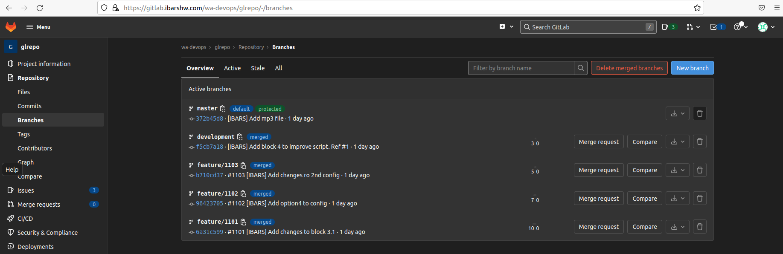

* 1. Створити задачі та залінкувати їх з комітами

* 1. Додати до репозиторія submodule

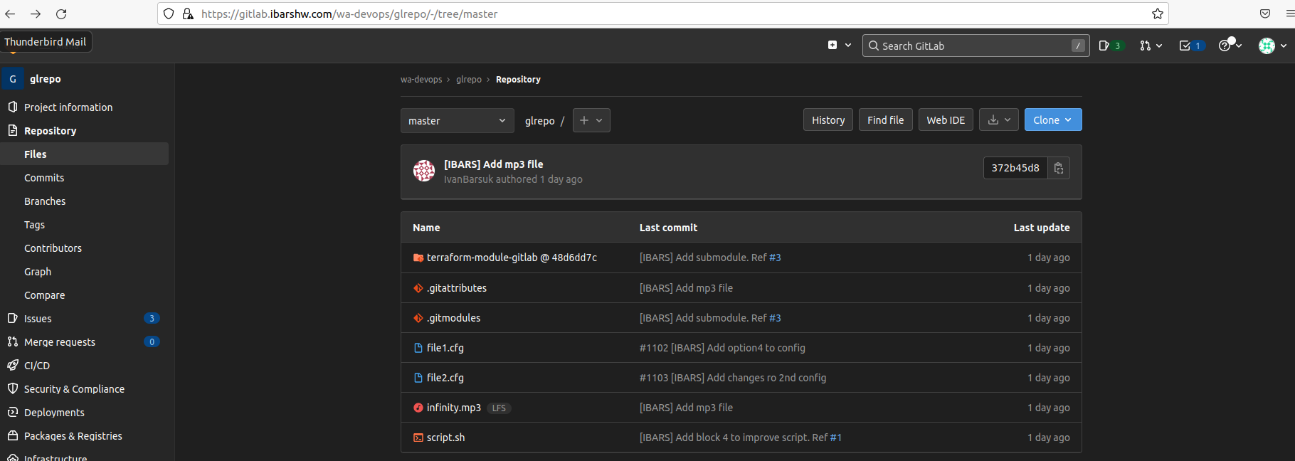

* 1. Зробити мерж реквест

0000000000000000000000000000000000000000 807543a28c7d63d2db66b4327e71bbcfd9b19ecc IvanBarsuk <ivanbarsuk@gmail.com> 1659599461 +0300 commit (initial): [IBARS] Initial state of the script

807543a28c7d63d2db66b4327e71bbcfd9b19ecc 807543a28c7d63d2db66b4327e71bbcfd9b19ecc IvanBarsuk <ivanbarsuk@gmail.com> 1659599854 +0300 checkout: moving from master to feature/1101

807543a28c7d63d2db66b4327e71bbcfd9b19ecc 671f207079965f2918aabd7f997d920a054d995a IvanBarsuk <ivanbarsuk@gmail.com> 1659600093 +0300 commit: #1101 [IBARS] Add block 3 to script

671f207079965f2918aabd7f997d920a054d995a 807543a28c7d63d2db66b4327e71bbcfd9b19ecc IvanBarsuk <ivanbarsuk@gmail.com> 1659600131 +0300 checkout: moving from feature/1101 to master

807543a28c7d63d2db66b4327e71bbcfd9b19ecc 671f207079965f2918aabd7f997d920a054d995a IvanBarsuk <ivanbarsuk@gmail.com> 1659600174 +0300 checkout: moving from master to feature/1101

671f207079965f2918aabd7f997d920a054d995a 807543a28c7d63d2db66b4327e71bbcfd9b19ecc IvanBarsuk <ivanbarsuk@gmail.com> 1659600362 +0300 checkout: moving from feature/1101 to master

807543a28c7d63d2db66b4327e71bbcfd9b19ecc 671f207079965f2918aabd7f997d920a054d995a IvanBarsuk <ivanbarsuk@gmail.com> 1659600398 +0300 checkout: moving from master to feature/1101

671f207079965f2918aabd7f997d920a054d995a 86c5b6b4859baf79ff5ab1967e657a8fbf5c5530 IvanBarsuk <ivanbarsuk@gmail.com> 1659600478 +0300 commit: #1101 [IBARS] Add changes to block 3

86c5b6b4859baf79ff5ab1967e657a8fbf5c5530 6a31c599bd49212e7eca817885ab19daa9895d5b IvanBarsuk <ivanbarsuk@gmail.com> 1659600729 +0300 commit: #1101 [IBARS] Add changes to block 3.1

6a31c599bd49212e7eca817885ab19daa9895d5b 6a31c599bd49212e7eca817885ab19daa9895d5b IvanBarsuk <ivanbarsuk@gmail.com> 1659600802 +0300 checkout: moving from feature/1101 to development

6a31c599bd49212e7eca817885ab19daa9895d5b 6a31c599bd49212e7eca817885ab19daa9895d5b IvanBarsuk <ivanbarsuk@gmail.com> 1659601170 +0300 checkout: moving from development to feature/1102

6a31c599bd49212e7eca817885ab19daa9895d5b 6a31c599bd49212e7eca817885ab19daa9895d5b IvanBarsuk <ivanbarsuk@gmail.com> 1659601506 +0300 checkout: moving from feature/1102 to development

6a31c599bd49212e7eca817885ab19daa9895d5b 807543a28c7d63d2db66b4327e71bbcfd9b19ecc IvanBarsuk <ivanbarsuk@gmail.com> 1659601573 +0300 checkout: moving from development to master

807543a28c7d63d2db66b4327e71bbcfd9b19ecc 6a31c599bd49212e7eca817885ab19daa9895d5b IvanBarsuk <ivanbarsuk@gmail.com> 1659601599 +0300 checkout: moving from master to feature/1102

6a31c599bd49212e7eca817885ab19daa9895d5b ae78226c89ce4a85395a359d49e447df594734e4 IvanBarsuk <ivanbarsuk@gmail.com> 1659601638 +0300 commit: #1102 [IBARS] Add config

ae78226c89ce4a85395a359d49e447df594734e4 807543a28c7d63d2db66b4327e71bbcfd9b19ecc IvanBarsuk <ivanbarsuk@gmail.com> 1659601651 +0300 checkout: moving from feature/1102 to master

807543a28c7d63d2db66b4327e71bbcfd9b19ecc ae78226c89ce4a85395a359d49e447df594734e4 IvanBarsuk <ivanbarsuk@gmail.com> 1659601666 +0300 checkout: moving from master to feature/1102

ae78226c89ce4a85395a359d49e447df594734e4 32339cb5170af1866cb71cfd9df7687a09292425 IvanBarsuk <ivanbarsuk@gmail.com> 1659601751 +0300 commit: #1102 [IBARS] Add option3 to config

32339cb5170af1866cb71cfd9df7687a09292425 96423705b71f4aed348cb0aadaa1080b1b80e865 IvanBarsuk <ivanbarsuk@gmail.com> 1659601792 +0300 commit: #1102 [IBARS] Add option4 to config

96423705b71f4aed348cb0aadaa1080b1b80e865 6a31c599bd49212e7eca817885ab19daa9895d5b IvanBarsuk <ivanbarsuk@gmail.com> 1659601821 +0300 checkout: moving from feature/1102 to development

6a31c599bd49212e7eca817885ab19daa9895d5b 96423705b71f4aed348cb0aadaa1080b1b80e865 IvanBarsuk <ivanbarsuk@gmail.com> 1659601840 +0300 merge feature/1102: Fast-forward

96423705b71f4aed348cb0aadaa1080b1b80e865 96423705b71f4aed348cb0aadaa1080b1b80e865 IvanBarsuk <ivanbarsuk@gmail.com> 1659601954 +0300 checkout: moving from development to feature/1103

96423705b71f4aed348cb0aadaa1080b1b80e865 2801a2bd1763fe436c292b842400d1c55de312d8 IvanBarsuk <ivanbarsuk@gmail.com> 1659602082 +0300 commit: #1103 [IBARS] Add 2nd config file

2801a2bd1763fe436c292b842400d1c55de312d8 b710cd3713c9f8c32feb38cd2749d314dca55e1f IvanBarsuk <ivanbarsuk@gmail.com> 1659602183 +0300 commit: #1103 [IBARS] Add changes ro 2nd config

b710cd3713c9f8c32feb38cd2749d314dca55e1f 96423705b71f4aed348cb0aadaa1080b1b80e865 IvanBarsuk <ivanbarsuk@gmail.com> 1659602603 +0300 checkout: moving from feature/1103 to development

96423705b71f4aed348cb0aadaa1080b1b80e865 b710cd3713c9f8c32feb38cd2749d314dca55e1f IvanBarsuk <ivanbarsuk@gmail.com> 1659602637 +0300 merge feature/1103: Fast-forward

b710cd3713c9f8c32feb38cd2749d314dca55e1f 807543a28c7d63d2db66b4327e71bbcfd9b19ecc IvanBarsuk <ivanbarsuk@gmail.com> 1659602698 +0300 checkout: moving from development to master

807543a28c7d63d2db66b4327e71bbcfd9b19ecc b710cd3713c9f8c32feb38cd2749d314dca55e1f IvanBarsuk <ivanbarsuk@gmail.com> 1659614263 +0300 checkout: moving from master to development

b710cd3713c9f8c32feb38cd2749d314dca55e1f 7808ddb1b1c92274478913875e7e3e80fdf8d3e3 IvanBarsuk <ivanbarsuk@gmail.com> 1659614407 +0300 commit: [IBARS] Add more description. Ref #2

7808ddb1b1c92274478913875e7e3e80fdf8d3e3 f5cb7a1893afe2467ab26ddf66aacefb55b8c1b1 IvanBarsuk <ivanbarsuk@gmail.com> 1659614803 +0300 commit: [IBARS] Add block 4 to improve script. Ref #1

f5cb7a1893afe2467ab26ddf66aacefb55b8c1b1 807543a28c7d63d2db66b4327e71bbcfd9b19ecc IvanBarsuk <ivanbarsuk@gmail.com> 1659615141 +0300 checkout: moving from development to master

807543a28c7d63d2db66b4327e71bbcfd9b19ecc f5cb7a1893afe2467ab26ddf66aacefb55b8c1b1 IvanBarsuk <ivanbarsuk@gmail.com> 1659615196 +0300 merge development: Fast-forward

f5cb7a1893afe2467ab26ddf66aacefb55b8c1b1 7c29e6c0c1510b2eb81ef4ba00a999c0da1f3724 IvanBarsuk <ivanbarsuk@gmail.com> 1659617761 +0300 commit: [IBARS] Add submodule. Ref #3

7c29e6c0c1510b2eb81ef4ba00a999c0da1f3724 309146bcf78e41a09233da141abf3d132ce4da34 IvanBarsuk <ivanbarsuk@gmail.com> 1659617776 +0300 commit: [IBARS] Add submodule. Ref #3

309146bcf78e41a09233da141abf3d132ce4da34 372b45d81e63ec6aae3d8ccca049229fe4336784 IvanBarsuk <ivanbarsuk@gmail.com> 1659621007 +0300 commit: [IBARS] Add mp3 file

1. Налаштувати GitLab GitLFS локально та перевірити його роботу

1. Підняти та налаштувати Minio

* 1. Налаштувати LFS GitLab на використання minio як бекенду
  2. Перевірити роботу

