
Cancellation Policy

On acceptance of a quotation issued by Simon Bradley Horticulture, or we receive authority to proceed, you have the right to cancel the contract within 14 days of your instruction. This is also referred to as a "cooling off period".

The 14 day period begins from the day after you have agreed to proceed with the outlined work whether you have accepted the work/quotation verbally, via email or in person.

You are not obliged to give a reason and the cancellation period will expire after this period has lapsed.

To exercise your right to cancel within this period we must receive a written instruction in the form of an email or letter on or before the 14 days from the day after acceptance to proceed.

If we receive a written instruction within this period we will reimburse you all payments received in relation to the contract and/or quotation. For example, a deposit or interim payment for materials.

We may make a deduction from any reimbursements for the loss of value to goods supplied or any handling charges incurred by a third party such as a delivery/courier/administration charge.

If you instruct us to proceed, and both parties agree to the work being carried out within the 14 day cancellation period, you waive the right of cancellation.

We will make the reimbursement without undue delay and within 14 days from the date we receive your written instruction to cancel the contract.

We will make the reimbursement to you using the same means of payment as you used for the initial order unless you express otherwise.

Kind Regards,
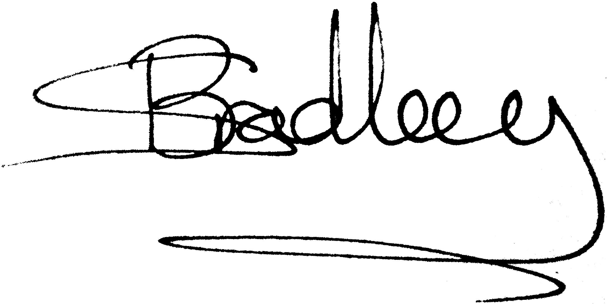
Simon Bradley

