
Client Feedback Form

Thank you for choosing Simon Bradley Horticulture to complete your garden care.

We aim to provide a client experience and service that is unrivalled. Therefore, to ensure we deliver, your feedback is always keenly received. This enables us to gain an understanding from our clients prospective and where we excelled or recommendations for improvement. Therefore we would appreciate a few minutes of your time to complete this form.
We use this information to make improvements where necessary and provide an insight to new, potential, clients to assist them in their decision making process.

We would request that you rate each category defined below from 1-5.

- Poor: slow, very expensive, won’t recommend to a friend.
- Below average: expensive, expected a better service, won’t recommend to a friend.
- Average: service as expected, reasonable cost, likely to recommend to a friend.
- Good: responsive, good level of service, competitively priced, would recommend to a friend.
- Excellent: very responsive, exceeded my expectations, excellent value for money, would definitely recommend to a friend.

How responsive was the service from your initial enquiry?
□ 1 □ 2 □ 3 □ 4 □ 5

How quickly was an initial appointment made to discuss your requirements?
□ 1 □ 2 □ 3 □ 4 □ 5

How quickly did you receive your quotation?
□ 1 □ 2 □ 3 □ 4 □ 5

How would you rate the accuracy of the agreed appointment times?
□ 1 □ 2 □ 3 □ 4 □ 5

How would you rate the quality of workmanship completed?
□ 1 □ 2 □ 3 □ 4 □ 5

How accurate was the completed work to that described in the quotation?
□ 1 □ 2 □ 3 □ 4 □ 5

Upon completion of the work how was your garden left?
□ 1 □ 2 □ 3 □ 4 □ 5


Would you consider using our services in the future?
□ 1 □ 2 □ 3 □ 4 □ 5

How did you get to hear about our services?
□ Internet search □ Recommendation □ Publication □ Branding

We would be grateful for any additional comments, recommendations or feedback you may have.

We may like to use your comments and feedback in our marketing literature. This is to give a transparent and honest perception to potential new clients of how our existing clients have found their experiences with using our services.

We will NEVER publish, advertise, disclose or share any personal details in my correspondences. Therefore, please indicate if you are happy for me to use your comments for marketing purposes.
□ Yes □ No

From time to time we are requested to provide details of existing clients to enable potential clients to gain a better understanding of our services. Please indicate if you are happy to be contacted and if so, what form of communication would you prefer.
□ Yes □ No
□ Telephone-Landline □ Telephone-Mobile □ Post □ Email

Thank you for taking the time to complete this form.

Kind Regards,
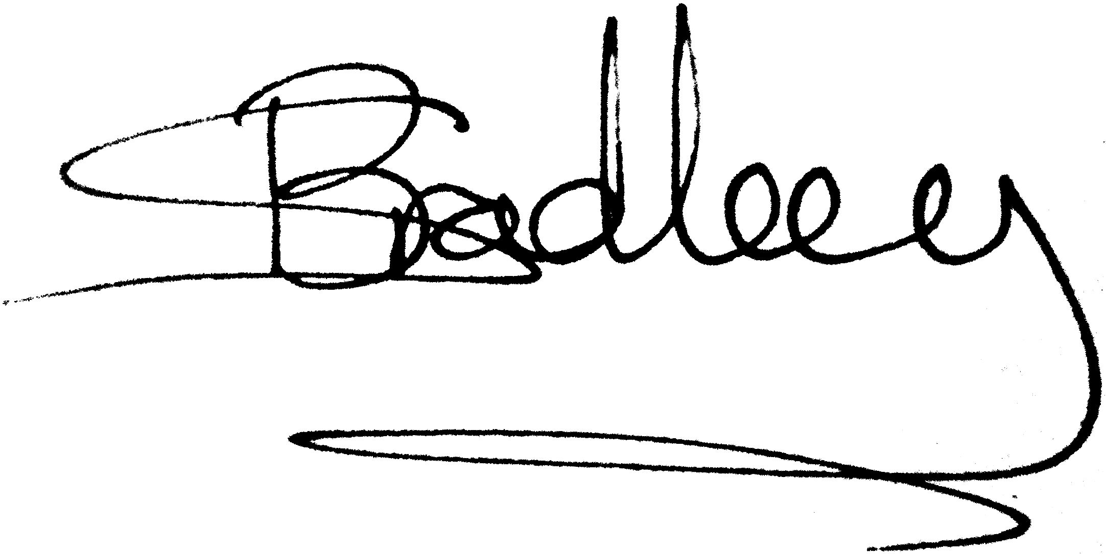
Simon Bradley

