
Health & Hygiene Policy XX/XX/2017

As of the 1st October 2017 we have implemented a health and hygiene charge. This is to cover the cost of labour, materials and time lost to clean and disinfect our equipment and personal protective clothing once soiled by pet waste.

We take the health and safety of both clients and our staff very seriously and have a duty of care to those who use our services. Our equipment is used across multiply sites and in many various environments. Therefore, it’s necessary to introduce this charge to safeguard other clients, including children, from across site contamination.

This charge will be added and shown on your invoice as a "Heath & Hygiene Charge" and by continuing to use our services you accept responsibility of these terms.

Health & Hygiene charge | Total: £20.00

We therefore encourage you to take all necessary steps to avoid incurring this charge and appreciate your understanding on this matter.

Kind Regards,
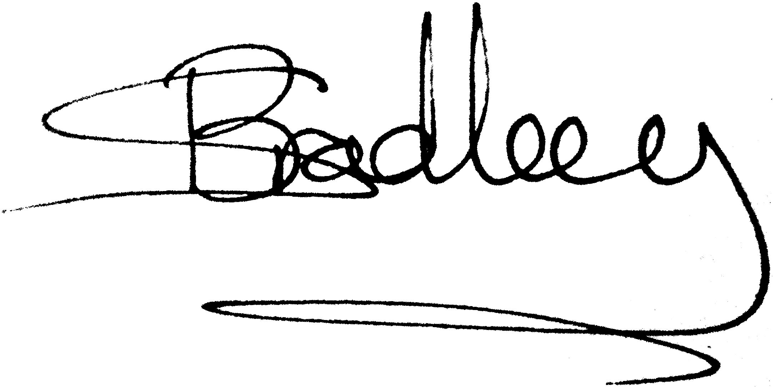
Simon Bradley

