
Plant Rejuvenation & Plan Pruning XX/XX/2017

The vast majority of plants require periodic pruning. This is best completed at least annually or more regularly depending on the plant, shrub or tree. This is to ensure they don’t outgrow their surroundings, reduces competition between neighbouring plants and encourages and stimulates new growth.

What if I don’t prune my plants?
If this work isn’t carried out, over time plants may become unproductive, “woody” or “leggy”. They will use their energy to compete for light, space, water and nutrients and therefore won’t have the capacity to flower or perform for the purpose they were intended.

Why do my plants need this attention?
Plants are living organisms like us! They require certain basic elements to survive and be healthy. These consist of light, space, water, nutrients (food) and air. By removing one or more of these elements you are putting the plant under unnecessary stress and reducing the overall health of the plant.

What is plant rejuvenation pruning?
Rejuvenation pruning is a method of pruning applied to trees and shrubs when either incorrect or irregular pruning has been applied over a sustained period of time. This method of pruning may initially appear drastic, extreme or unsightly. However, with the correct pruning methods applied, plants will respond positively to this work and often result in the equivalent to replacing old plants with new!

Can all plants be rejuvenated?
No. Care must be taken to ensure the correct pruning methods are applied to the right plants. Not all shrubs or trees will respond well to this method and can result in the plant dying. There will also be occasions when the plant is simply beyond the point of rejuvenation and replacement is the only realistic option.

My plant looks worse than before!
Most likely! This method of pruning is extreme and time consuming so therefore the difference from the start to the end of the job will also vary hugely. This may not always result in instant positive results! However, over a short period of time, the plant will show signs of benefiting from the additional light, space and air created with the addition of new growth.

Kind Regards,
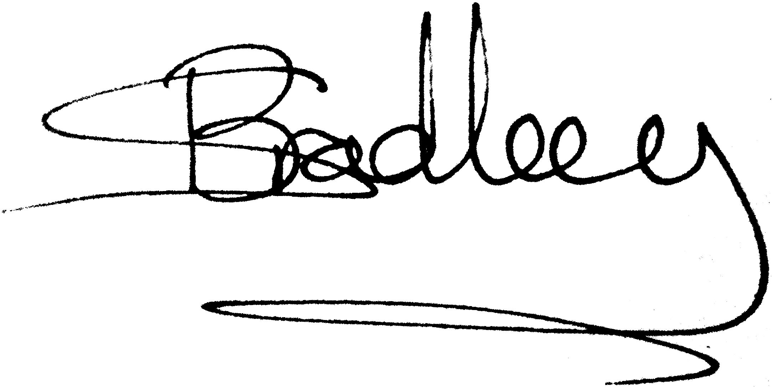
Simon Bradley



