
Useful Information & Terms

Thank you for considering S.B Horticulture to undertake your garden care. We are committed to ensuring you experience the best possible service. To assist you in your decision-making we have compiled some regularly asked questions with answers and additional information you may find useful when choosing to use our services.
Please note, this information forms part of our terms and conditions and therefore by choosing to use our services you are agreeing to these terms.
Health and Safety Considerations
We are committed to complying with, and adhering to, industry best practices and health and safety guidelines. All our work is completed in a competent manner with due diligence and care taken. Furthermore, S.B Horticulture holds certification with IOSH (Institute of Safety & Health).

Pet Owners
We would request that all pet waste is removed and cleared from your garden prior to our agreed appointment time. Our equipment is transported and used across multiple sites. As a responsible company, we have a duty of care to our clients and staff to safeguard their wellbeing. To ensure these terms are met we have a Health & Hygiene Policy and would ask pet owners to request and read this policy in advance of agreeing or acceptance of a quotation. This will be enforced should the policy be breached.

Standard of Work
All work undertaken by S.B Horticulture will be of a high standard whilst being conducted and executed in a safe and responsible manner. On completion of the agreed works your garden will be left clean and tidy and in the condition it was found.

Feedback and Comments
We appreciate and encourage feedback from all our clients, good or bad, new or existing. On completion of your work you will be sent a Client Feedback Form and we kindly request you find the time to complete and return this to us. Alternatively, please email us on info@sbhorticulture.com.

Do you take away my green waste material?
The majority of our clients require removal of all arising green waste material from site upon completion of their job. This is an additional charge of £15.00 per bulk bag. This only includes green waste such as pruning and lawn cuttings or hedge trimmings. We are registered with the Environment Agency as a waste carrier, our registration number is CBDL196022 We are unable to transport or dispose of soil, aggregates, hardcore or building materials so therefore request you make alternative arrangements for the disposal of these materials.

Will my neighbours be affected?
It may sometimes be necessary to access a neighbouring property, particularly when there is an overhang from trees or shrubs along a boundary. We therefore request that you notify and liaise with your neighbour/s in advance of our arrival to obtain agreement of your intentions and the date on which the planned work is scheduled to take place.


Licences, accreditation and permissions
As a professional trader within our industry of horticulture we hold and have been granted licence and permission to use logos in our marketing literature and client communications. These include City & Guilds, The Gardeners Guild and Lantra Awards. We are a registered member of The Gardeners Guild and actively seek advice from our local Trading Standards department on trading best practice.

Do you replace trees/shrubs that die?
We will always obtain high quality plants from reputable sources. Where possible, this is from local, professional suppliers. However, on some occasions, purchases may be made on behalf of the client via phone or internet, though this isn’t our preferred method. In this instance, we are unable to quality control the stock. If, on delivery, the plants fall short of your expectations then we request you let us know at your earliest convenience and we will arrange replacement.
It is important that you look after your new plants and ensure that they are regularly watered and cared for. We will offer advice at the time of planting and can be contacted for additional support via phone or email.
On rare occasions trees and shrubs may fail due to circumstances beyond our control. In this instance we will look into the circumstances, on an individual basis, and try to find a suitable solution.

What time will you arrive?
An appointment time will be mutually agreed and confirmed prior to our visit. We will endeavour to fulfil this appointment. However, on occasions, it is possible a job may overrun or factors such as weather and traffic conditions may delay our arrival time. In this instance, all reasonable steps will be taken to keep you updated and notify you of any delays. We will never arrive at your property without prior arrangement.

When and how do I pay?
On completion of your job we will ensure you are completely satisfied with the work. It is only then that payment will be requested and can be made. Once payment has been received the job will be deemed completed.
Payment can be made at the time of site attendance, via internet or by phone bank transfer.
Payment is required within 5 working days on receipt of the invoice. We request you use the first line of your address as a reference when making internet or phone payments.
Please use the details below for this form of payment.

Sort code 40-24-18
Account number 31175130

Invoices are automatically generated for accounting purposes. If settlement has been made by cash or cheque on the day then please contact us if you require a copy of your invoice and this will be provided.
As a small independent company we are currently not registered for VAT. However, when materials are purchased on behalf of a client where VAT is applicable then this cost will be passed onto the client.

Do I need permission?
We would request that you make enquires and seek approval from your local authority, or if a tenanted property, the landlord/owner, regarding possible tree preservation orders (T.P.O) if this type of work is planned. We would also recommend you check to see whether your property is within, or covered by, a conservation area, is in an area of historical interest, in an area of outstanding natural beauty or grade listed. It’s also worth checking to if there are any stipulations in your house deeds relating to your land. Any work to a boundary hedge, shrubbery or tree may require permission from the land owner if this isn’t within your garden and we request this is obtained prior to work commencing. When instructing S.B Horticulture to undertake your work we will assume these background checks have been completed and permission granted if required.

Do I need to protect, move or clear anything prior to your arrival?
S.B Horticulture will work with diligence and care at all times. Sometimes the nature of our work may entail the operating of equipment, movement of green waste material and erecting of access equipment. We will take all reasonable precautions to safeguard your property, outbuildings and garden. However, we request, prior to our arrival, you arrange the relocation of fragile objects such as plant pots and garden furniture or cover any vulnerable areas in the near vicinity of the planned work area. If, on arrival, the local area isn’t clear for work to proceed then, if instructed, we will complete this at an additional cost and don’t accept any responsibility for breakages.

Pruning Techniques
We will always apply and implement the correct pruning methods and techniques for each individual plant, shrub or tree we work on. We will take a number of factors into consideration such as the time of year, weather and soil conditions, season, plant type and age, position, proximity of neighbouring plants and likely recovery rate. However, if there is a personal preference, for example, maintaining height for screening, then we would request this is discussed with us prior to work commencing.

Underground and overhead services
We request that underground or over ground services are made known to us prior to work commencing. These may consist of outdoor lighting, external sockets or power supply to an outbuilding, drainage systems such as septic tanks, phone or broadband cables; soak away systems and irrigation systems. We will take all reasonable precautions to locate the presence of services in the area for which we are working prior to work commencing.

Insurance
All work carried out by S.B Horticulture, a trading name for Simon Bradley Horticulture, is covered by a £1,000,000 Public Liability Insurance.

Sub contractors
S.B Horticulture will never sub contract work which we are awarded. We do however have strong working relationships with specialists in their field such as tree surgeons and turf care specialists to enable us to deliver a broader service. You will always be made aware of a third party involvement and you have assurances that they are vetted and will provide the same level of workmanship as we strive to deliver.

Quotations
We will only ever issue you with a written quotation. No verbal quotations are provided. Quotations are valid for a period of 30 days from the date stated on the quotation.

Cancellation
To ensure you have time to consider your decision, and to comply with current guidelines, you have the right to cancel without giving a reason within 14 days of instructing us to proceed. This is also referred to as a “cooling off period”. You can find our cancellation policy on page two of your quotation or on our website.

Parking permits and site restrictions
We would request that you notify us at the time of accepting a quotation of any parking constraints or restrictions. If required, we ask that permission or any permits are arranged in advance, prior to our arrival and any expenses that we incur will be added to your invoice.

Kind Regards,
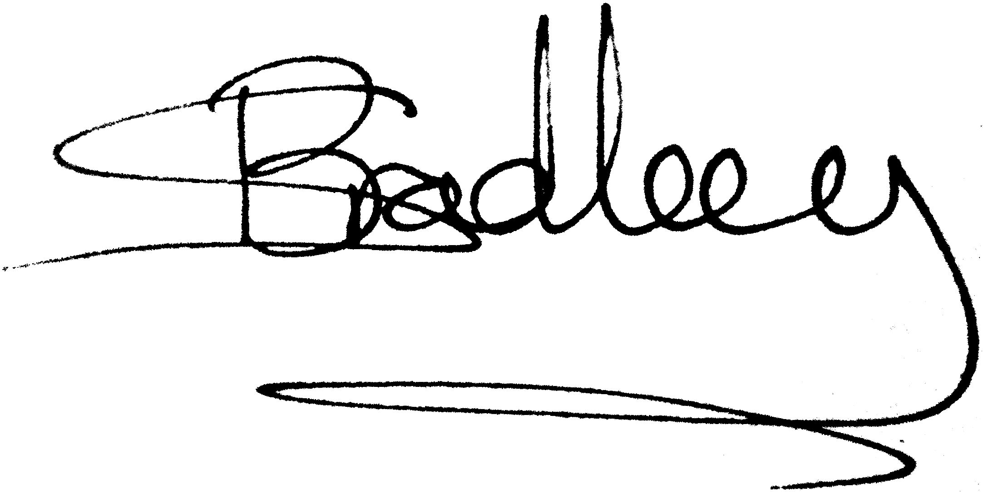
Simon Bradley

