**Identifica elemente specifice   
(<https://translate.google.com/?hl=ru&tab=TT>)**

**b. Identificare secțiuni si elemente de conținut**  
**<h1>**  
  
 **<h2>** **<h3>**  
**...**  
  
**<p>**  
  
**<div>  
1)**  
**2)**  


**<tr>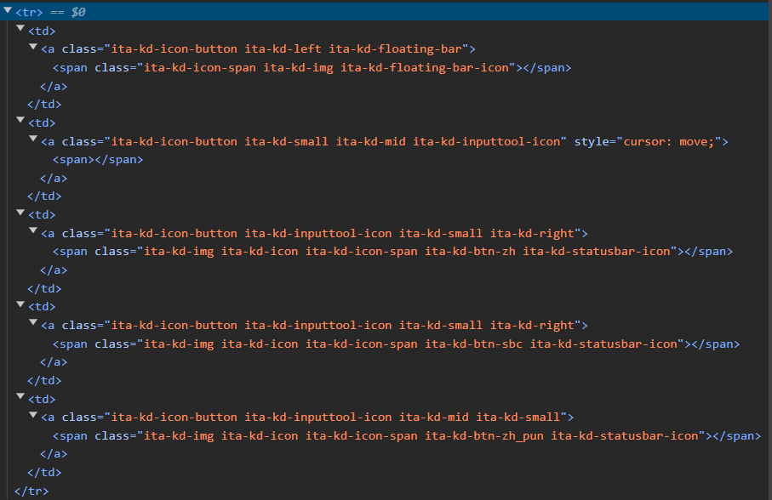 <img>**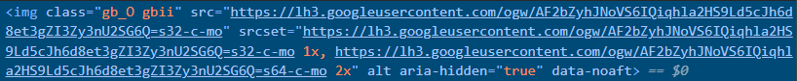

**c. Modificare valoare / conținut  
  
<h1>**  
<h1 class="oBOnKe" id="ucj-3">Text translate</h1>  
  
**<h2>**<h2 class="pWIpbc">Settings</h2>

**<h3>**

<h3 class="Jp7KKb">Speech speed</h3>  
  
**<img>**element.style {

}

.gb_O {

-webkit-background-size: 64px 64px;

background-size: 32px 32px;

border: 0;

-webkit-border-radius: 50%;

border-radius: 50%;

display: block;

margin: 0px;

position: relative;

height: 164px;

width: 20px;

z-index: 0;

}  
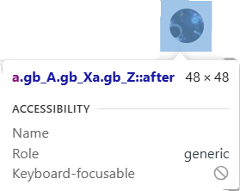 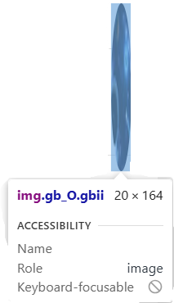  
  
**<p>**<p id="i53" class="VfPpkd-fmcmS-yrriRe-W0vJo-fmcmS VfPpkd-fmcmS-yrriRe-W0vJo-fmcmS-OWXEXe-Rfh2Tc-EglORb" jscontroller="eM1C7d" jsname="xl1FBb" aria-hidden="true">Introduce URL</p>  
  
**<div>  
2)**<span class="gb_sd gb_9c">Translate</span>  
  
color: #3300ff;  
