**Nume**: Ivan

**Prenume**: Chernei

**E-mail**: [chernei.le.ivan@student.utcluj.ro](mailto:chernei.le.ivan@student.utcluj.ro)

**Poza**:

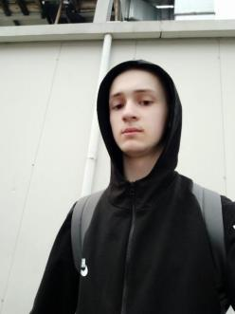

**Asteptari legate de educatie:**

- Programare

- Informatica aplicata - CCP

- Fizica

**Discipline:**

|  |  |  |
| --- | --- | --- |
| **Disciplina** | **An** | **Link** |
| Informatica Aplicata | 1 | https://etti.utcluj.ro/files/Acasa/Site/FiseDisciplina/EaRo/06.pdf |
| Programare | **1** | https://etti.utcluj.ro/files/Acasa/Site/FiseDisciplina/EaRo/04a.pdf |
| Componente si circuite pasive | **1** | https://etti.utcluj.ro/files/Acasa/Site/FiseDisciplina/EaRo/05a.pdf |
| Fizica | **1** | https://etti.utcluj.ro/files/Acasa/Site/FiseDisciplina/EaRo/03.pdf |

**Hobby-uri:**

- Reading

- Listening to music

- Watching films

**HTML:** <https://github.com/IvanChe673/Resume/tree/main>  
  
**Repository link:** https://github.com/IvanChe673/Resume/blob/main/Chernei_Ivan_Resume.docx