ICT0362330

IVAN CHONG JIA HAO

Evaluation

Menu Option 1 ) WORKS

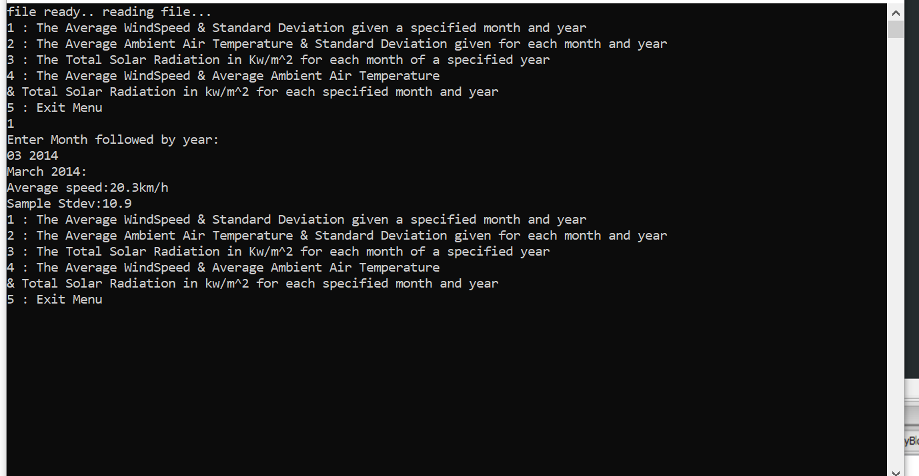

Menu Option 2 ) WORKS

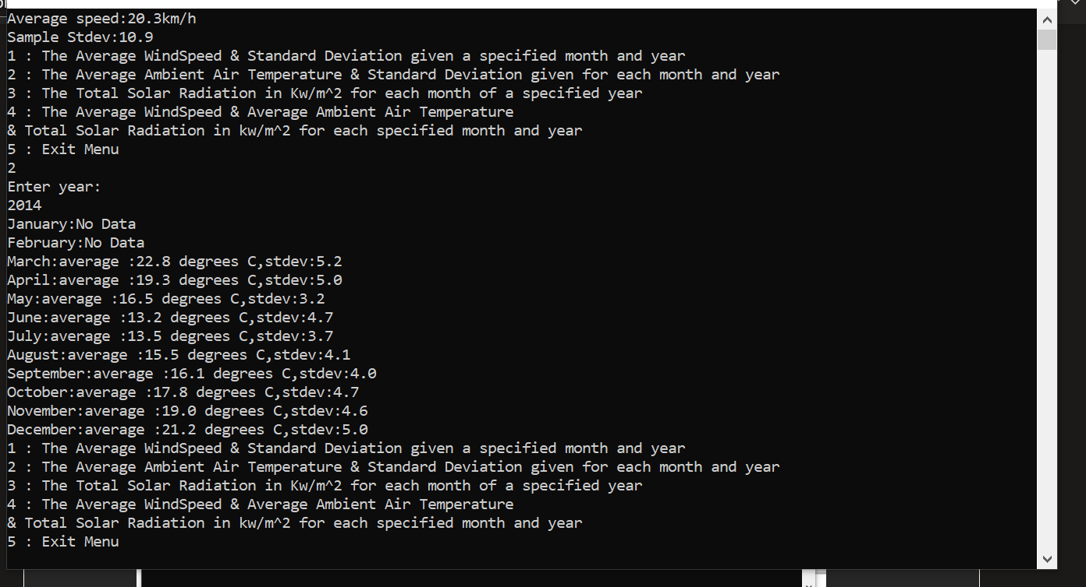

Menu Option 3 ) WORKS

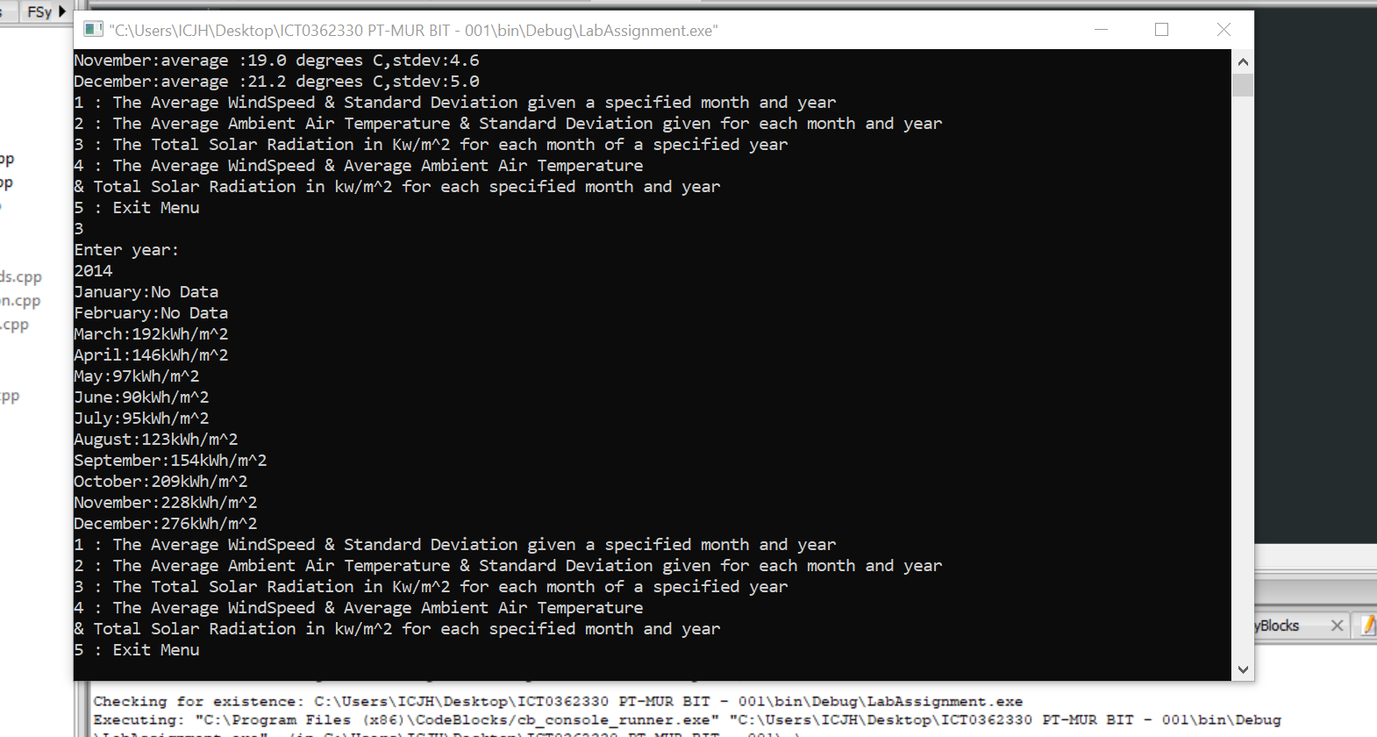

MENU 4 ) WORKS

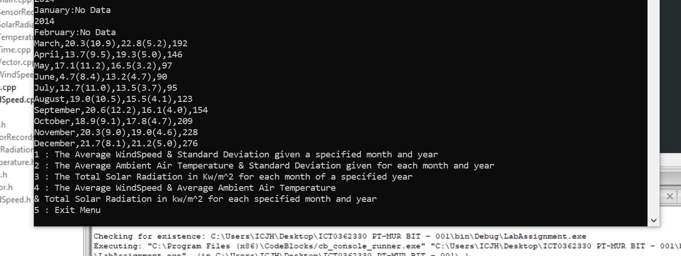

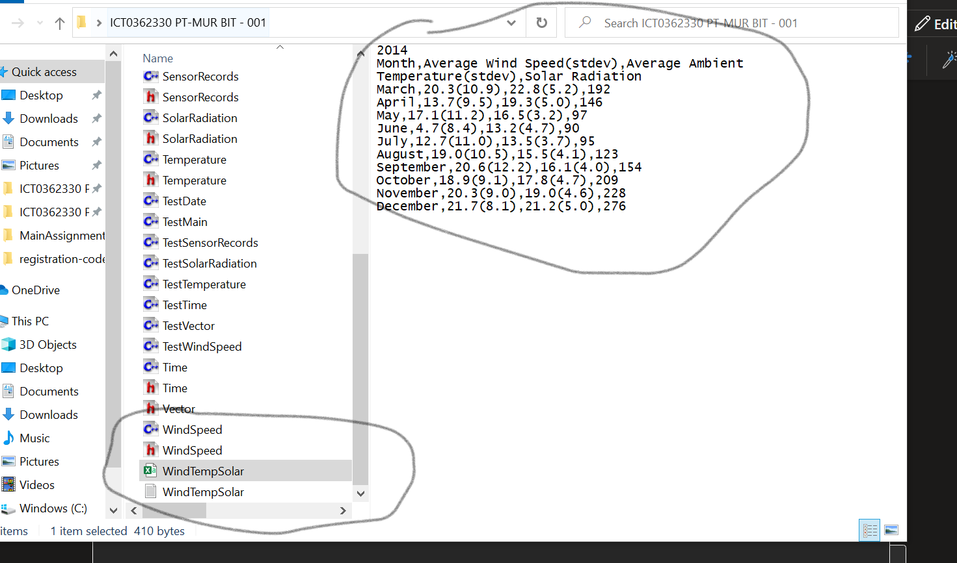

MENU 5 )

