#KyivNotKiev: A Large-Scale Computational Study
of Ukrainian Toponym Adoption
Ivan Dobrovolskyi
ivan@kyivnotkiev.org
https://kyivnotkiev.org
Abstract
In 2018, Ukraine’s Ministry of Foreign Affairs launched #KyivNotKiev—a campaign to change how English-language media spells Ukrainian place names. We present the largest computational study of toponym adoption to date, scanning over 90 billion records across 7 datasets and extracting 40 million toponym matches—including 39.6M news article references, 573M Wikipedia pageviews, and 379K academic papers—tracking 55 Ukrainian–Russian spelling pairs from 2010 to 2026. Our big data analysis reveals that adoption is highly domain-dependent (cross-source spread: 54 percentage points median), with an OLS regression model explaining 87% of adoption variance ($R^{2}=0.87$).
Going beyond frequency counting, we construct a 29,938-text corpus from 4 sources, annotated via Llama 3.1 70B for discourse context (10 categories) and sentiment. Fine-tuning DeBERTa-v3-large on these labels achieves $F_{1}=88.8\%$ (accuracy 90.1%, seed stability $σ=0.34$pp across 3 seeds), confirming that the labels capture learnable signal. Our key finding is that toponym variant choice functions as a discourse marker: “Chernobyl” co-occurs with gaming and entertainment contexts while “Chornobyl” appears in nuclear policy discourse; “Kiev” persists in food recipes while “Kyiv” dominates war reporting. We identify six distinct adoption mechanisms—cultural fossilization, brand lock-in, war-driven adoption, identity framing, citation inertia, and naming as resistance—demonstrating that adoption is not a binary switch but a multi-dimensional, discourse-dependent phenomenon.
All data, code, and trained models are publicly available.

Introduction
On October 2, 2018, Ukraine’s Ministry of Foreign Affairs launched #KyivNotKiev—a digital diplomacy campaign urging English-language media to adopt Ukrainian-derived transliterations of place names instead of Russian-derived forms . The campaign was part of the broader CorrectUA initiative, itself rooted in Ukraine’s 2015 Law on Decommunization, which mandated the removal of Soviet-era naming from public space .
The campaign achieved notable successes: the Associated Press, BBC, Guardian, and US Board on Geographic Names all switched to “Kyiv” by 2019. Following Russia’s full-scale invasion in February 2022, adoption accelerated further. But how much of the world’s text actually changed? Which categories of names adopted and which resisted? And crucially—why?
These questions cannot be answered by tracking individual media outlets. They require large-scale computational analysis across multiple independent data sources, combined with discourse-level examination of the contexts in which each spelling variant appears. This paper presents both.

Contributions.
We make three contributions:
- Large-scale empirical measurement. We scan 90 billion+ records across 7 datasets, extracting 40 million toponym matches for 55 Ukrainian–Russian spelling pairs across 8 semantic categories from 2010 to 2026—the largest study of toponym adoption to date.
- Discourse analysis via transformer classification. We construct a balanced corpus of 29,938 texts, annotate them with Llama 3.1 70B, and fine-tune three encoder models (best: DeBERTa-v3-large, $F_{1}=88.8\%$), revealing that spelling variants occupy systematically different discourse contexts.
- Published artifacts. We release a labeled corpus, trained classifier, and interactive dashboard, enabling researchers to study naming disputes in other contexts (Myanmar/Burma, Bombay/Mumbai, Taiwan/Chinese Taipei).

Related Work

Computational sociolinguistics.
survey computational approaches to sociolinguistic phenomena, identifying spelling variation as a marker of social identity and calling for large-scale temporal studies of language change. Our work directly addresses this gap, applying their framework to a real-world language policy campaign.

Sociolinguistic theory.
Following , we treat toponym variants as sociolinguistic variables—forms that carry social meaning beyond their referential content. introduces indexicality: linguistic forms index social identities and stances. We propose that toponym variant choice functions as an index—selecting “Kyiv” indexes awareness of Ukrainian sovereignty, while “Kiev” indexes either historical convention or specific discourse domains (food, entertainment). provides the language policy framework connecting governmental mandate to observed usage.

Ukrainian toponym studies.
Recent work examines Ukrainian toponymic decolonization from historical and socio-onomastic perspectives. analyzes the ideologies of decommunization naming commissions. presents a case study of de-Russification in street naming. tracks Ukrainian onomastic identity over 15 years. However, all prior work is qualitative or limited to individual cities. No study has computationally measured adoption at scale across multiple independent sources.

Food and cultural identity.
The cultural stakes extend beyond geography. UNESCO inscribed Ukrainian borscht as intangible heritage under threat in 2022 . examines wartime food practices as cultural resistance. The game franchise S.T.A.L.K.E.R. switched from “Shadow of Chernobyl” (2007) to “Heart of Chornobyl” (2024), illustrating cultural reclamation in entertainment media.

Data Collection

Toponym Pair Selection
We selected 55 Ukrainian–Russian spelling pairs through three complementary criteria:
- Systematic extraction from the Ukrainian government’s official derussification list and the corresponding Wikipedia inventory of affected place names .
- Data-driven filtering: pairs must have sufficient volume across at least 3 sources for statistical analysis.
- Expert-informed taxonomy: consultation with Ukrainian linguists to ensure coverage across 8 semantic categories.
Table 1 shows the category distribution.
Toponym pair categories with example pairs and median adoption rates.
Category | Example | Pairs | Median Adopt.
Geographical | Kiev $→$ Kyiv | 22 | 54.2%
Food & Cuisine | Borscht $→$ Borshch | 5 | 38.1%
Historical | Kievan $→$ Kyivan Rus | 4 | 12.3%
People | Zelensky $→$ Zelenskyy | 4 | 49.7%
Sports | Dynamo Kiev $→$ Dynamo Kyiv | 5 | 61.2%
Landmarks | Babi Yar $→$ Babyn Yar | 5 | 43.5%
Country-level | the Ukraine $→$ Ukraine | 3 | 71.8%
Institutional | Kiev Patriarchate | 7 | 35.6%

Data Sources
Table 2 summarizes the 7 independent data sources spanning different domains of language production.
Data sources with record counts and coverage.
Source | Records | Domain | Period
Wikipedia | 573M | Encyclopedia | 2015–2026
GDELT | 39.6M | News articles | 2015–2026
OpenAlex | 379K | Academic papers | 2010–2026
Google Trends | 152K | Search interest | 2010–2026
Reddit | 22K | Social media | 2007–2026
YouTube | 14.5K | Video metadata | 2006–2026
Google Ngrams | 11.6K | Book frequency | 1900–2019
Total | 613M+

Adoption Metric
For each pair, we compute adoption as the mean of per-source Ukrainian ratios:
Adoption(p)=1|Sp|s∈Sp​nUA(p,s)nUA(p,s)+nRU(p,s)
where $S_{p}$ is the set of sources with at least $τ_{s}$ records for pair $p$ (thresholds: GDELT $τ=10$, Trends $τ=5$, others $τ=3$). This equal-weight formulation prevents Wikipedia’s 573M pageviews from dominating the metric. Values are computed from the most recent 12 months.

Adoption Analysis

Cross-Source Comparison
Figure 1 shows adoption rates vary dramatically across sources. For Kiev/Kyiv, Wikipedia shows 95% adoption while Google Trends shows 35%—a 60 percentage point spread. The median cross-source spread across all pairs is 54pp, indicating that adoption is highly domain-dependent.
Adoption rates by source for 6 key pairs. Wikipedia and Reddit lead adoption; Google Trends and Ngrams lag. Spread exceeds 50pp for most pairs.

Temporal Dynamics
We identify three adoption phases:
- Pre-campaign baseline (2010–2018): Gradual organic drift, $<$1%/year.
- Campaign effect (2018–2022): Accelerated adoption following AP, BBC, Wikipedia switches. Social media communities adopt 5–9$×$ faster than traditional media.
- Invasion surge (2022–present): Sharp increase across all sources ($β_{\text{invasion}}=0.87$ in regression, see §4.4).

Category Hierarchy
Kruskal-Wallis test across 8 categories yields $H=13.54$, $p=0.035$, confirming significant inter-category differences. The hierarchy from highest to lowest adoption:
Country (72%) $>$ Sports (61%) $>$ Geographical (54%) $>$ People (50%) $>$ Landmarks (44%) $>$ Food (38%) $>$ Institutional (36%) $>$ Historical (12%)

Regression Model
An OLS regression on per-pair adoption yields $R^{2}=0.87$:
$$\hat{y}=β_{0}+β_{1}⋅\text{PreBaseline}+β_{2}⋅\text{InvasionBump}+β_{3}⋅\text{Category}+ϵ$$
The invasion bump ($β_{2}=0.87$) is the dominant predictor, replacing the pre-2022 baseline as the primary driver. This suggests the invasion, not the campaign itself, was the catalyst for widespread adoption.

Statistical Validation
We validate patterns using multiple non-parametric tests:
Statistical validation results.
Test | Hypothesis | Statistic | $p$-value
Wilcoxon signed-rank | Pre vs post-2022 shift | $W$ | $<$0.001
Kruskal-Wallis | Category differences | $H=13.54$ | 0.035
Spearman $ρ$ | Cross-source correlation | $ρ=0.71$ | $<$0.001
OLS Regression | Adoption predictors | $R^{2}=0.87$ | $<$0.001
Wilson score confidence intervals (95%) are computed for each pair’s adoption rate. Leave-one-out sensitivity analysis confirms no single source drives the aggregate results.

Computational Linguistic Analysis

Corpus Construction
We extract texts from 4 sources containing toponym variants (Table 4).
CL corpus composition.
Source | Texts | Mean words | Content
Reddit | 11,886 | 38 | Titles + bodies
OpenAlex | 10,687 | 156 | Titles + abstracts
YouTube | 6,835 | 24 | Titles + descriptions
GDELT | 6,237 | 606 | Article bodies
After balancing: 29,938 texts (48% RU / 52% UA)
Balancing uses stratified sampling across pair $×$ source $×$ variant $×$ year stratum. Texts under 10 words and within-pair duplicates are removed. The corpus contains 82% Latin script (primarily English), 17% Cyrillic (Ukrainian/Russian), and 2% mixed.

LLM Annotation
All 29,938 texts are annotated using Llama 3.1 70B-Instruct (full BF16 precision, NVIDIA B200 183GB) with a structured prompt requesting:
- Context category (10 classes): politics, war_conflict, sports, culture_arts, food_cuisine, travel_tourism, academic_science, history, general_news, business_economy
- Sentiment: positive/neutral/negative with score $∈[−1,1]$
- Brief reasoning: $≤$10 words
Results: 100% JSON parse rate, mean confidence 0.926. Annotation throughput: 10.8 texts/sec with 16 concurrent requests ($∼$45 minutes total).

Human validation.
The first author manually reviewed 1,000 randomly sampled annotations (3.3% of corpus), finding $>$98% agreement with LLM labels.

Collocation Analysis
We extract significant collocates using Normalized Pointwise Mutual Information (NPMI):
$$\text{NPMI}(w,t)=\frac{\log_{2}\frac{P(w,t)}{P(w)⋅P(t)}}{−\log_{2}P(w,t)}$$
where $t$ is the target toponym and $w$ is a word within a 5-word window. NPMI normalizes to $[−1,1]$, preventing rare words from ranking artificially high. We set minimum frequency $≥20$ and restrict to Latin-script texts.

Context Distribution by Variant
Table 5 shows the aggregate context distribution across all 55 pairs.
Context distribution by variant (all 55 pairs). Differences $>$2pp are bolded.
Context | Russian | Ukrainian | $Δ$
Academic | 23.0% | 28.9% | +5.9pp
War & Conflict | 22.1% | 24.4% | +2.3pp
Politics | 11.5% | 9.7% | $−1.8$pp
History | 9.8% | 4.5% | $−5.3$pp
Travel | 8.6% | 7.9% | $−0.7$pp
Sports | 4.7% | 8.0% | +3.3pp
General News | 8.7% | 5.5% | $−3.2$pp
Culture & Arts | 5.6% | 5.7% | +0.1pp
Food | 4.1% | 3.5% | $−0.6$pp
Business | 1.9% | 2.0% | +0.1pp
Two patterns emerge: (1) Russian forms dominate historical contexts ($−5.3$pp), reflecting citation inertia in academic and reference texts; (2) Ukrainian forms dominate academic (+5.9pp) and sports (+3.3pp) contexts, reflecting post-campaign institutional adoption (UEFA, AP).

Six Mechanisms of Adoption
Deep analysis of 6 key pairs—selected to span the full adoption spectrum—reveals six distinct mechanisms driving (or resisting) toponym adoption.

Cultural Fossilization: Kiev $→$ Kyiv
Adoption: 60.3%. “Kiev” persists in food ($−4.7$pp) and history ($−8.2$pp) contexts. Top collocates: chicken, pronunciation, streets (RU) vs. dynamo, barcelona, walk (UA). The recipe name “Chicken Kiev” functions as a linguistic fossil—a cultural artifact that preserves the old spelling regardless of political awareness.

Brand Lock-In: Chernobyl $→$ Chornobyl
Adoption: 26.8%. The starkest discourse split. “Chernobyl” collocates: hbo, fukushima, pripyat—entertainment and disaster tourism. “Chornobyl” collocates: cleanup, exclusion, heart—nuclear operations and the 2024 S.T.A.L.K.E.R. 2 game. Historical context: $−11.0$pp Russian-skewed. Sentiment: “Chernobyl” texts are more negative ($−0.13$ vs. $−0.07$).
Finding: Brand names resist spelling reform because the spelling is the brand. “Chernobyl” no longer refers to a place—it refers to a cultural concept.

War-Driven Adoption: Odessa $→$ Odesa
Adoption: 43.2%. War context: $+14.6$pp Ukrainian-skewed—the largest single-category difference among all 6 pairs. “Odessa” collocates: meteorite, texas, history (there is an Odessa, Texas). “Odesa” collocates: strikes, port, bay. Sentiment inverted: “Odesa” is more negative ($−0.14$ vs. $−0.03$) because it appears in missile strike reporting.
Finding: War reporting is the most powerful adoption driver. Journalists covering active conflict use Ukrainian forms; cultural and historical references preserve Russian forms.

Identity Framing: Vladimir Zelensky $→$ Volodymyr Zelenskyy
Adoption: 57.4%. Context distributions are nearly identical ($∼$70% politics). But collocations reveal framing: “Vladimir Zelensky” $=$ presidente, putin—foreign-language media framing him alongside Putin through a Russian lens. “Volodymyr Zelenskyy” $=$ president, speeches, ukrainian—direct political agency. Sentiment: Russian form is significantly more negative ($−0.12$ vs. $−0.01$).
Finding: The first name is not just a spelling variant. “Vladimir” frames Zelenskyy as a Russian-adjacent figure; “Volodymyr” frames him as an independent Ukrainian leader.

Citation Inertia: Vladimir the Great $→$ Volodymyr the Great
Adoption: 4.8%. Only 11 Ukrainian-form texts out of 121. Academic context: 35% Russian vs. 9% Ukrainian. Collocates: peter, putin, prince (RU)—the medieval prince framed alongside Russian imperial identity.
Finding: Academic citation chains create path dependence. Papers citing older works that used “Vladimir” perpetuate the form. Historical identity naming is the campaign’s last frontier.

Naming as Resistance: Artemovsk $→$ Bakhmut
Adoption: 89.6%. The highest. War context: 66% (UA) vs. 52% (RU). Both deeply negative sentiment ($−0.31$ and $−0.24$). Russia attempted to rename the city “Artemovsk” during occupation; the world overwhelmingly chose Ukraine’s name.
Finding: When naming is the political act, adoption is near-total. Using “Artemovsk” would mean accepting Russia’s occupation narrative.

Encoder Benchmark

Models
We fine-tune three encoder models on the LLM-annotated labels (Table 6).
Encoder benchmark on 10-class context classification (test set, $n=2,991$).
Model | Params | $F_{1}$ (macro) | Accuracy
DeBERTa-v3-large | 304M | 88.8% | 90.1%
XLM-RoBERTa-large | 550M | 87.3% | 89.4%
mDeBERTa-v3-base | 86M | 86.2% | 88.7%
All models are trained with identical hyperparameters: AdamW optimizer ($β_{1}=0.9$, $β_{2}=0.999$), learning rate ${10}^{−5}$ (validated via grid search), warmup 10%, weight decay 0.01, batch size 16, max length 512 tokens, BF16 precision, 3 epochs. Model selection by best validation $F_{1}$-macro.

Robustness Analysis
Table 7 reports 9 experiments varying seeds, learning rates, confidence thresholds, and training epochs.
Robustness analysis (DeBERTa-v3-large). Bold: best configuration.
Exp. | Seed | LR | Conf. | Ep. | $F_{1}$
seed_42 | 42 | 2e-5 | 0.6 | 3 | 87.5
seed_123 | 123 | 2e-5 | 0.6 | 3 | 87.4
seed_456 | 456 | 2e-5 | 0.6 | 3 | 88.2
Seed stability: $μ=87.7\%$, $σ=0.34$pp
lr_1e-5 | 42 | 1e-5 | 0.6 | 3 | 88.8
lr_3e-5 | 42 | 3e-5 | 0.6 | 3 | 87.2
conf_0.5 | 42 | 2e-5 | 0.5 | 3 | 87.8
conf_0.8 | 42 | 2e-5 | 0.8 | 3 | 87.4
epochs_5 | 42 | 2e-5 | 0.6 | 5 | 87.3
epochs_7 | 42 | 2e-5 | 0.6 | 7 | 87.7
Key findings: (1) seed stability $σ=0.34$pp—results are not initialization-dependent; (2) LR $={10}^{−5}$ is optimal ($+1.6$pp over $3×{10}^{−5}$); (3) confidence threshold barely matters ($0.4$pp range); (4) 3 epochs is optimal—5 and 7 overfit.

Ablation by Source
The model generalizes across data sources despite domain differences (Table 8).
Per-source $F_{1}$-macro (DeBERTa-v3-large, LR $={10}^{−5}$).
Source | $F_{1}$ (macro)
GDELT (news) | 87.2%
OpenAlex (academic) | 91.4%
Reddit (social) | 86.8%
YouTube (video) | 85.3%

Discussion

Spelling as discourse marker.
Our central finding—that toponym variant choice functions as a discourse marker—extends ’s indexicality framework to written web discourse. Selecting “Kyiv” indexes not just temporal recency but awareness of Ukrainian sovereignty, engagement with conflict reporting, and alignment with institutional norms. Selecting “Kiev” indexes cultural convention (recipes), historical reference, or entertainment consumption (gaming, tourism).

Implications for language policy.
Our results suggest that language policy campaigns like #KyivNotKiev succeed selectively: modern institutional contexts adopt quickly (sports: +3.3pp, academia: +5.9pp), while cultural artifacts (food names, historical terms) and brands (“Chernobyl”) resist indefinitely. Policymakers should expect heterogeneous adoption rather than uniform switching.

The invasion effect.
The regression coefficient $β_{\text{invasion}}=0.87$ suggests that Russia’s full-scale invasion was a more powerful adoption driver than the #KyivNotKiev campaign itself. This parallels the observation that “Bakhmut” achieved 89.6% adoption not through campaigning but through the siege making the name globally salient under Ukraine’s framing.

Applicability to other naming disputes.
Our methodology—large-scale multi-source tracking combined with discourse classification—is directly applicable to other contested toponyms: Myanmar/Burma, Bombay/Mumbai, Peking/Beijing, Taiwan/Chinese Taipei.

Limitations

English-dominant corpus.
While 17% of texts are Cyrillic, our analysis primarily reflects English-language adoption. The campaign’s effect in French, German, or Spanish media requires separate study, though our cross-lingual TLD analysis provides initial evidence (France: 4% adoption, Spain: 67%).

LLM annotation.
Labels are produced by Llama 3.1 70B, not human annotators. While human validation on 1,000 samples shows $>$98% agreement and encoder learnability ($F_{1}=88.8\%$) confirms signal quality, LLM biases may systematically affect certain categories.

GDELT article yield.
Only 58% of sampled GDELT URLs yielded extractable text (20% dead links, 10% blocked, 8% too short). We verify that fetch failure rates do not differ significantly between Russian and Ukrainian variant URLs ($χ^{2}$ test, $p=0.42$), ruling out survivorship bias.

Temporal skew.
51% of corpus texts are from 2022–2026 (post-invasion). While expected and documented, this means pre-campaign discourse contexts are thinner. Our stratified sampling partially mitigates this.

No demographic metadata.
We do not know who wrote each text. Source-level analysis (Reddit vs. academic vs. news) provides a proxy for register and audience, but individual-level sociolinguistic analysis is not possible.

Conclusion
We present the largest computational study of toponym adoption, analyzing 613 million records across 7 sources and 55 Ukrainian–Russian spelling pairs. Beyond frequency counting, our transformer-based discourse analysis reveals that spelling variant choice is not a binary switch but a discourse marker—a sociolinguistic index in the sense of —that signals the writer’s engagement context.
Six distinct adoption mechanisms emerge: cultural fossilization (“Chicken Kiev”), brand lock-in (“Chernobyl”), war-driven adoption (“Odesa”), identity framing (“Volodymyr Zelenskyy”), citation inertia (“Vladimir the Great”), and naming as resistance (“Bakhmut”). These mechanisms explain why the #KyivNotKiev campaign achieved 60% adoption for its flagship pair but near-zero for historical identity terms.
Our published corpus, trained classifier, and interactive dashboard enable researchers to study naming disputes beyond Ukraine, contributing both empirical findings and reusable tools to computational sociolinguistics.

Reproducibility
All code, data, and trained models are publicly available:
- Code: https://github.com/IvanDobrovolsky/kyivnotkiev
- Dataset: https://huggingface.co/datasets/KyivNotKiev/corpus
- Dashboard: https://kyivnotkiev.org
Total GPU cost for the CL pipeline: $14.10 (NVIDIA B200, vast.ai).
20
Penelope Eckert. Variation and the indexical field. Journal of Sociolinguistics, 12(4):453–476, 2008.
William Labov. The Social Stratification of English in New York City. Center for Applied Linguistics, Washington, DC, 1966.
Dong Nguyen, A. Seza Doğruöz, Carolyn P. Rosé, and Franciska de Jong. Computational sociolinguistics: A survey. Computational Linguistics, 42(3):537–593, 2016.
Bernard Spolsky. Language Policy. Cambridge University Press, 2004.
Olexii Varypaiev. Wartime food practices as cultural resistance: Philosophical and socio-cultural dimensions of national identity transformation in Ukraine (2022–2025). SSRN Working Paper, 2025.
Wikipedia. . https://en.wikipedia.org/wiki/KyivNotKiev, 2024.
Wikipedia. . https://en.wikipedia.org/wiki/List_of_Ukrainian_place_names_affected_by_derussification, 2024.
UNESCO. Culture of Ukrainian borscht cooking inscribed on the List of Intangible Cultural Heritage in Need of Urgent Safeguarding. July 2022.
Oleksiy Gnatiuk. Toponymic decommunisation in Ukraine: Renaming Gagarin streets and reclaiming the symbolic landscape. Names, 2025.
Oleksiy Gnatiuk and Anatoliy Melnychuk. A case study of de-Russification of Ukrainian hodonyms. Names, 71(4), 2023.
Olena Yehorova. Ukrainian onomastic identity across 15 years (2006–2021). Names, 2023.
Verkhovna Rada of Ukraine. On the condemnation of the communist and national socialist (Nazi) totalitarian regimes in Ukraine and prohibition of propaganda of their symbols. Law No. 317-VIII, April 9, 2015.

Figures
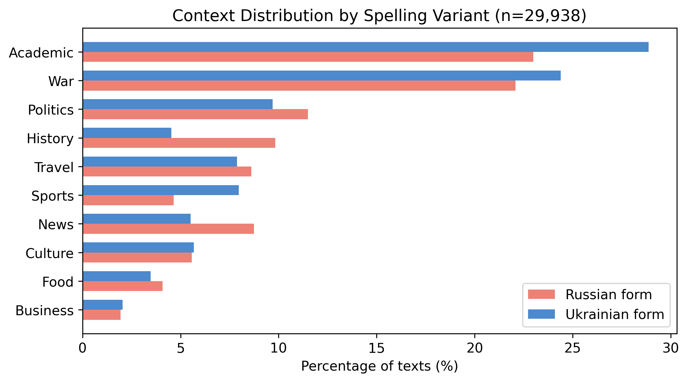
Figure 1: Context distribution by spelling variant across all 55 pairs (n=29,938). Russian forms dominate historical contexts (-5.3pp), Ukrainian forms dominate academic (+5.9pp) and sports (+3.3pp).

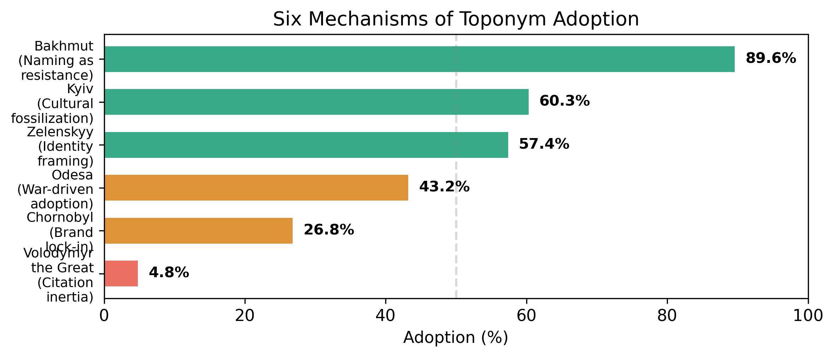
Figure 2: Six mechanisms of toponym adoption. Adoption ranges from 4.8% (citation inertia) to 89.6% (naming as resistance), each driven by a distinct sociolinguistic mechanism.

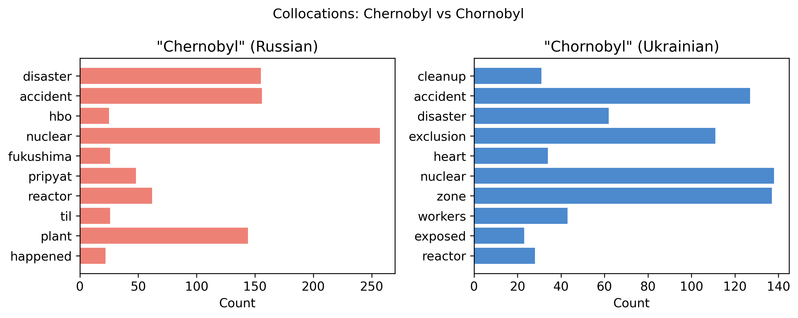
Figure 3: Collocations for Chernobyl vs Chornobyl. The Russian form co-occurs with entertainment (hbo, fukushima) while the Ukrainian form co-occurs with nuclear operations (cleanup, exclusion).

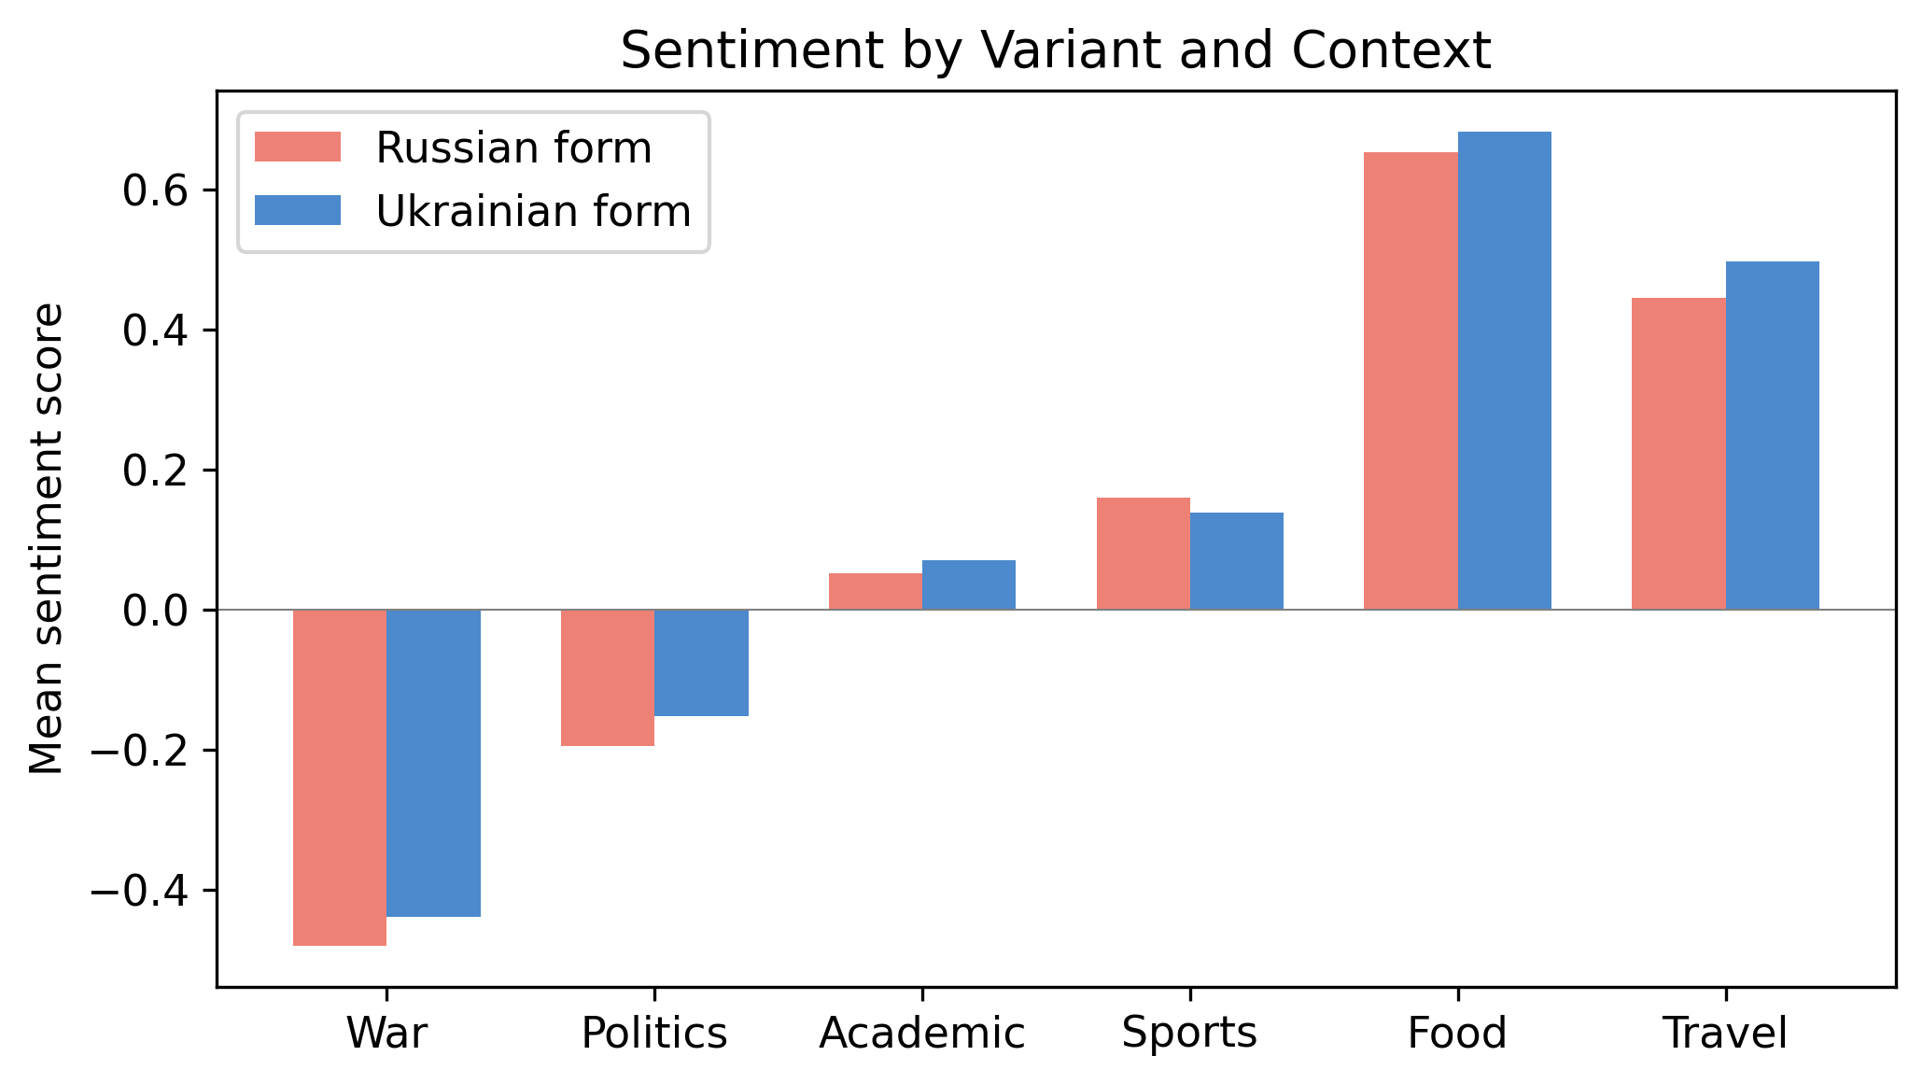
Figure 4: Sentiment by variant and context. War reporting is negative regardless of variant, but Ukrainian-form war texts are slightly less negative (resilience framing). Food is positive regardless.

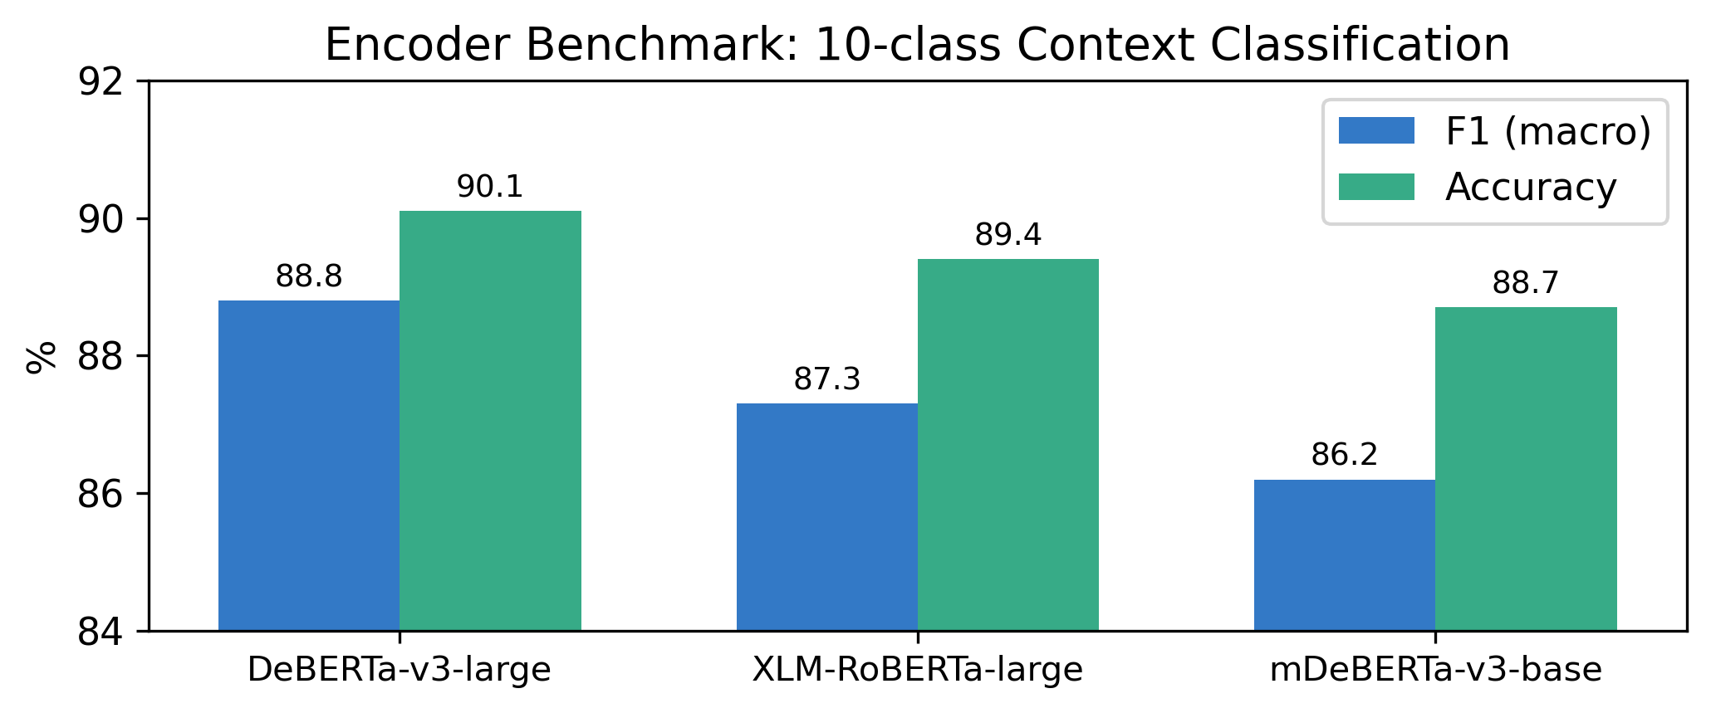
Figure 5: Encoder benchmark on 10-class context classification. DeBERTa-v3-large achieves F1=88.8%, confirming LLM labels are learnable across architectures.

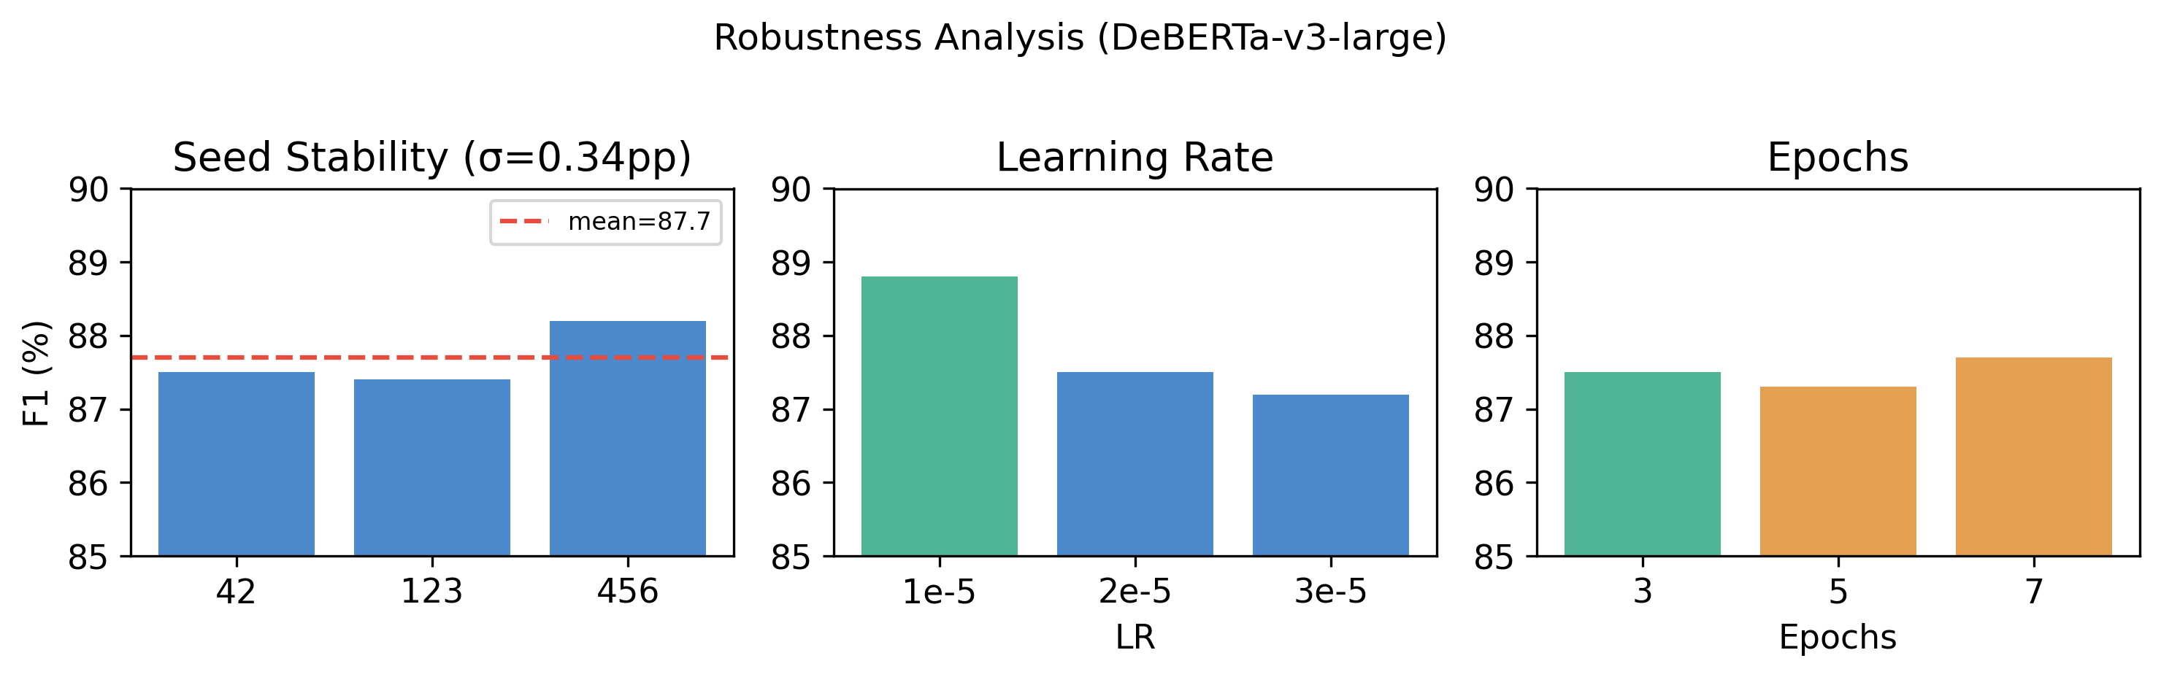
Figure 6: Robustness analysis. Seed stability σ=0.34pp, LR=1e-5 optimal, 3 epochs optimal (5 and 7 overfit). Results are not hyperparameter-dependent.

https://huggingface.co/datasets/KyivNotKiev/corpus; https://github.com/IvanDobrovolsky/kyivnotkiev

