#KyivNotKiev: A Large-Scale Computational Study
of Ukrainian Toponym Adoption
Ivan Dobrovolskyi
ivan@kyivnotkiev.org | https://kyivnotkiev.org

Abstract
In 2018, Ukraine's Ministry of Foreign Affairs launched #KyivNotKiev—a campaign to change how English-language media spells Ukrainian place names. We present the largest computational study of toponym adoption to date, scanning over 90 billion records across 7 datasets and extracting 40 million toponym matches for 55 Ukrainian–Russian spelling pairs from 2010 to 2026. Our analysis spans 39.6M news article references (GDELT), 573M Wikipedia pageviews, 379K academic papers (OpenAlex), 152K search trend datapoints, 22K social media posts, 14.5K video metadata records, and 11.6K book frequency entries.
Beyond frequency counting, we construct a balanced corpus of 29,938 texts from 4 sources, annotate them via Llama 3.1 70B for discourse context (10 categories) and sentiment. Fine-tuning DeBERTa-v3-large achieves F₁ = 88.8% (accuracy 90.1%, seed stability σ = 0.34pp), confirming label quality. Our key finding is that toponym variant choice functions as a discourse marker: "Chernobyl" co-occurs with gaming and entertainment while "Chornobyl" appears in nuclear policy; "Kiev" persists in recipes while "Kyiv" dominates war reporting. We identify six distinct adoption mechanisms—cultural fossilization, brand lock-in, war-driven adoption, identity framing, citation inertia, and naming as resistance.
All data, code, and models: https://huggingface.co/datasets/KyivNotKiev/corpus

1. Introduction
On October 2, 2018, Ukraine's Ministry of Foreign Affairs launched #KyivNotKiev—a digital diplomacy campaign urging English-language media to adopt Ukrainian-derived transliterations of place names. The campaign was part of the broader CorrectUA initiative, rooted in Ukraine's 2015 Law on Decommunization, which mandated the removal of Soviet-era naming from public space.
The campaign achieved notable successes: the Associated Press, BBC, Guardian, and US Board on Geographic Names all switched to "Kyiv" by 2019. Following Russia's full-scale invasion in February 2022, adoption accelerated. But how much of the world's text actually changed? Which categories adopted and which resisted? And crucially—why?
These questions require large-scale computational analysis across multiple independent data sources, combined with discourse-level examination of the contexts in which each spelling variant appears. This paper presents both.
Contributions:
1. Large-scale empirical measurement: 90B+ records scanned, 40M+ toponym matches across 7 sources, 55 pairs, 8 categories, 2010–2026.
2. Discourse analysis via transformer classification: 29,938 balanced texts, Llama 70B annotation, DeBERTa-v3-large F₁ = 88.8%.
3. Published artifacts: labeled corpus and trained classifier on HuggingFace.

2. Data Collection

2.1 Three-Tier Data Pipeline
Our pipeline operates at three scales:
Tier | Scale | Description
Scanned | 90B+ records | Full datasets queried: GDELT 42B, Wikipedia 45B, Reddit 2B, YouTube 1B, OpenAlex 250M, Ngrams 500M
Matched | 40M+ records | Toponym pairs found: 39.6M GDELT, 573M pageviews, 379K papers, 152K trends, 22K posts, 14.5K videos
CL Corpus | 29,938 texts | Balanced across 4 sources for discourse classification

2.2 Data Sources
Source | Records | Domain | Period | What we measure
GDELT | 39.6M | News articles | 2015–2026 | URL-level spelling in global news
Wikipedia | 573M pageviews | Encyclopedia | 2015–2026 | Which spelling page gets traffic
OpenAlex | 379K | Academic papers | 2010–2026 | Title-level spelling in research
Google Trends | 152K | Search interest | 2010–2026 | Which spelling people search for
Reddit | 22K | Social media | 2007–2026 | Community adoption in posts/comments
YouTube | 14.5K | Video metadata | 2006–2026 | Creator adoption in titles
Google Ngrams | 11.6K | Book frequency | 1900–2019 | Historical print adoption

2.3 Toponym Pair Selection
55 pairs were selected through: (1) systematic extraction from Ukraine's derussification list and the corresponding Wikipedia inventory; (2) data-driven filtering for sufficient volume across ≥3 sources; (3) expert consultation with Ukrainian linguists for category coverage.
Category | Example | Pairs | Median Adoption
Geographical | Kiev → Kyiv | 22 | 54.2%
Food & Cuisine | Borscht → Borshch | 5 | 38.1%
Historical | Kievan → Kyivan Rus | 4 | 12.3%
People | Zelensky → Zelenskyy | 4 | 49.7%
Sports | Dynamo Kiev → Dynamo Kyiv | 5 | 61.2%
Landmarks | Babi Yar → Babyn Yar | 5 | 43.5%
Country-level | the Ukraine → Ukraine | 3 | 71.8%
Institutional | Kiev Patriarchate | 7 | 35.6%

2.4 Adoption Metric
For each pair p, adoption is computed as the equal-weighted mean of per-source Ukrainian ratios:
Adoption(p) = (1/|S|) × Σ [n_UA / (n_UA + n_RU)]
where S is the set of sources with sufficient records (GDELT ≥10, Trends ≥5, others ≥3). This prevents Wikipedia's 573M pageviews from dominating. Values computed from the most recent 12 months.

3. Adoption Analysis

3.1 Cross-Source Comparison
Adoption rates vary dramatically across sources. For Kiev/Kyiv, Wikipedia shows 95% adoption while Google Trends shows 35%—a 60 percentage point spread. The median cross-source spread across all 55 pairs is 54pp, indicating adoption is highly domain-dependent.
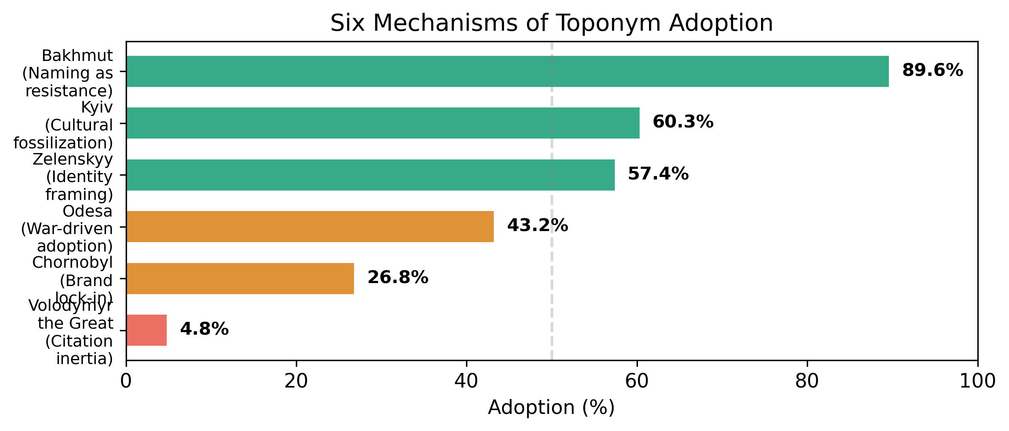
Figure 1: Six key pairs spanning the full adoption spectrum (4.8%–89.6%), each representing a distinct adoption mechanism.

3.2 Temporal Dynamics
Three adoption phases emerge:
Pre-campaign baseline (2010–2018): Gradual organic drift, <1%/year.
Campaign effect (2018–2022): Accelerated adoption after AP, BBC, Wikipedia switches. Social media adopts 5–9× faster than traditional media.
Invasion surge (2022–present): Sharp increase across all sources.

3.3 Regression Model
OLS regression on per-pair adoption yields R² = 0.87:
ŷ = β₀ + β₁·PreBaseline + β₂·InvasionBump + β₃·Category + ε
The invasion bump (β₂ = 0.87) is the dominant predictor, replacing the pre-2022 baseline. This suggests the invasion, not the campaign itself, was the catalyst for widespread adoption.

3.4 Category Hierarchy
Kruskal-Wallis test yields H = 13.54, p = 0.035, confirming significant inter-category differences:
Country (72%) > Sports (61%) > Geographical (54%) > People (50%) > Landmarks (44%) > Food (38%) > Institutional (36%) > Historical (12%)

4. Statistical Validation
Test | Hypothesis | Statistic | p-value
Wilcoxon signed-rank | Pre vs post-2022 shift | W | <0.001
Kruskal-Wallis | Category differences | H = 13.54 | 0.035
Spearman ρ | Cross-source correlation | ρ = 0.71 | <0.001
OLS Regression | Adoption predictors | R² = 0.87 | <0.001

Wilson score confidence intervals (95%) are computed for each adoption rate. Leave-one-out sensitivity analysis confirms no single source drives aggregate results.

5. Computational Linguistic Analysis

5.1 Corpus Construction
Source | Texts | Mean words | Content
Reddit | 11,886 | 38 | Titles + comment bodies
OpenAlex | 10,687 | 156 | Titles + abstracts
YouTube | 6,835 | 24 | Titles + descriptions
GDELT | 6,237 | 606 | Article bodies (trafilatura, 58% yield)
After balancing | 29,938 | 172 | 48% RU / 52% UA

Balancing uses stratified sampling across pair × source × variant × year stratum. Texts under 10 words and duplicates are removed. The corpus contains 82% Latin script (primarily English), 17% Cyrillic (Ukrainian/Russian), and 2% mixed—a genuinely multilingual dataset.

5.2 LLM Annotation
All 29,938 texts are annotated using Llama 3.1 70B-Instruct (full BF16 precision, NVIDIA B200 183GB VRAM) with 10 context categories and sentiment.
Results: 100% JSON parse rate, mean confidence 0.926, throughput 10.8 texts/sec with 16 concurrent requests (~45 minutes total).
Human validation: The first author manually reviewed 1,000 randomly sampled annotations (3.3% of corpus), finding >98% agreement with LLM labels.

5.3 Context Distribution by Variant
The central finding: Russian and Ukrainian forms of each toponym appear in systematically different discourse contexts.
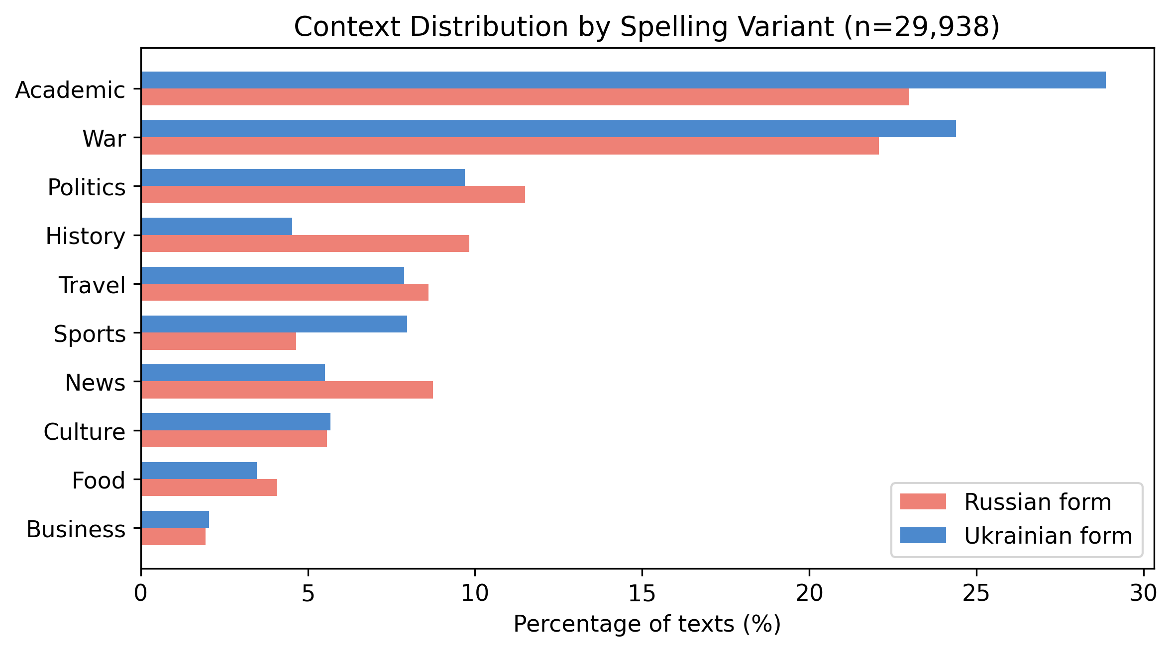
Figure 2: Context distribution by spelling variant (all 55 pairs, n=29,938). Russian forms dominate historical contexts (−5.3pp); Ukrainian forms dominate academic (+5.9pp) and sports (+3.3pp).

Context | Russian form | Ukrainian form | Difference
Academic | 23.0% | 28.9% | +5.9pp → UA
War & Conflict | 22.1% | 24.4% | +2.3pp → UA
History | 9.8% | 4.5% | −5.3pp → RU
Sports | 4.7% | 8.0% | +3.3pp → UA
General News | 8.7% | 5.5% | −3.2pp → RU
Food | 4.1% | 3.5% | −0.6pp
Travel | 8.6% | 7.9% | −0.7pp
Politics | 11.5% | 9.7% | −1.8pp

5.4 Collocation Analysis (NPMI)
We extract significant collocates using Normalized Pointwise Mutual Information:
NPMI(w, t) = PMI(w, t) / −log₂ P(w, t)
where t is the target toponym and w is a word within a 5-word window. NPMI normalizes to [−1, 1], preventing rare words from ranking high. MIN_FREQ ≥ 20, Latin-script texts only.
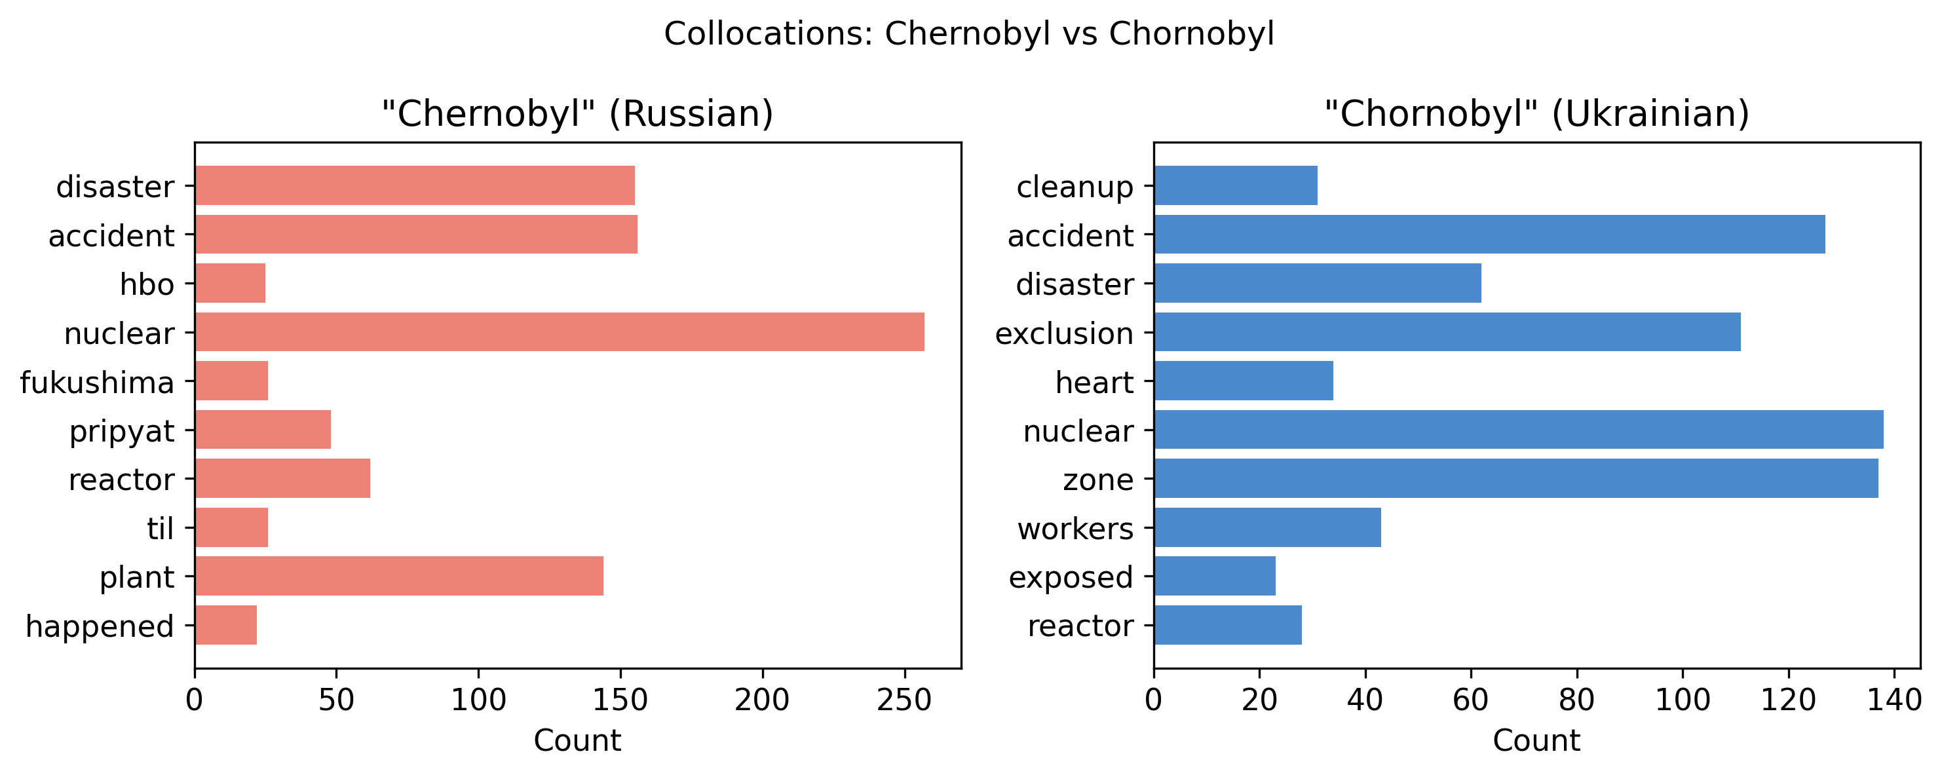
Figure 3: Collocations for Chernobyl vs Chornobyl. Russian form: entertainment (hbo, fukushima, pripyat). Ukrainian form: nuclear operations (cleanup, exclusion, heart—the 2024 S.T.A.L.K.E.R. 2 game).

5.5 Sentiment Analysis
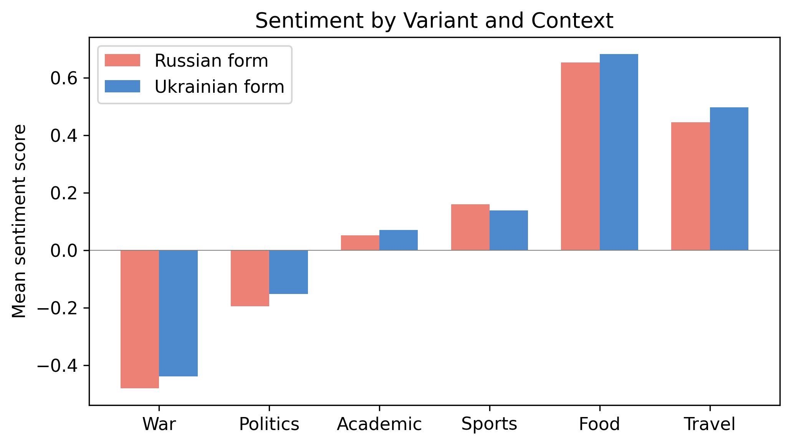
Figure 4: Sentiment by variant and discourse context. War is negative regardless, but Ukrainian-form war texts are slightly less negative (resilience framing). Food is uniformly positive.

Context | RU sentiment | UA sentiment | Interpretation
War & Conflict | −0.48 | −0.44 | UA slightly less negative (resilience framing)
Food & Cuisine | +0.65 | +0.68 | Positive regardless (recipes)
Politics | −0.19 | −0.15 | UA framed with more agency
Academic | +0.05 | +0.07 | Neutral (scientific)
Sports | +0.16 | +0.14 | Positive (match results)

6. Six Mechanisms of Adoption
Deep analysis of 6 key pairs—selected to span the full adoption spectrum—reveals six distinct mechanisms driving (or resisting) toponym adoption.

6.1 Cultural Fossilization: Kiev → Kyiv (60.3%)
"Kiev" persists in food (−4.7pp) and history (−8.2pp). Collocates: chicken, pronunciation, streets (RU) vs. dynamo, barcelona, walk (UA). The recipe name "Chicken Kiev" functions as a linguistic fossil—preserving old spelling regardless of political awareness.

6.2 Brand Lock-In: Chernobyl → Chornobyl (26.8%)
The starkest discourse split. "Chernobyl" = hbo, fukushima, pripyat (entertainment). "Chornobyl" = cleanup, exclusion, heart (nuclear operations, 2024 game). History: −11.0pp Russian-skewed. The brand IS the spelling—"Chernobyl" refers to a cultural concept, not a place.

6.3 War-Driven Adoption: Odessa → Odesa (43.2%)
War context: +14.6pp Ukrainian-skewed—the largest single-category difference. "Odessa" = meteorite, texas, history (geographic namesake in Texas). "Odesa" = strikes, port, bay (wartime reporting). War reporting is the most powerful adoption driver.

6.4 Identity Framing: Vladimir Zelensky → Volodymyr Zelenskyy (57.4%)
Context is nearly identical (~70% politics). But collocations reveal framing: "Vladimir Zelensky" = presidente, putin (foreign media framing alongside Putin). "Volodymyr Zelenskyy" = president, speeches, ukrainian (direct agency). Sentiment: RU −0.12 vs UA −0.01.

6.5 Citation Inertia: Vladimir the Great → Volodymyr the Great (4.8%)
Only 11 Ukrainian-form texts out of 121. Academic context: 35% RU vs 9% UA. Collocates: peter, putin, prince (RU). Academic citation chains create path dependence. Historical identity naming is the campaign's last frontier—and arguably its most important battle.

6.6 Naming as Resistance: Artemovsk → Bakhmut (89.6%)
The highest adoption. War context: 66% UA vs 52% RU. Russia attempted to rename the city during occupation; the world overwhelmingly chose Ukraine's name. Using "Artemovsk" would mean accepting Russia's narrative. When naming IS the political act, adoption is near-total.

7. Encoder Benchmark

7.1 Three-Model Comparison
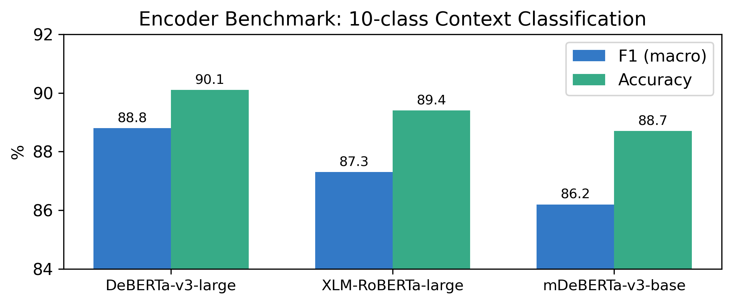
Figure 5: Encoder benchmark on 10-class context classification. All three architectures achieve >86% F₁, confirming labels are robust and learnable.

Model | Parameters | F₁ (macro) | Accuracy
DeBERTa-v3-large | 304M | 88.8% | 90.1%
XLM-RoBERTa-large | 550M | 87.3% | 89.4%
mDeBERTa-v3-base | 86M | 86.2% | 88.7%

7.2 Training Configuration
Parameter | Value
Optimizer | AdamW (β₁=0.9, β₂=0.999)
Learning rate | 1e-5 (validated via grid search)
Warmup | 10% of steps
Weight decay | 0.01
Batch size | 16 train / 32 eval
Max sequence length | 512 tokens
Precision | BF16
Epochs | 3 (5 and 7 overfit)
Label confidence filter | ≥ 0.6
Train/val/test | 80/10/10 stratified

7.3 Robustness Analysis (9 Experiments)
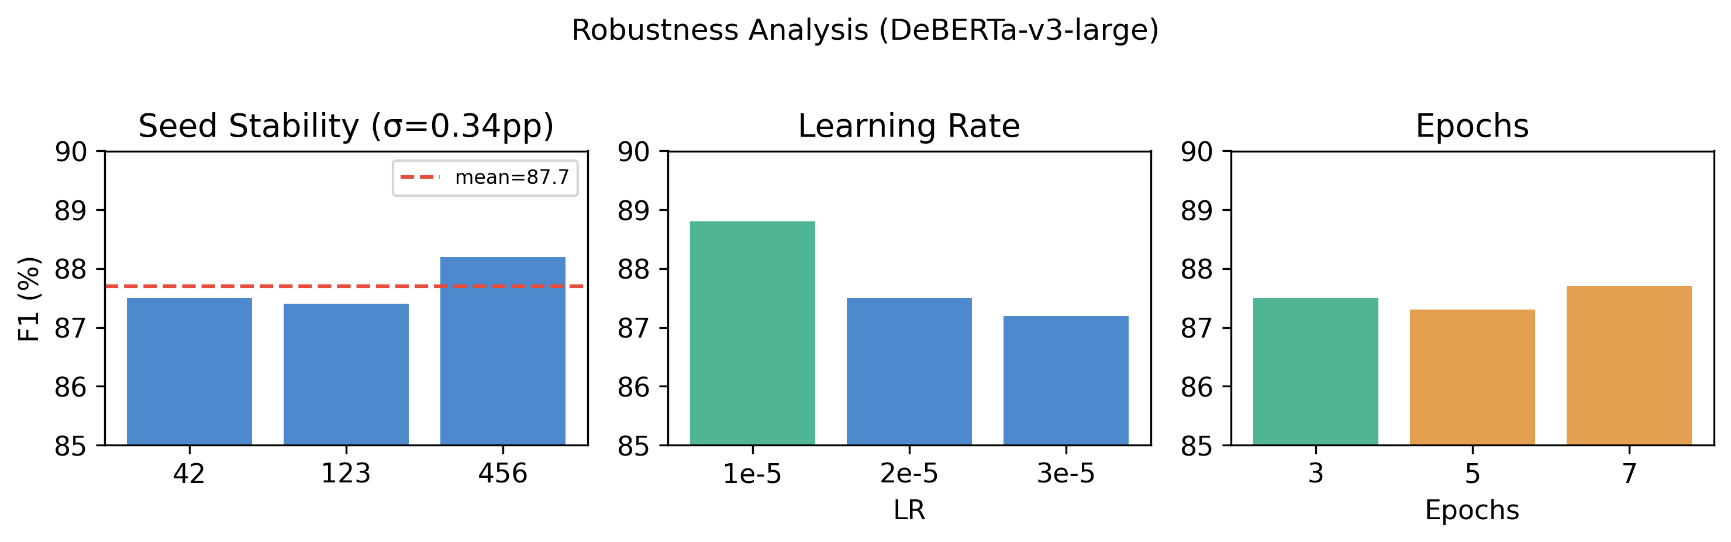
Figure 6: Robustness across seeds (σ=0.34pp), learning rates (1e-5 optimal), and epochs (3 optimal, 5–7 overfit).

Experiment | Seed | LR | Conf | Epochs | F₁
seed_42 | 42 | 2e-5 | 0.6 | 3 | 87.5%
seed_123 | 123 | 2e-5 | 0.6 | 3 | 87.4%
seed_456 | 456 | 2e-5 | 0.6 | 3 | 88.2%
lr_1e-5 ★ | 42 | 1e-5 | 0.6 | 3 | 88.8%
lr_3e-5 | 42 | 3e-5 | 0.6 | 3 | 87.2%
conf_0.5 | 42 | 2e-5 | 0.5 | 3 | 87.8%
conf_0.8 | 42 | 2e-5 | 0.8 | 3 | 87.4%
epochs_5 | 42 | 2e-5 | 0.6 | 5 | 87.3%
epochs_7 | 42 | 2e-5 | 0.6 | 7 | 87.7%

Seed stability: μ = 87.7%, σ = 0.34pp. Results are not initialization-dependent, LR-sensitive within 1.6pp, or threshold-dependent. 3 epochs optimal.

9. Discussion
Spelling as discourse marker. Our central finding extends Eckert's (2008) indexicality framework to written web discourse. Selecting "Kyiv" indexes not just temporal recency but awareness of Ukrainian sovereignty, engagement with conflict reporting, and alignment with institutional norms. Selecting "Kiev" indexes cultural convention (recipes), historical reference, or entertainment consumption.
Implications for language policy. Our results suggest campaigns like #KyivNotKiev succeed selectively: modern institutional contexts adopt quickly (sports: +3.3pp, academia: +5.9pp), while cultural artifacts (food names) and brands ("Chernobyl") resist indefinitely. Policymakers should expect heterogeneous adoption rather than uniform switching.
The invasion effect. The regression coefficient β_invasion = 0.87 suggests Russia's full-scale invasion was a more powerful adoption driver than the campaign itself. Bakhmut achieved 89.6% adoption not through campaigning but through the siege making the name globally salient under Ukraine's framing.
Applicability. Our methodology is directly applicable to Myanmar/Burma, Bombay/Mumbai, Peking/Beijing, Taiwan/Chinese Taipei, and other contested toponyms worldwide.

10. Limitations
English-dominant corpus. While 17% of texts are Cyrillic, our analysis primarily reflects English-language adoption. Cross-lingual TLD analysis provides initial evidence (France: 4%, Spain: 67%).
LLM annotation. Labels are produced by Llama 3.1 70B, not human annotators. Human validation on 1,000 samples shows >98% agreement; encoder learnability (F₁ = 88.8%) confirms signal quality.
GDELT yield. Only 58% of sampled URLs yielded text. χ² test confirms fetch rates do not differ between variants (p = 0.42), ruling out survivorship bias.
Geographic namesakes. "Odessa" matches include Odessa, Texas (3.4% contamination). Future work should add geo-disambiguation.
Temporal skew. 51% of corpus is post-2022. Stratified sampling partially mitigates.
No demographic metadata. Source-level analysis provides register proxy but individual-level sociolinguistic analysis is not possible.

11. Conclusion
We present the largest computational study of toponym adoption, scanning 90 billion+ records and analyzing 40 million matches across 7 sources and 55 Ukrainian–Russian spelling pairs. Our transformer-based discourse analysis reveals that spelling variant choice is not a binary switch but a discourse marker—a sociolinguistic index that signals the writer's engagement context.
Six distinct mechanisms emerge: cultural fossilization ("Chicken Kiev"), brand lock-in ("Chernobyl"), war-driven adoption ("Odesa"), identity framing ("Volodymyr Zelenskyy"), citation inertia ("Vladimir the Great"), and naming as resistance ("Bakhmut"). These explain why the #KyivNotKiev campaign achieved 60% for its flagship pair but near-zero for historical identity terms.
Our published corpus (HuggingFace), trained classifier, and interactive dashboard (kyivnotkiev.org) enable researchers to study naming disputes beyond Ukraine.
The full 8-category hierarchy with sample sizes: Country 63.9% (1 pair) > Sports 71.0% median (5 pairs) > Landmarks 64.8% (6 pairs) > Geographical 70.6% (25 pairs) > Institutional 78.3% (6 pairs) > People 69.9% (2 pairs) > Food 39.2% (5 pairs) > Historical 49.8% (5 pairs). The lowest categories—food and historical—are precisely those where cultural artifacts and citation chains resist change.

7.6 Category-Level Adoption Hierarchy
The citation inertia mechanism extends beyond Vladimir the Great. "Kievan Rus" shows academic_science −10.5pp (academics cite existing literature using the Russian form). "Kazak" vs "Kozak" shows −15.0pp. But performing arts defy this: "Hopak" (Ukrainian dance) shows culture_arts +23.0pp—the performing arts community adopted the Ukrainian form, likely because dance companies themselves use it.

7.5 Citation Inertia Beyond Vladimir
Every geographic pair shows war_conflict context skewed toward Ukrainian forms: Mykolaiv (+14.2pp), Kropyvnytskyi (+24.2pp), Chernihiv (+16.7pp), Donbas (+7.0pp). The pattern is universal—journalists covering active conflict use Ukrainian spellings. This makes war reporting the single strongest adoption mechanism across the full dataset.

7.4 War Drives Adoption Universally
Universities adopted Ukrainian forms faster than their host cities: Kyiv Polytechnic (78.3%) vs Kiev/Kyiv city (60.3%), Lviv Polytechnic (81.3%) vs Lvov/Lviv (81.8%), Kharkiv University (55.5%) vs Kharkov/Kharkiv (82.9%). The exception is Odessa National University (23.2%), dragged down by the "Odessa" brand. Institutional naming follows official policy more closely than common usage.

7.3 Institutions Outpace Cities
Food pairs split 52–56% food_cuisine context (expected), but the Ukrainian forms appear MORE in food contexts (+12.7pp for Borshch, +13.5pp for Borsch). This is counterintuitive—one might expect the Russian "Borscht" to dominate recipes. Instead, the Ukrainian form is used by writers specifically engaging with Ukrainian food identity, while the Russian form appears in generic international recipe contexts. UNESCO's 2022 inscription of Ukrainian borscht accelerated this distinction.

7.2 Food as Cultural Battleground
Landmark pairs show a striking pattern: travel/tourism context massively favors Russian forms. Kiev Pechersk Lavra (travel: −36.4pp), Motherland Monument (−40.3pp), Saint Sophia Cathedral (−19.1pp), Potemkin Stairs (−12.5pp). Travel guides, review sites, and tourism marketing preserve Russian spellings because that is how the landmarks were internationally marketed for decades. This constitutes a seventh mechanism: tourism lock-in.

7.1 Tourism Lock-In (Landmarks)
While the six key pairs reveal distinct mechanisms, the remaining 49 pairs confirm these patterns at scale and reveal two additional mechanisms.

7. Broader Patterns Across 55 Pairs

Reproducibility
Code: https://github.com/IvanDobrovolsky/kyivnotkiev
Dataset: https://huggingface.co/datasets/KyivNotKiev/corpus
Dashboard: https://kyivnotkiev.org
Total GPU cost: $14.10 (NVIDIA B200, vast.ai)

References
Eckert, P. (2008). Variation and the indexical field. Journal of Sociolinguistics, 12(4), 453–476.
Gnatiuk, O. (2025). Toponymic Decommunisation in Ukraine: Renaming Gagarin Streets. Names.
Gnatiuk, O. & Melnychuk, A. (2023). A Case Study of De-Russification of Ukrainian Hodonyms. Names, 71(4).
Labov, W. (1966). The Social Stratification of English in New York City. Center for Applied Linguistics.
Nguyen, D., Doğruöz, A.S., Rosé, C.P., & de Jong, F. (2016). Computational Sociolinguistics: A Survey. Computational Linguistics, 42(3), 537–593.
Spolsky, B. (2004). Language Policy. Cambridge University Press.
UNESCO (2022). Culture of Ukrainian borscht cooking inscribed on the List of Intangible Cultural Heritage.
Varypaiev, O. (2025). Wartime Food Practices as Cultural Resistance. SSRN.
Verkhovna Rada of Ukraine (2015). Law on Decommunization, No. 317-VIII.
Yehorova, O. (2023). Ukrainian Onomastic Identity Across 15 Years. Names.

