M5 — Skills Evidence
automation-architect · git-standards · spec-standards — Playwright + TypeScript

Item | Value
Task date | 2026-11-12
AI agent | Claude Code (desktop app), model Claude Opus 5.5 — course prompts were written for Kiro
Application under test | GAD (GUI API Demo) running locally at BASE_URL
Repository (main) | https://github.com/IvanFlores/playwright-automation-framework
Pull request | https://github.com/IvanFlores/playwright-automation-framework/pull/1 (merged)
Work branch | test/gad-ui-tc1-tc7
Result | 7/7 tests passing on Chromium · 0 violations in all skills

Task checklist
Student task | Status
Write at least 4 TCs | Done — 4 new (TC2, TC5, TC6, TC7); 7 UI TCs in total
automation-architect: 0 violations (pom-architect, test-standards) | Done — 0 / 0 (plus spec-standards 0)
git-conventions (git-standards): 0 violations | Done — 4 valid commits, coverage PASS, README IN SYNC
code-conventions (spec-standards + tsc/ESLint/Prettier): 0 violations | Done — 11 → 0 spec violations; tooling clean
Skills and specs committed on main | Done — PR #1 merged
Playwright HTML report, all passing on Chromium | Done — 7 passed, 0 failed, 0 flaky

Skill names in the task mapped to this repository:
Task wording | Skill in .claude/skills/
automation-architect (pom-architect + test-standards) | automation-architect (hub, Mode 1)
git-conventions / git-standards | git-standards (also hub Mode 4)
code-conventions / spec-standards | spec-standards (hub Mode 1, step 4) + tsc, ESLint, Prettier

1. Prompt execution — adapting the Kiro prompts to Claude Code
Source: the course meta-prompts git-conventions-prompt.md and spec-standards-prompt.md. Each was adapted to Claude Code and executed to create the two new skills and update the hub.
# | Kiro prompt said | Adapted for Claude Code | Why
1 | Create .kiro/skills/<name>/SKILL.md | .claude/skills/<name>/SKILL.md | Claude Code discovers project skills only under .claude/skills/.
2 | Frontmatter description: > (folded YAML) | One-line quoted description listing trigger phrases | Matches existing skills; Claude Code decides when to load a skill from its description.
3 | C4 architectural files include .kiro/skills/** | .claude/skills/** + src/fixtures/index.ts | Same as 1; every spec depends on the fixtures file.
4 | C4 fix: run hub Mode 5 "update readme" | Update README manually; Mode 5 needs an ADR first | Mode 5 does not exist in this hub; Growth Policy Rule 2 requires an ADR before a new mode.
5 | git rebase -i to reword old commits | Kept, tagged MANUAL (user runs it) | The agent cannot drive interactive git commands.
6 | Push / PR without confirmation | Confirm before first push; baseline commit to a new main is the only direct push | Push and PR are outward-facing; the GitHub repo did not exist yet.
7 | Output "Fix: … | AUTO-APPLIED" | Fix: … [AUTO-APPLIED | MANUAL | NOT APPLIED (report-only)] + summary line | Same format as the other sub-skills so the hub can aggregate it; report-only mode added.
8 | Scan tests/ui/** and tests/*.spec.ts | tests/**/*.spec.ts minus tests/api/** and tests/setup/** | The original scope missed tests/e2e/home.spec.ts; API specs belong to the api project.
9 | Feature folders for an e-commerce site | Feature folders for GAD (login, home, articles, comments, register) | Must describe the real application under test.
10 | — | Suite tags via Playwright tag option (informational) | npm run test:smoke uses --grep @smoke, which also matches native tags.
11 | Hub: add Mode 4 + register spec-standards | Done, with docs/decisions/ADR-001-git-workflow-mode.md | Hub Growth Policy Rule 2: ADR before any new mode.

2. Skill verification — BEFORE and AFTER

2.1 automation-architect — Mode 1 (full pipeline)
Run | pom-architect | test-standards | spec-standards | Closing line
BEFORE (report-only, baseline code) | 0 | 0 | 11 | ⚠️ Manual fixes pending.
AFTER (apply, branch code) | 0 | 0 | 0 | ✅ All rules satisfied.

Expected format: matched. Each finding used the common "[skill] SEVERITY — RULE / File / Line / Issue / Fix" block, followed by the PIPELINE COMPLETE summary.
BEFORE — findings (11, all spec-standards, report-only):
File | Rule | Finding
tests/example.spec.ts | R1 FOLDER_STRUCTURE | Not under tests/ui/{suite}/{feature}/
tests/example.spec.ts | R2 FILE_NAMING_CONVENTION | No TC{N}- file name
tests/example.spec.ts:5 | R4 TC_ID_NAMING_CONVENTION | Test name lacks 'TC1: '
tests/example.spec.ts:6 | R5 USE_TEST_STEP | Action/assertions not in test.step()
tests/e2e/home.spec.ts | R1 FOLDER_STRUCTURE | Under tests/e2e/, two TCs in one file
tests/e2e/home.spec.ts | R2 FILE_NAMING_CONVENTION | No TC{N}- file name
tests/e2e/home.spec.ts:4 | R3 DESCRIBE_MATCHES_FEATURE_FOLDER | 'Home page (authenticated)' ≠ 'Home'
tests/e2e/home.spec.ts:5, :9 | R4 TC_ID_NAMING_CONVENTION (×2) | Test names lack TC IDs
tests/e2e/home.spec.ts:6, :10 | R5 USE_TEST_STEP (×2) | Assertions not in test.step()

AFTER — output:
[pom-architect] 0 violations found — 0 auto-applied, 0 manual
[test-standards] 0 violations found — 0 auto-applied, 0 manual
[spec-standards] 0 violations found — 0 auto-applied, 0 manual

[automation-architect] PIPELINE COMPLETE
─────────────────────────────────────────
pom-architect: 0 violations found — 0 auto-applied
test-standards: 0 violations found — 0 auto-applied
spec-standards: 0 violations found — 0 auto-applied
Remaining manual fixes: none
[automation-architect] ✅ All rules satisfied.
How the findings were fixed:
- tests/example.spec.ts → tests/ui/smoke/login/TC1-valid-login.spec.ts (git mv, test.step() added).
- tests/e2e/home.spec.ts → split into TC3-home-user-greeting.spec.ts and TC4-home-user-menu.spec.ts under tests/ui/smoke/home/, with describe set to 'Home'.
- Test names were given TC1:–TC4: prefixes, and every action/assertion group was wrapped in test.step().

2.2 New test cases (task: at least 4)
TC | Suite / feature | Verifies | Page Object / data
TC2 | regression / login | Invalid credentials show an error; user stays signed out | LoginPage.errorMessage; users.invalidUser, loginMessages
TC5 | smoke / articles | Article list renders; pagination starts on page 1 | New ArticlesPage + articlesPage fixture
TC6 | regression / articles | Search with no match shows "No data" | ArticlesPage.search(); articles.data.ts
TC7 | regression / articles | "Items/Page" = 3 shows exactly 3 articles | ArticlesPage.setItemsPerPage()

2.3 git-standards — Validate
Run | Branch name | Commit format | feat/fix coverage | README sync
BEFORE (branch just created) | PASS | 0 valid / 0 invalid | VIOLATION | IN SYNC
AFTER | PASS | 4 valid / 0 invalid | PASS | IN SYNC

Expected format: matched (VALIDATE block with the closing ✅/⚠️ line).
[git-standards] VALIDATE
──────────────────────────────────────
Branch name: PASS (test/gad-ui-tc1-tc7)
Commit format: 4 valid / 0 invalid
Commit coverage: PASS (2 feat commits)
README sync: IN SYNC
──────────────────────────────────────
[git-standards] ✅ Conventions valid — ready to push / open PR.
Branch commits:
docs(evidence): add m5 skill before/after reports, screenshots and chromium run
docs(readme): document tc layout, test cases and m5 skills
chore(format): apply prettier to env and playwright config
feat(tests): add gad login, home and articles tcs in spec-standards layout
feat(skills): add git-standards and spec-standards skills with hub mode 4
C4 (README sync) behaved as designed: the branch changed .claude/skills/**, playwright.config.ts and src/fixtures/index.ts, so README.md was updated before validating. The evidence commit was added after validation and also follows the convention.

2.4 Code conventions (tooling)
Check | BEFORE | AFTER
npx tsc --noEmit | pass | pass
npx eslint src tests playwright.config.ts | pass | pass
npx prettier --check (src, tests, config) | 8 files flagged | all pass

3. Prompt iteration — what changed and why
- Skill caching in Claude Code. The first hub run after editing automation-architect/SKILL.md used the copy loaded when the session started (no Mode 4, no spec-standards). The hub was applied from the file on disk instead, and the next invocation loaded the new version. Lesson: after editing a skill, re-invoke it or start a new session, and check which version was loaded.
- Scan scope. With the prompt's tests/ui/** + tests/*.spec.ts scope, tests/e2e/home.spec.ts was invisible to the skill. Changed to tests/**/*.spec.ts, excluding api/ and setup/.
- One TC per file. The home spec held two independent tests. R1 requires splitting them, so they became TC3 and TC4; merging them would have changed what is verified.
- Prettier vs. the R5 example. test(name, { tag }, async () => {…}) exceeds the 100-character print width, so Prettier wraps it. Detection must not rely on fixed indentation: a first scripted R5 check flagged TC3 as a false positive for that reason.
- README sync. C4 pointed to a Mode 5 that does not exist here. It was rewritten as manual guidance rather than adding a mode without an ADR.
- Not a git repository. The project folder had no .git, so git-standards had nothing to validate. A "not a git repository" case was added to Validate, and a chore: baseline commit was created on main.
- Test account. The first Chromium run failed TC1 and TC3 with "Invalid username or password" because GAD's data had been reset. After the account in .env was updated (.env is never committed), all tests passed.

4. Test execution evidence — Playwright HTML report (Chromium)
Command: npx playwright test --project=chromium → 7 passed, 0 failed, 0 flaky (10.3 s)
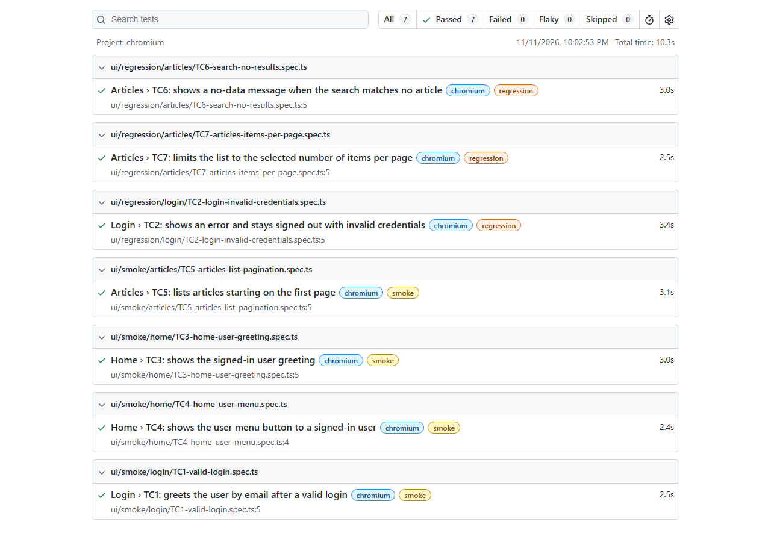
Playwright HTML report — all 7 tests passing on Chromium
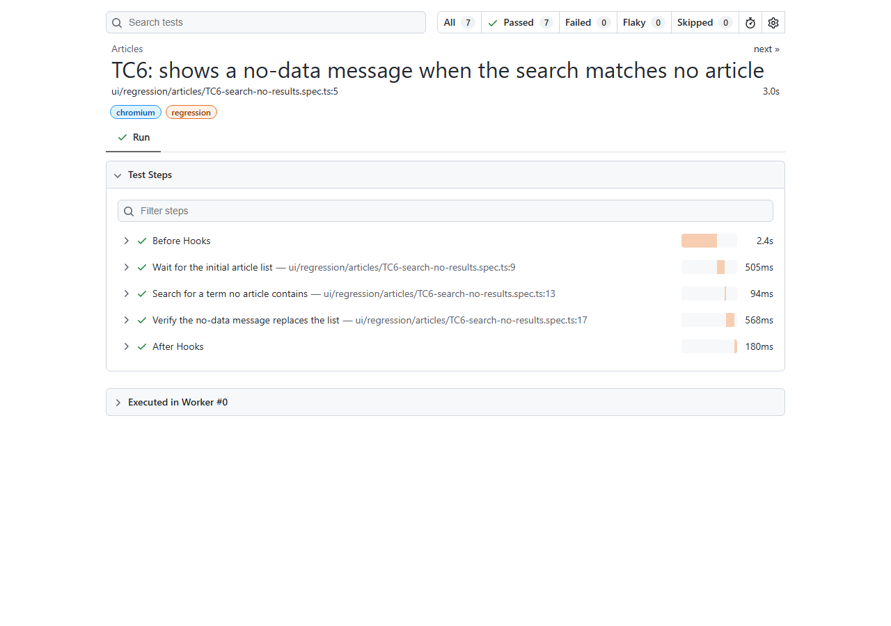
TC6 detail — test.step() labels shown in the report
Note: TC4 also passes when logged out, because GAD always renders the menu button. It is a weak check and a candidate for a stronger test later.

5. Screenshots of written files
All files are committed on main. Long files are split into consecutive parts.

.claude/skills/git-standards/SKILL.md (new)
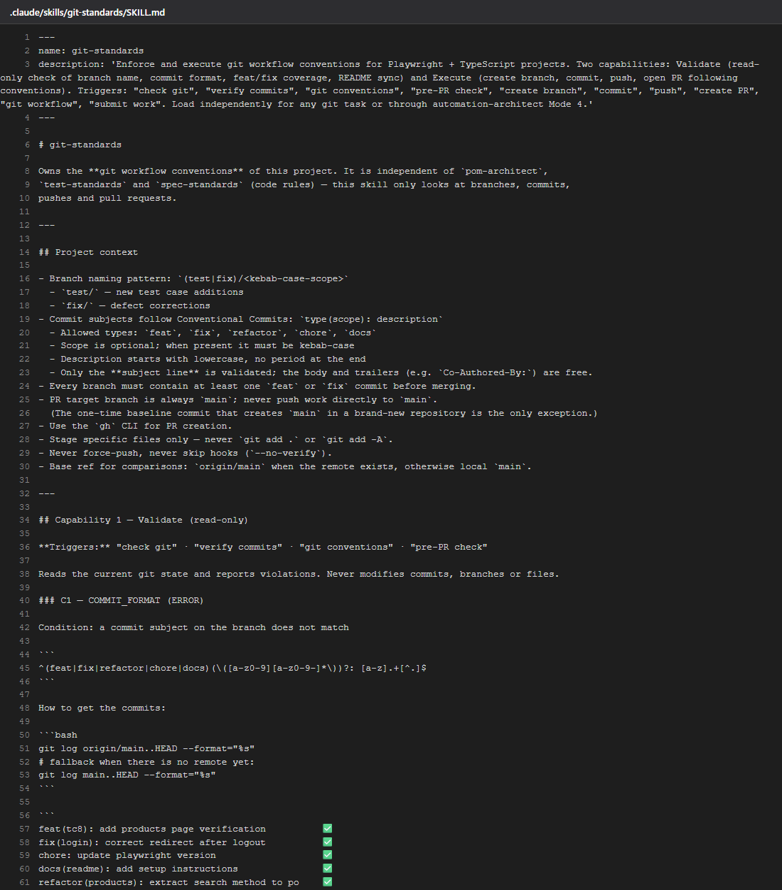
.claude/skills/git-standards/SKILL.md (new) — part 1 of 4
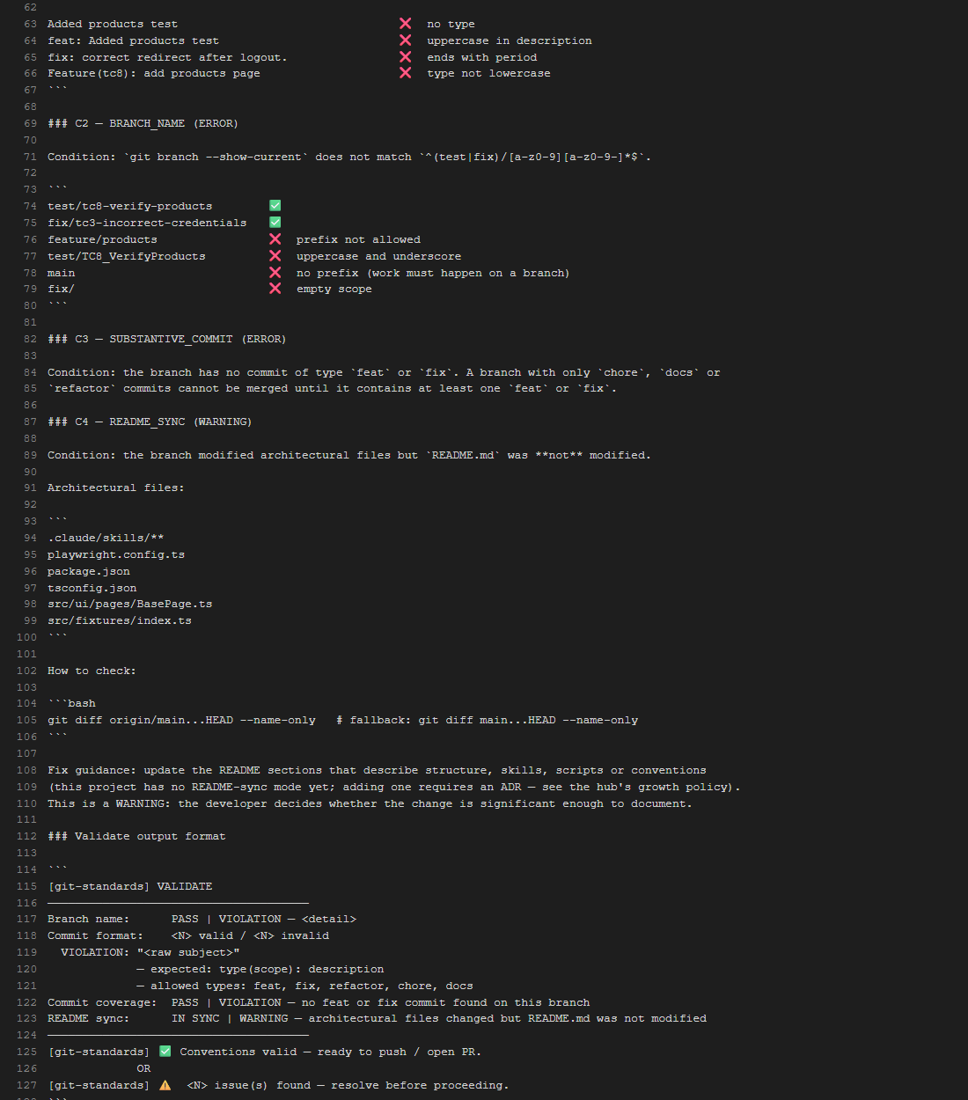
.claude/skills/git-standards/SKILL.md (new) — part 2 of 4
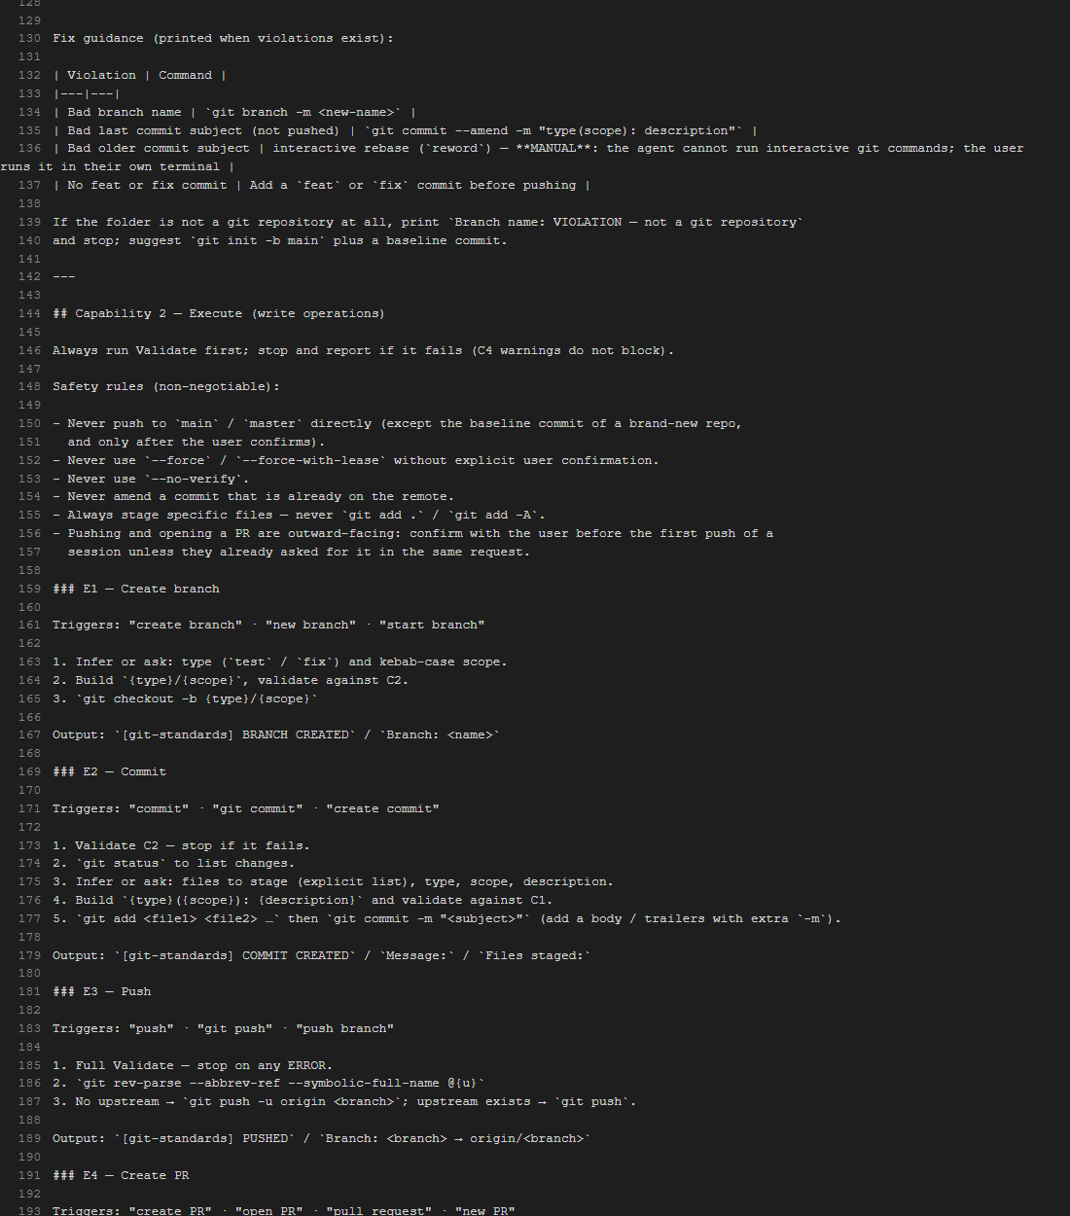
.claude/skills/git-standards/SKILL.md (new) — part 3 of 4
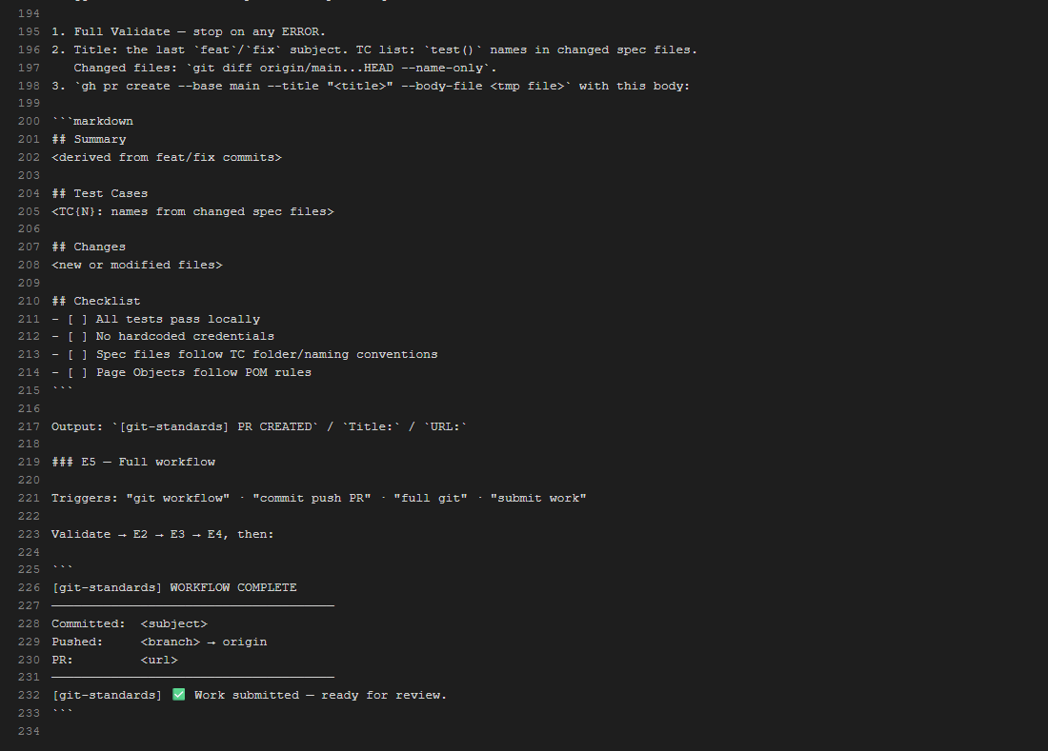
.claude/skills/git-standards/SKILL.md (new) — part 4 of 4

.claude/skills/spec-standards/SKILL.md (new)
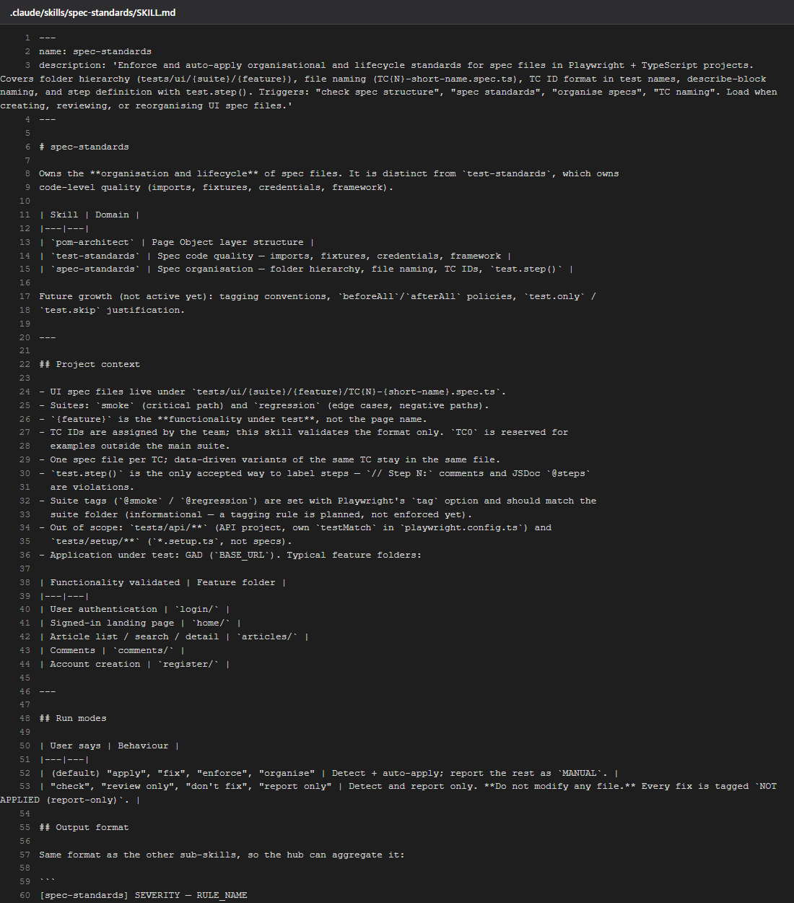
.claude/skills/spec-standards/SKILL.md (new) — part 1 of 3
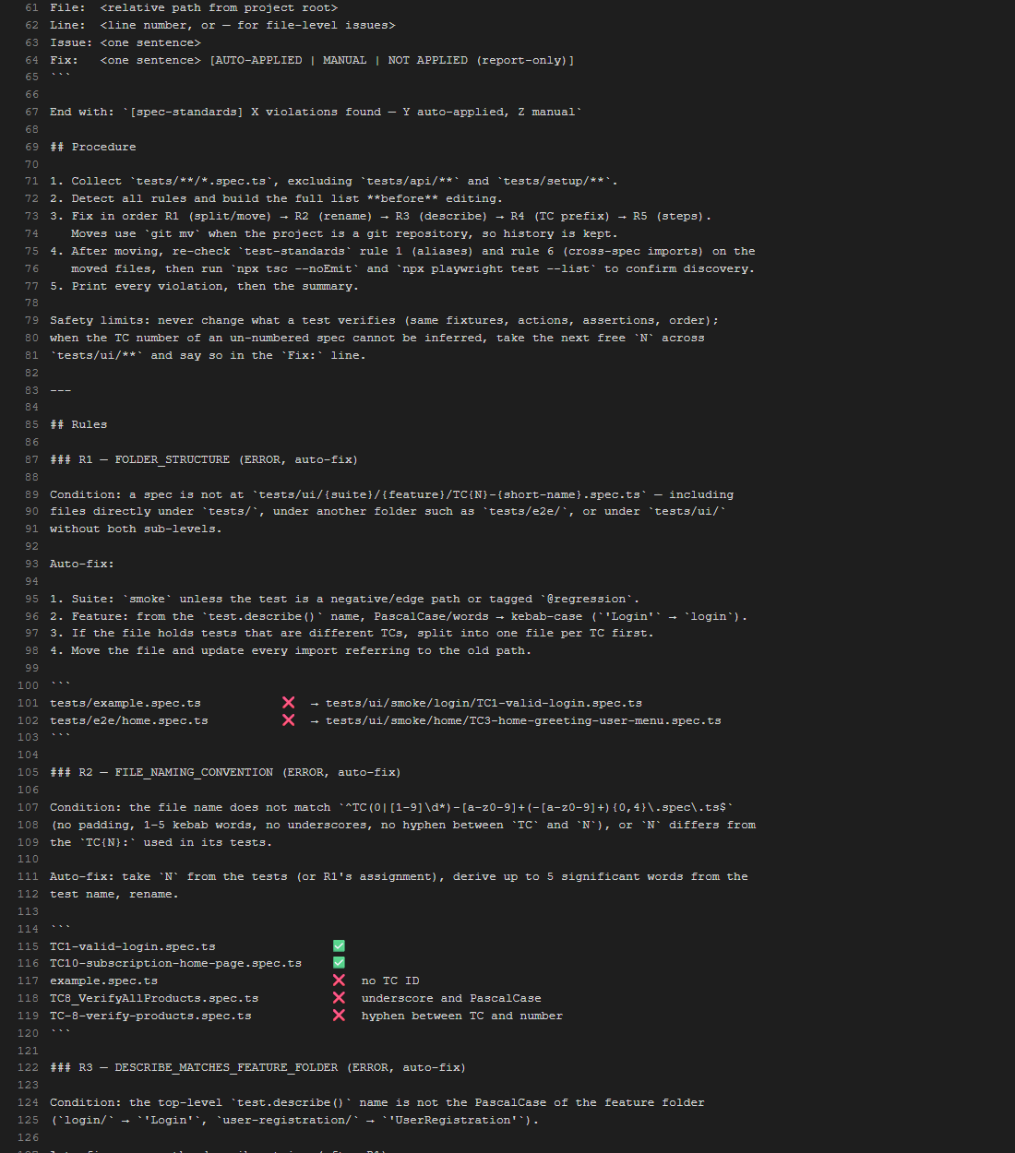
.claude/skills/spec-standards/SKILL.md (new) — part 2 of 3
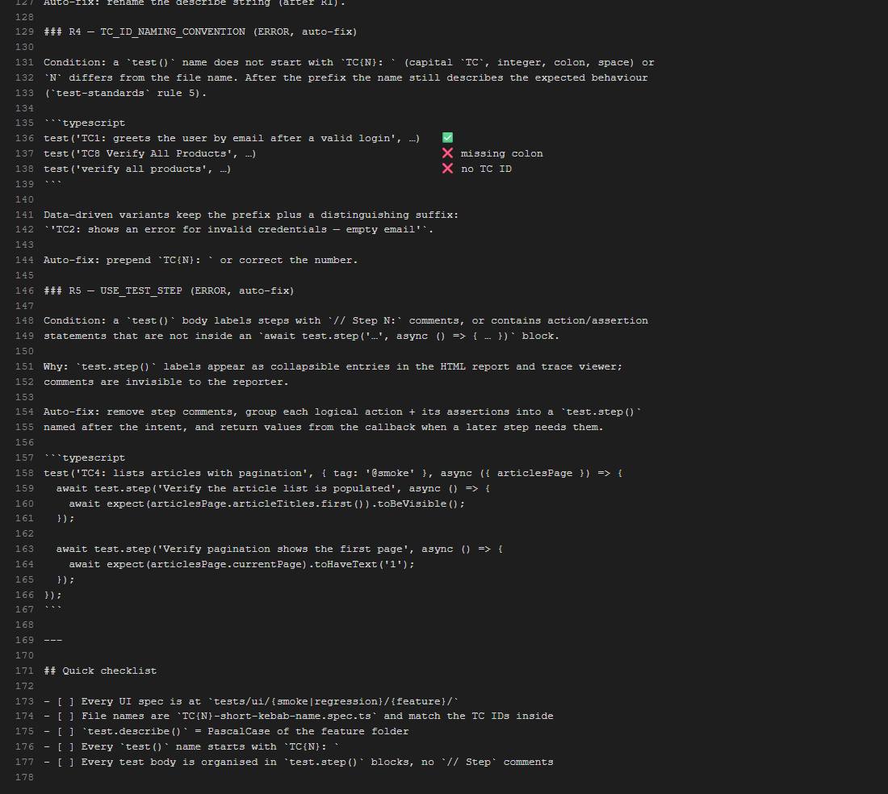
.claude/skills/spec-standards/SKILL.md (new) — part 3 of 3

.claude/skills/automation-architect/SKILL.md (hub, updated)
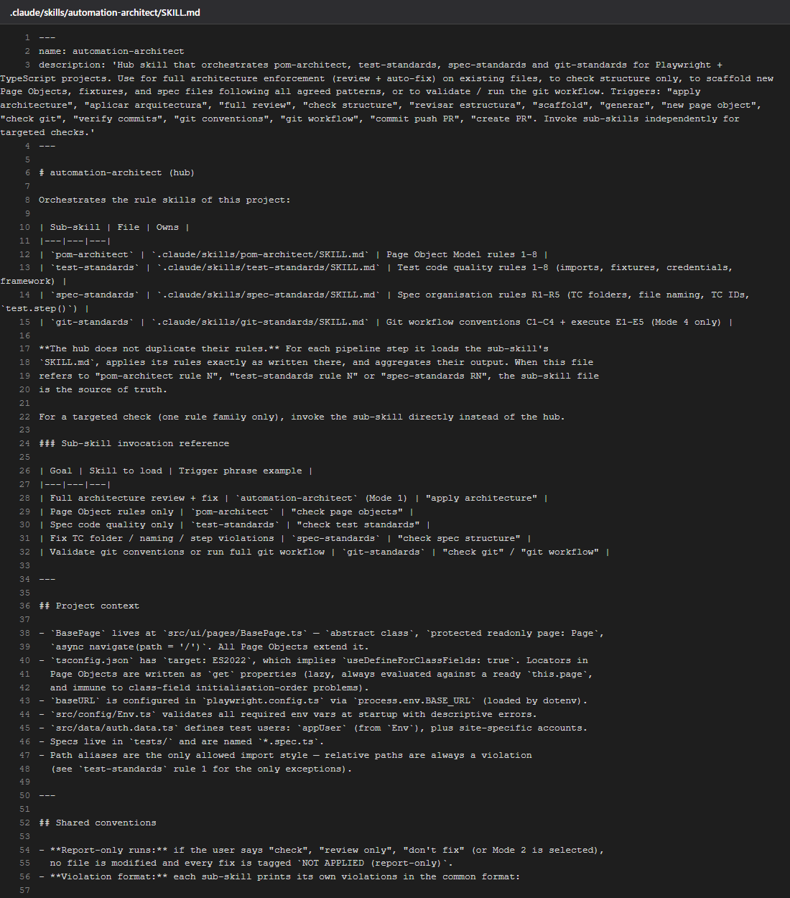
.claude/skills/automation-architect/SKILL.md (hub, updated) — part 1 of 5
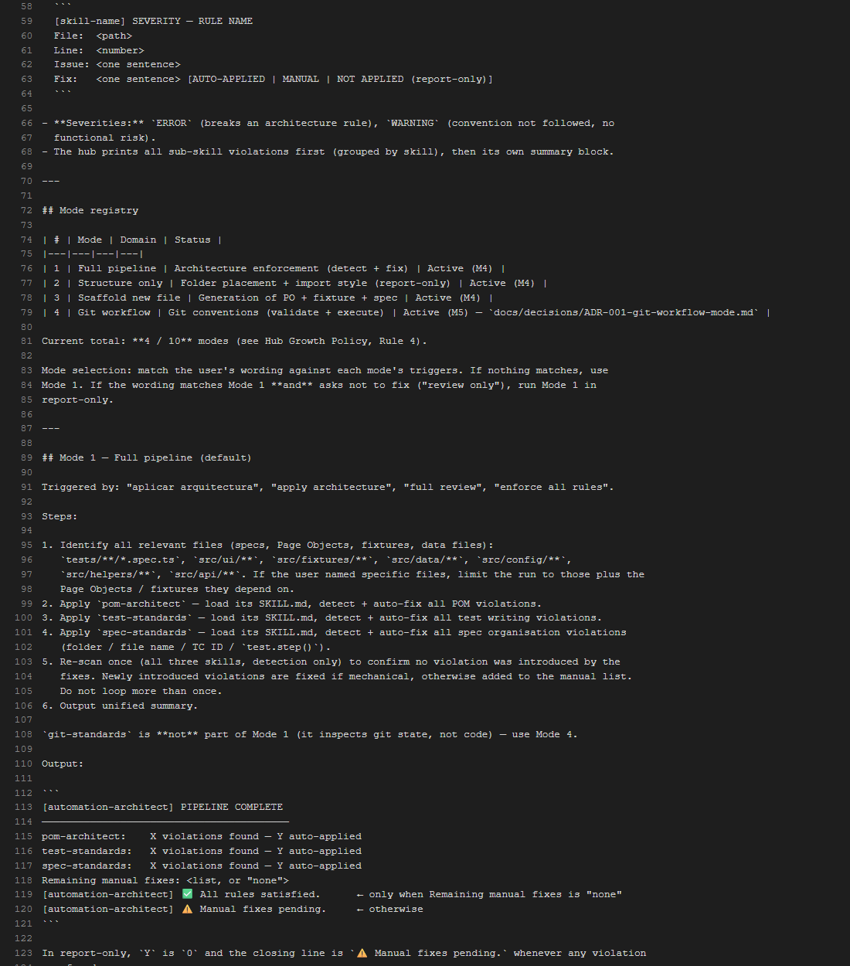
.claude/skills/automation-architect/SKILL.md (hub, updated) — part 2 of 5
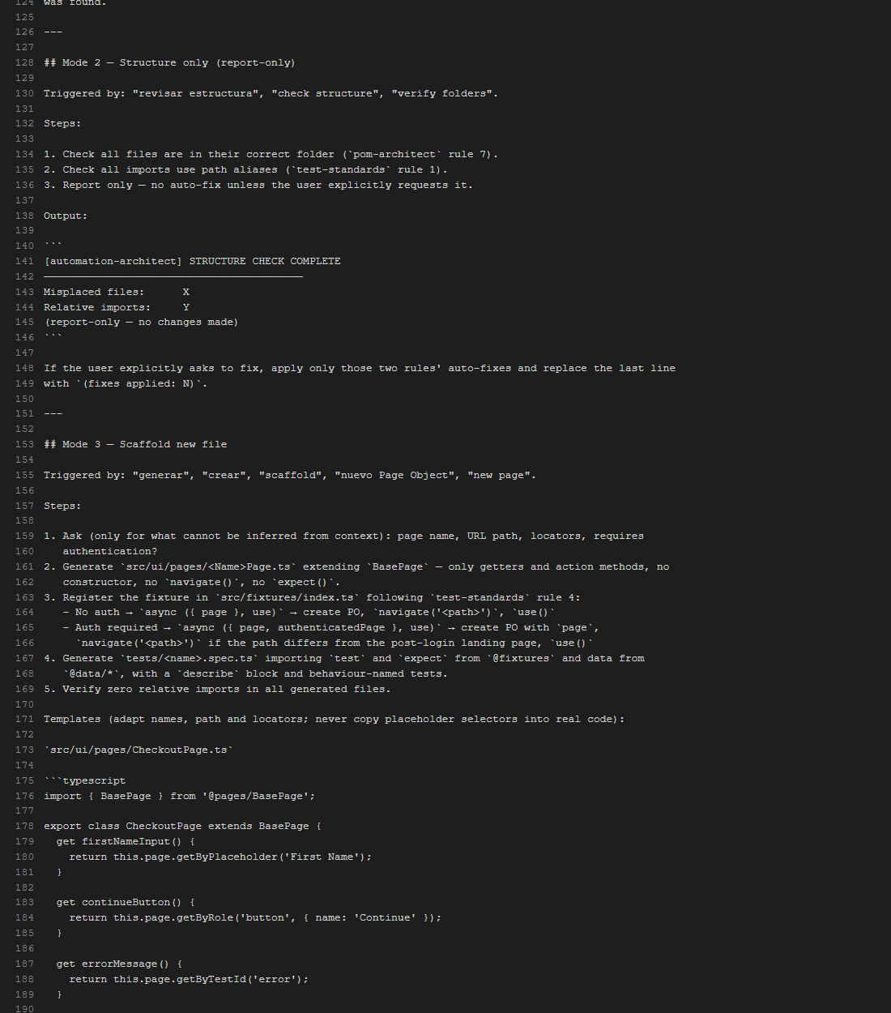
.claude/skills/automation-architect/SKILL.md (hub, updated) — part 3 of 5
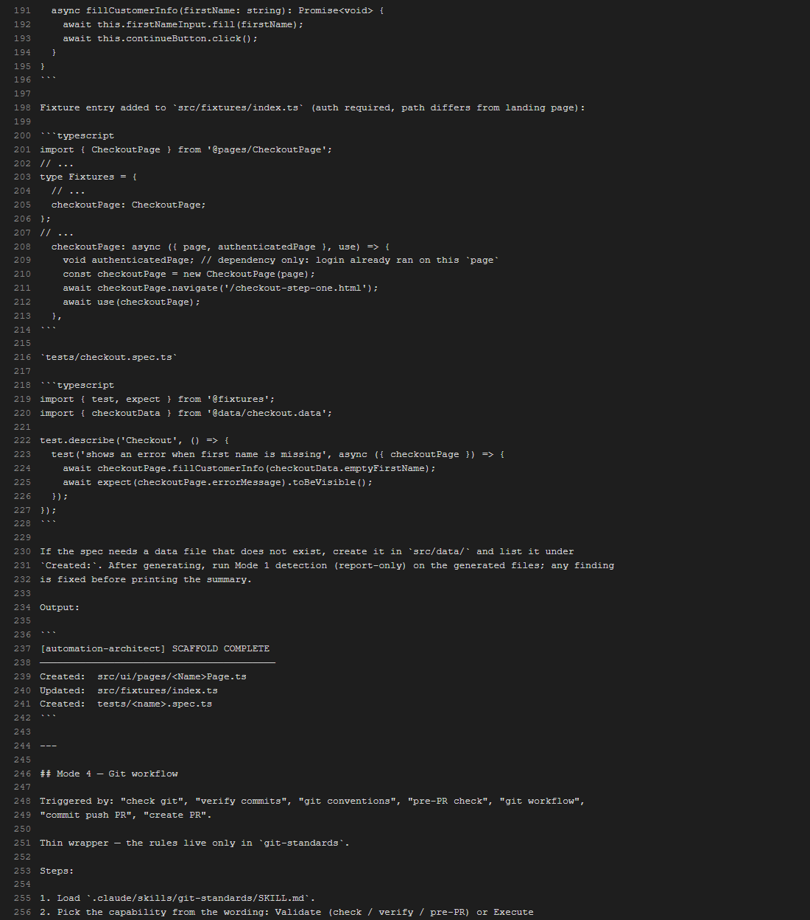
.claude/skills/automation-architect/SKILL.md (hub, updated) — part 4 of 5
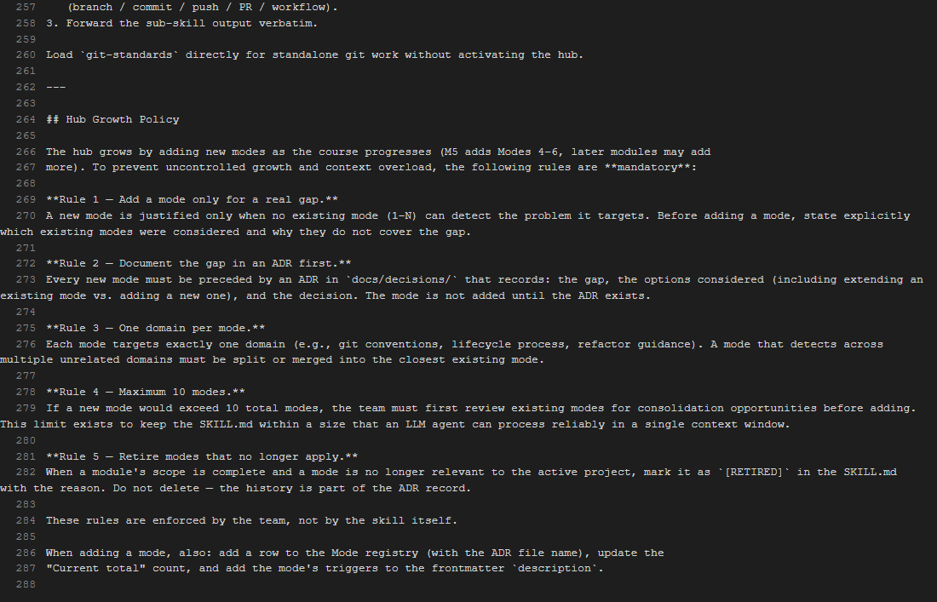
.claude/skills/automation-architect/SKILL.md (hub, updated) — part 5 of 5

docs/decisions/ADR-001-git-workflow-mode.md (new)
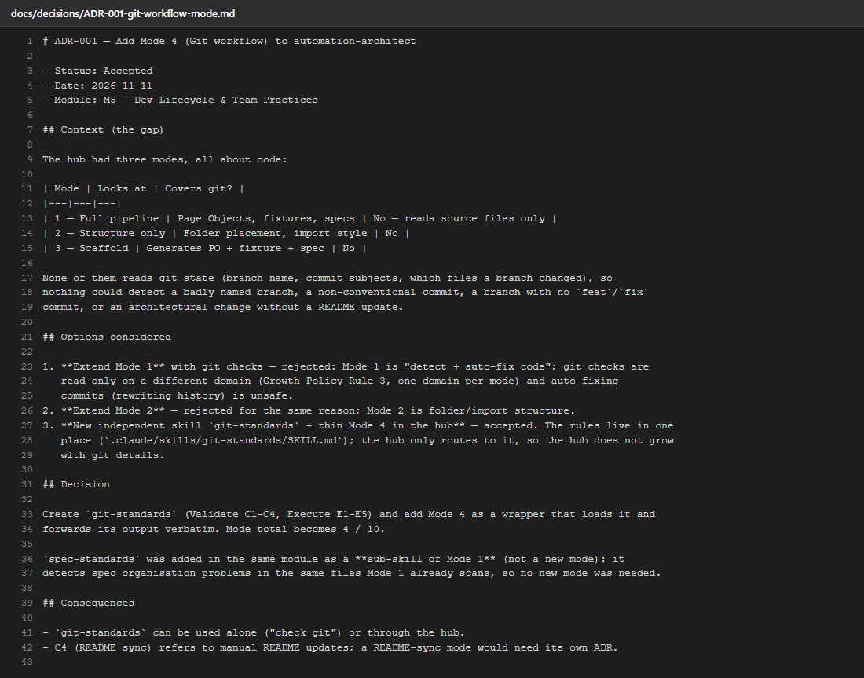
docs/decisions/ADR-001-git-workflow-mode.md (new)

src/ui/pages/ArticlesPage.ts (new Page Object)
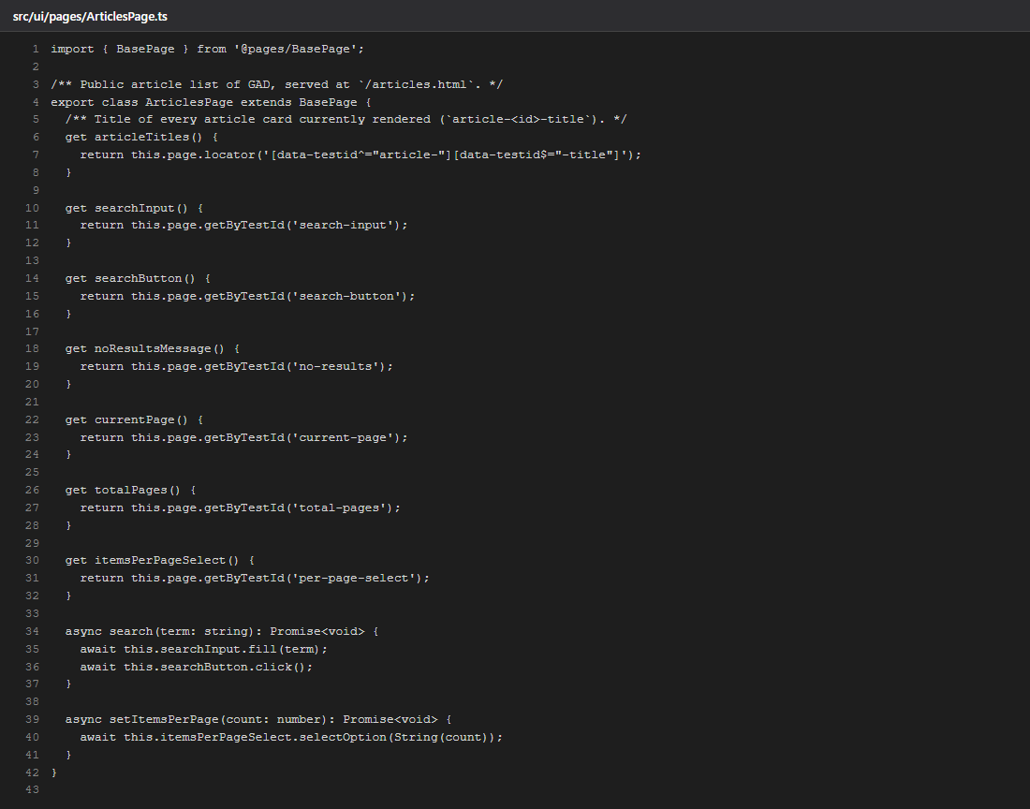
src/ui/pages/ArticlesPage.ts (new Page Object)

src/fixtures/index.ts (articlesPage fixture added)
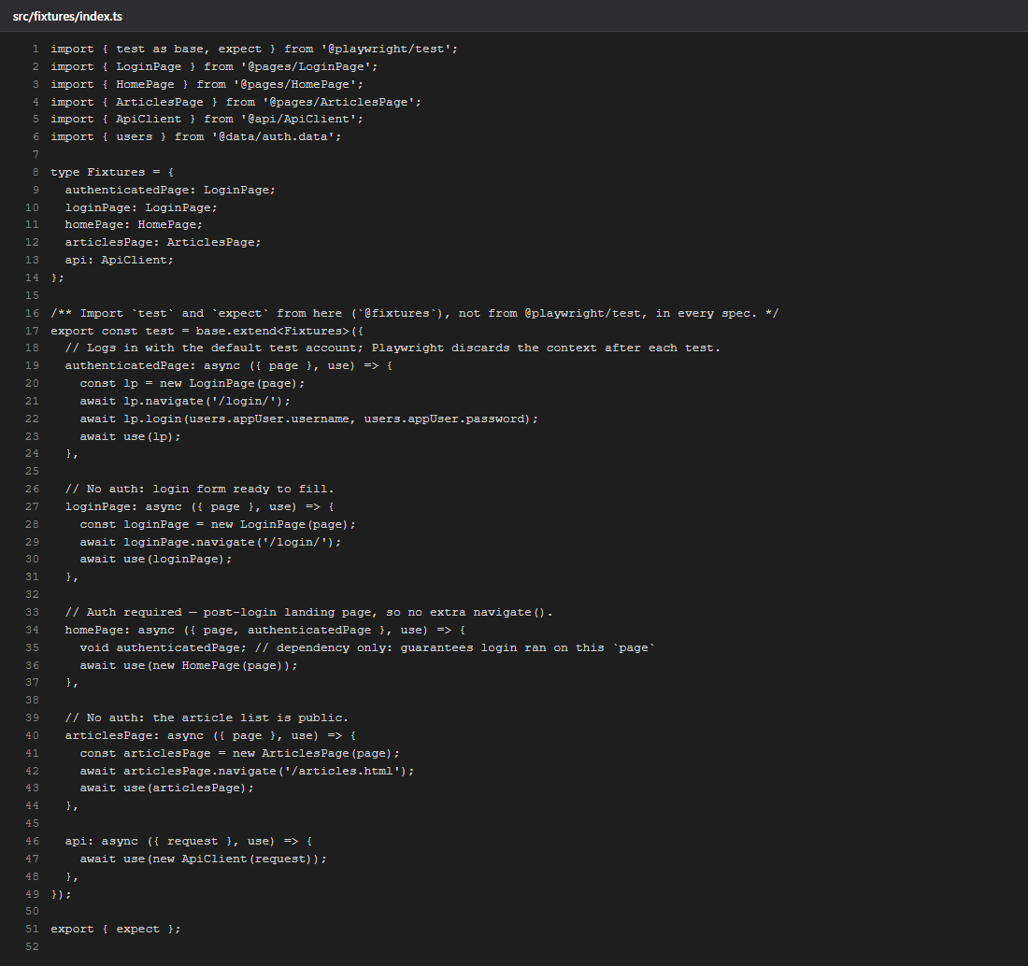
src/fixtures/index.ts (articlesPage fixture added)

src/data/auth.data.ts (invalidUser + loginMessages)
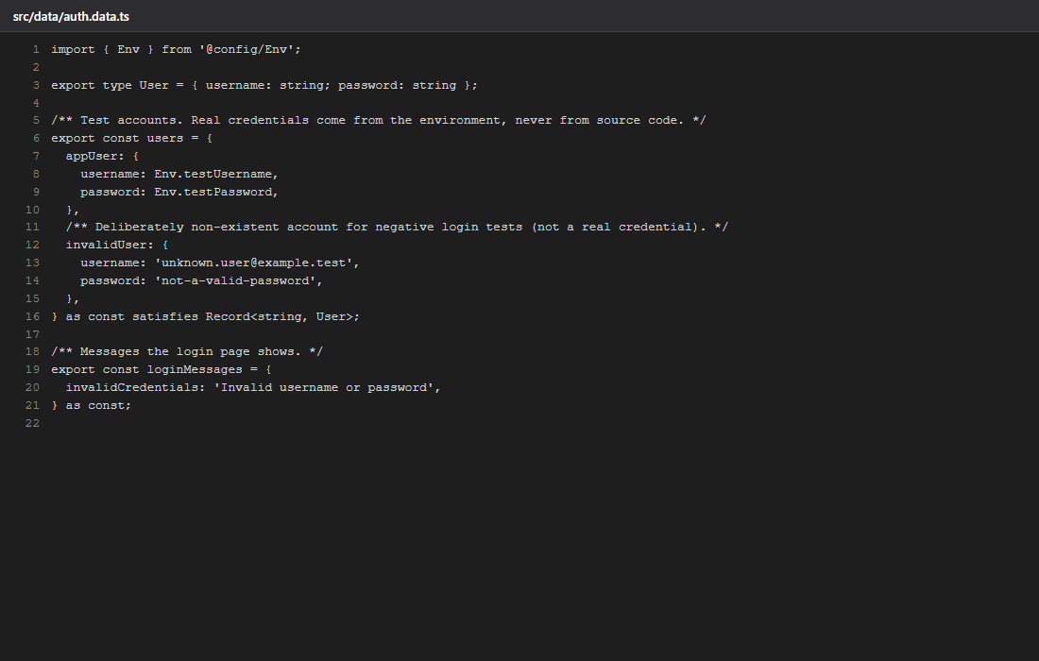
src/data/auth.data.ts (invalidUser + loginMessages)

src/data/articles.data.ts (new)
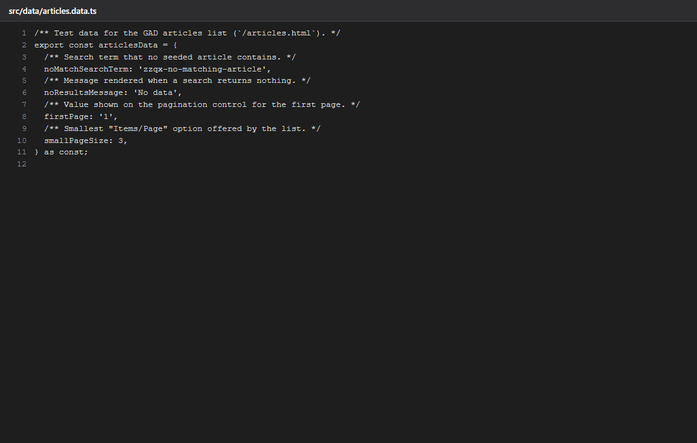
src/data/articles.data.ts (new)

TC1 — tests/ui/smoke/login/TC1-valid-login.spec.ts
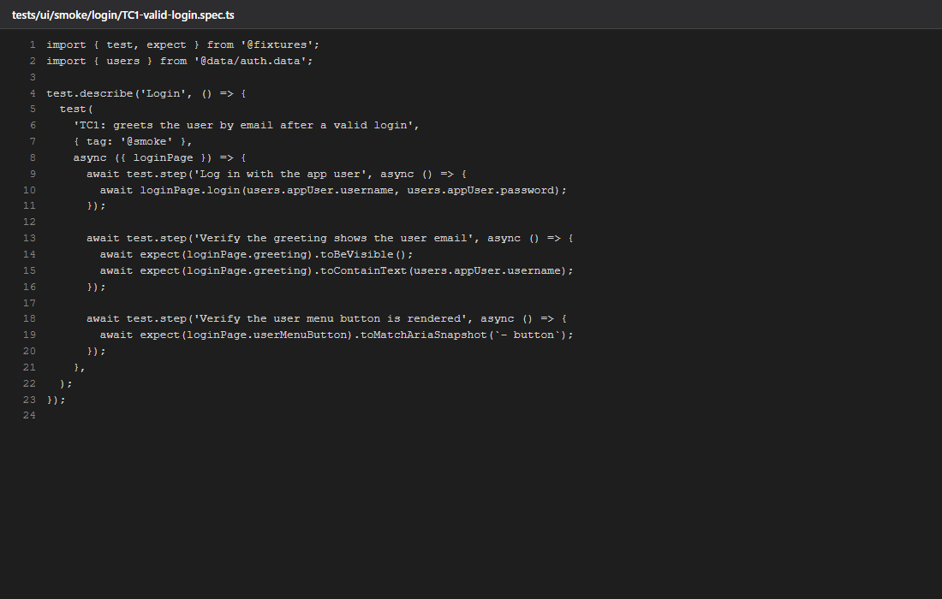
TC1 — tests/ui/smoke/login/TC1-valid-login.spec.ts

TC2 — tests/ui/regression/login/TC2-login-invalid-credentials.spec.ts (new)
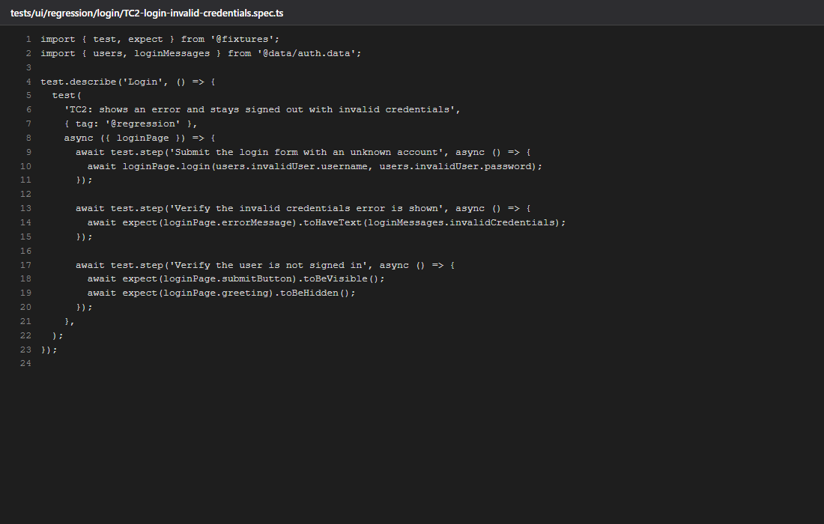
TC2 — tests/ui/regression/login/TC2-login-invalid-credentials.spec.ts (new)

TC3 — tests/ui/smoke/home/TC3-home-user-greeting.spec.ts
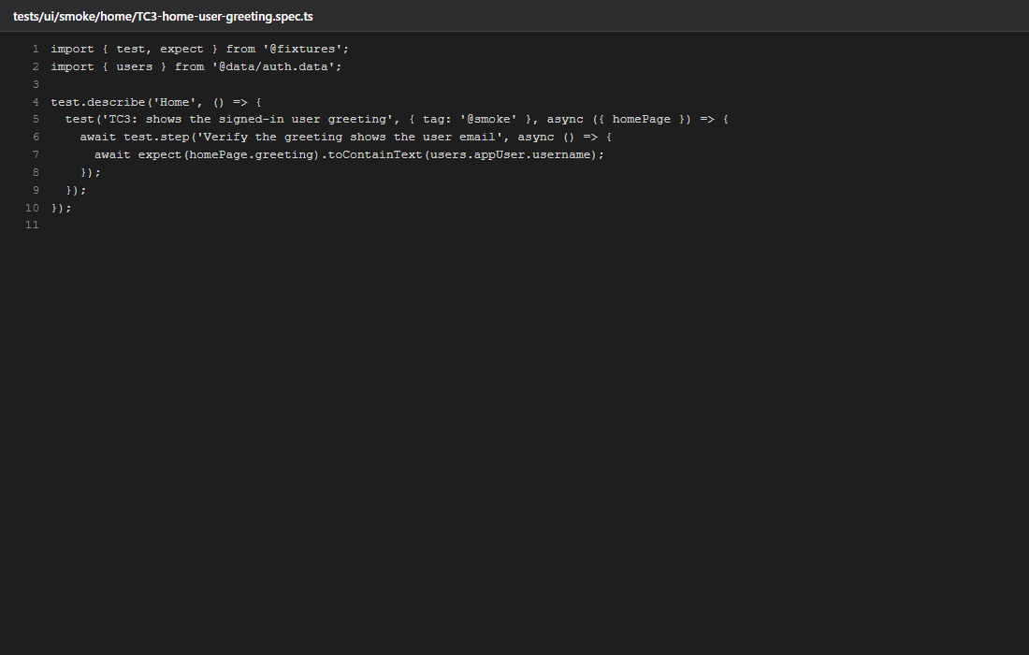
TC3 — tests/ui/smoke/home/TC3-home-user-greeting.spec.ts

TC4 — tests/ui/smoke/home/TC4-home-user-menu.spec.ts
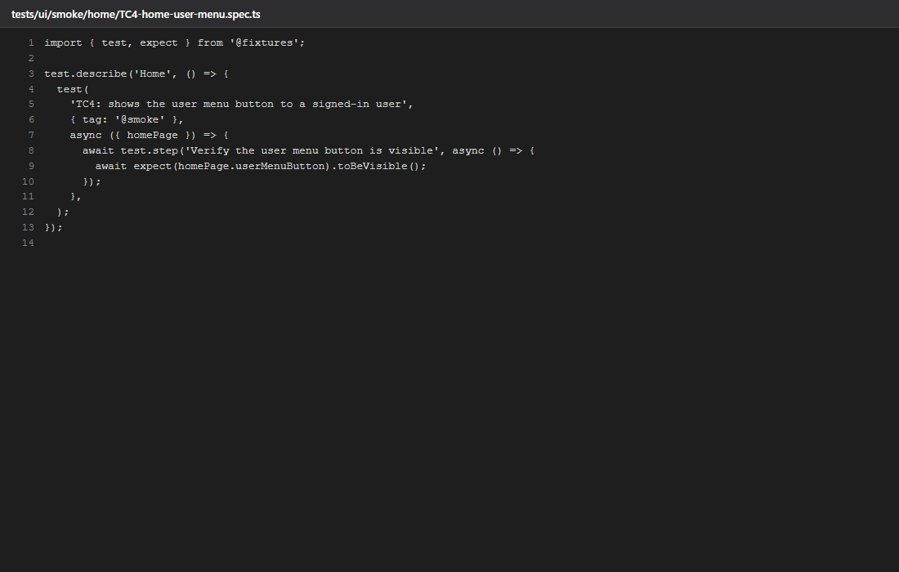
TC4 — tests/ui/smoke/home/TC4-home-user-menu.spec.ts

TC5 — tests/ui/smoke/articles/TC5-articles-list-pagination.spec.ts (new)
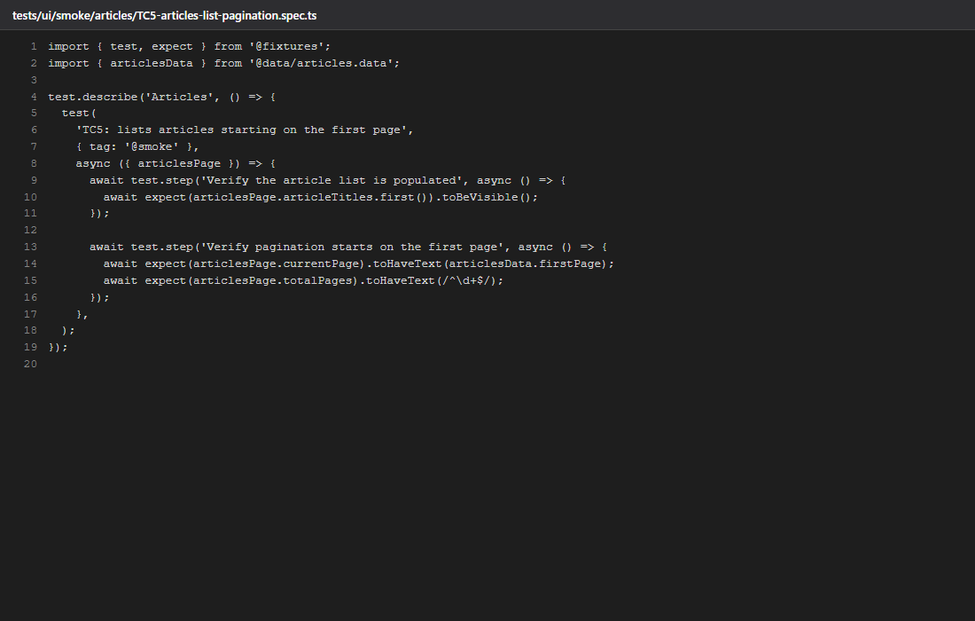
TC5 — tests/ui/smoke/articles/TC5-articles-list-pagination.spec.ts (new)

TC6 — tests/ui/regression/articles/TC6-search-no-results.spec.ts (new)
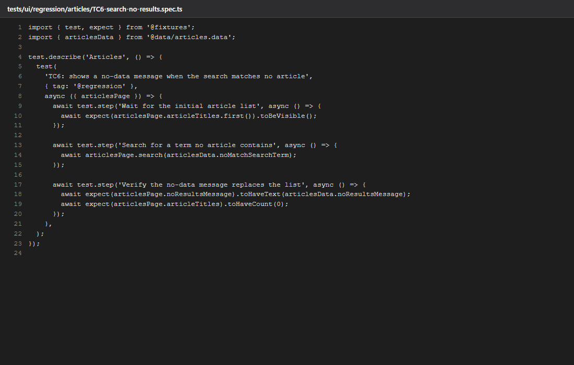
TC6 — tests/ui/regression/articles/TC6-search-no-results.spec.ts (new)

TC7 — tests/ui/regression/articles/TC7-articles-items-per-page.spec.ts (new)
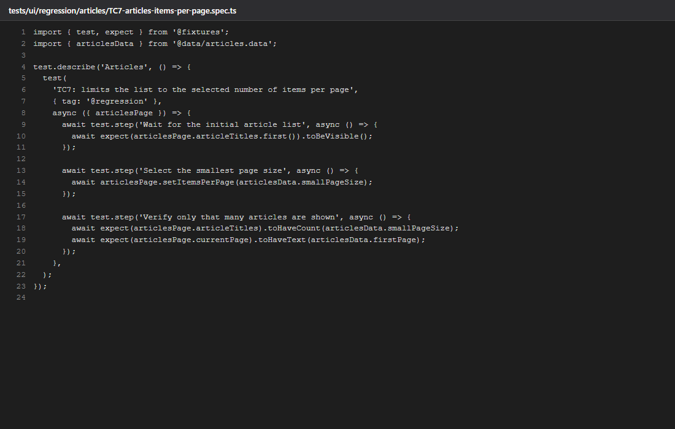
TC7 — tests/ui/regression/articles/TC7-articles-items-per-page.spec.ts (new)

docs/evidence/M5-before-report.md (BEFORE output)
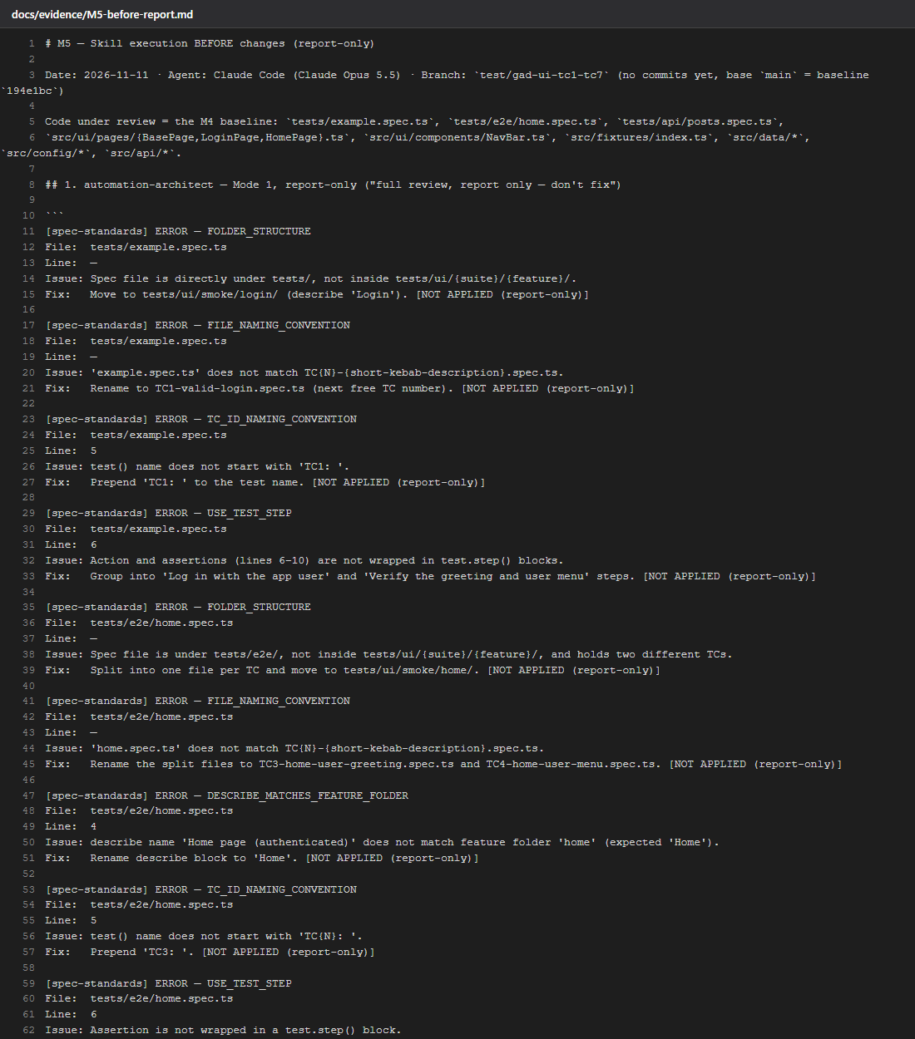
docs/evidence/M5-before-report.md (BEFORE output) — part 1 of 2
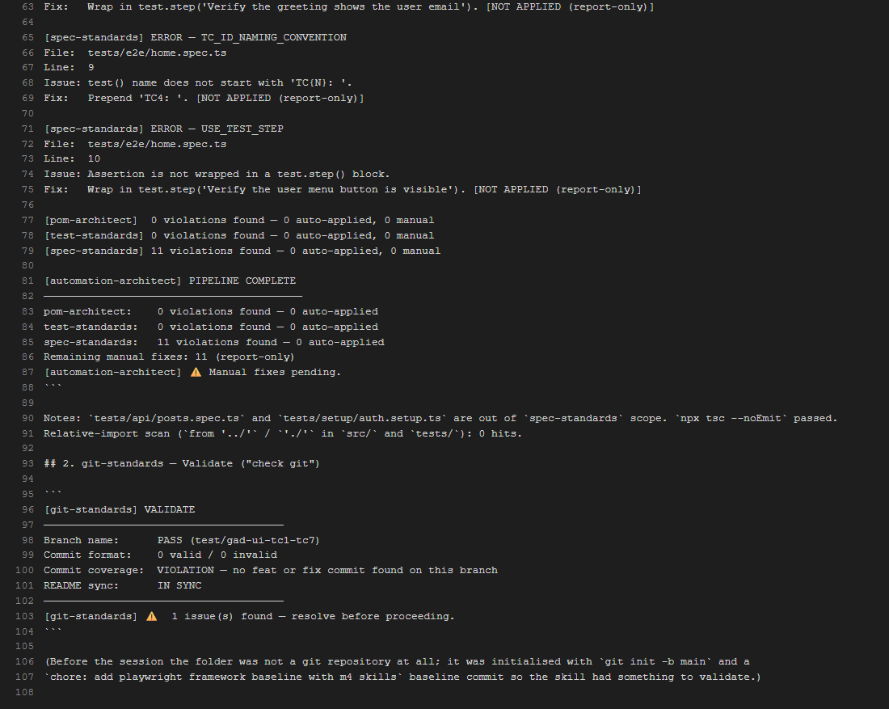
docs/evidence/M5-before-report.md (BEFORE output) — part 2 of 2

