Technical description

Table of Contents
Architecture overview 1
Technology 1

Architecture overview
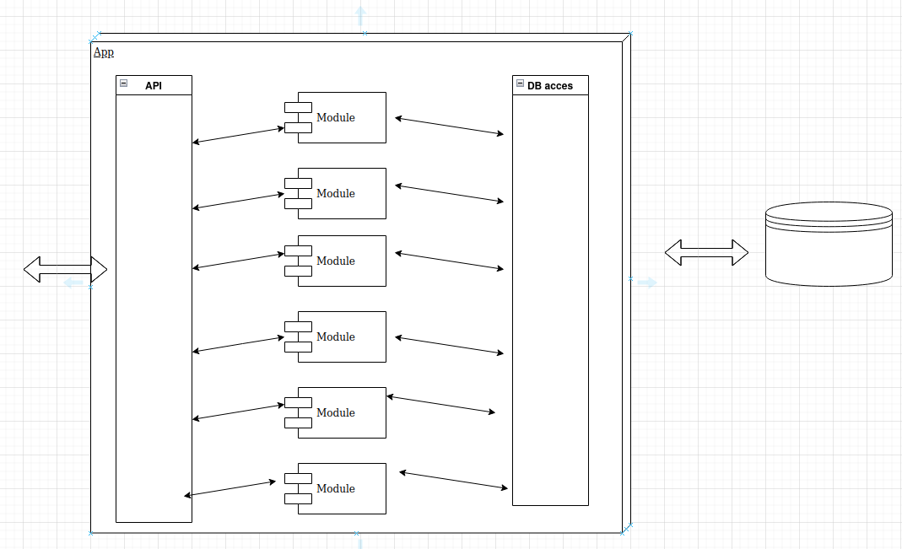

The application is designed as a modular monolith with three layers.
- The API layer, responsible for handling requests and validating them.
- The business layer, which consists of multiple independent modules (e.g., search module, request storage module, printing module).
- DB access layer, responsible for communicating with the database and containing data definitions.

Technology

Basic
- Java 17 (long term support version)
- Spring Boot
- Maven

Checkstyle
Used for a static code analysis tool to enforce coding standards and conventions
Docker
Used to automate the deployment and management of applications within software containers.
For development use it to start DB.
For production used it to deployment and start app.
Liquidbase
Used for DB migration.
Mapstruct
Mapping java objects from one to another, mostly used to map from entity to dto and vice versa
OpenAPI
Using OpenAPI to generate documentations and generate stubs for API endpoints.
Also some basic build-in and custom (oib validator) validation
Junit5, Mockito Testcontainers
Using Junit5 and Mockito for junit test and Testcontainers to set up infra for integration tests

