Application Architecture

Mainly based on:

- layered architecture ( n–tire architecture)
- separation by modules (also called components)
- clean code principles (SOLID, KISS, YAGNI)

Here are the pros and cons of using a architecture like this:

Pros
- deployment:
On every change you must redeploy entire application (or large portion of the application), but with today’s CI tools this is not problem.
- development:
Pattern is not complex to implement
- testabilty:
Layers can be mocked or stubbed to test specific functionality making it relatively easy to test

Cons
- agility:
Change can be isolated through the layers of isolation feature. But sometimes may happened that change will affect more than one layer.
- performance:
Can perform well, but the request must go though multiple layers
- scalability:
Expensive to scale (multiple node of app or split layers into multiple nodes)

Diagram

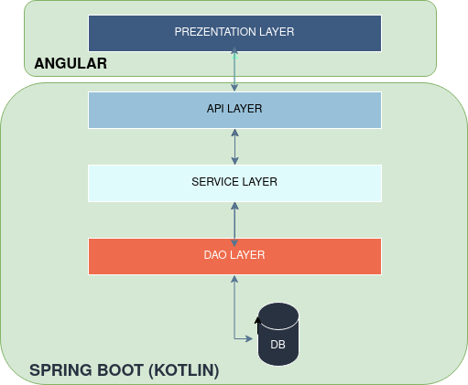

In short, data flow look like this (from top to bottom)

- Request is sent from the presentation layer (angular application) through REST using plan dto json. Request should have all data and configuration that is necessary to execute operation
- API layer parses json and created Command/Query object and passes it to a Service layer
- Service layer handles this Command/Query, executes business logic and uses Dao layer to update state on DB, also returns result of operation to API layer who send its back to presentation

Keep in mind that each layer of the app has a specific role and responsibility within application (Layers of isolation concept).
Presentation layer is responsible for handling user interface.
API layer is responsible for exposing rest end points for presentation layer.
Service layer is responsible for executing specific business logic (rules) associated with the request.
Dao layer is responsible is persistence

Separation by modules

Also called separation by components. Each module gets its own folder with a dedicated code base, because it is easier to work on things that change together if those things are gathered relatively close to each other.

Try not to create dependencies between modules or use cases, move shared logic into a separate files and make both depend on that instead of depending on each other.

Presentation layer
Angular

PrimeNg Angular

API layer
Dto’s
Command/Query
Mapping
Swagger
Rest

Service Layer
Bussines operations

DAO Layer
Entities

Validation
On FE

Validation at end point

business logic validation

Exception Handling
Types
Fall as sun as possible

Using Libraries

Main recommendations to keep in mind is that libraries imported in application shouldn't be expose, so consider creating an anti-layer corruption layer by using adapter of facade patterns.

Testing

Black Box
Load (Performance) testing
Fuzz Testng

Configuration

Store all configurable variables/parameters in config files.
Never store sensitive configuration variables (passwords/API keys/secret keys etc) in plain text in a configuration files or source code.
Environment variables

Logging

Monitoring

Code analysis
Also code convention

Documentation

Endpoints (also examples)
User Guide
tehnical and architecture doc (this)
business doc
developer build guide how to start project

DB Migration

Pre-push/pre-commit hooks

Also convention for commits
Git pipline

Deploy

Docker and other stuf

