Architecture Decisions

Table of Contents
How to read this document 3
Notes 3
Basic Architecture 2023-08-17 4
Components 4
Benefits 4
Pros and Cons 5
Conclusion 5

How to read this document
This document is keeping track architectural decisions.
This document serves as a comprehensive record of the architectural decisions made throughout the development process. Each architectural decision is documented under a header, providing a clear structure for understanding the evolution of the project. The document format is designed to enhance readability and traceability, enabling stakeholders to follow the decision-making process effectively.

Notes
- Decisions Log:
  - Each architectural decision is captured under a header that includes the topic name and the decision date in italic format. For example: "Basic Architecture 2023-08-17."
- Updating the Document:
  - As new architectural decisions are made, add headers with the topic name and the decision date.
  - Include detailed descriptions following the context, rationale, considerations, and implications format.
- Review and Maintenance:
  - Periodically review and update the document to reflect the latest architectural decisions and their impact.
Conclusion: This document's structure and content provide a roadmap for understanding the architectural decisions shaping the project. By following the chronological headers and exploring the decision details, stakeholders can gain insight into the project's direction, evolution, and the reasoning behind its architectural choices.

Basic Architecture 2023-08-17

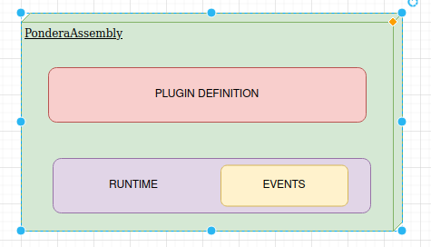

Components
- Plugin Declaration/Definition Module: This module provides annotations for marking plugins and defining lifecycle hooks. Developers use these annotations in client code to identify and manage plugins.
- Plugin Runtime Module: This module houses the "PonderaKernel," a runtime responsible for managing plugin lifecycles. It coordinates plugin loading, initialization, and communication.
  - Events Sub-Module: Responsible for facilitating event-based communication between plugins. Events enable plugins to interact, exchange data, and trigger actions.

Benefits
- Simplicity: Annotation-based identification and lifecycle management streamline plugin integration.
- Efficiency: Plugins run in separate processes, minimizing disruptions and resource conflicts.
- Innovation: Extension points and event-based communication encourage modular development and creative enhancements.
- Compatibility: Modern design ensures compatibility with contemporary Java versions and practices.
- User-Friendly: Seamless integration and comprehensive documentation reduce learning curves.

Pros and Cons
Pros:
- Streamlined integration process, reducing complexity and configuration overhead.
- Enables modular development and creative enhancements through extension points.
- Promotes loose coupling and event-based communication among plugins.
- Simplifies plugin lifecycle management through annotations and the "PonderaKernel."
- Supports modern Java versions and practices, ensuring compatibility and longevity.
Cons:
- Plugin separation in separate processes may introduce communication overhead.
- Event-based communication might require careful design to ensure efficiency and responsiveness.
- Annotation-based approach might be limiting in certain complex scenarios.
- Plugin interactions and dependency management could become challenging in larger systems

Conclusion
The "PonderaAssembly" architecture bridges the gap in the plugin framework landscape, providing developers with a user-friendly, lightweight, and modern solution for integrating plugins. By fulfilling the technical requirements, this architecture empowers developers to focus on innovation, enhancing their applications without the complexities found in existing options.

