Technical doc

Table of Contents
Requirements 2
Goal 2
User Requirements 2
Functional Requirements 2
Nonfunctional Requirements 2
Performance Requirements 2
Security Requirements 2
Design and Implementation Constraints 2
Quality Assurance Requirements 3
Documentation Requirements 3
Architecture overview 4
Software design 5
Major Classes 5
Data Design 5
Error handling 5
Programming/Coding conventions 5
Code quality 5
Technology info 6

Requirements

Goal
Provide a simple to use library for displaying ongoing match scores during football events.

User Requirements
- Users should be able to start match .
- Users should be able to update match scores.
- Users should be able to finish matches.
- Users should be able to view a summary of ongoing matches sorted by total score (max first) and started time (earliest first)

Functional Requirements
- The lib should allow the initiation of new matches with initial scores.
- The lib should allow the updating of match scores.
- The lib should allow the removal of finished matches.
- The lib should provide a summary of ongoing matches sorted by total score.

Nonfunctional Requirements
- The system should be implemented using an in-memory store solution.
- The system should follow Test-Driven Development (TDD) practices.
- The system should adhere to Object-Oriented (OO) design principles.
- The system should ensure clean code practices.
- The system should not have external dependencies.

Performance Requirements
No performance requirements

Security Requirements

No security requirements

Design and Implementation Constraints
- The lib should be implemented as a simple library without the need for external APIs or services.
- The lib should utilize an in-memory store solution for data storage.
- The lib does not have dependencies on external systems or APIs.

Quality Assurance Requirements
- The lib is implemented using TDD approach
- The lib use statistical code analysis tool
- The lib also has integration tests

Documentation Requirements
- The lib have technical doc for keeping track of technical decisions (this)
- The lib have README file includes how to start app, start tests, build app and links to useful documentation

Architecture overview
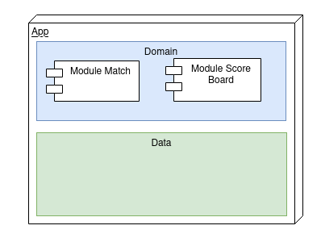

The application is designed as a modular monolith with two layers.
- The Domain layer contains the core business logic.
- The Data layer responsible for data storage.
The client interacts with library using interfaces without beaning aware of their concrete implementations.

Pros
- SRP: separating components responsible for specific functionality

Cons
- tight coupling when accessing data

Software design

Major Classes

Match interface represents individual matches
MatchService interface manages match lifecycle operations or the match,
Repo interface handles persistence operations for matches
ScoreBoard interface displays ongoing match information retrieved through the MatchService interface.
These interfaces work together to provide a comprehensive solution for managing and displaying live football match scores.

Data Design
Each Match entity encapsulates the data associated with an individual football match, including team names, scores, start time.
Each match is uniquely identified by home Team name away Team name and in Progress flag.
The Repository pattern is utilized to manage persistence operations for Match entities.
- The Repo interface defines generic methods for saving, updating, deleting, and filtering Match objects.
- The repository implementation interacts with an in-memory data store to perform CRUD operations on Match entities.

Error handling
Error conditions and edge cases are addressed as part of the overall development process, through the addition of new test cases or through refactoring existing code to handle errors as they arise.

Programming/Coding conventions
Code formatting: Google code formatting
Coding to interfaces approach (interface that defines what the behavior of the object should be. It involves creating an interface first, defining its methods and then creating the actual class with the implementation)
Single responsibility principle (A class should have one, and only one, reason to change)
Follow DRY (Don't Repeat Yourself)

Code quality
- TDD approach
- SOLID principles
- KISS
- integration test
- statistical code analysis tool: SpotBugs

