database is a collection of data or records. Database management systems are designed to manage databases. A database management system (DBMS) is a software system that uses a standard method to store and organize data. The data can be added, updated, deleted, or traversed using various standard algorithms and queries.

**Types of Database Management Systems**

There are several types of database management systems. Here is a list of seven common database management systems:

1. Hierarchical databases
2. Network databases
3. Relational databases
4. Object-oriented databases
5. Graph databases
6. ER model databases
7. Document databases
8. NoSQL databases

**Hierarchical Databases**

In a hierarchical database management system (hierarchical DBMSs) model, data is stored in a parent-children relationship node. In a hierarchical database, besides actual data, records also contain information about their groups of parent/child relationships.

In a hierarchical database model, data is organized into a tree-like structure. The data is stored in the form of a collection of fields where each field contains only one value. The records are linked to each other via links into a parent-children relationship. In a hierarchical database model, each child record has only one parent. A parent can have multiple children.

To retrieve a field’s data, we need to traverse through each tree until the record is found.

The hierarchical database system structure was developed by IBM in the early 1960s. While the hierarchical structure is simple, it is inflexible due to the parent-child one-to-many relationship. Hierarchical databases are widely used to build high-performance and availability applications usually in the banking and telecommunications industries.

The IBM Information Management System (IMS) and Windows Registry are two popular examples of hierarchical databases.

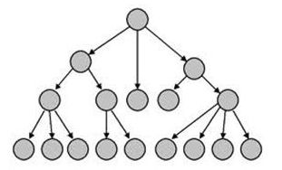

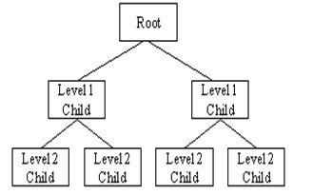

**Advantage**

A hierarchical database can be accessed and updated rapidly. As shown in the figure above, its model structure is like a tree and the relationships between records are defined in advance. This feature is a double-edged sword.

**Disadvantage**

This type of database structure is that each child in the tree may have only one parent. Relationships or linkages between children are not permitted, even if they make sense from a logical standpoint. Hierarchical databases are like this in their design. Adding a new field or record requires that the entire database be redefined.

**Network Databases**

Network database management systems (Network DBMSs) use a network structure to create a relationship between entities. Network databases are mainly used on large digital computers. Network databases are hierarchical databases, but unlike hierarchical databases where one node can have a single parent only, a network node can have a relationship with multiple entities. A network database looks more like a cobweb or interconnected network of records.

In network databases, children are called members and parents are called occupiers. The difference between each child or member is that it can have more than one parent.

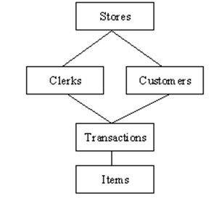

The approval of the network data model is similar to a hierarchical data model. Data in a network database is organized in many-to-many relationships.

The network database structure was invented by Charles Bachman. Some of the popular network databases are the Integrated Data Store (IDS), IDMS (Integrated Database Management System), Raima Database Manager, TurboIMAGE, and Univac DMS-1100.

**Relational Databases**

In a relational database management system (RDBMS), the relationship between data is relational and data is stored in tabular form of columns and rows. Each column of a table represents an attribute and each row in a table represents a record. Each field in a table represents a data value.

Structured Query Language (SQL) is the language used to query RDBMS, including inserting, updating, deleting, and searching records. Relational databases work on each table that has a key field that uniquely indicates each row. These key fields can be used to connect one table of data to another.

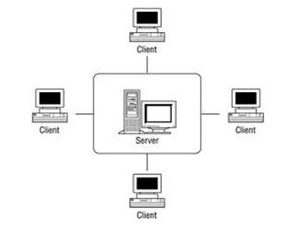

Relational databases are the most popular and widely used databases. Some of the popular DDBMS are Oracle, SQL Server, MySQL, SQLite, and IBM DB2.

**The relational database has two major advantages:**

1. Relational databases can be used with little or no training.
2. Database entries can be modified without specifying the entire body.

**Properties of Relational Tables**

In a relational database, we have to follow the properties given below:

* Values are Atomic
* Each Row is alone.
* Column Values are the same thing.
* Columns are undistinguished.
* Sequence of Rows is Insignificant.
* Each Column has a common name.

**Object-Oriented Model**

In this Model, we have to discuss the functionality of object-oriented Programming. It takes more than the storage of programming language objects. Object DBMS's increase in the semantics of C++ and Java. It provides full-featured database programming capabilities while containing native language compatibility. It adds the database functionality to object programming languages. This approach is analogical of the application and database development into a constant data model and language environment. Applications require less code, use more natural data modeling, and code bases are easier to maintain. Object developers can write complete database applications with a decent amount of additional effort.

The object-oriented database derivation is the integrity of object-oriented programming language systems and consistent systems. The power of object-oriented databases comes from the cyclical treatment of both consistent data, as found in databases, and transient data, as found in executing programs.

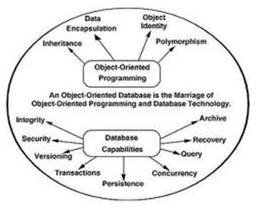

Object-oriented databases use small, recyclable separated from software called objects. The objects themselves are stored in the object-oriented database.

Each object contains two elements:

1. A piece of data (e.g., sound, video, text, or graphics).
2. Instructions, or software programs called methods, for what to do with the data.

Object-oriented database management systems (OODBMs) were created in the early 1980s. Some OODBMs were designed to work with OOP languages such as Delphi, Ruby, C++, Java, and Python. Some popular OODBMs are TORNADO, Gemstone, ObjectStore, GBase, VBase, InterSystems Cache, Versant Object Database, ODABA, ZODB, Poet. JADE, and Informix.

**Disadvantages of Object-oriented databases**

1. Object-oriented databases are more expensive to develop.
2. Most organizations are unwilling to abandon and convert from those databases.

**Benefits of Object-oriented databases**

The benefits of object-oriented databases are compelling. The ability to mix and match reusable objects provides the incredible multimedia capability.

**Graph Databases**

Graph Databases are NoSQL databases and use a graph structure for semantic queries. The data is stored in the form of nodes, edges, and properties. In a graph database, a Node represents an entity or instance such as a customer, person, or car. A node is equivalent to a record in a relational database system. An Edge in a graph database represents a relationship that connects nodes. Properties are additional information added to the nodes.

The Neo4j, Azure Cosmos DB, SAP HANA, Sparksee, Oracle Spatial and Graph, OrientDB, ArrangoDB, and MarkLogic are some of the popular graph databases. Graph database structure is also supported by some RDBMS including Oracle and SQL Server 2017 and later versions.

**ER Model Databases**

An ER model is typically implemented as a database. In a simple relational database implementation, each row of a table represents one instance of an entity type, and each field in a table represents an attribute type. In a relational database, a relationship between entities is implemented by storing the primary key of one entity as a pointer or "foreign key" in the table of another entity.

The entity-relationship model was developed by Peter Chen in 1976.

**Document Databases**

Document databases (Document DB) are also NoSQL databases that store data in the form of documents. Each document represents the data, its relationship between other data elements, and attributes of data. Document database store data in a key-value form.

Document DB has become popular recently due to their document storage and NoSQL properties. NoSQL data storage provides a faster mechanism to store and search documents.

Popular NoSQL databases are Hadoop/Hbase, Cassandra, Hypertable, MapR, Hortonworks, Cloudera, Amazon SimpleDB, Apache Flink, IBM Informix, Elastic, MongoDB, and Azure DocumentDB.

**NoSQL Databases**

NoSQL databases are databases that do not use SQL as their primary data access language. Graph database, network database, object database, and document databases are common NoSQL databases. This article answers the question, what is a NoSQL database.

NoSQL database does not have predefined schemas, which makes NoSQL databases a perfect candidate for rapidly changing development environments.

NoSQL allows developers to make changes on the fly without affecting applications.

NoSQL databases can be categorized into the following five major categories, Column, Document, Graph, Key-value, and Object databases.

Here is a list of 10 popular NoSQL databases:

1. Cosmos DB
2. ArangoDB
3. Couchbase Server
4. CouchDB
5. Amazon DocumentDB
6. MongoDB, CouchBase
7. Elasticsearch
8. Informix
9. SAP HANA
10. Neo4j

**Want more?**

Here are some more articles that you may be interested in:

1. [What Are Different Types of Database Management Systems](https://www.c-sharpcorner.com/UploadFile/65fc13/types-of-database-management-systems/)
2. [What are Hierarchical Databases](https://www.c-sharpcorner.com/article/what-is-a-hierarchical-database/)
3. [What are Relational Databases](https://www.c-sharpcorner.com/article/what-is-a-relational-database/)
4. [What are Graph Databases](https://www.c-sharpcorner.com/article/what-is-a-relational-database/)
5. [What are Network Databases](https://www.c-sharpcorner.com/article/what-is-a-network-database/)
6. [What are Document Databases](https://www.c-sharpcorner.com/article/what-is-a-document-database/)
7. [What are NoSQL Databases](https://www.c-sharpcorner.com/article/what-is-a-nosql-database/)
8. [What are Column Store Databases](https://www.c-sharpcorner.com/article/what-is-a-column-store-database/)
9. [What is SQL](https://www.c-sharpcorner.com/article/what-is-sql/)

**Summary**

In this article, we discussed various database management system types and their examples. Next reading: [What Is The Most Popular Database In the World](https://www.c-sharpcorner.com/article/what-is-the-most-popular-database-in-the-world/).

From: https://www.c-sharpcorner.com/UploadFile/65fc13/types-of-database-management-systems/