Building Agents with Model Context Protocol - Full Workshop with Mahesh Murag of Anthropic
Source: https://www.youtube.com/watch?v=kQmXtrmQ5Zg

APIs standard how web app interact

LSP (language server protocol) – how IDEs interact with language specific tools

MCP – standard how AI app interact with external systems: prompts, tools, resources

MCP – standardized ai development
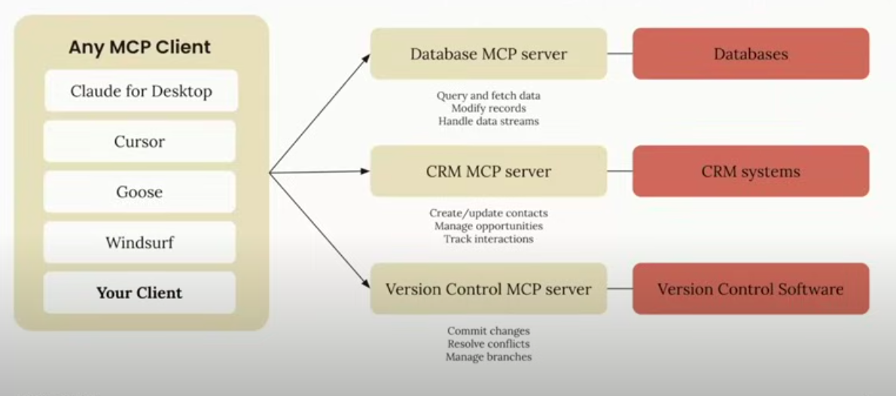
MCP – client any AI tool
MCP server – server that has standardnized protocol for any AI mcp tool that allows them to access databases (query fetch data) CRM tools, access to git and version control
For AI app developers connect your app to any MCP server
For tool or API developer – build server once see adaption everywhere

Deep dive
MCP Client
- invokes tools
- qqueries for resources
- interpolates propmts
MCP Server
- exposes tools
- exposes resources
- exposes prompts
Tools
- model controlled (MCP client decided when to use tools)
- functions invoked by the model
- retrive /serach, send a message, update DB
Resources
- files DB records api responses
- data exposed to the app
- app controlled
Prompots
- user contolled
- pre defined templates for ai interiactions
- document Q&A, transctior summary, output as JSON

