Caching in programing

TODO
- https://hackernoon.com/understanding-web-resource-caching-server-side
- https://hackernoon.com/web-resource-caching-client-side?ref=hackernoon.com

- Common cache frameworks include Ehcache and Guava. Also search for cache frameworks
- Many cache applications, such as Redis, Memcached, and Tair, are available. Understand the pros and cons, app scope, memory efficiency
- http caching: https://developer.mozilla.org/en-US/docs/Web/HTTP/Caching
- there are only two hard things in Computer Science: cache invalidation and naming things (Phil Karlton for software sauna daily https://www.youtube.com/watch?v=G4Ugczt3qNQ)
- look into resources mine
- best practice spring/java caching
- https://arxiv.org/pdf/2011.00477.pdf also has metrices
- Choosing a cache https://blog.frankel.ch/choose-cache/1/
- ecample project https://github.com/Project-Books/book-project
- Benchmarks: https://github.com/ben-manes/caffeine/wiki/Benchmarks
- http://highscalability.com/blog/2016/1/25/design-of-a-modern-cache.html (https://www.reddit.com/r/programming/comments/42s3ku/design_of_a_modern_cache/)
http://highscalability.com/blog/2019/2/25/design-of-a-modern-cachepart-deux.html
- https://www.youtube.com/watch?v=3NLS7147UQo (try example spring distributed cache) – notes are done
- http caching
- hazelcast vs redis

https://www.ehcache.org/documentation/3.0/caching-concepts.html
https://pantheon.io/docs/caching-advanced-topics
https://www.youtube.com/watch?v=uBqysgyyquk
https://www.youtube.com/watch?v=Rzdxgx3RC0Q
https://www.youtube.com/watch?v=0x-ZV_vP73k
https://www.youtube.com/watch?v=Cy2ZJOBgk84
https://www.youtube.com/watch?v=iuqZvajTOyA
caching algorithms implementations
caching write modes and read modes
-------
A cache is high-speed data storage layer which stores a subset of data, typically transient in nature.
A cache's primary purpose is to increase data retrieval performance by reducing the need to access the underlying slower storage layer. Trading off capacity for speed, a cache typically stores a subset of data transiently, in contrast to databases whose data is usually complete and durable. Caching allows you to efficiently reuse previously retrieved or computed data.
Introduce a cache when the performance and scalability benefits are required. Otherwise you are simply prematurely optimizing. How do you know if they are required? Evaluate the performance of your code (think about how expensive a retrieval from the primary datasource is → metrics).
Challenges
- what to cache, when (add / remove data), where to store, who,
- corruption (data my be wrong – no updated)
- size of caches (if too big performance can be problem)
- Caching is not a magic fix to all performance problems. When misused, a cache may lead to high cache maintenance costs and makes the system more complex and difficult to maintain.
- evaluate and consider multiple factors, such as value sizes, cache memory space, peak QPS, expiration time, cache hit ratio, read/write update policies, key-value distribution routing policies, expiration policies, and data consistency solutions
- a monitoring system is required to explicitly observe the operational status of the cache system so that problems are quickly detected
- right cache size, expiration policy, and eviction policy.

Considerations
- data loading / updating (push data into a cache)
- performance/ memory size
- eviction policy (LRU, LFU, FIFO..)
- concurrency
- hit count (found value in cache)
- miss count (not found value in cache)
- load success count (successfully loaded a new value)
- load success time (time spent loading new values)
- load exception count
- eviction count (number of entries evicted form the cache)
- https://www.ehcache.org/documentation/3.0/caching-terms.html
Can be applied throughout various layers
- Operating Systems (CPU cache, GPU cache,)
- Networking layers (CDN, DNS, Browser, Proxy, and Gateway caching work differently but have the same goal: to reduce overall network traffic and latency; Application/Output Caching utilizes server-level caching techniques that cache raw HTML..;)
- Application Cache – caches web content that can be accessed offline
- Web applications (Memoization, In-memory caching, web client caching)
- Level 1 (L1) – default transactional cache per session managed by JPA or ORM tool
- Level 1 (L2) – at the session factory-level (exist as long as the session factory is available)
- Database
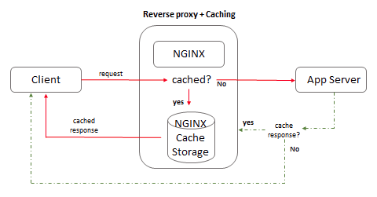
- Proxy / Load balancer cache (Apache, NGINX, F5 support proxy cache)

Cache can be implemented (dedicated caching layer)
- separate node (their own lifecycle) – good for dynamical scaling
- same node as app (in process cache)
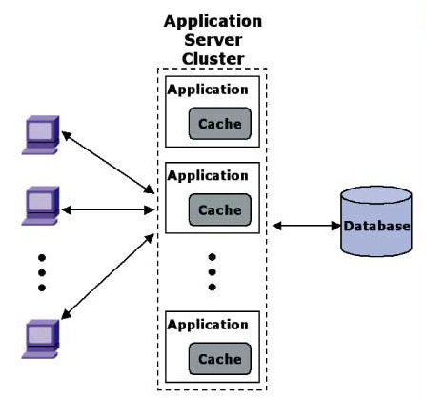
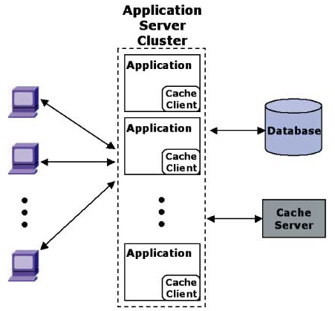

Motivation
- Latency (latency for access – e.g. it can take hundreds of clock cycles for a modern 4 GHz processor to reach DRAM.)
- Throughput
Operation
A cache is made up of a pool of entries. Each entry has
- data (copy of the same data from backing store)
- tag (identity of the data)
Client need to access data, first checks the cache if an entry can be found with a tag marching that data from the entry is used instead. The percentage of accesses that result in cache hits is known as the hit rate. If data is not found we have cache miss. During a cache miss some previously cache entry data is removed in order to make room for newly data.
Replacement policy
- LRU replace the oldest entry
- hit-frequency
Write policies
- write-through: write is done synchronously both to the cache and to the backing store
- write-back: write to cache first. Write fo the backing store is postponed until the modified content is about to be replaced by another cache block.
- Write-around: write to storage first
Cache algo
TODO Cache replacement polices/ cache algo https://en.wikipedia.org/wiki/Cache_replacement_policies
- LFU – last frequently used
- LRU – last recently used
- ARC – adaptive replacement cache
- MRU – most recently used
Terminology.
A cache hit occurs when the requested data can be found in a cache, while a cache miss occurs when it cannot. Cache hits are served by reading data from the cache, which is faster than recomputing a result or reading from a slower data store
TTLs (Time to live) can be applied to expire the data accordingly
Do we need highly Available, (which can be satisfied by In-Memory engines such as Redis) -
RTO (Recovery Time Objective--the time it takes to recover from an outage) and RPO (Recovery Point Objective--the last point or transaction captured in the recovery)
Cache prefetching is a technique used by computer processors to boost execution performance by fetching instructions or data from their original storage in slower memory to a faster local memory before it is actually needed (hence the term 'prefetch')
Expiration Policies – determine auto-eviction or remove of entries
Strategies – read through, write trough, write behind, refresh ahead
In-memory database stores data in the main memory instead of a disk to produce quicker response times. Redis on one of them
In-memory data grid is a data structure that resides entirely in RAM and is distributed among multiple servers
User Cases
Problem 1.
Accelerate retrieval of web content from websites (browser or device).
Technologies: HTTP Cache, Headers, Browsers
Problem 2.
Domain to IP resolution. Technology is DNS Servers
Problem 3.
Accelerate app performance and data access. Technologies: Key/Value data stores, Local caches (Redis, Memcached..)
Problem 4.
Reduce latency associated with database query. Technologies: Database buffers, Key/Value data stores

Various Solutions
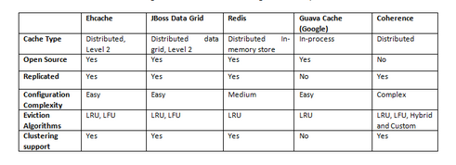
Redis, Memcached, Spring Cache, EhCache, Caffeine

In Java
In order to create a standard set of APIs to abstract over these heterogeneous caching solutions, JSR 107: Java Temporary Caching API was initiated
more info here:
- https://hazelcast.com/glossary/jcache-java-cache/
- https://github.com/jsr107/jsr107spec (is still awaliable ?)
Types
- local cache
  - JVM heap for storage – managed automatically by garbage collectors
  - off heap (array of bytes)
- remote cache (in memory stores as Redis or Memcached)

LIST OF FRAMEWORKS AND LIBRARIES
https://blog.frankel.ch/choose-cache/2/ (https://blog.frankel.ch/choose-cache/1/)
https://www.baeldung.com/jcache
https://www.developer.com/open-source/caching-solutions-in-java/
https://github.com/ben-manes/caffeine
https://www.baeldung.com/java-caching-caffeine
https://github.com/google/guava/wiki/CachesExplainedŽ
https://www.ehcache.org/
https://commons.apache.org/proper/commons-jcs/
https://infinispan.org/
https://indico.cern.ch/event/650119/attachments/1493683/2322987/Standardize_caching_in_Java_1.pdf
https://www.cacheonix.org/articles/Caching_for_Java_Applications.htm
https://dzone.com/articles/java-distributed-caching-in-redis
Hazelcast
https://cache2k.org/benchmarks.html
https://www.javatpoint.com/spring-boot-ehcaching

TODO SPRING
https://docs.spring.io/spring-framework/docs/current/reference/html/integration.html#cache
https://spring.io/guides/gs/caching/

level 2 caching
https://www.quora.com/How-do-I-enable-a-Level-2-cache-in-a-Spring-Boot-application

Things to consider
- clustered enviroments
- sessions replications
- distributed servers
- failover scenarios
- object replication, garbage collection
- memory utilization
Factors
- TTL (time to live)
- frequency of accesses
- frequency of update
- architecture (deployment also)
- scalability of the system
- object site
- hep memory availability
Different needs different solutions
- static data (state list, countries list)
- pseudo static data (catalog data, exchange rate=
- context specific data (user profile data, session data, data from external systems)Factors
Layers
- browser cache
- CDN
- load balancer (no cache)
- web layer – cache, service – cache, orm cache
- db cache
Approaches
- hasMap
- session object
- localized on-memory cache
- global distributed cache
- JSR 107

Java.lang.instrument.Instrumentation
Cache population strategies: eager of lazy
Cache configuration
- maximum memory
- purge strategy
- reload
- scheduled cache expiry
- LRU/FIFO/MRO/Last Access time (algo for removing item)
- object size
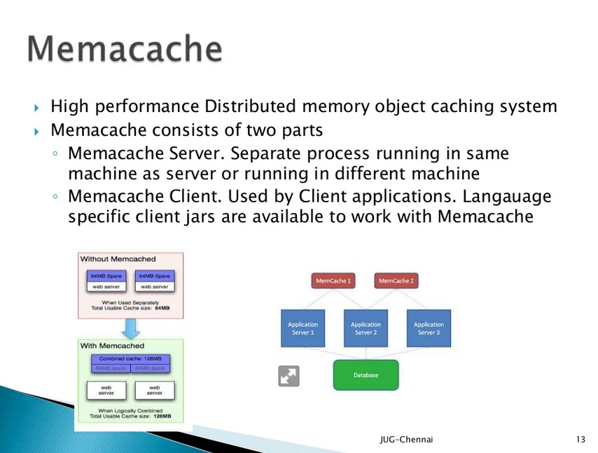
Spring framework
https://docs.spring.io/spring-boot/docs/current/reference/html/io.html#io.caching
https://docs.spring.io/spring-framework/docs/5.3.23/reference/html/integration.html#cache
https://springframework.guru/caching-in-spring-boot-restful-service-part-1/
todo spring data caching
hibernate caching
database caching
Example:
- https://github.com/ivangfr/springboot-caching-neo4j
- https://www.linkedin.com/pulse/spring-boot-caching-abid-anjum/
- https://www.section.io/engineering-education/spring-boot-caching/
- https://www.digitalocean.com/community/tutorials/spring-boot-redis-cache
- https://www.techgeeknext.com/spring-boot/spring-boot-caching

google search for “distributed java cache”

How is caching used in Java applications?

To use caching in your Java application (written using JDK), try following...
Basic:
[1] HashMap<K,V> : this will let you make a in memory key value store, it uses chaining to resolve the collisions. Java 8 has implemented a mechanism where if the list associated with a key becomes large, Java automatically converts it to a tree.
[2] ConcurrentHashMap <K, V> : for multi-threaded application
[3] HashTable<K, V> : Has been deprecated, use options [1] / [2]
[4] TreeMap <K,V> : A tree based on keys to store the values
[5] LinkedHashMap<K, V> : Preserves the order of insertion, can be used as LRU.

So above data structures are the base of caching in Java applications, one can use them and learn about the basics.
Above data structure will keep on growing in memory, and generally has no eviction policies. So eventually it may lead to OutOfMemoryException for a large data set (to be cached)

Advanced:
To use more advanced version of hashing, there are several libraries available. These libraries can provide many different features Cache server and java application can connect to them and store the data (distributed caching). The cached data is backed by hard disk storage and will never run out of memory. These will also have some eviction policy (e.g. LRU flavours)
[1] Redis : Recently gaining momentum
[2] Memcached
[3] .…

TODO: https://stackoverflow.com/questions/230649/lightweight-java-object-cache-api

Java Caching with Apache Commons JCS
Documentation here: https://github.com/apache/commons-jcs
java doc here: https://commons.apache.org/proper/commons-jcs/commons-jcs3-core/apidocs/index.html
Resources: https://www.infoworld.com/article/2077936/open-source-java-projects-java-caching-system.html
JCS can be local and distributed.
JCS as a collection of maps that you reference by name. Map is called a region and is configured independently of the others.
“Auxiliaries” are optional plugins that a region can use. (Indexed Disk Cache, TCP Lateral Cache, Remote Cache Server).
JCS is configured from a properties file called "cache.ccf". The cache configuration has three parts: default, regions, and auxiliaries. For each region (or category) you can specify and auxiliary (or appender to use). If you don't define a region in the cache.ccf, then the default settings are used, pre-defined regions do not inherent auxiliaries from the default region
Basic JCS configuration is described in more detail HERE
Element level configuration is described in more detail HERE

JCS is most useful for high read, low put applications.
- Prime candidates for caching range from the list data for stable dropdowns, user information, discrete and infrequently changing information, to stable search results that could be sorted in memory
- object cache, you can put objects (elements) and reference them via key
Features
- memory management
- data expiration (idle time and max life)
- lateral distribution of elements via HTTP, TCP, UDP
- remote server chaining (clustering)
- custom object serializer injection

The foundation of JCS is the Composite Cache, which is the pluggable controller for a cache region. Four types of caches can be plugged into the Composite Cache
- memory cache
  - LRUMemoryCache (recommended - removes the least recently used items when the cache is full)
  - LHMLRUMemoryCache
  - MRUMemoryCache
  - FIFOMemoryCache
  - ARCMemoryCache
  - configurable parameters such as time to live and maximum idle time
- disk cache
  - indexed (IndexedDiskCache – RECOMMENDED, data on disk keys in memory)
  - HSQL
  - JISP
  - Berkeley DB JE
  - JDBC Disk Cache (It stores both the keys and elements in a JDBC compatible database. The JDBC disk cache stores elements in a database as BLOBs. Periodically, the table is swept to remove expired elements)
- lateral cache
  - TCP socket server distribution (distributed cached data to multiple servers)
  - JGroups
- remote cache
  - RMI
  - HTTP

Although each cache region must have one (and only one) memory auxiliary, it can have any number of other auxiliaries that can hold cached data. In this example I create an indexed disk cache, but you can also define lateral and remote auxiliaries. A lateral auxiliary can replicate your cached data to other caches via a TCP socket or JGroups protocol stack. A remote auxiliary can replicate data to other caches via Remote Method Invocation (RMI).

Java Caching with JCache API (JSR 107)

Standard set of APIs to abstract over various caching solutions → JSR 107: Java Temporary Caching API.
JCache is the standard caching API (application programming interface) for the Java programming language. The JCache API is located in the javax.cache package. It consists of five core interfaces:
- Entry (single key-value pair)
- Cache (map in wich key-value pairs are stored)
- CachingManager (controling one cache, → configuration and management)
- CachingProvider (handles one or more CachingManager)
- ExpiryPolicy (length of time with which single Java object is stored in Cache
Interfaces provide a general structure for JCache APIs, they do not implement it. Instead you can chose one of the vendors (Hazelcast, Terracotta Ehcache, Oracle Coherence, Infinispan)

In JCache implementations choose between the "store by value" and "store by reference" paradigms:
- Store by value: The Cache makes a copy of the object being inserted in the cache, and consults this copy rather than the original object.
- Store by reference: The Cache only holds a link to the original object, which is not stored in the cache. This saves on space requirements, but comes with the risk that the original objects will change during the lifetime of the Cache.
There are also other things to consider.
Note on Redis. Redis is an open-source, in-memory data structure store often used to implement key-value NoSQL databases and caches. The Redisson client includes an implementation of the JCache API for Redis.
Last time updated 2019 maven lib
Source:
https://redisson.org/glossary/jcache.html
https://dzone.com/refcardz/java-caching
https://jcp.org/aboutJava/communityprocess/implementations/jsr107/index.html

Java Caching with Caffeine

Resource: https://www.outbrain.com/techblog/2019/11/oh-my-guava-we-are-moving-to-caffeine/
Caffeine library is a rewrite of Guava’s cache that uses a Guava-inspired API that returns CompletableFutures, allowing asynchronous automatic loading of entries into a cache. The library was written by Ben Manes who is the author o ConcurrentLinkedHashMap on which Guava cache is based.
Caffeine vs Guava
- Guava blocks during loading when a key is not present in the cache
- Caffeine uses both a Least Recently Used (LRU) eviction policy and a frequency-based admission policy relying on CountMin sketch
- The main difference is because Caffeine uses ring buffers to record & replay events, whereas Guava uses ConcurrentLinkedQueue
- Caffeine doesn't create its own threads for maintenance or expiration. It does defer the cost to the commonPool, which slightly improves user-facing latencies but not throughput.

in-memory cache.

Caffeine does not implement LRU as its cache eviction policy. Instead, Caffeine uses a policy called TinyLFU. The Caffeine documentation includes a page on Efficiency, which discusses the rationale for this design choice. Caffeine uses the Window TinyLfu eviction policy

Examples and tutorial: https://self-learning-java-tutorial.blogspot.com/2021/04/caffeine-cache-tutorial.html

Tutorial on caffeine
A Cache is similar to ConcurrentMap, but not quite the same. The most fundamental difference is that a ConcurrentMap persists all elements that are added to it until they are explicitly removed. A Cache on the other hand is generally configured to evict entries automatically, in order to constrain its memory footprit
Population
- manual (put, or get(k, k → “if not found return”)
- loading – on build load cache
- asynchronous manual returns a CompletableFuture. This allows utilizing caches with the popular reactive programming model.
- Asynchronous loading
Eviction
- size-based (The cache will try to evict entries that have not been used recently or very often)
- weight-based
- time-based (expireAfterAccess, expireAfterWrite, expireAfter)
- week reference key based. stores keys using weak references. This allows entries to be garbage-collected if there are no other strong references to the keys. Compare by ==
- week reference value based. This allows entries to be garbage-collected if there are no other strong references to the values. Since garbage collection depends only on identity equality, this causes the whole cache to use identity (==) equality to compare values
- soft reference based. stores values using soft references. Softly referenced objects are garbage-collected in a globally least-recently-used manner, in response to memory demand. Because of the performance implications of using soft references, we generally recommend using the more predictable maximum cache size instead. Use of softValues() will cause values to be compared using identity (==)
Reference: https://en.wikipedia.org/wiki/Soft_reference
Eviction – removal due to the policy
Invalidation – removal by the caller (Ex: invalidate(key), invalidateAll()..)
Removal
- invalidation or eviction
- can specify removal listener

Refreshing
refreshing a key loads a new value for the key asynchronously. The old value (if any) is still returned while the key is being refreshed, in contrast to eviction, which forces retrievals to wait until the value is loaded anew
you can specify both refreshAfterWrite and expireAfterWrite. If an entry isn't queried after it comes eligible for refreshing, it is allowed to expir
Compute
External code to observe the changes for a given key. For manual operations provides the ability to perform logic within atomic operation that may create, update or remove an entry
Use cases: write through. Write back (batching and coalescing the operations, delaying the operations, performing a batch prior to a period fluch, handling retrials, rate limit). Layering (he loads from and writes to an external cache that is backed by the system of record. This allows having a small fast cache that falls back to slow large cache. Typical tiers are off-heap, file-based, and remote caches.). victim cache (evicted entries are written to the secondary cache)

Spring Boot caching

The cache abstraction mechanism applies to Java methods. The main objective of using cache abstraction is to reduce the number of executions based on the information present in the cache. It applies to expensive methods such as CPU or IO bound. Every time, when a method invokes, the abstraction applies a cache behavior to the method. It checks whether the method has already been executed for the given argument or not.
We have a lot of technologies available to set up a cache in our application. Each of these technologies, like Hazelcast or Redis, for example, has its own API. If we want to use it in our application, we would have a hard dependency on one of those cache providers.
The Spring cache abstraction gives us the possibility to use an abstract API to access the cache. Our business code can use this abstraction level only, without calling the Cache provider’s code directly. Spring provides an easy-to-use annotation-based method to implement caching.

Types of cache
- In memory
- database
- web server caching (Reverse proxies and caches such as Varnish can serve static and dynamic content directly)
- CDN caching

Spring boot – cache abstraction api
- @EnableCaching
- @CacheConfig
- @Cacheable
- @CachePut
- @CacheEvict
- @Caching

@EnableCaching
- add it to the @SpringBootApplication or to any of the configuration classes
- one concurrent hashmap as default
- override CacheManger to register external cache provider
@CacheConfig
- class level annotation that provides common cache-related setting
- where to store cache
@Cacheable
- method level
- response of the method is cacheable
- options; key of the cache, conditions
- sync (for multithread env)

@CachePut
- update cache before method call, allow the method to be executed
@CachePut and @Cacheable annotations on the same method is generally discouraged because they have different behaviors. One of the key differences between @Cacheable and @CachePut annotation is that the @Cacheable skips the method execution while the @CachePut runs the method and puts the result into the cache
@CacheEvict
- evict (remove) the cache previously loaded of master data (clears the cache).
@Caching
- need both @CachePut and @CacheEvict
@CacheEvict annotation is that it can be used with void methods because the method acts as a trigger. It avoids return values. On the other hand, the annotation @Cacheable requires a return value that adds/updates data in the cache.
Cache is a key-value storage and Spring provides a number of options for us to customize key generation
- default (https://github.com/spring-projects/spring-framework/blob/main/spring-context/src/main/java/org/springframework/cache/interceptor/SimpleKeyGenerator.java)
- custom using SpEL (@Cacheable(cacheNames="address", key="#customer.id"))
Advice Custom Caching Annotation – to eliminate the need to duplicate cache annotation declarations
Providers (is memachace here)
- JCache (JSR-107)
- EhCache
- Hazelcast
- Infinispan
- Couchbase
- Redis
- Caffeine
- Simple

declare many cache configurations programmatically → https://stackoverflow.com/questions/63670352/define-multiple-caches-configurations-with-spring-and-caffeine/63697163#63697163
Source:
https://www.javadevjournal.com/spring/spring-caching/
example Hazelcast as provider → https://github.com/thombergs/code-examples/tree/master/spring-boot/cache
https://auth0.com/blog/spring-boot-caching-101/
https://www.javatpoint.com/spring-boot-caching
https://docs.spring.io/spring-framework/docs/current/reference/html/integration.html#cache
TODO Distributed java app: https://www.cacheonix.org/articles/How_to_Distribute_Java_Application_on_Multiple_JVMs.htm

Hibernate - Caching
https://www.tutorialspoint.com/hibernate/hibernate_caching.htm
https://en.wikibooks.org/wiki/Java_Persistence/Caching
https://vladmihalcea.com/jpa-hibernate-second-level-cache/

Redis
https://www.nexsoftsys.com/articles/distributed-caching-in-java-microservices-using-redis-cluster.html

Elastic Search
https://medium.com/@hafandhalf/architecture-for-a-cache-based-application-249b5fc98289

