Programming Kotlin
By Venkat Subramaniam

Part 2.
Object-Oriented Kotlin
Functional Kotlin

Objects and Singletons

Kotlin’s facility to create and work with classes and objects is more akin to the features in Scala than in Java.

Object Expressions

In its most basic form, an object expression is the keyword object followed by a block {}. Such a trivial object expression is limited in use but not entirely purposeless.

Val c = object {
val x = 10
val y = 20
val radius = 30
}

Instead of defining the properties as val, you may make them mutable with var. You may add methods to the object as well.
Classes don’t have the limitations that anonymous objects have—and there are a few:
- The internal type of anonymous objects can’t stand as return types to functions or methods.
- The internal type of anonymous objects can’t be used as types of parameters to functions or methods.
- If they’re stored as properties in classes, they’ll be considered Any type and none of their properties or methods will then be available for direct access.
Anonymous objects can be useful as implementors of interfaces—that is, as anonymous inner classes like in Java.
Val c = object: Runnable { ….

Implemntation of functional interface
​fun​ ​createRunnable​(): Runnable = Runnable { println(​"You called..."​) }

If the anonymous inner class implements more than one interface, you have to specify the type the instance should represent upon return

Singleton
Use an object expression to create an instance of an anonymous inner class and an object declaration to create a singleton—a class with a single instance

 | ​object​ Util {
​ | ​fun​ ​numberOfProcessors​() = Runtime.getRuntime().availableProcessors()
​ | }

The Util object we created using the object declaration is a singleton. We can’t create objects of Util—it’s not considered to be a class by the Kotlin compiler; it’s already an object. Think of it like a Java class with a private constructor and only static methods.

Singletons aren’t limited to having methods. They may have properties as well, both val and var. Object declarations may implement interfaces or may extend from existing classes, like object expressions do. If a singleton has a base class or interface, then that single instance may be assigned to a reference or passed to a parameter of the base type

Placing mutable state in a singleton isn’t a good idea, especially in a multithreaded application.

f a group of functions are high level, general, and widely useful, then place them directly within a package. If on the other hand, a few functions are more closely related to each other than the other functions then place them within a singleton if a group of functions needs to rely on state a class may be a better option

Functions and singletons make good sense when we’re focused on behaviors, computations, and actions. But if we want to deal with state, then classes are a better choice

Classes

Kotlin moves the code generation from the IDE to the compiler

​class​ Car(​val​ yearOfMake: Int)
This line is a shortcut for this:

public​ ​class​ Car ​public​ ​constructor​(​public​ ​val​ yearOfMake: Int)

By default, the access to the class and its members is public and the constructor is public as well. In Kotlin, the line that defines the class is actually defining the primary constructor. The keyword constructor isn’t needed unless we want to change the access modifier or place an annotation for the primary constructor.

You can add property to class in a body

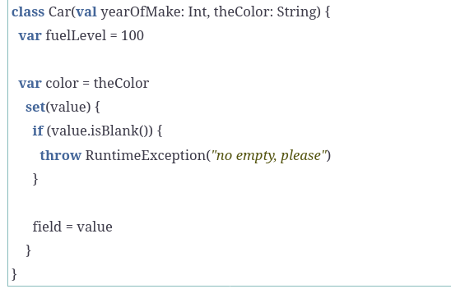

To reiterate, in Kotlin you never define fields—backing fields are synthesized automatically, but only when necessary. If you define a field with both a custom getter and custom setter and don’t use the backing field using the field keyword, then no backing field is created. If you write only a getter or a setter for a property, then a backing field is synthesized.
In our constructor we defined one property, yearOfMake, and one parameter, not field, named theColor—we didn’t place val or var for this parameter. If you really wanted to call this color, you could have done that as well

use different names for properties and parameters.This is reason why var color = theColor

Kotlin will synthesize a getter and a setter for the fuelLevel property. For the color property it will only synthesize a getter, but use the setter provided in code. The setter throws an exception if the value given for the property is empty. You may call the parameter something other than value if you like. Also, you may specify the type for the parameter of set if you desire, but in this case the compiler knows the type, based on the type of the property initialization. If the given value is acceptable, then assign it to the field which is referenced by a special keyword field. Since Kotlin synthesizes fields internally, it doesn’t give access to that name in code. You may refer to it using the keyword field only within getters and setters for that field.

Access modifiers

The properties and methods of a class are public by default in Kotlin. The possible access modifiers are: public, private, protected, and internal. The first two have the same meaning as in Java. The protected modifier gives permission to the methods of the derived class to access that property. The internal modifier gives permission for any code in the same module to access the property or method, where a module is defined as all source code files that are compiled together

The access permission for the getter is the same as that for the property
To make the setter private, simply place the keyword private before the keyword set.

Initialization
The primary constructor declaration is part of the first line. Parameters and properties are defined in the parameter list for the constructor. Properties not passed through the constructor parameters may also be defined within the class. If the code to initialize the object is more complex than merely setting values, then we may need to write the body for the constructor. Kotlin provides a special space for that.
A class may have zero or more init blocks. These blocks are executed as part of the primary constructor execution. The order of execution of the init blocks is top-down. Within an init block you may access only properties that are already defined above the block. Since the properties and parameters declared in the primary constructor are visible throughout the class, any init block within the class can use them. But to use a property defined within the class, you’ll have to write the init block after the said property’s definition.
Don’t write more than one init block, and avoid it if you can. The less work we do in constructors, the better from the program safety and also performance point of view.

Secondary Constructors

Your secondary constructors are required to either call the primary constructor or call one of the other secondary constructors. Also, secondary constructors’ parameters can’t be decorated with val or var; they don’t define any properties. Only the primary constructor and declarations within the class may define properties.

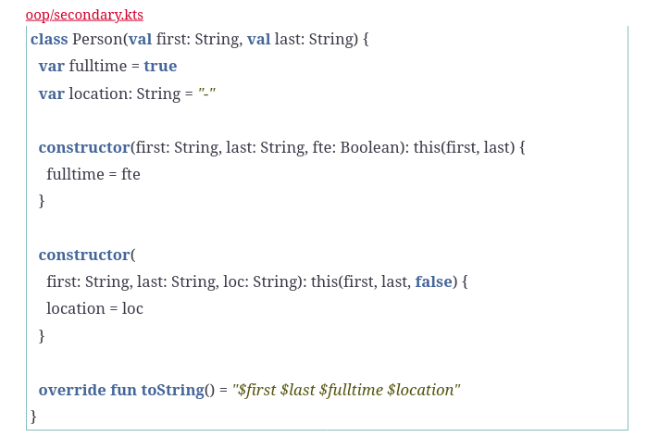

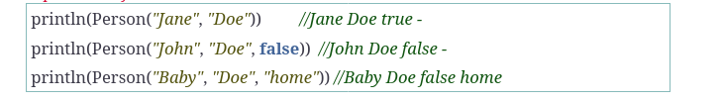

Defining instance methods

Define methods in classes using the fun keyword. By default methods are public, but you may mark them as private, protected, or internal before the fun keyword if you want to change the access permission.

Companion Objects and Class Members

If a property or a method is needed at the class level and not on a specific instance of the class, we can’t drop them into the class. Instead, place them in a companion object (replacement for static keyword)
Companion objects are singletons defined within a class—they’re singleton companions of classes. In addition, companion objects may implement interfaces and may extend from base classes, and thus are useful with code reuse as well.

The members of the companion object of a class can be accessed using the class name as reference, like so:

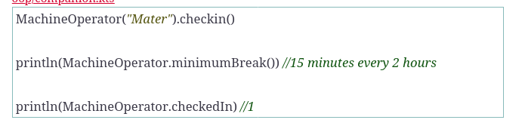
to acces reference of companion object

​val​ ref = MachineOperator.MyIneerObj

Companion as Factory

the Factory suffix alludes to an intent of the companion object to serve as a factory. Whether you give an explicit name or not, the companion object can serve as a factory to create instances of the class they are part of.

The constructors initialize an object to a valid state, but there are times when we may have to perform some extra steps before an object becomes available for use. For example, we may want to register an object as an event handler or register with a timer to execute a method. Registering within the constructor isn’t a good idea; you don’t want a reference to the object to become available anywhere before the construction is completed. Providing a method to be called after construction isn’t good either: the user of the class may forget to register or may invoke other methods before registering. The companion object for the class, acting as a factory, can help with this design concern.

To use a companion as a factory, provide a private constructor for the class. Then, provide one or more methods in the companion object that creates the instance and carries out the desired steps on the object before returning to the caller.

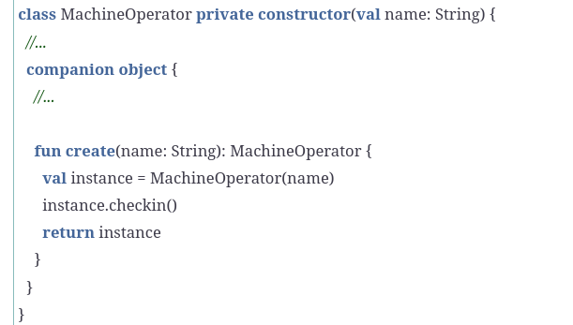

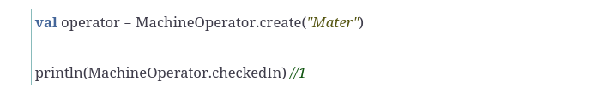

Generics Classes

example
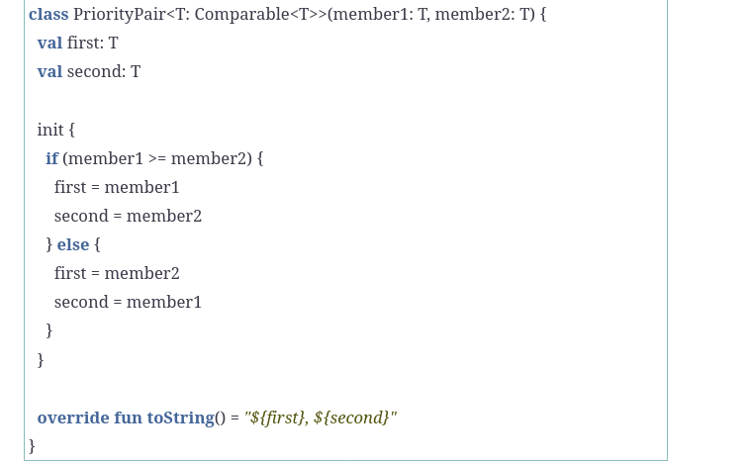

Data classes

specialized classes that are intended to carry mostly data rather than behavior. The primary constructor is required to define at least one property, using val or var. Non-val or var parameters aren’t allowed here. You may add other properties or methods to the class, within the body {}, if you desire.

For each data class Kotlin will automatically create the equals(), hashCode(), and toString() methods. In addition, it provides a copy() method to make a copy of an instance while providing updated values for select properties. It also creates special methods that start with the word component—-component1(), component2(), and so on—to access each property defined through the primary constructor. We’ll refer to these methods as componentN() methods for convenience.

For data classes, Kotlin generates a copy() method that creates a new object with all the properties of the receiver object copied into the result object. Unlike the equals(), hashCode(), and the toString() methods, the copy() method includes any property defined within the class, not just those presented in the primary constructor. Each parameter to the method receives a default argument, and we may pass an alternative value to any property using named arguments

The copy() function only performs a shallow copy of primitives and references. The objects referenced internally are not deep copied by the method. This isn’t an issue if the entire hierarchy of nested objects is immutable.

Destructing

To destructure, we have to extract the properties in the same order as they appear in the primary constructor. However, we’re not required to extract each and every property. If you don’t want a property, simply leave it out from the request. If you need the value of a property that comes after a property you want to ignore, then use underscore—which is the international symbol for “I don’t care.”

If a developer inserts a new parameter in between current parameters, then the result may be catastrophic.

With the choices offered by Kotlin we have to decide when to use a data class vs. a regular class. Use a data class in these situations:
- You’re modeling data more than behavior.
- You want equals(), hashCode(), toString(), and/or copy() to be generated, knowing that you may override any of these methods if you like.
- It makes sense for the primary constructor to take at least one property—no-argument constructors are not allowed for data classes.
- It makes sense for the primary constructor to take only properties.
- You want to easily extract data from the object using the destructuring facility (be aware that the extraction is based on the order of properties and not their names).

Class Hierarchies

Interfaces in Kotlin

Interface can have abstract methods in them. In addition, you may also implement methods within interfaces, but without the default keyword that Java requires. Interfaces can also have static methods, but only via companion objects written within the interfaces.
To make the Kotlin default methods visible as default methods in the bytecode, you can use the @JvmDefault annotation.

Override keyword is required for any method that is overriding a method of a base class or an interface.

Interfaces cannot store a state. They can have properties, but these need to be abstract or provide accessor implementations.

interface MyInterface {
val prop: Int // abstract

val propertyWithImplementation: String
get() = "foo"

fun foo() {
print(prop)
}
}

class Child : MyInterface {
override val prop: Int = 29
}
Abstract class

Diff between interface and abstract class is that abstract class can have state.

​abstract​ ​class​ Musician(​val​ name: String, ​val​ activeFrom: Int) {
​ ​abstract​ ​fun​ ​instrumentType​(): String
​ }
​
​ ​class​ Cellist(name: String, activeFrom: Int) : Musician(name, activeFrom) {
​ ​override​ ​fun​ ​instrumentType​() = ​"String"​
​ }
​
​ ​val​ ma = Cellist(​"Yo-Yo Ma"​, 1961)

The main differences between an abstract class and an interface are these:
- The properties defined within interfaces don’t have backing fields; they have to rely on abstract methods to get properties from implementing classes. On the other hand, properties within abstract classes can use backing fields.
- You may implement multiple interfaces but can extend from at most one class, abstract or not.

If you want to reuse state between multiple classes, then an abstract class is a good choice. You can implement the common state in the abstract class and have implementing classes override the methods, while reusing the state provided by the abstract class.

If you want multiple classes to abide by one or more contracts or specifications, but you want those classes to choose their own implementations, then interfaces are the better choice.

Inheritance

As an author of a class, you have to provide explicit permission for your class to be used as a base class. Likewise, when writing a method, you have to tell Kotlin that it’s OK for a derived class to override that method. Let’s take a look at how Kotlin provides this safety net.

Solution: Only open methods of an open class may be overridden in a derived class and have to be marked with override in the derived

A val property in the base may be overridden with a val or var in the derived. But a var property in the base may be overridden only using var in the derived.

Sealed Class

Kotlin’s sealed classes are open for extension by other classes defined in the same file but closed—that is, final or not open—for any other classes.

Since the constructors of sealed classes are considered to be private, we can’t instantiate an object of these classes. However, we can create objects of classes that inherit from sealed classes, assuming their constructors aren’t marked private explicitly.

Enums

The values() method provides an array of all the instances of the enum class. The name and ordinal properties of an enum instance will return the name and an index of the instance in the definition.

We may also hold state and provide methods in enum classes, but a semicolon has to separate the list of values from the methods. Let’s add a symbol property for each value of the Suit enum and provide a method to return the name and symbol.

enum​ ​class​ Suit(​val​ symbol: Char) {
​ | CLUBS(​'\​u2663​'​),
​ | DIAMONDS(​'\​u2666​'​),
​ | HEARTS(​'\​u2665​'​) {
​ | ​override​ ​fun​ ​display​() = ​"${super.display()} $symbol"​
​ | },
​ | SPADES(​'\​u2660​'​);
​
​ | ​open​ ​fun​ ​display​() = ​"$symbol $name"​
​ | }

Has a method display() to return the name and symbol for a suit. Had we defined it as abstract, then each of the suit values would be required to implement that method. Had we defined it without open, then none of the suit values could override it. We took the middle ground here—those suits that want to override that method may do so and the other suits will use the implementation provided.

Kotlin has no default keyword, and static methods go into companion objects even for interfaces. Kotlin’s nested and inner classes also differ from the same concepts in Java—unlike Java, Kotlin makes a clear distinction between nested and inner classes, to make the intent clear.

Delegation

Delegation is more flexible than inheritance. An object may delegate or pass some of its responsibilities to an instance of another class. Different instances of a class may delegate to instances of different classes. It’s like the way siblings, with the same parents, can and do choose different friends.

When to choose delegation over inheritance

Use inheritance if you want an object of a class to be used in place of an object of another class.
Use delegation if you want an object of a class to simply make use of an object of another class.

Use inheritance to specialize the implementation of a class and to substitute an instance of one class in place of another—that is, to design the kind-of relationship, like in Dog is a kind of Animal. To merely reuse an object in the implementation of another, use delegation, like a Manager has an Assistant, to do part of the work.

Delegates

interface Worker { fun doWork(); }

open class JProgramer: Worker {
override fun doWork() { println("JP work"); }
}

open class CProgamer: Worker {
override fun doWork() { println("C work"); }
}

class Manager: JProgramer() {}

class Manager2(val worker: Worker) {
fun doWork() {
worker.doWork();
}
}

class Manager3: Worker by JProgramer() {}

fun main() {
Manager().doWork();
Manager2(JProgramer()).doWork();
Manager3().doWork()
println("Hello, world!!!")
}

Manager → inheritance
Manager2 → delegate manual
Manager3 → delegate Kotlin

Delegating to a Parameter

The constructor of the Manager class receives a parameter named staff which also serves as a property, due to val in the declaration. If the val is removed, staff will still be a parameter, but not a property of the class. Irrespective of whether or not val is used, the class can delegate to the parameter staff.

 | ​class​ Manager(​val​ staff: Worker) : Worker ​by​ staff {
​ | ​fun​ ​meeting​() =
​ | println(​"organizing meeting with ${staff.javaClass.simpleName}"​)
​ | }

Method Collisions

The Kotlin compiler creates a wrapper in the delegating class for each method that’s in the delegate. What if there’s a method in the delegating class with the same name and signature as in the delegate? Kotlin resolves this conflict in favor of the delegating class.

​class​ Manager(​val​ staff: Worker) : Worker ​by​ staff {
​ ​override​ ​fun​ ​takeVacation​() = println(​"of course"​)
​ }

Kotlin requires the delegating class to implement a delegate interface, but without actually implementing each of the methods of the interface.

But that’s true only if the delegating class doesn’t already have an implementation of a method. If the delegating class has an implementation for a method that’s in the interface, then it must be marked as override, that implementation takes precedence, and a wrapper method isn’t created.
A class may delegate to multiple interface implementors as well. If there are any method collisions between the interfaces, then the candidate class should override the conflicting methods.
Problems with delegate: https://learning.oreilly.com/library/view/programming-kotlin/9781680507287/f_0078.xhtml#d24e24024

Delegating variables and properties

TODO: https://learning.oreilly.com/library/view/programming-kotlin/9781680507287/f_0079.xhtml#sec.delegatevar

Built-in delegates

The Lazy delegate is useful to defer creating objects or executing computations until the time the result is truly needed. The observable delegate is useful to observe or monitor changes to the value of a property. The vetoable delegate can be used to reject changes to properties based on some rules or business logic

​val​ temperature ​by​ lazy { getTemperature(city) }

We turned the simple variable temperature into a delegate property using the by keyword. The lazy function takes as argument a lambda expression that will perform the computation, but only on demand and not eagerly or immediately. The computation within the lambda expression will be evaluated if and when the value of the variable is requested.

 | ​var​ count ​by​ observable(0) { property, oldValue, newValue ->
​ | println(​"Property: $property old: $oldValue: new: $newValue"​)
​ | }

Use the observable delegate to keep an eye on changes to local variables or properties within objects. It can be useful for monitoring and debugging purposes. Instead of merely observing, if you want to partake in deciding if a change should be accepted or rejected, then use the vetoable delegate.

Unlike the handler registered with observable, whose return type is Unit, the handler we register with vetoable returns a Boolean result. A return value of true means a favorable nod to accept the change; false means reject. The change is discarded if we reject.

​var​ count ​by​ vetoable(0) { _, oldValue, newValue -> newValue > oldValue }

Use the vetoable delegate anywhere you like to keep an eye on a local variable or property and want to reject certain changes based on some business logic.

Using these low-ceremony facilities, you may create your own custom delegates easily. You can also benefit from a few built-in standard delegates in the Kotlin standard library

Functional programming intro

Functional-style code is declarative—you focus on what to do and assign the details of how to do it to underlying libraries of functions.
Higher-order functions may receive functions as parameters and/or may return functions as a result. We can nicely compose a chain of function calls—known as functional composition—to accomplish tasks, and that leads to fluent and easier-to-understand code.

Why and when to apply FP

The functional style is less complex, but that doesn’t make it better than imperative style all the time. Use the functional style when the code is mostly focused on computations—you can avoid mutability and side effects—and for the problems that can be expressed in terms of series of transformations. But if the problem at hand involves a lot of IO, has unavoidable state mutation or side effects, or if code will have to deal with many levels of exceptions, then imperative style may be a better option

Given a problem, we have to think in terms of transformational steps and look for functions that can help us with intermediate steps.

Lambda Expressions

Lambdas carry over only the most essential parts of a function—the parameters list and body.
Here’s the syntax of lambdas in Kotlin:
{ parameter list -> body }

If the lambdas passed to a function take only one parameter, then we can omit the parameter declaration and use a special implicit name it instead.

For short lambdas with only a single parameter, feel free to leave out the parameter declaration and the arrow, ->, and use it for the variable name. The only downside is you can’t quickly tell if a lambda is a no-parameter lambda or if it takes one parameter that’s referenced using it.

Create function that receives a lambda.

​fun​ ​walk1To​(action: (Int) -> Unit, n: Int)
Int) -> Unit. The syntax signifies that the function takes some inputs of the type specified to the left of -> and returns a result of the type specified on the right of →.

However, we can reduce some noise, get rid of the comma, and place the lambda outside the parenthesis:
walk1To(5) { i -> print(i) } → when you place lambda fun as last parameter

walk1To(5) { print(it) }

Function Reference

We can replace pass-through lambdas with references to the functions the parameter is passed through.

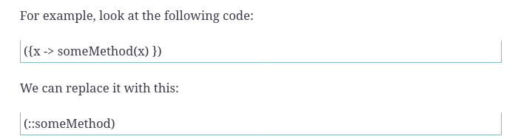

If the pass-through is to another lambda, then we don’t need the ::.

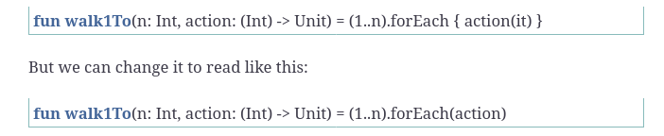

and then



function Returns function

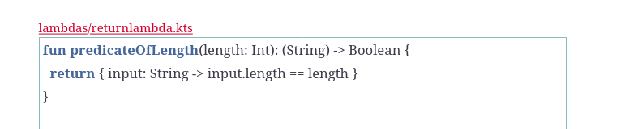

The parameter passed to predicateOfLength() is of type Int, but the return type isn’t that simple. The return type is the signature of a function that takes String as parameter and returns Boolean as output.

Lambdas and Anonymous functions

If the same lambda is needed on multiple calls, that may lead to code duplication.
- One is to store a lambda into a variable for reuse.
- create anonymous functions instead of lambdas

But if we define a variable to store a lambda, Kotlin doesn’t have any context about the types. So, in this case, we need to provide sufficient type information. Use like this

val​ checkLength5: (String) -> Boolean = { name -> name.length == 5 }
In this case, if the lambda doesn’t return the expected type that’s specified in the variable declaration, then the compiler will complain.

An anonymous function is written like a regular function, so the rules of specifying the return type—no type inference for block-body, return required for block-body, and so on—apply, with one difference: the function doesn’t have a name

​val​ checkLength5 = ​fun​(name: String): Boolean { ​return​ name.length == 5 }

Also, you may use it directly as an argument in a function call, in place of a lambda.

names.find(​fun​(name: String): Boolean { ​return​ name.length == 5 })

Some restrictions apply when an anonymous function is used instead of a lambda. The return keyword is required for block-body anonymous functions that return a value. The return will always return from the anonymous function, and not from the encompassing function.

Prefer lambdas over anonymous functions where possible, and use anonymous functions selectively only in those rare occasions when they are suitable instead of lambdas

Closures and Lexical Scoping

A lambda is stateless; the output depends on the values of the input parameters

Sometimes we want to depend on external state. Such a lambda is called a closure—that’s because it closes over the defining scope to bind to the properties and methods that aren’t local.

 | ​fun​ ​predicateOfLength​(length: Int): (String) -> Boolean {
​ | ​return​ { input: String -> input.length == length }
​ | }

The lambda being returned has a parameter named input. Within the body of the lambda we compare the value of the length property of this input parameter with the value in the length variable. But, the variable length isn’t part of the lambda—it’s from the closure’s lexical scope, which happens to be the parameter passed to the predicateOfLength() function.

