PostgreSQL 14.0 Documentation notes

STAO: https://www.postgresql.org/files/documentation/pdf/14/postgresql-14-A4.pdf
and: https://cuteboyprogrammers.com/pdf/humblebundle/learningsql3e.pdf

todo: referential integrity of data

Simple introduction

Architectural fundamentals
PostgreSQL uses a client/server model. A PostgreSQL session consists of the following cooperating processes (programs):
- A server process, which manages the database files, accepts connections to the database from client applications, and performs database actions on behalf of the clients. The database server program is called postgres.
- The user's client (frontend) application that wants to perform database operations. Client applications can be very diverse in nature: a client could be a text-oriented tool, a graphical application, a web server that accesses the database to display web pages, or a specialized database maintenance tool.

Creating DB
A running PostgreSQL server can manage many databases. Typically, a separate database is used for each project
To create a new database, in this example named mydb
createdb mydb

If you do not want to use your database anymore you can remove it.
dropdb mydb

Accessing DB
Can access by:
- running psql program in terminal
- using DB tool like pgAdmin
- write a custom app

SQL Language

Concepts
PostgreSQL is a relational database management system (RDBMS). That means it is a system formanaging data stored in relations. Relation is essentially a mathematical term for table.
A more modern development is the object-oriented database.
Each table is a named collection of rows. Each row of a given table has the same set of namedcolumns, and each column is of a specific data type.

Create a new table
You can create a new table by specifying the table name, along with all column names and their types:

CREATE TABLE weather (
city varchar(80),
temp_lo int, -- low temperature
temp_hi int, -- high temperature
prcp real, -- precipitation date date
);
Two dashes (“--”) introduce comments.

PostgreSQL supports the standard SQL types int, smallint, real, double precision,char(N), varchar(N), date, time, timestamp, and interval, as well as other types ofgeneral utility and a rich set of geometric types. PostgreSQL can be customized with an arbitrarynumber of user-defined data types. Consequently, type names are not key words in the syntax, exceptwhere required to support special cases in the SQL standard.

Insert a data into table
The INSERT statement is used to populate a table with rows:

INSERT INTO weather VALUES ('San Francisco', 46, 50, 0.25, '1994-11-27');

Constants that are not simple numeric values usually must be surrounded by single quotes ('), as in the example. The date type is actually quite flexible in what it accepts,

You could also have used COPY to load large amounts of data from flat-text files. This is usually faster because the COPY command is optimized for this application while allowing less flexibility than INSERT. An example would be:

COPY weather FROM '/home/user/weather.txt';

Querying a table

An SQL SELECT statement is divided into a select list (the part that lists the columns to be returned), a table list (thepart that lists the tables from which to retrieve the data), and an optional qualification (the part thatspecifies any restrictions)

You can write expressions, not just simple column references, in the select list.
SELECT city, (temp_hi+temp_lo)/2 AS temp_avg, date FROM weather;
You can request that duplicate rows be removed from the result of a query
SELECT DISTINCT city from weather;

Joins between tables

Queries can access multiple tables at once,or access the same table in such a way that multiple rows of the table are being processed at the sametime. → join → They combine rows from one table with rows from a second table, with an expressionspecifying which rows are to be paired.

SELECT * FROM weather
JOIN cities ON city = name;

or

SELECT * FROM weather, cities
WHERE city = name;

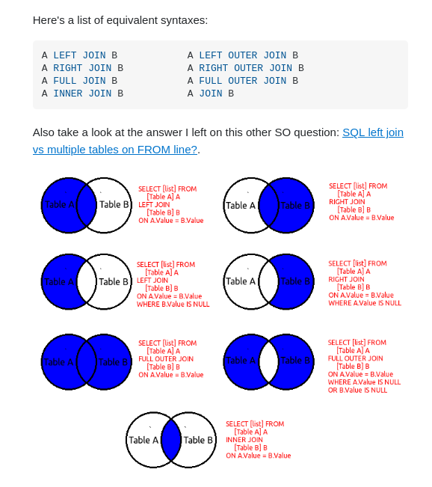

Aggregate Functions

An aggregate function computes a single result from multiple input rows. For example, there are aggregates to compute the count, sum, avg (average), max (maximum) and min (minimum) over a set of rows.

Aggregates are also very useful in combination with GROUP BY clauses. For example, we can get the maximum low temperature observed in each city with:
SELECT city, max(temp_lo)
FROM weather
GROUP BY city;

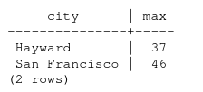

Each aggregate result is computed over the table rows matching that city. We can filter these grouped rows using HAVING:
SELECT city, max(temp_lo)
FROM weather
GROUP BY city
HAVING max(temp_lo) < 40;
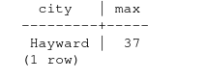

The fundamental difference between WHERE and HAVING is this: WHERE selects input rows before groups and aggregates are computed (thus, it controls which rows go into the aggregate computation), whereas HAVING selects group rows after groups and aggregates are computed. Thus,the WHERE clause must not contain aggregate functions; it makes no sense to try to use an aggregate to determine which rows will be inputs to the aggregates. On the other hand, the HAVING clause always contains aggregate functions. (Strictly speaking, you are allowed to write a HAVING clause that doesn't use aggregates, but it's seldom useful. The same condition could be used more efficiently at the WHERE stage.)

Update data in table

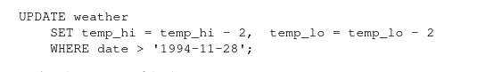

Delete data in table

DELETE FROM weather
WHERE city = 'Hayward';

Features

Views

You can create a view over the query, which gives a name to the query that you can refer to like an ordinary table:
CREATE VIEW myview AS
SELECT name, temp_lo, temp_hi, prcp, date, location
FROM weather, cities
WHERE city = name;
SELECT * FROM myview;
Making liberal use of views is a key aspect of good SQL database design. Views allow you toencapsulate the details of the structure of your tables, which might change as your application evolves,behind consistent interfaces

Foreign keys
You wantto make sure that no one can insert rows in the weather table that do not have a matching entryin the cities table. This is called maintaining the referential integrity of your data

Transactions
Transactions are a fundamental concept of all database systems. The essential point of a transaction is that it bundles multiple steps into a single, all-or-nothing operation. The intermediate states between the steps are not visible to other concurrent transactions, and if some failure occurs that prevents the transaction from completing, then none of the steps affect the database at all.
A transaction is said to be atomic: from the point of view of other transactions, it either happens completely or not at all. We can group sql commands into transaction.

We also want a guarantee that once a transaction is completed and acknowledged by the database system, it has indeed been permanently recorded and won't be lost even if a crash ensues shortly thereafter.
A transactional database guarantees that all the updates made by a transaction are logged in permanent storage (i.e.,on disk) before the transaction is reported complete.
when multiple transactions are running concurrently, each one should not be able to see the incomplete changes made by others.
A transaction is set up by surrounding the SQL commands of the transaction with BEGIN and COMMIT commands.
BEGIN;
UPDATE accounts
SET balance = balance - 100.00
WHERE name = 'Alice';
...
COMMIT;

we can issue the command ROLLBACK instead of COMMIT, and all our updates so far will be canceled.

If you do not issue a BEGIN command, then each individual statement has an implicit BEGIN and (if successful)COMMIT wrapped around it. A group of statements surrounded by BEGIN and COMMIT is some time scalled a transaction block

It's possible to control the statements in a transaction in a more granular fashion through the use of save points. Save points allow you to selectively discard parts of the transaction, while committing the rest. After defining a save point with SAVE POINT, you can if needed roll back to the save point with ROLLBACK TO. All the transaction's database changes between defining the save point and rolling back to it are discarded, but changes earlier than the save point are kept.

All this is happening within the transaction block, so none of it is visible to other database sessions. When and if you commit the transaction block, the committed actions become visible as a unit to other sessions, while the rolled-back actions never become visible at all.

Window functions
A window function performs a calculation across a set of table rows that are somehow related to the current row. This is comparable to the type of calculation that can be done with an aggregate function. However, window functions do not cause rows to become grouped into a single output row like non-window aggregate calls would. Instead, the rows retain their separate identities. Behind the scenes,the window function is able to access more than just the current row of the query result

