OCA
Table of Contents
TODO 3
Java Building Blocks 4
Understanding the Java Class Structure 4
Fields and Methods 4
Comments 4
Classes vs. Files 4
Writing a main() Method 5
Understanding Package Declarations and Imports 5
Wildcards 5
Naming conflicts 5
Terminal 5
Creating Objects 6
Constructors 6
Instance Initializer Block 6
Object reference vs primitives 6
Primitive types 6
Reference types 7
Declaring and initializing variables 7
Local variables 7
Instance variables 7
Destroying Objects 8
Garbage Collection 8
finalize() 9
Operators and Statements 10
Understanding Java Operators 10
Numeric Promotion Rule: 10
Increment and decrement operators rule 11
Casting primitives 11
Logical operators 11
Equality Operators 12
Java statements 12
Core Java API 14
Strings 14
String Pool 14
String methods 14
String Builder 14
Some of the methods 15
Equality 15
String case 15
Arrays 15
ArrayList 16
Converting Between array and List 16
Wrapper Classes 16
Dates and Times 17
Creating 17
Manipulating Date and Times 20
Periods 20
Formatting Dates and Times 20
Parsing Date and Times 21
Methods and Encapsulation 22
Access Modifiers 22
Static 22
Method overloading 22
Constructor 22
Creating immutable classes 22
Writing Simple Lambda 23
Functional interfaces 23
Class Design 24
Inheritance 24
Creating Java Objects 24
Overriding a Method 24
Hiding static methods 24
Inheriting Variables 25
Abstract Class 25

TODO

- Java docs https://www.oracle.com/technical-resources/articles/java/javadoc-tool.html#format and https://www.baeldung.com/javadoc
- JDK vs JRE vs JVM vs Java compiler
- base of the numbering system octal hexal
- garbage collector
- Shift operators: <<, >>, >>>
- why why Oracle recommends avoiding time zones unless you really need them.

Java Building Blocks

Understanding the Java Class Structure
An object is a run-time instance of a class in memory

Fields and Methods
Java classes have two primary elements: methods and variables. When object is created it is called instance/class variables.

Comments
// comment until end of line
/* Multiple
* line comment
*/
/**
* Javadoc multiple-line comment
* @author Jeanne and Scott
*/

Classes vs. Files
You can even put two classes in the same file. When you do so, at most one of the classes in the file is allowed to be public. If you do have a public class, it needs to match the filename.

Writing a main() Method
A Java program begins execution with its main() method.
To compile Java code, the file must have the extension .java. The result is a file of byte code by the same name, but with a .class file name extension. Bytecode consists of instructions that the JVM knows how to execute.
The keyword static binds a method to its class so it can be called by just the class name. Java doesn’t need to create an object to call the main() method.
You need to have a JDK to compile because it includes a compiler. You do not need to have a JDK to run the code—a JRE is enough. Java class files run on the JVM and therefore run on any machine with Java rather than just the machine or operating system they happened to have been compiled on.

Understanding Package Declarations and Imports

Java classes are grouped into packages. The import statement tells the compiler which package to look in to find a class. Package names are hierarchical (starts with the top level).
There’s one special package in the Java world called java.lang . This package is special in that it is automatically imported.
You can tell the code is in the default package, because there’s no package name in class file.

Wildcards
You can use a shortcut to import all the classes in a package:
import java.util.*; // imports java.util.Random among other things
The * is a wildcard that matches all classes in the package. Every class in the java.util package is available to this program when Java compiles it. It doesn’t import child packages, fields, or methods; it imports only classes.

Naming conflicts
import java.util.*;
import java.sql.*; // DOES NOT COMPILE
Because of the Date class (one is in util other is in the sql)

Terminal
To compile: javac packagea/ClassB.java
To run: java packageb.ClassB

Creating Objects

An object is an instance of a class.

Constructors
Name of the constructor matches the name of the class and there is no return type.
For most classes, you don’t have to code a constructor—the compiler will supply a “do nothing” default constructor for you.

Instance Initializer Block
The code between the braces is called a code block if is outside methods and constructors (inside class) then is called instance initialier block.
Order of initialization
Fields and instance initialier blocks are run in the order in which they appear in the file. The constructor runs after all fileds and instance initializer blocks have run.

Object reference vs primitives

Primitive types
8 build-in primitive types. Represent the building blocks for Java objects (object is complex collection of primitive data types and references)
- boolean true of false
- byte 8-bit integer (-128 TO 127)
- short 16-bit integer
- int 32-bit integer
- long 64-bit integer (letter L)
- float 32-bit floating point value (letter F)
- double 64-bit floating point value
- char 16-bit unicode value (‘a’)
When a number is present in the code it is called a literal.
To change the base of the numbering system add it’s prefix before numbering
- octal 0 (017)
- hexadecimal 0x (0xFF)
- binary 0b/0B (0b01)
Example
System.out.println(56); // 56
System.out.println(0b11); // 3
System.out.println(017); // 15
System.out.println(0x1F); // 31

Reference types
Primitive type hold value in the memory where the variable is allocated. Reference variable do not hold the value instead they hold a reference “pointer” to an object by storing the memory address where the object is located.
Example:
java.util.Date today = new java.util.Date();
The today reference now points to a new Date object in memory, and today can be used to access the various fields and methods of this Date object.
Reference types can be assigned null (which means they do not currently refer to an object) but primitive types can not.

Declaring and initializing variables

A variable is a name for a piece of memory that stores data .
Declaring variable is to define its type and name.
Initializing a variable is when we give it a value.
Example:
String s3 = "yes", s4 = "no";
declaring and initializing multiple variables.
Identifiers (variable name)
- Begin with a letter or the symbol $ or _
- subsequent character might be number
- can not use reserved word

Local variables
Variable defined within method. Must be initialized before use (default value does not apply).

Instance variables
Inside class but not in the method, (variables that are not local). Also called fields.
If has static the it is class/static variable.
Instance and class variables do not require you to initialize them. As soon as you declare these variables, they are given a default value.
When you see a set of braces ( { } ) in the code, it means you have entered a new block of code. Each block of code has its own scope. Remember that blocks can contain other blocks. These smaller contained blocks can reference variables defined in the larger scoped blocks, but not vice versa.

Destroying Objects

Java provides a garbage collector to automatically look for objects that aren’t needed anymore. All objects are stored in your program memory’s heap (large pool of unused memory allocated to your Java app). If your program keeps instantiating objects and leaving them on the heap, eventually it will run out of memory,

Garbage Collection
Automatically free memory on the heap by deleting objects that are no longer reachable in your program.
System.gc() it suggests that now might be good time for Java to kick off a garbage collection run. Java is free to ignore the request.
An object will remain on the heap until is no longer reachable
- has not any references pointing to it
- all references have gone out of scope
Do not confuse a reference with the object that it referes to; they are two different entities. The reference is a variable that has a name and can be used to access the contents of an object. A reference can be assigned to another one, passed/returned to/from a method. All references are the same size, no matter what their type is.
An object sits on the heap and does not have a name. You have no way to access an object except throughout a reference. It is the object that gets GC not its reference.

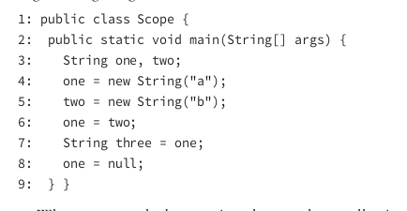

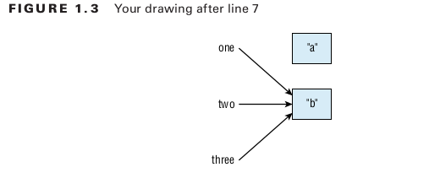

On line 6, the variable one changes to point to "b" . so “a” can be GC.
"b" has arrows pointing to it until it goes out of scope. This means "b" doesn’t go out of scope until the end of the method on line 9.

finalize()
Object can implement this method. Gets called if the GC tries to collect the object (when is object eligible for GC). If GC doesn’t run the method doesn’t get called. It is only run zero on one time (Jave remembers already running finalize()).
1: public class Rabbit {
2: public static void main(String[] args) {
3: Rabbit one = new Rabbit();
4: Rabbit two = new Rabbit();
5: Rabbit three = one;
6: one = null;
7: Rabbit four = one;
8: three = null;
9: two = null;
10: two = new Rabbit();
11: System.gc();
12: } }

A. The Rabbit object from line 3 is first eligible for garbage collection immediately following line 6.
B. The Rabbit object from line 3 is first eligible for garbage collection immediately following line 8.
C. The Rabbit object from line 3 is first eligible for garbage collection immediately following line 12.
D. The Rabbit object from line 4 is first eligible for garbage collection immediately following line 9.
E. The Rabbit object from line 4 is first eligible for garbage collection immediately following line 11.
F. The Rabbit object from line 4 is first eligible for garbage collection immediately following line 12.
Answer: B, D.
The Rabbit object from line 3 has two references to it: one and three . The references are nulled out on lines 6 and 8, respectively. Option B is correct because this makes the object eligible for garbage collection after line 8. Line 7 sets the reference four to the now null one , which means it has no effect on garbage collection. The Rabbit object from line 4 only has a single reference to it: two . Option D is correct because this single reference becomes null on line 9. The Rabbit object declared on line 10 becomes eligible for garbage collection at the end of the method on line 12. Calling System.gc() has no effect on eligibility for garbage collection.

Operators and Statements

Understanding Java Operators

Java operators are not necessarily evaluated from left-to-right order.
Example:
x = 3 + 2 * --y;
First is decrement y. then multiply value by 2 and finally add 3. So unless overridden with parentheses, Java operators flow order of operation:
- Post-unary operators: expresssion++, expresssion++
- Pre-unary operators: ++ expresssion
- Other unary operators: +, - !
- Multiplication, division, modulus (% )
- Addition, subtraction
- Shift operators: <<, >>, >>>
- Relational operators: <, >, <=, >=, instance of
- equal; == !=
- logical operators & , ^ , |
- Short-circuit logical operators: && , ||
- Ternary operators:
- Assignment operators
Multiplication operators have a higher order of precedence than the additive operators.
Example:
int x = 2 * 5 + 3 * 4 – 8;
You first evaluate the 2 * 5 and 3 * 4 , which reduces the expression to the following:
int x = 10 + 12 – 8;

Numeric Promotion Rule:
- If two values have different data types, Java will automatically promote one of the values to the larger of the two data types.
- If one of the values is integer and the other is floating-point. Java promotes the integer valut to the floating point data type
- small data types (byte, short chart) are first promoted to int any time when they’re used with a Java binary arithmetic operator, event if either of them is int. Unary operators are excluded from this rule.
- After all promotion has occurred and the operand have the same data type the resulting value will have the same data types as its promoted operand
Example
short x = 10;
short y = 3;
short z = x * y; // DOES NOT COMPILE (they are promoted to int)

Increment and decrement operators rule
If the operator is placed before the operand, referred to as the pre-increment operator and the pre-decrement operator, then the operator is applied first and the value return is the new value of the expression. Alternatively, if the operator is placed after the operand, referred to as the post-increment operator and the post-decrement operator, then the original value of the expression is returned, with operator applied after the value is returned.
Example
int counter = 0;
System.out.println(counter); // Outputs 0
System.out.println(++counter); // Outputs 1
System.out.println(counter); // Outputs 1
System.out.println(counter--); // Outputs 1
System.out.println(counter); // Outputs 0

Casting primitives
Casting primitives is required any time you are going from a larger numerical data type to a smaller numerical data type, or converting from a floating-point number to an integral value.
Be careful is value to large to be stored as smaller data type. You will have overflow. Overﬂow is when a number is so large that it will no longer fit within the data type, so the system “wraps around” to the next lowest value and counts up from there. There’s also an analogous underﬂow, when the number is too low to ﬁt in the data type.

Logical operators
The logical operators, ( & ), ( | ), and ( ^ ), may be applied to both numeric and boolean data types. When they’re applied to boolean data types, they’re referred to as logical operators. Alternatively, when they’re applied to numeric data types, they’re referred to as bitwise operators, as they perform bitwise comparisons of the bits that compose the number.
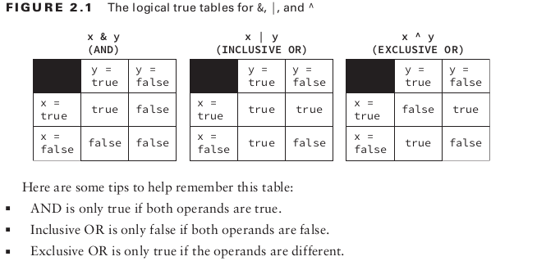
&& and || , which are often referred to as short-circuit operators. The right-hand side of the expression may never be evaluated if the final result can be determined by the left-hand side of the expression.

Equality Operators
Basic
- Comparing two numeric primitive types. If the numeric values are of different data types, the values are automatically promoted as previously described. For example, 5 == 5.00 returns true since the left side is promoted to a double
- Comparing two boolean values.
- Comparing two objects, including null and String values.
For object comparison, the equality operator is applied to the references to the objects, not the objects they point to. Two references are equal if and only if they point to the same object, or both point to null.

Java statements

- If-then
- if-then-else
- ternary operator
- switch: String, enum, primitive types and its wrapper classes (there is a break statement at the end of each case and default section)
- while
- do-while
- for
- for-each

Core Java API

Strings
String is basically a sequence of characters. It is a reference type
If one of the operand is a String then it means concatenation
Immutability. Once a String object is created, is it not allowed to change.

String Pool
The string pool also known as the intern pool is a location in the Java virtual machine that collectthese strings, contains literal values that are in the program (myObject.toString() → not literal so it doest not go into the string pool). String not in the string pool are GC just like other objhect
String name = “into” // will end up in string pool
String name = new String(“”) → creae a new object even though it is less efficient → do not use it is stored in the heap instead of string pool
String.intern() method puts the string in the String pool

String methods
String is a sequence of characters and Java counts from 0 when indexed.
- length()
- charAt() // return character at specific index
- indexOf()
- substring() → start (included) , end (optional not included)
- toLowerCase / toUpperCase
- equals() equalsIgnoreCase() startsWith() endsWith() contains()
- replace(old, new)
- trim() remove spaces from start and end

String Builder
Not immutable.
If you have lots of String object creation replace it with String Builder because it will save memory and create only one object, because it changes its own state and return a reference to itself

Some of the methods
- chartAt(), indexOf(), length(), substring()
- append
- insert
- delete(), → remote characters from the sequence deleteChartAt()
- reverse
- toString()
String Buffer it tread save String Builder

Equality
To compare primitive types == is ok. For reference types == is used to compare address of the object (reference) not object content.
StringBuilder one = new StringBuilder();
StringBuilder two = new StringBuilder();
StringBuilder three = one.append("a");
System.out.println(one == two); // false
System.out.println(one == three); // true

String case
String x = "Hello World";
String y = "Hello World";
System.out.println(x == y); // true
True is because Strings are immutable and pooled (Only one in memory, so x and y point to the same location in the memory)
String x = "Hello World";
String z = " Hello World".trim();
System.out.println(x == z); // false → we don’t have same string because new one in string pool is created
Never use == to compare String objects but equals (it will compare context). This works because the authors of the String class implemented a equals methods to check and compare values inside the String,
Be careful. String Builder does not have implemented equals. So it will compare using ==

Arrays
Creating
- int[] n = new int[3];
- int[] n = new int[] {1, 2, 3}
- int[] n = {1, 2, 3}
You can chose any Java type to be the type of the array (including classes – default value null).
Array is an object so we can call equals (it does not look at the elements of the array it check reference)
Array does not allocate space for the String (or other reference data types) but for its references (it saves references)
Elements are indexed starting with 0
Sorting use Arrays.sort(). If array is sorted you can use Arrays.binarySearch() to find index of value (if not found -1).

ArrayList
Can change size at run time as needed. It is an ordered sequence that allows duplicated
Methods
- add, also index
- remove removes the first matching value in the Arrayist or remove the element at a specified index
- set
- isEmpty, size, clear
- contains, equals (same elements in same order)
- Collections.sort(listInstance)

Converting Between array and List
listInstance.toArray(); // returns Object[]
listInstance.toArray(new String[0]); // returns String[]
Arrays.asList(array) // returns fixed size list. You are not allowed to change size (remove or add elements)

Wrapper Classes
Each primitive type has a wrapper class, which is an object type that corresponds to the primitive.

parsetInt(“value”) returns primitive
valueOf(“value”) returns wrapper class

They both throws NumberFormatException

You don’t need to worry whether a primitive or wrapper class is returned. Java will convert it to the relevant type for you. This is called autoboxing.

List<Integer> numbers = new ArrayList<>();
numbers.add(1);
numbers.add(2);
numbers.remove(1);
System.out.println(numbers);

It prints 1. Because we are removing element at index 1. Because there is a method that takes an int as parameter. If you want to remove the 1 you can write numbers.remove(new Interger(1)); to force wrapper class use

Dates and Times
Import java.time.*
In the real world talk with dates and times zones automatically. Example Tuesday 11:00 CET

Creating
- LocalDate – contains just a date
- LocalTime – contains just a time
- LocalDateTime – contains date and time no time zone
- ZoneDateTime – date time and time zone
Oracle recommends avoiding time zones unless you really need them.
Each of classes has a static method called now() that gives the current data and time
Each of classes has a static method called of(int yer, month, day) which you can use to create specific date. Month start with integer 1. Also you can combine of(localdateInstance, localTimeInstance)
Also Java tends to use 24-hour clock.
Notice classes does not have public or protected constructor, only private.
Working with Java 1.7

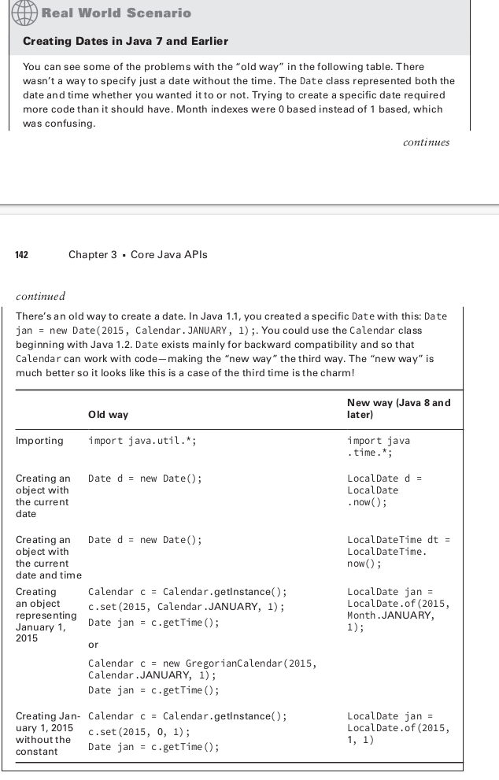

Manipulating Date and Times
The date and time classes are immutable. Do not forget to assign the result of the methods to a reference variable.
Some of the methods
- plusDays() plustMonths() plustYears()
- minusDays() minusHours(), minisSexonds()

Periods
LocalDate methods
- isBefore
- plus(Period period) → adds period of time that gets passed in
- plus(Duraction duration) → add duration (specific than period)
LocalDateTime methods
- toEpochDays() → numerb of days since 1.1.1970.
- toEpochTime() → number of seconds since 1.1.1970,
Period methods
- ofYears(int)
- ofMonths(int) Example Period.ofMonths(3) // every 3 months
- ofWeeks, ofDays..
- of(year, month, days)
- can not chain this methods
Duration same as period but for smaller time size used it for hours, minutes, days, but not for year or years (then use Period)

Formatting Dates and Times
For basic case (ISO standard date/time format)
dateInstance.format(DateTimeFormatter.ISO_LOCAL_DATE);
Class DateTimeFormatter can be used to format any type of data and/or time object. What changes is the format.
DateTimeFormatter shortDateTime = DateTimeFormatter.ofLocalizedDate(FormatStyle.SHORT);
System.out.println(shortDateTime.format(dateTime)); // 1/20/20
You can create your own format.
DateTimeFormatter f = DateTimeFormatter.ofPattern("MMMM dd, yyyy, hh:mm");

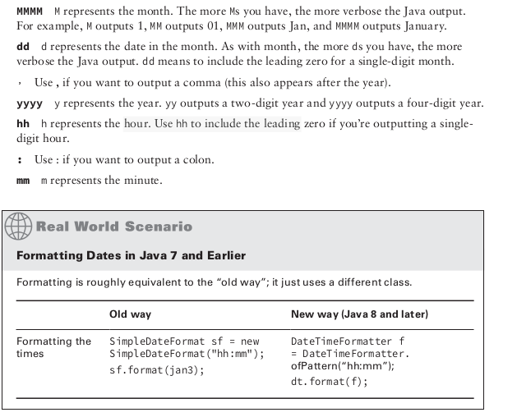
Parsing Date and Times
LocalDate.parse("value", dateTimeFormatterInstance); // DateTimeFormatter.ofPattern("MM dd yyyy");

Methods and Encapsulation

Access Modifiers
public – accessible from any class
private – accessible within the same class
protected – accessible in the same package or subclasses
default (package private) – only from classes in the same package

Static
Static method can not call instance methods or fields
Java is a pass by value language. Copy of the variable is made and the method receives that copy. Assignments made in the method do not affect the caller (be careful with refereces).

Method overloading
Creating methods with the same signature in the same class. Method same name but different signature (because of the parameters – number of type). Everything other than the method signature can vary (diff access modifiers, return type, exception list).
Java calls the most specific method it can find when has to chose with one of the overloaded to call.

Constructor
Called when we write new ClassName()
Order of initialization
- super class
- static variable declaration and static init blocks (in the order they appear in the file) – only once per class
- instance variable declaration and instance init blocks (in the order they appear in the file)
- constructor

Creating immutable classes
Omit the setters.
Public constructor.
Return type of the method must be immutable (be careful with references)
Final class

Writing Simple Lambda
Lambda - expression that can be passed as method param
Syntax
- parameter list ( can remove (), if single parameter without type)
- arrow operator to separate parameters and body
- body (can have {}, if yes return is needed and semicolon)

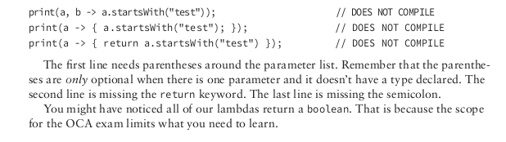
Lambda can access final or effective final variables.

Functional interfaces
- interface with one public method (can have static and default)
Predicate<T> → boolean test(T t)

Class Design

Inheritance
Inherit from an existing class (includes any public or protected primitives, objects or methods declared in parent class).

The primitive age is marked as private and therefore not accessible from the subclass Lion, as the following would not compile:
public class Lion extends Animal {
private void roar() {
System.out.println("The "+age+" year old lion says: Roar!"); // DOES NOT COMPILE
}
}
Despite the facet that age is inaccessible by the child class, if we have an instance of Lion object there is still an age value that exist within instance. The Lion object is actually “bigger” than the Animal object in the sense that it includes all the properties of the Animal object (all of those properties may not be directly accessible)

Creating Java Objects
In Java, all classes automatically inherit form a single class (java.lang.Object – this cvlass doesn’t have any parent classes)
In Java first statement of every constructor is either a call to another constructor using this() or call to a constructor of the parent class using supper()
If no super() call is declared in a constructor, Java will insert a no-argument super() as the first statement of the constructor.

Overriding a Method
Declaring a new method in subclass with the same signature and return type as the method in the parent class (access modificator can no be stricker)
User super. To call parent method.
It is not possible to override a private method in a since is not accessible, but you can create your own version of it.
Final methods can not be overriden

Hiding static methods
When a child class defines a static method with the same name and signature as a static method in a parent class. hidden methods only replace parent methods in the calls defined in the child class
At runtime the child version of an overridden method is always executed for an instance regardless of whether the method call is defi ned in a parent or child class method. In this manner, the parent method is never used unless an explicit call to the parent method is referenced, using the syntax ParentClassName.method() . The class only knows about static from its own class definition.

Inheriting Variables
Java doesn’t allow variables to be overridden but instead hidden. When you hide a variable, you define a variable with the same name as a variable in a parent class. This creates two copies of the variable within an instance of the child class: one instance defined for the parent reference and another defined for the child reference.
This rule is the same regardless of whether the variable is an instance variable or a static variable.

Abstract Class
Abstract class – provide reusable variables and methods to developers and you don’t want an instance of parent class to be instantiated unless it is an instance of the child class.
Abstract class or method can not be marked final. Method can not be marked private and abstact.

Interfaces
Interface is an abstract data type that defines a list of abstract public methods that class implementing it must provide. Also can have list of
- constant variables
- default methods
- static methods
Interface that extends another interface as well abstract class that implements an interface inherits all of the abstract methods as its own,
The first concrete class that implements an interface must provide a implementation for all of the inherited abstract method.
Define a class that inherits from two interfaces that contain the same abstract method (the methods are considered duplicates since they have the same signature) so class is required to implement only one.
Unfortunately, if the method name and input parameters are the same but the return types are different between the two methods, the class or interface attempting to inherit both interfaces will not compile.

Default method
Method with body. It is an abstract method with a default implementation. Class have the option to override or not. Good for backward compatibility..
When an interface extends another interface that contains a default method, it may
- choose to ignore the default method, in which case the default implementation for the
method will be used.
- may override the definition of the default method using the standard rules for method overriding
- may redeclare the method as abstract, requiring classes that implement the new interface to explicitly provide a method body
Analogous options apply for an abstract class that implements an interface.
If a class implements two interfaces that have default methods with the same name and signature, the compiler will throw an error. There is an exception to this rule, though: if the subclass overrides the duplicate default methods, the code will compile without issue

Static interface methods
Function nearly identically to static methods defined in classes.
To reference the static method, a reference to the name of the interface must be used (it can be accessed without an instance of the class). without an explicit reference to the name of the interface the code will not compile

Polymorphism
Property of an object to take on many different forms, a Java object may be accessed using a reference with the same type, superclass reference type or subclass reference type.
All objects are accessed by reference so as a developer you never have direct access to the object itself. Object is the entity that exist in memory allocated by the Java runtime environment. Regardless of the type of the reference you have for the object in memory the object itself doesn’t change.
Principles
- the type of the object determines which properties exist within the object in memory
- the type of the reference determine which methods and variables are accessible to the Java program
Changing a reference of an object to a new reference type may give you access to new properties of the object, but those existed before the reference change occurred.

Exceptions

An exception is Java’s way of saying “I give up. I don’t know what to do. You deal with it”. So you have option to deal with the problem or make it calling code’s problem. Method can handle the exception case itself or make it the caller’s responsibility.

Exception Types
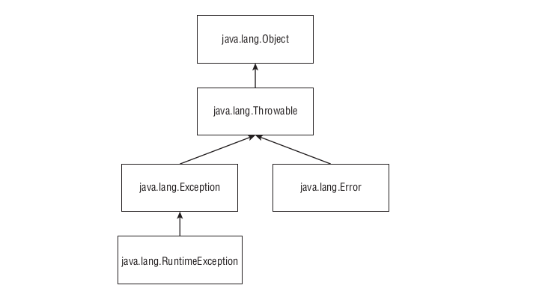

Super class for all objects that throw exception is Throwable class.
Error means something went so horribly wrong that your program should not attempt to recover from it.
Unchecked exceptions are exceptions that tend to be unexpected but not necessarily fatal, defined as the RuntimeException and its sub-classes. An example is NullPointerException (when you try to call a null reference) it can occure in any method.
Checked exception includes Exception and all subclasses that do not extend RuntimeException. Those are exceptions that tend to be anticipated – read a file that doesn’t not exist. Java requires the code to either handle them or declare them in the method.
void fatal() throws Exception() { throw new Exception(); }
Because checked exceptions tend to be anticipated, Java enforces that the programmer do something about them. (catch or rethrow)
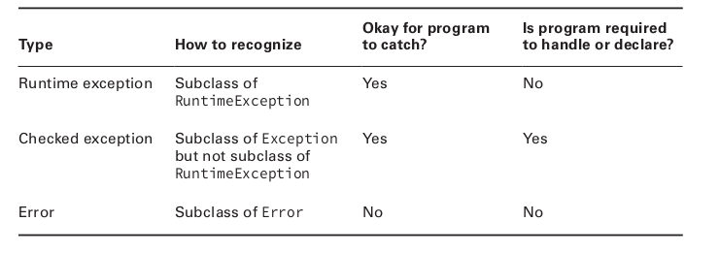

Using a try statement
Java uses a try statement to separate the logic that might throw exception from the logic to handle that exception.
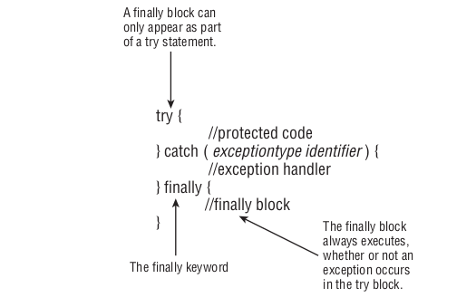
If an exception is thrown the finally block is run after the catch block. If no exception is thrown the finally block is run after the try block completes. When System.exit(0) is called Java stops the program right at that line, no finally block is called.

Catch various Types of Exceptions
The order of catch blocks matters. Put the specific ones first.
Also you can trow new exception in the catch block or finally block.

Sub classes
When a class overrides a method from superclass or implements a method from an interface, it’s not allowed to add new checked exceptions to the method signature (only for checked - runtime can add more, or If empty declare new), but A class is allowed to declare a subclass of an exception type.
A subclass is allowed to declare fewer exceptions than the superclass or interface. This is legal because callers are already handling them.

Printing Exception
You can let Java print it out (the exception type and message), print just the message, or print where the stack trace comes from (the exception type + message + stack trace).
System.out.println(e);
System.out.println(e.getMessage());
e.printStackTrace();

Common Exception Types
Runtime Exceptions
They are unchecked exceptions, don’t have to be handled or declared.
- ArithmeticException when divied by zero
- ArrayIndexOutOfBoundsException illega index to access an array
- ClassCastException can to an class that is not in inhertance tree
- NullPointerException when reference is null
- NumberFormatException string to number but the value is not number
Checked Exceptions
Exceptions that extend Exception but not RuntimeException class, they must be handled or declared
- FileNotFoundException
- IOException
Errors
Extend Erros class. Should not be handled or declared,
- ExceptionInInitializerError
- StackOverflowError
- NoClassDefFoundError

