Angular Cookbook

Components Communication

@Input and @Output
In order to communicate between components using @Input(s) and @Output(s), the data flow will always go from the child components to the parent component, which can provide the new (updated) value as input back to the required child components.
Example
NotificationsManagerComponent emits the countChanged event. AppComponent (being the parent component) listens for the event and updates the value of notificationsCount, which automatically updates the count property in NotificationsButtonComponent because notificationsCount is being passed as the @Input() count to NotificationsButtonComponent. Figure 1.2 shows the entire process:

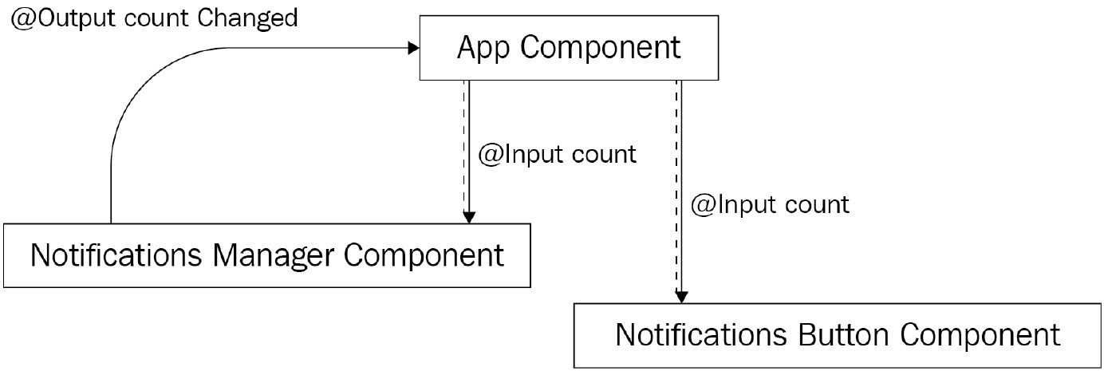

More info here https://www.thirdrocktechkno.com/blog/how-angular-components-communicate

Using service
BehaviorSubject is a special type of Observable that requires an initial value and can be used by many subscribers. In this recipe, we create a BehaviorSubject and then create an Observable using the .asObservable() method on BehaviorSubject. Although we could've just used BehaviorSubject, using the .asObservable() approach is recommended by the community.
Once we have created the Observable named count$ in NotificationsService, we inject NotificationsService in our components and assign the count$ Observable to a local property of the components. Then, we subscribe to this local property (which is an Observable) directly in NotificationsButtonComponent's template (html) and in NotificationsManagerComponent's template using the async pipes.

Then, whenever we need to update the value of the count$ Observable, we use the setCount method of NotificationsService to update the actual BehaviorSubject's value by using the .next() method on it. This automatically emits this new value via the count$ Observable and updates the view with the new value in both of the components.
More info here:
https://www.learnrxjs.io/learn-rxjs/subjects
https://stackoverflow.com/questions/39494058/behaviorsubject-vs-observable/40231605#40231605

Input intercept using setters
Getters and setters are components of a built-in feature of JavaScript. Many developers have used them in their projects while using vanilla JavaScript, or even TypeScript. Fortunately, Angular's @Input()can also use getters and setters since they're basically a property of the provided class.
For this recipe, we use a getter and, more specifically, a setter for our input so whenever the input changes, we use the setter method to do additional tasks. Moreover, we use the setter of the same input in our HTML so we directly show the value in the view when updated.
It is always a good idea to use a private variable/property with getters and setters to have a separation of concerns on what the component receives as input and what it stores in itself separately.
More info here
https://angular.io/guide/component-interaction#intercept-input-property-changes-with-a-setter
https://www.jackfranklin.co.uk/blog/es5-getters-setters/

ngOnChanges to intercept input property changes

ngOnChanges is one of the many life cycle hooks Angular provides out of the box. It triggers even before the ngOnInit hook. So, you get the initial values in the first call and the updated values later on. Whenever any of the inputs change, the ngOnChanges callback is triggered with SimpleChanges and you can get the previous value, the current value, and a Boolean representing whether this is the first change to the input (that is, the initial value). When we update the value of the vName input in the parent, ngOnChanges gets called with the updated value. Then, based on the situation, we add an appropriate log into our logs array and display it on the UI.
More info here
- Angular life cycle hooks: https://angular.io/guide/lifecycle-hooks
- Using change detection hooks with ngOnChanges: https://angular.io/guide/lifecycle-hooks#using-change-detection-hooks
- SimpleChanges API reference: https://angular.io/api/core/SimpleChanges

Angular template reference variable

A template reference variable is often a reference to a DOM element within a template. It can also refer to a directive (which contains a component), an element, TemplateRef, or a web component (source: https://angular.io/guide/template-reference-variables).

More info here
Angular template variables: https://angular.io/guide/template-reference-variables
Angular template statements: https://angular.io/guide/template-statements

ViewChild

ViewChild() is basically a decorator that the @angular/core package provides out of the box. It configures a view query for the Angular change detector. The change detector tries to find the first element matching the query and assigns it to the property associated with the ViewChild() decorator.

The view query is executed after the ngOnInit life cycle hook and before the ngAfterViewInit hook.

More info here
Angular ViewChild: https://angular.io/api/core/ViewChild
Array's shift method: https://developer.mozilla.org/en-US/docs/Web/JavaScript/Reference/Global_Objects/Array/shift

Create dynamic component in Angular
ComponentFactoryResolver is an Angular service that allows you to resolve components dynamically at runtime. In our recipe, we use the resolveComponentFactory method, which accepts a Component and returns a ComponentFactory. We can always use the create method of ComponentFactory to create instances of the component. But in this recipe, we're using ViewContainerRef's createComponent method, which accepts ComponentFactory as an input. It then uses ComponentFactory behind the scenes to generate the component and then to add it to the attached ViewContainerRef. Every time you create a component and attach it to ViewContainerRef, it'll add a new component to the existing list of elements. For our recipe, we only needed to show one component at a time, that is, either FBCardComponent or TwitterCardComponent. So that only a single element exists in ViewContainerRef, we used the clear() method on it before adding an element.

More info
The resolveComponentFactory method: https://angular.io/api/core/ComponentFactoryResolver#resolvecomponentfactory
Angular's documentation on the dynamic component loader: https://angular.io/guide/dynamic-component-loader
ViewContainerRef docs: https://angular.io/api/core/ViewContainerRef
Loading Components Dynamically in Angular 9 with IVY: https://labs.thisdot.co/blog/loading-components-dynamically-in-angular-9-with-ivy

Directives

We create an attribute directive that takes the highlightText and highlightColor inputs and then listens to the input changes for the highlightText input using the SimpleChanges application programming interface (API) and the ngOnChanges life cycle hook.

@Directive({
selector: '[appHighlight]'
})
export class HighlightDirective implements OnChanges {
@Input() highlightText = '';
@Input() highlightColor = 'yellow';
originalHTML = '';
constructor(private el: ElementRef) { }
ngOnChanges(changes: SimpleChanges) {
if (changes.highlightText.firstChange) {
this.originalHTML = this.el.nativeElement. innerHTML;
return;
}
const { currentValue } = changes.highlightText;
if (currentValue) {
const regExp = new RegExp(`(${currentValue})`, 'gi')
this.el.nativeElement.innerHTML = this.originalHTML.replace(regExp, `<span style="background-color: ${this. highlightColor}">\$1</span>`)
}
}
}

More info here
Testing Angular attribute directives documentation (https://angular.io/guide/testing-attribute-directives)

Directive can have input
<div class="content" role="main" id="mainContent" appReadTime (readTimeCalculated)="onReadTimeCalculated($event)">

(readTimeCalculated) is output of appReadTime directive

We use the ElementRef service inside the directive to get the native element that the directive is attached to, then we take out its text content

from directive:
constructor(private el: ElementRef) { }

Structural directives in Angular are special for multiple reasons. First, they allow you to manipulate DOM elements—that is, adding/removing/manipulating based on your needs. Moreover, they have this * prefix that binds to all the magic Angular does behind the scenes. As an example, *ngIf and *ngFor are both structural directives that behind the scenes work with the <ng-template> directive containing the content you bind the directive to and create the required variables/properties for you in the scope of ng-template. In the recipe, we do the same. We use the TemplateRef service to access the <ng-template> directive that Angular creates for us behind the scenes, containing the host element on which our appIfNot directive is applied. Then, based on the value provided to the directive as input, we decide whether to add the magical ng-template to the view or clear the ViewContainerRef service to remove anything inside it.

More info here
Angular structural directive microsyntax documentation (https://angular.io/guide/structural-directives#microsyntax)
Angular structural directives documentation (https://angular.io/guide/structural-directives)
Creating a structural directive by Rangle.io (https://angular-2-training-book.rangle.io/advanced-angular/directives/creating_a_structural_directive)

Group sibling elements with <ng-container> documentation (https://angular.io/guide/structural-directives#group-sibling-elements-with-ng-container)

"angularCompilerOptions": {
"strictInputTypes": true
"strictNullChecks": true,
"strictNullInputTypes": true
}
More info here
https://angular.io/guide/structural-directives
https://angular.io/guide/template-typecheck#template-type-checking
Troubleshooting template errors in Angular documentation (https://angular.io/guide/template-typecheck#troubleshooting-template-errors)

todo stao: https://learning.oreilly.com/library/view/angular-cookbook/9781838989439/B15150_03_Final_JC_ePub.xhtml#_idParaDest-88

Depedency injection

Every class can have an InjetionToken.

export const GREETER = new InjectionToken('Greeter',
{ providedIn: 'root', factory: () => Greeter}
);

Then you can use @Inject() to get instance of a class.

Constructor( @Inject(GREETER) public greeter: typeof Greeter )

Angular doesn't recognize regular TypeScript classes as injectables in services. However, we can create our own injection tokens and use the @Inject decorator to inject them whenever possible. Angular recognizes our token behind the scenes and finds its corresponding definition, which is usually in the form of a factory function. Notice that we're using providedIn: 'root' within the token definition. This means that there will be only one instance of the class in the entire application.

More info here:
https://angular.io/guide/dependency-injection
https://angular.io/api/core/InjectionToken

Use the @Optional decorator to configure optional dependencies in our components/services. Behind the scenes, Angular will provide the value as null when the dependency doesn't exist or is not provided to the app

Creating a singleton service version 1

This means that there will only be one instance of your service in the entire application. Here, we'll use a couple of techniques, including the providedIn: 'root' statement and making sure we only provide the service once in the entire app by using the @Optional() and @SkipSelf() decorators.

Whenever we try to inject a service somewhere, by default, it tries to find a service inside the associated module of where you're injecting the service. When we use providedIn: 'root' to declare a service, whenever the service is injected anywhere in the app, Angular knows that it simply has to find the service definition in the root module and not in the feature modules or anywhere else.
However, you have to make sure that the service is only provided once in the entire application. If you provide it in multiple modules, then even with providedIn: 'root', you'll have multiple instances of the service. To avoid providing a service in multiple modules or at multiple places in the app, we can use the @SkipSelf() decorator with the @Optional() decorator in the services' constructor to check whether the service has already been provided in the app.

Steps (Example on NotificationsService)

- providedIn: 'root'
@Injectable({providedIn: 'root'})
export class NotificationsService
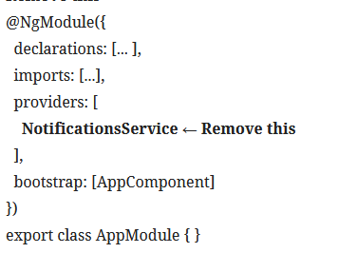
- remove service from providers array in app.module.ts

    - remove service form providers array from other modules.

4. In order to alert the developer about potential duplicate providers, use the @SkipSelf
decorator from the @angular/core package in our NotificationsService,

    - use the @Optional() decorator in notifications.service.ts, which is in the constructor for the dependency alongside the @SkipSelf decorator

More info here https://angular.io/guide/hierarchical-dependency-injection

Creating a singleton service version 2

use ModuleWithProviders and the forRoot() statement to ensure your Angular service is being used as a singleton in the entire app

ModuleWithProviders is a wrapper around NgModule, which is associated with the providers array that is used in NgModule. It allows you to declare NgModule with providers, so the module where it is being imported gets the providers as well. We created a forRoot() method in our ServicesModule class that returns ModuleWithProviders containing our provided NotificationsService. This allows us to provide NotificationsService only once in the entire app, which results in only one instance of the service in the app.

Steps

- Service has its own module
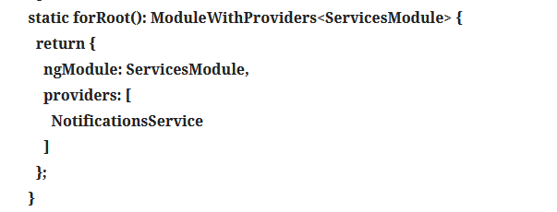
- Inside module.ts create forRoort method that retursn a ModuleWithProviders obects (declare NotificationsService in providers array)

3. remove Service form the app,module.ts imports array (and other modules also – do not import them , second part only on ). we'll add in the imports array using the forRoot() method (This is because it injects ServicesModule with the providers in AppModule )

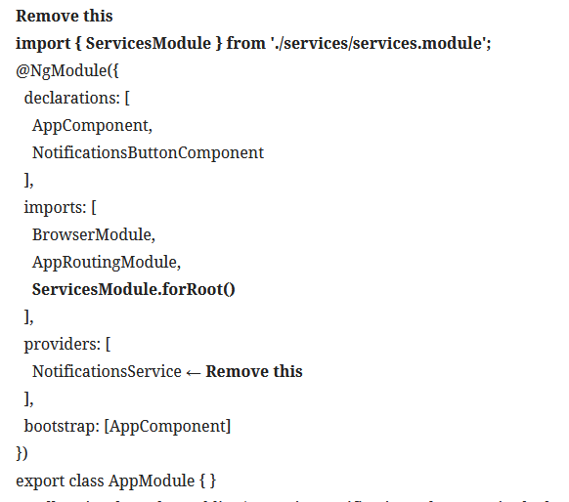

More info here
https://angular.io/api/core/ModuleWithProviders
https://angular.io/guide/migration-module-with-providers

Provide different service to the app with the same Aliased class provider

todo stao: https://learning.oreilly.com/library/view/angular-cookbook/9781838989439/B15150_03_Final_JC_ePub.xhtml#_idParaDest-110

