Introducing Bootstrap 4
Jörg Krause

1. Introduction to Bootstrap
The biggest advantage of Bootstrap is the huge selection of additional templates, themes, and boilerplate code. It makes it very easy and fast to create a sophisticated web site without a design agency or without having any professional design skills. There are also endless additions and extensions available to fill the rare gaps.

What’s New in Bootstrap 4?
This section gives an overview of the changes for those readers switching from Bootstrap 3.

Global Changes
The unit system has been changed from pixels (px) to rem (CSS) or em (Media Queries). The global font, which serves as the starting point, has been increased from 14 pixels to 16 pixels. This is mainly a reference to higher-resolution screens of mobile devices.

Grid System
So far there have been four raster layers: xs, sm, md, and lg. In the future, there will be another level: xl. This is designed to support extremely large displays (3,000 x 2,000 pixels and more).

Tables
Tables come with new options:
- .table-inverse inverts the table
- .thead-default and .thead-inverse format the header area
- .table-sm creates smaller tables
- All context classes now have the prefix .table-
- .responsive-table can now be directly assigned to the table element, the container is no longer needed
- .table-reflow supports reflow tables

Forms
Instead of the special class .form-horizontal, .row can now be used. All .control-- and .input--classes were unified to .form-control-. This means that the special classes .has-feedback and .help-block are obsolete.

Buttons
The classes .btn-default and .btn-info have been omitted in favor of .btn-secondary. Another new feature is .btn-xx-outline—a bezel button. The class .btn-xs is removed.

Pull-Down Menus
Instead of <ul><li>-structures , these can now be formatted using <div><a>-blocks directly. These are the classes .dropdown-item and .dropdown-menu. The class .dropdown-header can now be applied directly to <h1> and the like. Intervals are created with </div class="dropdown-divider"> rather than the previous method, which used <li>-tags.

Panels
The display forms Wells, Panels, and Thumbnails have been deleted and replaced by a new component with the name Card.

Other Updates
Progress bar can now be created with the HTML element <progress>. Quotations need the class .blockquote. Due to lack of browser support, this has some limitations.

2. It Begins with CSS

With CSS, you can address elements’ names.
p { color: blue; }

You can address element's by theire id
<button id="send">Save</button>
#send { color: blue; }
Use when you want applay css on single element.

You can address elements's by theire class atribute
<button class="btn">Save</button>
.btn { color: blue; }
Use when you want applay css on more then one element.

You can address elements's using attributes.
Use [name] { } or [name="value"] { }
<button data-item="22">Next</button>
[data-item] {
color: blue;
}

OR operator , (It often happens that rulesets are to be applied to multiple selectors )
a, b { }

Hierarchy Selectors
Dealing with hierarchies is essential to be able to use CSS properly, because HTML documents are hierarchies, which are often called trees. Figure 2-1 shows the relationships between elements in the document tree.

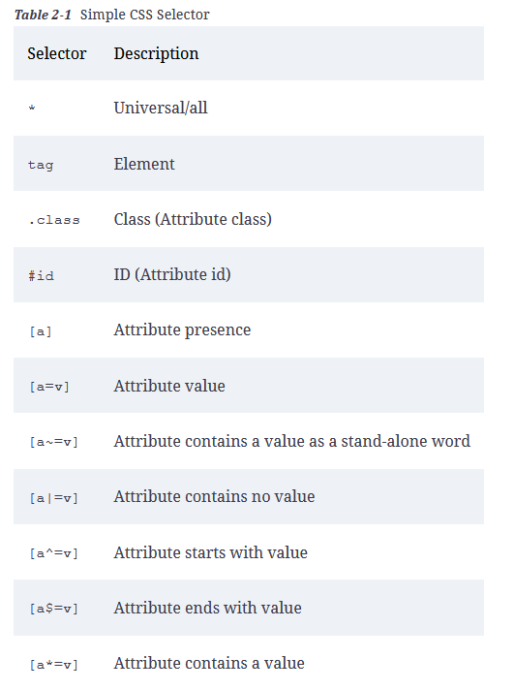

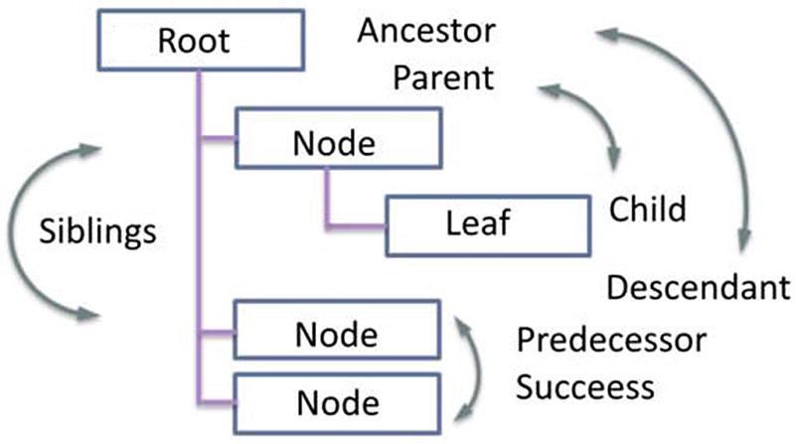

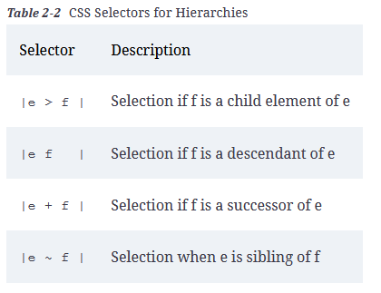

Pseudo Selectors
Pseudo selectors are those that have no comparable representation in HTML, but arise from the position of elements or their use. “Using” an element is primarily user action, such as clicking a hyperlink or placing the cursor in an input field. There are three types of pseudo selectors:
- Static positions (see Table 2-3 for a list of static selectors)
- Selection of areas (see Table 2-4 for a list of CSS selectors for areas)
- Dynamic behavior (see Table 2-5 for a list of dynamic CSS selectors)

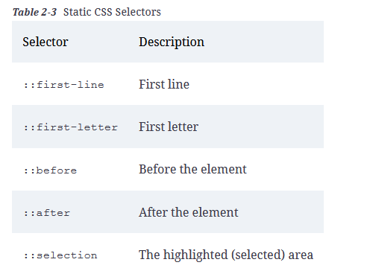

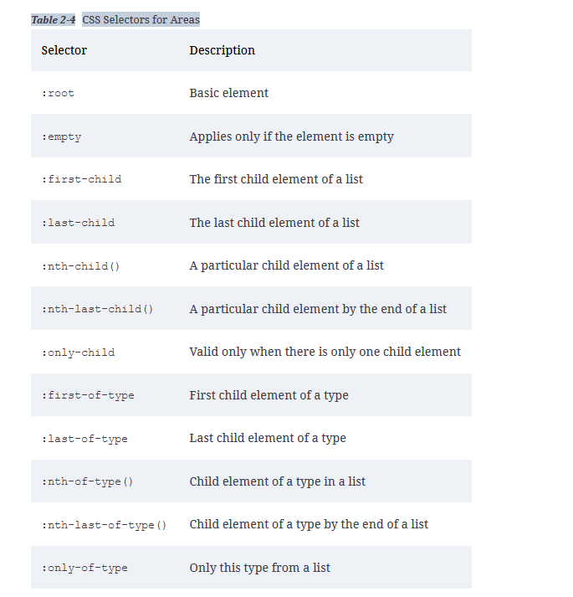

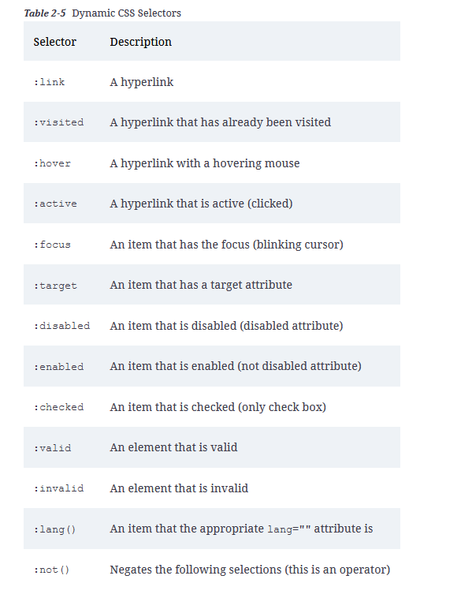

CSS units express length specifications. This is needed for widths, heights, spacing, margins, and so forth. Unit information consists syntactically from a number and a unit. For the number 0 the unit can be omitted. There are two types of units: absolute and relative.

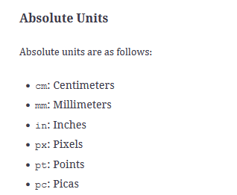

Relative Units
Relative units use a specific starting point, because they calculate only ratios. Available are the following units:
- em: Unit of font size, based on the height in pixels (1 em is the size in pixels of the base font’s uppercase letter “M”)
- ex: Unit of font size, based on the height of the lowercase letter “x”
- ch: Unit of font size, based on the width of the digit “0”
- rem: Unit of font size, based on the width of the lowercase letter “m” of the root element of the page (body)
- vw: Relative to 1% of the width of the viewport (46 cm screen width is 1 vw = 0.46 cm)
- vh: Relative to 1% of the height of the viewport
- vmin: Relative to 1% of the width of the narrow side of the viewport
- vmax: Relative to 1% of the width of the wide side of the viewport
- %: Percentage to the original value

The Box Model

HTML has two types of forms of representation for elements: flow and block. Flow elements embed themselves in the running text. These elements have dimensions such as width and height, for they depend on the surrounded content. On the other hand, block element dimensions cause adjacent elements to be displaced from their occupied space, and they can define the width and height they occupy by themselves. Moreover, the displacement behavior is highly customizable, up to the desired superposition. With special rules, elements that are actually floating elements are misidentified as block elements. This also can be reversed.

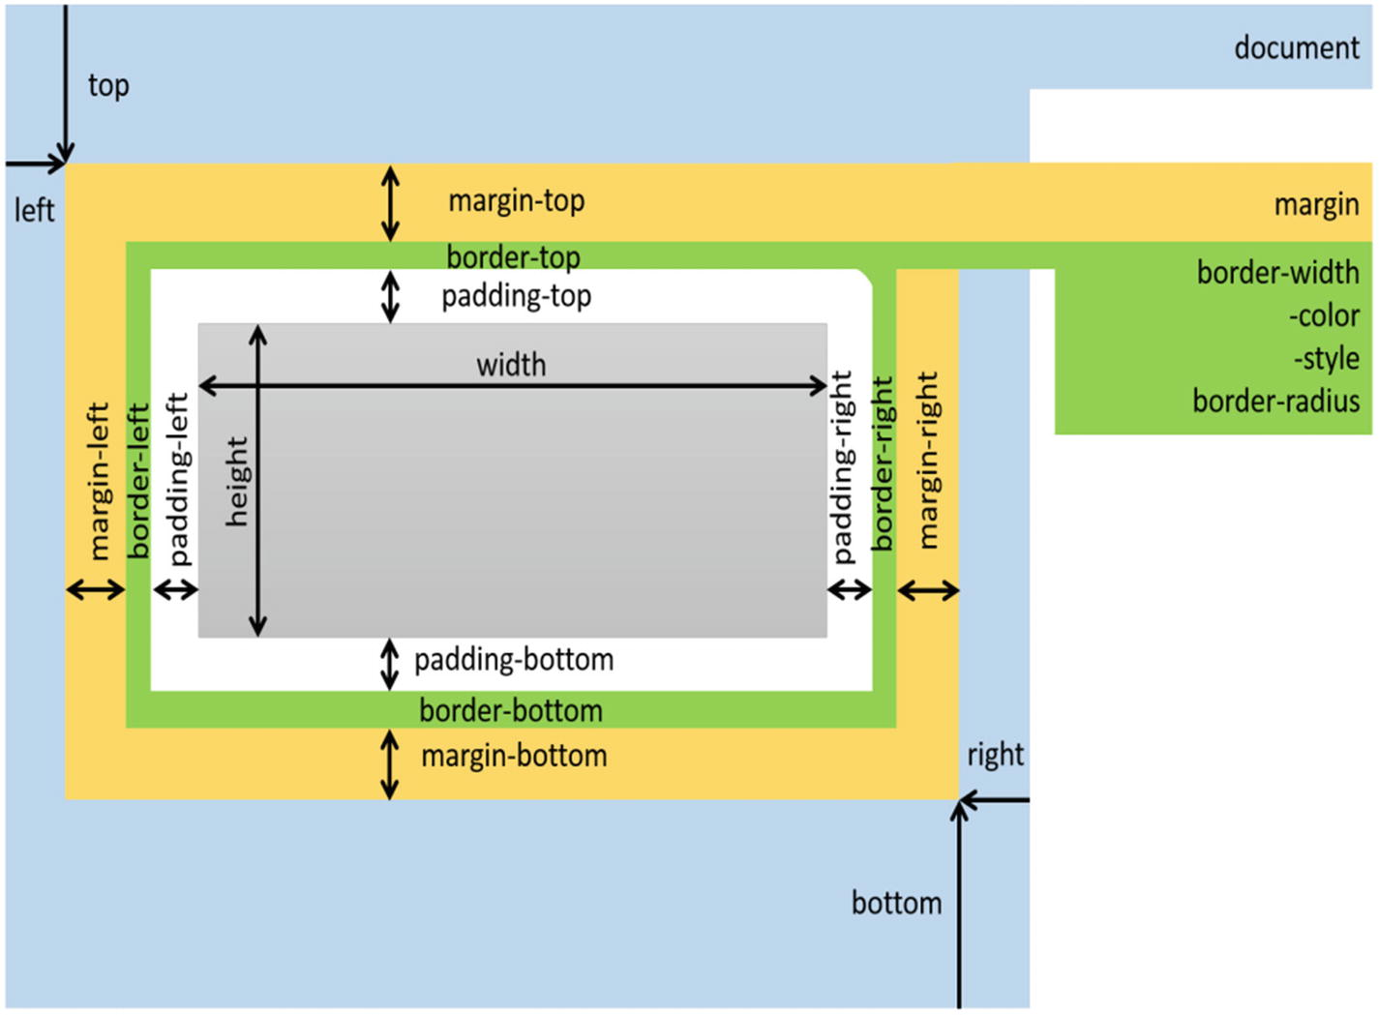
It is important to realize that the indication of the width and height are not the final dimensions, but the dimensions of the content area mapped. When a frame is enclosing the box with equal frame width on all sides, the frame width needs to be charged twice for the calculation of the final width, which makes the box dimensions on all sides equal to:
1 Width = Margin * 2 + Border width * 2 + Padding * 2
2 Height = Margin * 2 + Border width * 2 + Padding * 2
As there are differences between the paddings, border widths, and spacings, the calculation is accordingly complex. What’s graphically called a frame here is technically assigned as a “border,” assuming that the four sides are usually not exactly the same

The flexbox model

The flexbox model (also known as the flexible box model, flexbox layout, or “flex layout”) was introduced to solve the challenge of aligning elements and distributing space in a container. The size of the available space is usually unknown or dynamic. The flexbox model gives great control for almost all possible layout options.

The properties supported by the flexbox model allow the modification of an item’s width, height, and order. We can define the behavior to use the available space even if the user changes the browser dimensions. Items can be shrinked and expanded to fill the space perfectly.
A layout based on flexbox model instructions is direction-agnostic. You can arrange the items based on different rules that apply if the available space changes or the application resize

The flexbox model uses terms that are relatively new to CSS:
- Container: A container is the space where the items are being arranged
- Items: An item is a single element that takes space in the container
Both are controlled by a set of properties that CSS can apply. The actual element in HTML is not that important. While almost all examples use <div> elements, it is not limited to that.
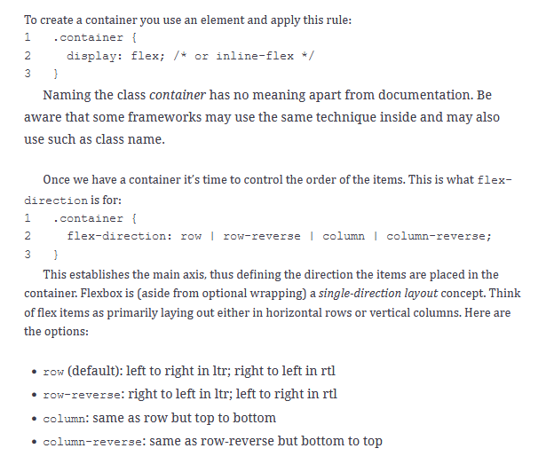
However, the space for one row is usually very limited. The items will therefore need to wrap to the next line. That’s why the property flex-wrap exists. It changes the behavior if the items do not fit on one line.
1 .container {
2 flex-wrap: nowrap | wrap | wrap-reverse;
3 }

- nowrap (default): all flex items will be on one line
- wrap: flex items will wrap onto multiple lines, from top to bottom
- wrap-reverse: flex items will wrap onto multiple lines from bottom to top

The additional property flex-flow applied to the container is a shorthand for the flex-direction and flex-wrap properties, which together define the flex container’s main and cross axes. The default value is row nowrap.
1 flex-flow: <'flex-direction'> || <'flex-wrap'>
The justify-content flex items within a flex container demonstrates the different spacing options. It tries to distribute the space between items equally, if the items cannot resize itself due to content or other restrictions, such as reaching their maximum width. IT can also be an option to control the behavior if an overflow happens at the end of the line.
1 .container {
2 justify-content: flex-start | flex-end | center | space-between | space-around | space-evenly | start | end | left | right ... + safe | unsafe;
3 }
- flex-start (default): items are laid out to the start of the flex-direction.
- flex-end: items are laid out to the end of the flex-direction.
- start: items are laid out to the start of the writing-mode direction.
- end: items are laid out to the end of the writing-mode direction.
- left: items are laid out to left edge of the container, unless that doesn’t make sense with the flex-direction, then it behaves like start.
- right : items are laid out to right edge of the container, unless that doesn’t make sense with the flex-direction, then it behaves like start.
- center: items are centered along the line.
- space-between: items are evenly distributed in the line; first item is on the start line, last item on the end line.
- space-around: items are evenly distributed in the line with equal space around them. Visually the spaces aren’t necessarily equal, since all the items have equal space on both sides. The first and last item doesn’t have a predecessor or successort, hence the space is only one of the given units.
- space-evenly : items are distributed so that the spacing between any two items (and the space at start and end) is equal.
You can also pair these values with two other keywords: safe and unsafe. Safe means here that you can’t render items in a way that they are off-screen to either side and would be no longer visible.

More alignment options are provided by align-items . The alignment applies against the parent’s top or bottom, or along a baseline. Hence it applies to the vertical distribution of items.
1 .container {
2 align-items: stretch | flex-start | flex-end | center | baseline | first baseline | last baseline | start | end | self-start | self-end + ... safe | unsafe;
3 }
- stretch (default): stretch to fill the container (this will respect min-width/max-width).
- flex-start / start / self-start: items are placed at the start of the cross axis. The difference between these three keywords is subtle, and has to do with respecting the flex-direction rules or the writing-mode rules.
- flex-end / end / self-end: items are placed at the end of the cross axis. The difference again is subtle and is about respecting flex-direction rules versus writing-mode rules.
- center: items are centered in the cross axis.
- baseline: items are aligned such as their baselines align.
Again, the safe and unsafe modifier keywords prevent content from being rendered invisible or not.

similar option is align-content , which is used to group items in a cluster. The whole cluster can be at the top or bottom, or stretch out to fill the space, or have equal spaces between the items. This aligns a flex container’s lines within when there is extra space in the cross axis, similar to how justify-content aligns individual items within the main axis. If there is only one line of flex items this property has no meaning:
1 .container {
2 align-content: flex-start | flex-end | center | space-between | space-around | space-evenly | stretch | start | end | baseline | first baseline | last baseline + ... safe | unsafe;
3 }
- flex-start / start : items are laid out according to the start of the container. flex-start honors the flex-direction while start honors the writing-mode direction.
- flex-end / end: items laid out to the end of the container. The (more support) flex-end honors the flex-direction while end honors the writing-mode direction.
- center: items are centered in the container.
- space-between: items are evenly distributed; the first line is at the start of the container while the last one is at the end.
- space-around: items are evenly distributed with equal space around each line.
- space-evenly : items are evenly distributed with equal space around them.
- stretch (default): lines stretch to take up the remaining space.
The safe and unsafe modifier keywords can be used here as well.

Items
Items are usually laid out by the containers options. In some cases it might be necessary to align single items differently. The few options CSS provides here are described as follows.
You can change the order. By default, flex items are laid out in the source order (as they appear in HTML). However, the order property controls a different order in which they appear in the flex container.
1 .item {
2 order: <integer>; /* default is 0 */
3 }
The rule flex-grow allows an item to grow if the items’ size is not equal. It gives the ability for a flex item to grow if necessary. It accepts a unitless value that serves as a proportion. It dictates what amount of the available space inside the flex container the item should take up. If all items have flex-grow set to 1, the remaining space in the container will be distributed equally to all children. If one of the children has a value of 2, the remaining space would take up twice as much space as the others (or it will try to) .
1 .item {
2 flex-grow: <number>; /* default 0 */
3 }
The rule flex-shrink also defines the ability for a flex item to shrink if necessary.
1 .item {
2 flex-shrink: <number>; /* default 1 */
3 }
The rule flex-basis defines the default size of an element before the remaining space is distributed. It can be a length (e.g., 20%, 5rem) or a keyword. The auto keyword means “look at my width or height property.”
1 .item {
2 flex-basis: <length> | auto; /* default auto */
3 }
If flex-basis is set to 0; the extra space around content isn’t factored in. If set to auto, the extra space is distributed based on its flex-grow value.
The shorthand rule flex combines the rules for flex-grow, flex-shrink, and flex-basis combined. The second and third parameters (flex-shrink and flex-basis) are optional. The default is 0 1 auto, but if you set it with a single number value, then it is like <number> 1 0.
1 .item {
2 flex: none | [ <'flex-grow'> <'flex-shrink'>? || <'flex-basis'> ]
3 }
The shorthand sets the other values intelligently. That makes it more robust and easier to use.

The Grid Model
The grid model layout is the most powerful way to arrange items on the screen using pure CSS. It creates a two-dimensional system, using rows and columns. The flexbox model described earlier is more of a one-dimensional layout, with a single line that breaks at well-defined borders. In a two-dimensional layout you need to define a container (the grid container) and the containers items (grid items).
You can think of the grid model as an extremely powerful and flexible way to create tables.

Terminology
Some terms help to understand the explanations that follow. These terms are new to CSS and came with the grid model.
- Grid container: Made with the display: grid rule. It is the direct parent of all the grid items.
- Grid item: The children (i.e., direct descendants) of the grid container.
- Grid line: The dividing lines that make up the structure of the grid. They can be either vertical (“column grid lines”) or horizontal (“row grid lines”) and appear on either side of a row or column.
- Grid track: The space between two adjacent grid lines. You can think of them like the columns or rows of the grid, that’s the space where the items reside.
- Grid cell: The space between two adjacent rows and two adjacent column grid lines. Think of it as just a virtual space for an item.
- Grid area: The total space surrounded by four grid lines. A grid area may be composed of any number of grid cells. It is like merging cells into a larger space.
TODO

