Learning SQL
by Alan Beaulieu

Background
database systems, which are computerized data storage and retrieval mechanisms
Early database systems managed data stored on magnetic tapes. Because there were generally far more tapes than tape readers, technicians were tasked with loading and unloading tapes as specific data was requested.
Over the first several decades of computerized database systems, data was stored and represented to users in various ways. In a hierarchical database system, for example, data is represented as one or more tree structures
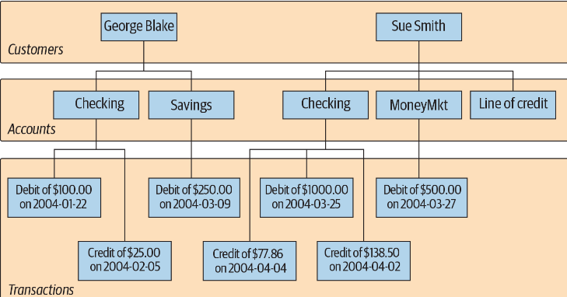
The hierarchical database system provides tools for locating a particular customer’s tree and then traversing the tree to find the desired accounts and/or transactions. Each node in the tree may have either zero or one parent and zero, one, or many children. This configuration is known as a single-parent hierarchy.
nother common approach, called the network database system, exposes sets of records and sets of links that define relationships between different records
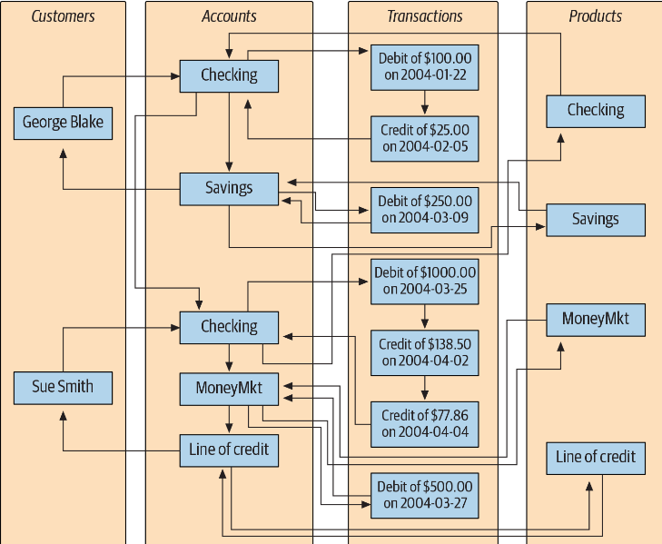
network database to act as a multiparent hierarch.

Relational model
In 1970, Dr. E. F. Codd of IBM’s research laboratory published a paper titled “A Relational Model of Data for Large Shared Data Banks” that proposed that data be represented as sets of tables. Rather than using pointers to navigate between related entities, redundant data is used to link records in different tables.
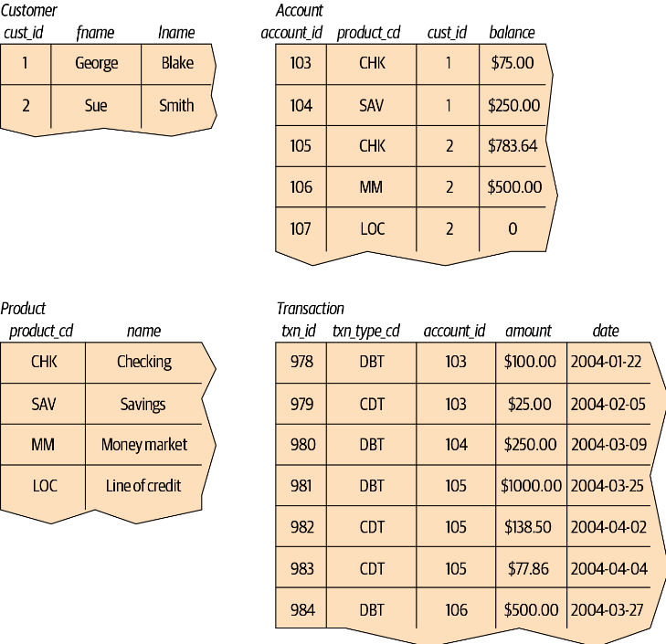

SQL
This group created a simplified version of DSL/Alpha that they called SQUARE. Refinements to SQUARE led to a language called SEQUEL, which was, finally, shortened to SQL. While SQL began as a language used to manipulate data in relational databases, it has evolved (as you will see toward the end of this book) to be a language for manipulating data across various database technologies.
In the mid-1980s, the American National Standards Institute (ANSI) began working on the first standard for the SQL language, which was published in 1986. Subsequent refinements led to new releases of the SQL standard in 1989, 1992, 1999, 2003, 2006, 2008, 2011, and 2016.
Sql standard here: https://blog.ansi.org/2018/10/sql-standard-iso-iec-9075-2016-ansi-x3-135/#gref
SQL schema statements, which are used to define the data structures stored in the database;
SQL data statements, which are used to manipulate the data structures previously defined using SQL schema statements
SQL transaction statements, which are used to begin, end, and roll back transactions
All database elements created via SQL schema statements are stored in a special set of tables called the data dictionary. This “data about the database” is known collectively as metadata
The optimizer’s job is to look at your SQL statements and, taking into account how your tables are configured and what indexes are available, decide the most efficient execution path (well, not always the most efficient). Most database engines will allow you to influence the optimizer’s decisions by specifying optimizer hints, such as suggesting that a particular index be used; most SQL users, however, will never get to this level of sophistication and will leave such tweaking to their database administrator or performance expert.

Creating and populating a database

MySQL Data Types

Character Data
Character data can be stored as either fixed-length or variable-length strings;
char(20) /* fixed-length */
varchar(20) /* variable-length */
fixed-length strings are right-padded with spaces and always consume the same number of bytes, and variable-length strings are not right-padded with spaces and don’t always consume the same number of bytes
When defining a character column, you must specify the maximum size of any string to be stored in the column.
The maximum length for char columns is currently 255 bytes, whereas varchar columns can be up to 65,535 bytes. If you need to store longer strings (such as emails, XML documents, etc.), then you will want to use one of the text types (mediumtext and longtext),
In general, you should use the char type when all strings to be stored in the column are of the same length, such as state abbreviations, and the varchar type when strings to be stored in the column are of varying lengths

Character sets
For languages that use the Latin alphabet, such as English, there is a sufficiently small number of characters such that only a single byte is needed to store each character. Other languages, such as Japanese and Korean, contain large numbers of characters, thus requiring multiple bytes of storage for each character. Such character sets are therefore called multibyte character sets.
To view the supported character sets in your server, you can use the show command
SHOW CHARACTER SET;
in prior versions of the MySQL server, the latin1 character set was automatically chosen as the default character set, but version 8 defaults to utf8mb4. However, you may choose to use a different character set for each character column in your database, and you can even store different character sets within the same table.
you may also set the default character set for your entire database:
create database european_sales character set latin1;

Text data
If you need to store data that might exceed the 64 KB limit for varchar columns, you will need to use one of the text types.
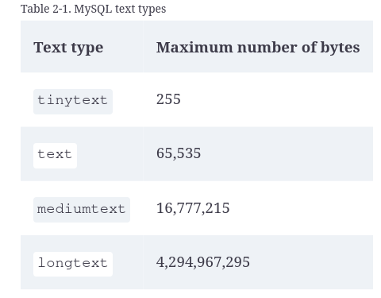

If you are creating a column for free-form data entry, such as a notes column to hold data about customer interactions with your company’s customer service department, then varchar will probably be adequate. If you are storing documents, however, you should choose either the mediumtext or longtext type

Numeric Data
When specifying one of these types, you may also specify that the data is unsigned, which tells the server that all data stored in the column will be greater than or equal to zero
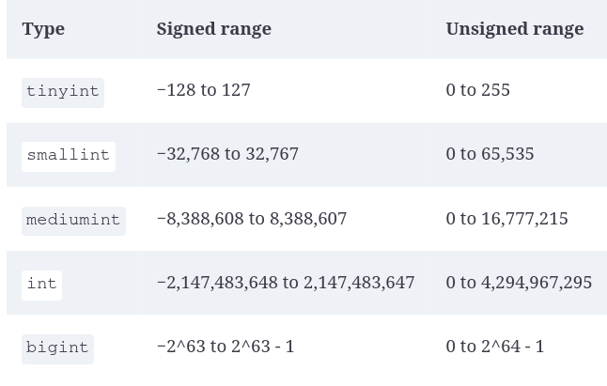
For floating-point numbers you may choose from the numeric types shown
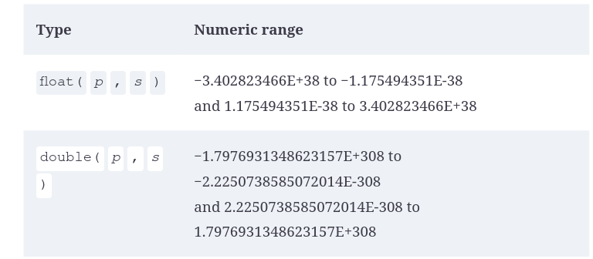

When using a floating-point type, you can specify a precision (the total number of allowable digits both to the left and to the right of the decimal point) and a scale (the number of allowable digits to the right of the decimal point), but they are not required.
If you specify a precision and scale for your floating-point column, remember that the data stored in the column will be rounded if the number of digits exceeds the scale and/or precision of the column.

Date types
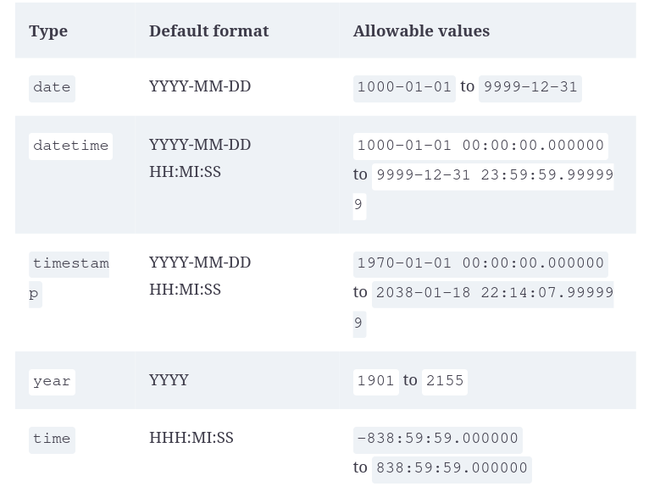

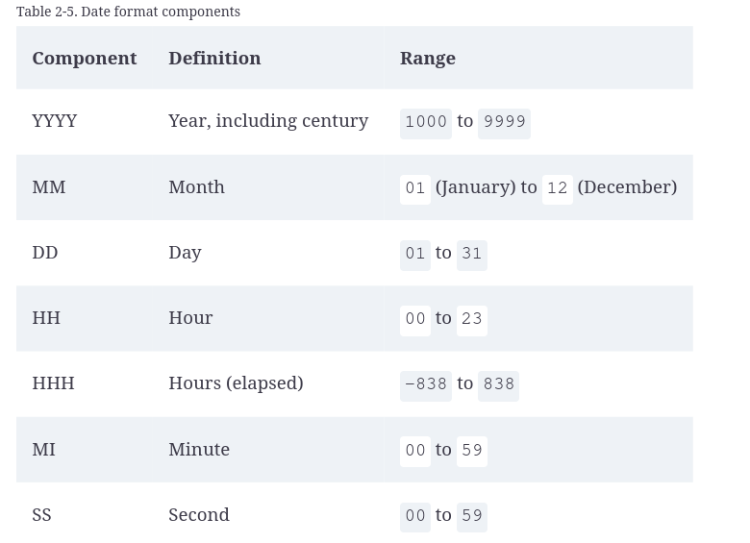
A column that tracks when a user last modified a particular row in a table would use the timestamp type. The timestamp type holds the same information as the datetime type (year, month, day, hour, minute, second), but a timestamp column will automatically be populated with the current date/time by the MySQL server when a row is added to a table or when a row is later modified.

Table Creation

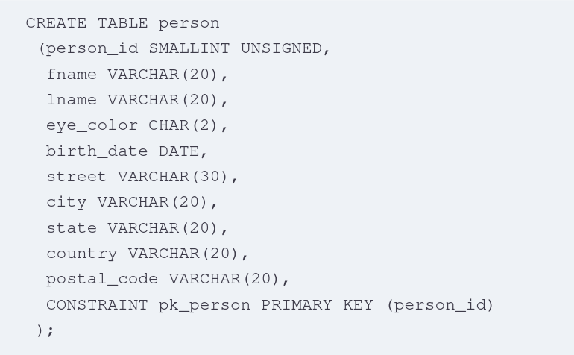
when you define your table, you need to tell the database server what column or columns will serve as the primary key for the table. You do this by creating a constraint on the table. his constraint is a primary key constraint. It is created on the person_id column and given the name pk_person
Another type of constraint called a check constraint constrains the allowable values for a particular column. MySQL allows a check constraint to be attached to a column definition, as in the following:
eye_color CHAR(2) CHECK (eye_color IN ('BR','BL','GR')),
MySQL does provide another character data type called enum that merges the check constraint into the data type definition.

You can use the describe command to see info. the column is said to be null (note that I do not say that it equals null), which indicates the absence of a value.
two-column primary key: person_id and food.
CONSTRAINT pk_favorite_food PRIMARY KEY (person_id, food),

The FOREIGN KEY constraint identifies the relationships between the database tables by referencing a column, or set of columns, in the Child table that contains the foreign key,
-> CONSTRAINT fk_fav_food_person_id FOREIGN KEY (person_id)
This constrains the values of the person_id column in the favorite_food table to include only values found in the person table.

Populating and modifying tables

Inserting data
INSERT
- name of the table
- name of the columns in the table to be populated
- values with which to populate the columns

Generation numeric key data (primary keys)
- Pick number of thin air
- look at the largest value in the table and add one
- let the DB provide the value for you
Turn on auto-increment feature for PK.
Use alter table, which is used to modify the definition of an existing table
ALTER TABLE person MODIFY person_id SMALLINT UNSIGNED AUTO_INCREMENT;

If you are running these statements in your database, you will first need to disable the foreign key constraint on the favorite_food table, and then re-enable the constraints when finished. The progression of statements would be:
set foreign_key_checks=0;
ALTER TABLE person
MODIFY person_id SMALLINT UNSIGNED AUTO_INCREMENT;
set foreign_key_checks=1;
When you insert data into the person table, you simply provide a null value for the person_id column, and MySQL will populate the column with the next available number
If you will be working with XML data, you will be happy to know that most database servers provide a simple way to generate XML output from a query. With MySQL, for example, you can use the --xml option when invoking the mysql tool, and all your output will automatically be formatted using XML.
TODO check for JSON

Updating data
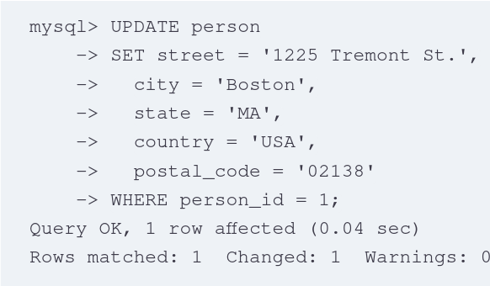

Deleting Data

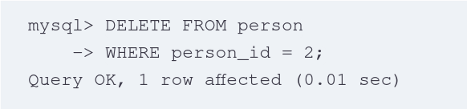

Query Primer

Query Mechanics
Stao: https://learning.oreilly.com/library/view/learning-sql-3rd/9781492057604/ch03.html

