Caching

What and where to cache

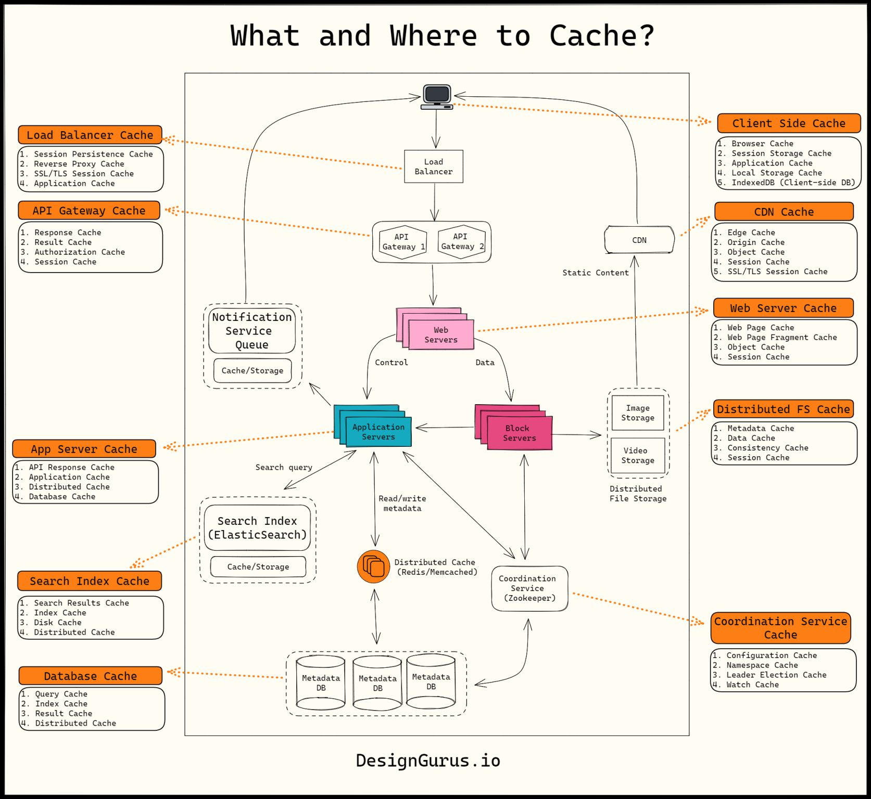
1. Client Side Cache
2. Load Balancer Cache
3. API Gateway Cache
4. CDN Cache
5. Web Server Cache
6. Application Server Cache
7. Distributed File System Cache
8. Search Index Cache
9. Database Cache
10. Coordination Service Cache

