FP and Java

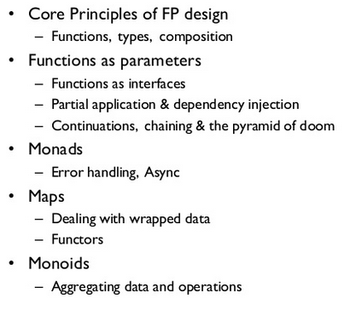
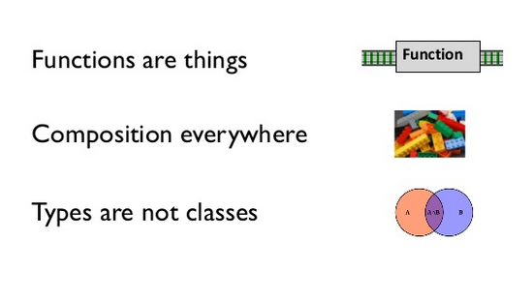
Function ia a standalone thing, not attacched to a class
Also function can have function as input or output.

Function composition
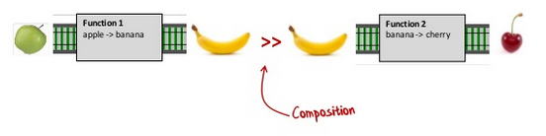
You mst have function in the small and functions in the large
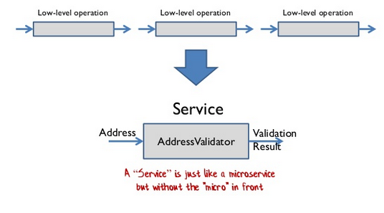
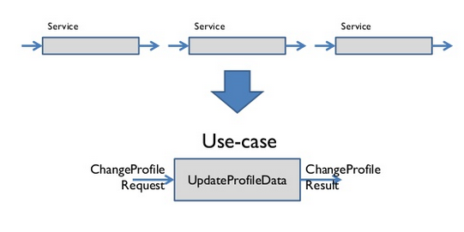
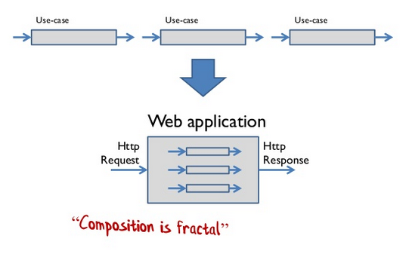
Strive for totaility

Types are inputs and outpus, and types are documentation

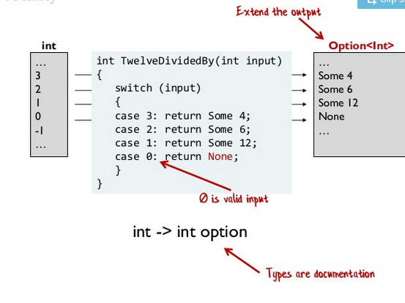
Use static types for domain modelling and documentation. See: https://fsharpforfunandprofit.com/ddd/
Also see https://fsharpforfunandprofit.com/series/thinking-functionally.html THINKING FUNCTIONALITY

Guideline: Parameterite all the things.
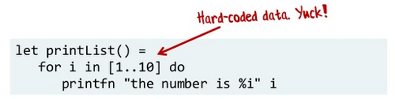
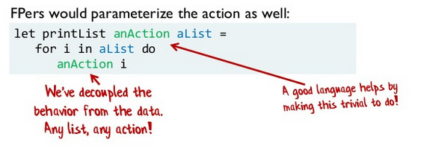
Function types are interfaces.
Every interface should have only one method! -> Single responsibility principel and the Interface Segregation Principle

FROM: https://www.slideshare.net/ScottWlaschin/fp-patterns-ndc-london2014
https://vimeo.com/113588389

Read and todo:
https://patternsinfp.wordpress.com/welcome/
https://www.infoq.com/presentations/Clojure-Design-Patterns/
https://www.youtube.com/watch?v=srQt1NAHYC0
https://www.youtube.com/watch?v=E8I19uA-wGY

http://ps.informatik.uni-tuebingen.de/teaching/ws16/sdpt/functionalpatterns.pdf
-> https://www.janestreet.com/programming/?gclid=EAIaIQobChMIwLOxlKOA7QIVMu7mCh2Umw5uEAAYASAAEgKUh_D_BwE
-> https://patternsinfp.wordpress.com/
-> https://www.slideshare.net/ScottWlaschin/fp-patterns-buildstufflt
-> https://www.freecodecamp.org/news/functional-programming-patterns-cookbook-3a0dfe2d7e0a/
-> https://livebook.manning.com/book/functional-programming-in-c-sharp/chapter-4/6
-> https://www.researchgate.net/publication/1955834_Design_Patterns_for_Functional_Strategic_Programming

Java

-> https://medium.com/better-programming/functional-patterns-in-java-b2b781f84124
-> https://www.youtube.com/watch?v=F02LKnWJWF4
-> https://dev.to/patferraggi/do-you-need-design-patterns-in-functional-programming-370c
-> https://www.amazon.com/Functional-Programming-Patterns/s?k=Functional+Programming+Patterns
-> https://arxiv.org/abs/2002.06176
-> https://www.infoq.com/presentations/fp-design-patterns/

