Java SE api

java.io

Working with bytes: Strem input output
Working wirh characters: Reader and writer
interfaces
File section
Serialization
Other: StreamTokenizer, Conzole

provides a set of input streams and a set of output streams used to read and write data to files or other input and output sources, serialization and the file system

A stream is a sequence of data. In Java, a stream is composed of bytes. It's called a stream because it is like a stream of water that continues to flow.
In Java, 3 streams are created for us automatically. All these streams are attached with the console.
1) System.out: standard output stream
2) System.in: standard input stream
3) System.err: standard error stream

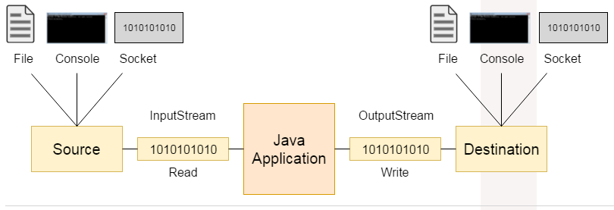
Input streams

Input streams read data from an input source. An input source can be a file, a string, or memory--anything that can contain data. All input streams inherit from InputStream

Simple Input Streams
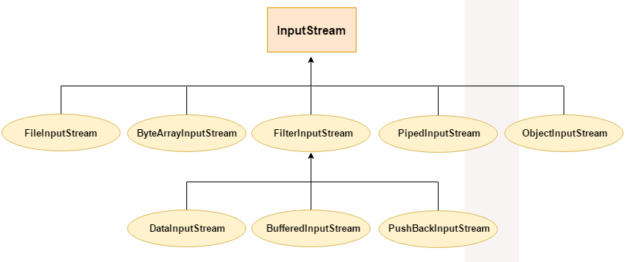
To concatenate multiple input streams: use SequenceInputStream.
To read from a pipe: use PipedInputStream. Typically attached to a PipedOutputStream.
To read from a file: use FileInputStream.
To read from a buffer: use ByteArrayStreamBuffer.
Direct Known Subclasses of InputStream:
AudioInputStream, ByteArrayInputStream, FileInputStream, FilterInputStream, ObjectInputStream, PipedInputStream, SequenceInputStream

AudioInputStream is an input stream with a specified audio format and length. The length is expressed in sample frames. See AudioSystem class that have method to to manipulate AudioInoutStream like obitain an audio inputm form an external audio file, stream url, conversions of an udio input stram and others.

ByteArrayInputStream enables you to read data from byte arrays as streams of bytes (can turn a byte array into an InputStream). To the constructor you pass the byte array you want to read as an InputStream
FileInputStream obtains input bytes from a file in a file system. Meant for reading streams of raw bytes such as image dana. To read the contents of a file as a stream of bytes. You can add transparent, automatic reading and buffering of an array of bytes from a FileInputStream using a Java BufferedInputStream. The Java FileInputStream is a byte based stream of data. You can convert a Java FileInputStream to a Java Reader(character based) using the Java InputStreamReader.

FilterInputStream abstract class that defines the interface for filtered streams. Filtered streams have some intelligence built into them about the data that they are reading. For example, the DataInputStream class, a subclass of FilterInputStream, reads a stream of primitive Java data types.
For a sream that can buffer while reading use BufferedInputStream. For a stream with one-byte pushback buffer user PushbackInputStream
Direct Known Subclasses:
BufferedInputStream, CheckedInputStream, CipherInputStream, DataInputStream, DeflaterInputStream, DigestInputStream, InflaterInputStream, LineNumberInputStream, ProgressMonitorInputStream, PushbackInputStream
ObjectInputStream deserializes primitive data and objects previously written using an ObjectOutputStream.

A piped input stream should be connected to a piped output stream; the piped input stream then provides whatever data bytes are written to the piped output stream. data is read from a PipedInputStream object by one thread and data is written to the corresponding PipedOutputStream by some other thread. Attempting to use both objects from a single thread is not recommended,
Pipes in IO provides a link between two threads running in JVM at the same time. So, Pipes are used both as source or destination.
A SequenceInputStream represents the logical concatenation of other input streams. It starts out with an ordered collection of input streams and reads from the first one until end of file is reached,

FilterInputStream subclasses
A BufferedInputStream adds functionality to another input stream-namely, the ability to buffer the input and to support the mark and reset methods.

CheckedInputStream is an input stream that also maintains a checksum of the data being read. The checksum can then be used to verify the integrity of the input data.

A CipherInputStream is composed of an InputStream and a Cipher so that read() methods return data that are read in from the underlying InputStream but have been additionally processed by the Cipher. For example, if the Cipher is initialized for decryption, the CipherInputStream will attempt to read in data and decrypt them, before returning the decrypted data.
A data input stream lets an application read primitive Java data types from an underlying input stream in a machine-independent way

DeflaterInputStream implements an input stream filter for compressing data in the "deflate" compression format.
DigestInputStream is a transparent stream that updates the associated message digest using the bits going through the stream. For security.

InflaterInputStream for uncompressing data in the "deflate" compression format. It is also used as the basis for other decompression filters, such as GZIPInputStream.

ProgressMonitorInputStream monitors the progress of reading from some InputStream.

PushbackInputStream is intended to be used when you parse data from an InputStream. Sometimes you need to read ahead a few bytes to see what is coming, before you can determine how to interpret the current byte. The PushbackInputStream allows you to do that. Well, actually it allows you to push the read bytes back into the stream

Output streams

Output streams write data to an output source. Similar to input sources, an output source can be anything that can contain data: a file, a string, or memory
The OutputStream class defines a programming interface for writing bytes or arrays of bytes to the stream and flushiing the stream.

Simple Output Streams
To write to a file: use FileOutputStream.
To write to a pipe: use PipedOutputStream. Typically attached to a PipedInputStream.
To write to a buffer: use ByteArrayOutput.

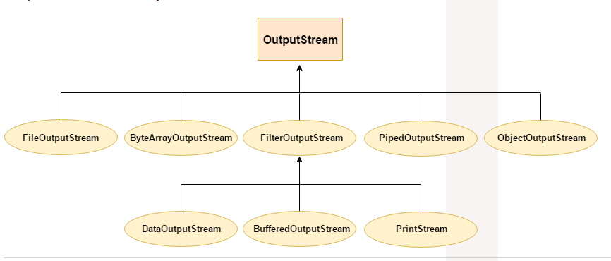
Direct Known Subclasses of OutputStream:
ByteArrayOutputStream, FileOutputStream, FilterOutputStream, ObjectOutputStream, OutputStream, PipedOutputStream
Same as InputStream,
Direct Known Subclasses of FilterOutputStream:
BufferedOutputStream, CheckedOutputStream, CipherOutputStream, DataOutputStream, DeflaterOutputStream, DigestOutputStream, InflaterOutputStream, PrintStream
A PrintStream adds functionality to another output stream, namely the ability to print representations of various data values conveniently. All characters printed by a PrintStream are converted into bytes using the platform's default character encoding. The PrintWriter class should be used in situations that require writing characters rather than bytes.

java.io contains a few other classes: File,

Reader

Same as InputStream only for reading characters (diif in subclasses).

Direct Known Subclasses of Reader:
BufferedReader, CharArrayReader, FilterReader, InputStreamReader, PipedReader, StringReader

An InputStreamReader is a bridge from byte streams to character streams: It reads bytes and decodes them into characters using a specified charset. The charset that it uses may be specified by name or may be given explicitly, or the platform's default charset may be accepted.

FileReader extends InputStreamReader

Direct Known Subclasses of FilterReader:
PushbackReader
LineNumberReader is a buffered character-input stream that keeps track of line numbers

Writer

Same as OutputStream only for reading characters (diif in subclasses).

Direct Known Subclasses of Writer:
BufferedWriter, CharArrayWriter, FilterWriter, OutputStreamWriter, PipedWriter, PrintWriter, StringWriter

An OutputStreamWriter is a bridge from character streams to byte streams: Characters written to it are encoded into bytes using a specified charset. The charset that it uses may be specified by name or may be given explicitly, or the platform's default charset may be accepted

FileWriter extends OutputStreamWriter

FilterWriter there is no known subclasses

Interfaces

interface Closeable

Implementing AutoCloseable (or Closeable) allows a class to be used as a resource of the try-with-resources construct introduced in Java 7, which allows closing such resources automatically at the end of a block, without having to add a finally block which closes the resource explicitely.
You only have to (or should) implement Closeable or AutoCloseable if you are about to implement your own class, which handles files or any other resources which needs to be closed.

interface DataInput
The DataInput interface provides for reading bytes from a binary stream and reconstructing from them data in any of the Java primitive types. There is also a facility for reconstructing a String from data in Java modified UTF-8 format.
interface DataOutput
The DataOutput interface provides for converting data from any of the Java primitive types to a series of bytes and writing these bytes to a binary stream.
interface Externalizable

is used whenever we need to customize serialization
is child interface of Serializable
provides control of serialization logic to programmer
Object Serialization uses the Serializable and Externalizable interfaces. Object persistence mechanisms can use them as well.
When an Externalizable object is reconstructed, an instance is created using the public no-arg constructor, then the readExternal method called. Serializable objects are restored by reading them from an ObjectInputStream.

The object implements the readExternal method to restore its contents by calling the methods of DataInput for primitive types and readObject for objects, strings and arrays

Interface FileFilter

boolean | accept(File pathname)  Tests whether or not the specified abstract pathname should be included in a pathname list.
Can be passed to the File#listFiles

interface FilenameFilter

boolean | accept(File dir, String name)  Tests if a specified file should be included in a file list.
Tests if a specified file should be included in a file list.

interface Flushable

A Flushable is a destination of data that can be flushed

Interface ObjectInput and ObjectOutput

Extends DataInput/DataOutput
implemented by ObjecInputStream/ObjctOutputStream
also used fot customization of the serlization process (Externalizable)

interface ObjectInputValidation

Callback interface to allow validation of objects within a graph. Allows an object to be called when a complete graph of objects has been deserialized.
ObjectInputStream.registerValidation(java.io.ObjectInputValidation, int)
A class implements this interface if it needs to validate deserialized objects. A class that needs to perform object validation on deserialized instances should pass a validation object to ObjectInputStream.registerValidation() at the beginning of its private readObject() method

Interface Serializable

Serializability of a class is enabled by the class implementing the java.io.Serializable interface.

File Section
TODO STAO:
- File
- FileDescriptor
- FilePermission
- RandomAccessFile

List of Exceptions: CharConversionException, EOFException, FileNotFoundException, InterruptedIOException, InvalidClassException, InvalidObjectException, IOException, NotActiveException, NotSerializableException, ObjectStreamException, OptionalDataException, StreamCorruptedException, SyncFailedException, UncheckedIOException, UnsupportedEncodingException, UTFDataFormatException, WriteAbortedException
List of errors: IOError

From:
https://docs.oracle.com/javase/8/docs/api/

TODO from
http://www.upv.es/~jgonsol/tutorial/tools/packages/java.io.html
https://www.tutorialspoint.com/java/io/index.htm
https://www.tutorialspoint.com/java/java_files_io.htm
https://bioinfo2.ugr.es/OReillyReferenceLibrary/java/fclass/ch11_js.htm
https://docstore.mik.ua/orelly/java-ent/jnut/ch11_01.htm
http://web.deu.edu.tr/doc/oreily/java/javanut/ch24_js.htm
https://www.hudatutorials.com/java/io/
http://tutorials.jenkov.com/java-io/index.html
https://www.sanfoundry.com/java-mcqs-java-io-introduction/
https://stackoverflow.com/questions/21082276/what-is-the-purpose-of-in-java-io
http://www.columbia.edu/cu/help/jdk/docs/api/Package-java.io.html
https://www3.ntu.edu.sg/home/ehchua/programming/java/J5b_IO.html
https://www.javaguides.net/p/java-io-package-tutorial.html
https://www.studytonight.com/java/java-io-stream.php
https://javatutorialhq.com/java/io/
https://www.cis.upenn.edu/~bcpierce/courses/629/papers/Java-tutorial/java/javaOO/javapkgs.html
https://intellipaat.com/blog/tutorial/java-tutorial/java-file-io/
https://www.programiz.com/java-programming/packages-import
http://www.allindiaexams.in/engineering/cse/java-questions-and-answers/javaio-package
https://www.quora.com/What-does-import-Java-io-*-actually-means-in-Java-programming
http://zetcode.com/lang/java/packages/
https://nick-lab.gs.washington.edu/java/jdk1.3.1/guide/lang/index.html
https://www.javatpoint.com/java-io-package

Notes:

File section
File
FileDescriptor
FilePermission
RandomAccessFile

Serialization section
SerializablePermission

Other
StreamTokenizer
Console

