Computer Networking A Top – Down Approach Notes

Contents
Contents 2
Computer Networks and the Internet 3
What is the Internet 3
The Network Edge 4
The Network Core 6
Throughput in Packet-switched Networks 7
Protocol Layers and Thier Service Models 8
Networks Under Attack 9
History 10
Summary 11

Computer Networks and the Internet

What is the Internet
The Internet is a computer network that interconnects hundreds of millions of computing devices throughout the world. In Internet jargon,all of these devices (comšuter, servers, tablets, tv, el devices...) are called hosts or end systems. End systems are connected together by a network of communication links and packet switches. Many types of communication links, which are made up of different types of physical media, including coaxial cable, copper wire, optical fiber, and radio spectrum. Different links can transmitdata at different rates, with the transmission rate of a link measured in bits/second. A packet switch takes a packet arriving on one of its incoming communication links and forwards that packet on one of its outgoing communication links. Packet switches come in many shapes af flavors but twp types are routers and link-layer switches. Link-layer switches are typically used in access networks, while routers are typically used in the network core.
End systems access the Internet through Internet Service Providers (ISPs), Each ISP is in itself a network of packet switches and communication links. These lower-tier ISPs are interconnected through national and international upper-tier ISPs such as Level 3 Communications. Each ISP network, whether upper-tier or lower-tier, is managed independently, runs the IP protocol (see below), and conforms to certain naming and address conventions.
End systems, packet switches, and other pieces of the Internet run protocols that control the sending and receiving of information within the Internet. The Transmission Control Protocol (TCP) and the Internet Protocol (IP)

The Network Edge
Internet can be described as an infrastructure that provides services to applications. These app run on end systems – they do not run in the paked switches in the network core. End systems attached to the Internet provide an Application Programming Interface (API) that specifies how a program running on one end system asks the Internet infrastructure to deliver data to a specific destination program running on another end system. (Suppose Alice wants to send a letter to Bob using the postal service...)
End systems are also referred to as hosts because they host (that is, run) application programs. Hosts are sometimes further divided into two categories: clients and servers
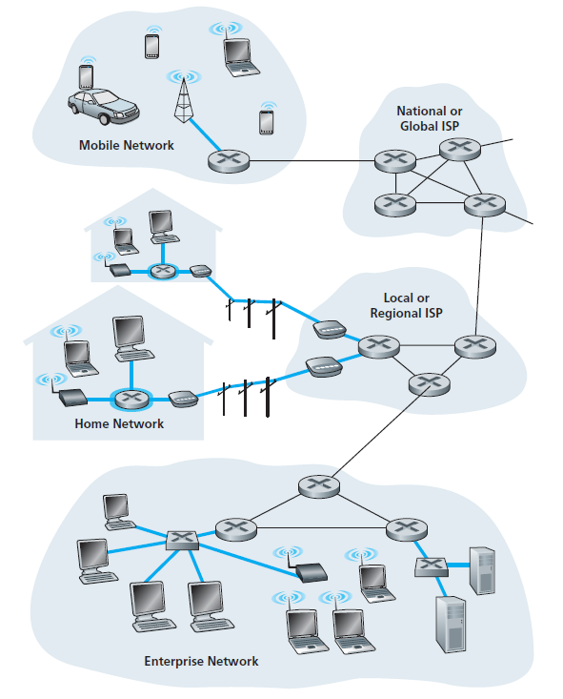
Today, the two most prevalent types of broadband residential access are digital subscriber line (DSL) and cable. A residence (home)typically obtains DSL Internet access from the same local telephone company (telco) that provides its wired local phone access. Thus, when DSL is used, a customer’s telco is also its ISP. The residential telephone line carries both data and traditional telephone signals simultaneously, which are encoded at different frequencies:
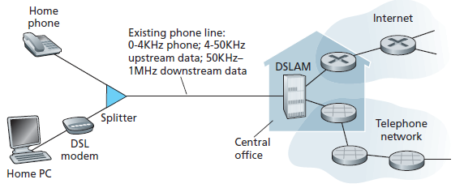
each customer’s DSL modem uses the existing telephone line (twistedpair copper wire, which we’ll discuss in Section 1.2.2) to exchange data with a digital subscriber line access multiplexer (DSLAM) located in the telco’s local central office (CO). The home’s DSL modem takes digital data and translates it to highfrequency tones for transmission over telephone wires to the CO.
While DSL makes use of the telco’s existing local telephone infrastructure, cable Internet access makes use of the cable television company’s existing cabletelevision infrastructure. A residence obtains cable Internet access from the same company that provides its cable television.
Cable internet access requires special modems, called cable modems. As with a DSL modem, the cable modem is typically an external device and connects to the home PC through an Ethernet port.
On corporate and university campuses, and increasingly in home settings, a local area network (LAN) is used to connect an end system to the edge router. Ethernet is by far the most prevalent access technology in corporate, university, and home networks
Physical media fall into two categories: guided media and unguided media. With guided media, the waves are guided along a solid medium, such as a fiber-optic cable, a twisted-pair copper wire, or a coaxial cable. With unguided media, the waves propagate in the atmosphere and in outer space, such as in a wireless LAN or a digital satellite channel.

The Network Core
There are two fundamental approaches to moving data through a network of links and switches: circuit switching and packet switching.
Packet Swiching
The source breaks long messages into smaller chunks of data known as packets. Between source and destination, each packet travels through communication links and packet switches. Most packet switches use store-and-forward transmission at the inputs to the links. Store-and-forward transmission means that the packet switch must receive the entire packet before it can begin to transmit the first bit of the packet onto the
outbound link.
Each packet switch has multiple links attached to it. For each attached link, the packet switch has an output buffer (also called an output queue), which stores packets that the router is about to send into that link.
In the Internet, every end system has an address called an IP address. When a source end system wants to send a packet to a destination end system, the source includes the destination’s IP address in the packet’s header.
Each router has a forwarding table that maps destination addresses (or portions of the destination
addresses) to that router’s outbound links. Internet has a number of special routing protocols that are
used to automatically set the forwarding tables. Traceroute program. Simply visit the site www.traceroute.org

Circuit Switching
The resources needed along a path (buffers, link transmission rate) to provide for communication between the end systems are reserved for the duration of the communication session between the end systems. In packet-switched networks, these resources are not reserved; Before the sender can send the information, the network must establish a connection between the sender and the receiver. A circuit in a link is implemented with either frequency-division multiplexing (FDM) or time-division multiplexing (TDM).

Packet switching provides essentially the same performance as circuit switching, but does so while
allowing for more than three times the number of users.

ISPs themselves must be interconnected. This is done by creating a network of networks—understanding this phrase is the key to understanding the Internet

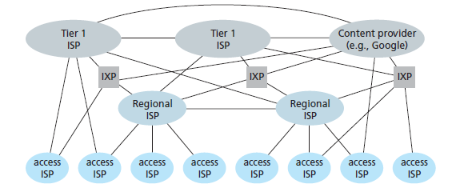
Customer ISPs pay their provider ISPs to obtain global Internet interconnectivity
IXP Internet exchange point typically in a stand-alone building with its own switches), which is a
meeting point where multiple ISPs can peer together.
ecosystem—consisting of access ISPs, regional ISPs, tier-1 ISPs, PoPs, multi-homing, peering, and IXPs. by adding content provider networks. Google

Throughput in Packet-switched Networks
The most important of delays are the nodal processing delay, queuing delay, transmission delay, and propagation delay; together, these delays accumulate to give a total nodal delay.

A packet can be transmitted on a link only if there is no other packet currently being transmitted on the link and if there are no other packets preceding it in the queue; if the link is currently busy or if there are other packets already queued for the link, the newly arriving packet will then join the queue.
The time required to examine the packet’s header and determine where to direct the packet is part of the processing delay. The processing delay can also include other factors, such as the time needed to check for bit-level errors in the packet that occurred in transmitting the packet’s bits from the upstream node to router

Protocol Layers and Thier Service Models
To provide structure to the design of network protocols, network designers organize protocols—and the network hardware and software that implement the protocols— in layers. Each protocol belongs to one of the layers. A protocol layer can be implemented in software, in hardware, or in a combination of the two. Application-layer protocols—such as HTTP and SMTP—are almost always implemented in software in the end systems; so are transport-layer protocols. Because the physical layer and data link layers are responsible for handling communication over a specific link, they are typically implemented in a network interface card (for example, Ethernet or WiFi interface cards
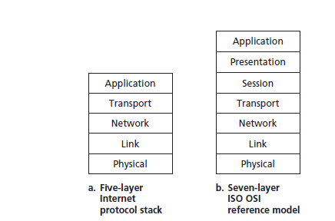

The network layer is often a mixed implementation of hardware and software. That is, there’s often a piece of a layer n protocol in each of these network components. One potential drawback of layering is that one layer may duplicate lower-layer functionality. For example, many protocol stacks provide error recovery on both a per-link basis and an end-to-end basis. A second potential drawback is that functionality at one layer may need information (for example, a timestamp value) that is present only in another layer; this violates the goal of separation of layers.
The application layer is where network applications and their application-layer protocols reside. The Internet’s application layer includes many protocols, such as the HTTP, SMTP, FTP, DNS. It is very easx to create and deploy out own new app layer protocol.
The Internet’s transport layer transports application-layer messages between application endpoints. In the Internet there are two transport protocols, TCP and UDP, either of which can transport application-layer messages. TCP provides a connection-oriented service to its applications. This service includes guaranteed delivery of application-layer messages to the destination and flow control (that is, sender/receiver speed matching). TCP also breaks long messages into shorter segments and provides a congestion-control mechanism, so that a source throttles its transmission rate when the network is congested. The UDP protocol provides a connectionless service to its applications. This is a no-frills service that provides no reliability, no flow control, and no congestion control. In this book, we’ll refer to a transport-layer packet as a segment.

Network Layer is the Internet’s network layer is responsible for moving network-layer packets known as datagrams from one host to another. The Internet’s network layer includes the celebrated IP Protocol, which defines the fields in the datagram as well as how the end systems and routers act on these fields. There is only one IP protocol, and all Internet components that have a network layer must run the IP protocol. Also contains routing protocols that determine the routes that datagrams take between sources and destinations.
To move a packet from one node (host or router) to the next node in the route, the network layer relies on the services of the link layer. The services provided by the link layer depend on the specific link-layer protocol that is employed over the link. For example, some link-layer protocols provide reliable delivery, from transmitting node, over one link, to receiving node. Note that this reliable delivery service is different from the reliable delivery service of TCP. The services provided by the link layer depend on the specific link-layer protocol that is employed over the link. For example, some link-layer protocols provide reliable delivery, from transmitting node, over one link, to receiving node. Note that this reliable delivery service is different from the reliable delivery service of TCP.
The job of the physical layer is to move the individual bits within the frame from one node to the next. The protocols in this layer are again link dependent and further depend on the actual transmission medium of the link (for example, twisted-pair copper wire, single-mode fiber optics)
Thus, let’s consider the two additional layers present in the OSI reference model—the presentation layer and the session layer. The role of the presentation layer is to provide services that allow communicating applications to interpret the meaning of data exchanged. These services include data compression and data encryption
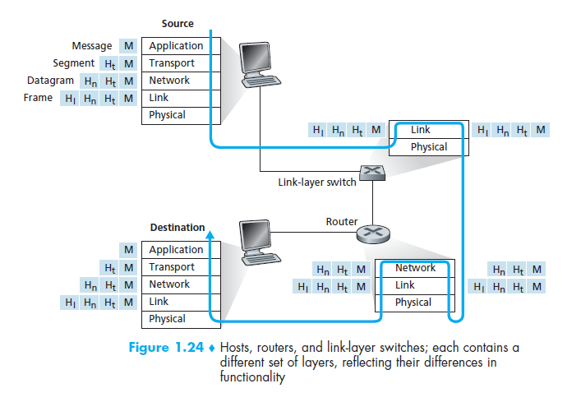
we see that at each layer, a packet has two types of fields: header fields and a payload field. The payload is typically a packet from the layer above.

Networks Under Attack
Just qick intreo on malware, worma DdoS, Idea is that at first internate was not design at the seuriy in the first place..

History
Packet Switching 1961 - 1972
The first published work on packet-switching techniques was that of Leonard Kleinrock [Kleinrock 1961; Kleinrock 1964], then a graduate student at MIT. Using queuing theory,
But the Internet also has a long history of a let’s-build-it-and-demonstrate-it attitude that also dates back to the 1960s. J. C. R. Licklider [DEC 1990] and Lawrence Roberts, both colleagues of Kleinrock’s at MIT, went on to lead the computer science program at the Advanced Research Projects Agency (ARPA) in the United States. Roberts published an overall plan for the ARPAnet [Roberts 1967], the first packet-switched computer network and a direct ancestor of today’s public Internet.
By 1972, ARPAnet had grown to approximately 15 nodes and was given its first public demonstration by Robert Kahn. The first host-to-host protocol between ARPAnet end systems, known as the network-control protocol (NCP),
Proprietary Networks and Internetworking: 1972–1980
The number of networks was growing. With perfect hindsight we can see that the time was ripe for developing an encompassing architecture for connecting networks together. Pioneering work on interconnecting networks (under the sponsorship of the Defense Advanced Research Projects Agency (DARPA)), in essence creating a network of networks, was done by Vinton Cerf and Robert Kahn [Cerf 1974]; the term internetting was coined to describe this work.These architectural principles were embodied in TCP. The early versions of TCP, however, were quite different from today’s TCP
In Hawaii, Norman Abramson was developing ALOHAnet, a packet-based radio network that allowed multiple remote sites on the Hawaiian Islands to communicate with each other
Metcalfe and Boggs built on Abramson’s multiple-access protocol work when they developed the Ethernet protocol [Metcalfe 1976] for wire-based shared broadcast networks (foundation for today’s PC LANs) .
Prolifernation of networks 1980 - 1990
BITNET provided e-mail and file transfers among several universities in the Northeast. 1986, NSFNET was created to provide access to NSF-sponsored supercomputing centers. 1983 saw the official deployment of TCP/IP as the new standard host protocol for ARPAnet (replacing the NCP protocol). The DNS, used to map between a human-readable Internet name (for example, gaia.cs.umass.edu) and its 32-bit IP address, was also developed
Internet Explosion in the 1990
emergence of the World Wide Web application, which brought the Internet into the homes and businesses of millions of people worldwide. The Web was invented at CERN by Tim Berners-Lee between 1989 and 1991 [Berners-Lee 1989], based on ideas originating in earlier work on hypertext from the 1940s by Vannevar Bush.
The Web was invented at CERN by Tim Berners-Lee between 1989 and 1991 [Berners-Lee 1989], based on ideas originating in earlier work on hypertext from the 1940s by Vannevar Bush. In 1996, Microsoft started to make browsers, which started the browser war between Netscape and Microsoft,

Summary
fsdjlfsa

