Modern Operating Systems

Introduction

On top of the hardware is the software. Most computers have two modes of operation: kernel mode and user mode. The operating system, the most fundamental piece of software, runs in kernel mode (also called supervisor mode). In this mode it has complete access to all the hardware and can execute any instruction the machine is capable of executing. The rest of the software runs in user mode, in which only a subset of the machine instructions is available. In particular, those instructions that affect control of the machine or do I/O )Input/Output" are forbidden to user-mode programs.
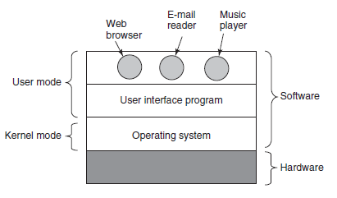
The user interface program, shell or GUI.

The concept of an operating system as primarily providing abstractions to application
programs is a top-down view. An alternative, bottom-up, view holds that the operating system is there to manage all the pieces of a complex system. Modern computers consist of processors, memories, timers, disks, mice, network interfaces, printers, and a wide variety of other devices. In the bottom-up view, the job
of the operating system is to provide for an orderly and controlled allocation of the processors, memories, and I/O devices among the various programs wanting them.

Os resouce management inclueds multiplexing (sharing) resources in two different ways: time and space.
Time (whic app to run and how long) Space (access to memeory)

History of OS

First Generation: Vacuum Tubes (1945 - 1955)
Primitive and took seconds to perform simple calculation
No programming languages
Punched cards

Second Generation: Transisistors (1955 – 1965)
Intro into mainframes for large organizations (batch jobs)
Fortran and assembler
First os: Fortan Monitor System and IBSYS (IBM's os)

The Third Generation (1965 – 1980) IC and Multiprogramming
IBM uses IC . Intergraed Circuits and OS/360 (introductions several key techniques as multiprogramming, partition memory, timesharing
MULTICS cmputers come back in the form cloud compuutin, influence on UNIX os. On Unix is created MINIX and then Linux Glyn Moody’s (2001) book history of Unix

The Fourth Generation (1980 . now) Persona Computers
Large Scale Integration circuits
Intel 8080 and CP/M (Control Program for Microcomputers) operating system.
IBM design IBM pc and nedd software ro run on it. People from IBM contacted Bill Gates to license his BASIC interpreter. Gates realized that a local computer manufacturer, Seattle Computer Products, had a suitable operating system, DOS (Disk Operating System). He approached them and asked to buy it (allegedly for $75,000), Gates then offered IBM a DOS/BASIC package
1960 Doug Engelbar inventd Graphical User Interface

The Fifth Generation (1990 - ) Moblie Computers
At the time of writing, Google’s Android is the dominant operating system with Apple’s iOS a clear second

Computer hardware review

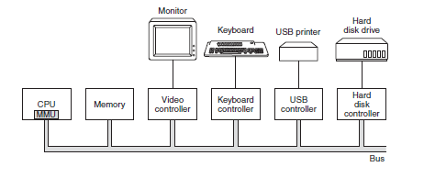
The ‘‘brain’’ of the computer is the CPU. It fetches instructions from memory and executes them. The basic cycle of every CPU is to fetch the first instruction from memory, decode it to determine its type and operands, execute it.
The program counter, which contains the memory address of the next instruction to be fetched.
Stack pointer, which points to the top of the current stack in memory.
PSW (Program Status Word). This register contains the condition code bits, which are set by comparison instructions (the CPU priority, the mode (user or kernel), and various other control bits).

The operating system will often stop the running program to (re)start another one. Every time it stops a running program, the operating system must save all the registers so they can be restored when the program runs later.

Many modern CPUs have facilities for executing more than one instruction at the same time. For example, a CPU might have separate fetch, decode, and execute units, so that while it is executing instruction n, it could also be decoding instruction n + 1 and fetching instruction n + 2. Such an organization is called a pipeline

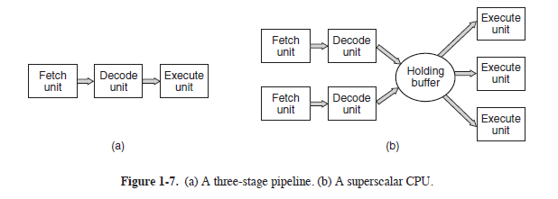
Even more advanced than a pipeline design is a superscalar CPU. multiple execution units are present, for example, one for integer arithmetic, one for floating-point arithmetic, and one for Boolean operations.
Two or more instructions are fetched at once, decoded, and dumped into a holding buffer until they can be executed.

To obtain services from the operating system, a user program must make a system call, which traps into the kernel and invokes the operating system. The TRAP instruction switches from user mode to kernel mode and starts the operating system

Multithreading or hyperthreading s allow the CPU to hold the state of two different threads and then switch back and forth on a nanosecond time scale. Multithreading has implications for the operating system because each thread appears to the operating system as a separate CPU. Consider a system with two
actual CPUs, each with two threads. The operating system will see this as four CPUs.

Many CPU chips now have four, eight, or more complete processors or cores on them.

GPU (Graphics Processing Unit). A GPU is a processor with, literally, thousands of tiny cores. They are very good for many small computations done in parallel, like rendering polygons in graphics applications. They are not so good at serial tasks

Memory system is constructed as a hierarchy of layers. Top = higer speed smaller capacity and greter cost per bit thath the lower ones.

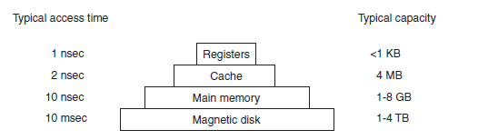
Caching plays a major role in many areas of computer science. Whenever a resource can be divided into pieces, some of which are used much more heavily than others, caching is often used to improve performance. Caches are such a good idea that modern CPUs have two of them. The first level or L1 cache is always inside the CPU and usually feeds decoded instructions into the CPU’s execution engine. L2 cache, that holds several megabytes of recently used memory words. The difference between the L1 and L2 caches lies in the timing. Access to the L1 cache is done without any delay, whereas access to the L2 cache involves a delay of one or two clock cycles.

Virtual memory makes it possible to run programs larger than physical memory by placing them on the disk and using main memory as a kind of cache for the most heavily executed parts. This scheme requires remapping memory addresses on the fly to convert the address the program generated to the physical address in RAM where the word is located. This mapping is done by a part of the CPU called the MMU (Memory Management Unit).

In a multiprogramming system, when switching from one program to another, sometimes called a context switch, it may be necessary to flush all modified blocks from the cache and change the mapping registers in the MMU. Both of these are expensive operations, and programmers try hard to avoid them.

I/O devices generally consist of two parts: a controller and the device itself. The controller is a chip or a set of chips that physically controls the device. It accepts commands from the operating system, for example, to read dana from the device, and carries them out. In many cases, the actual control of the device is complicated and detailed, so it is the job of the controller to present a simpler (but still very complex) interface to the operating system. The software that talks to a controller, giving it commands and accepting responses, is called a device driver. Each controller manufacturer has to supply a driver for each operating system it supports.
There are three ways the driver can be put into the kernel. The first way is to
relink the kernel with the new driver and then reboot the system. Many older UNIX
systems work like this. The second way is to make an entry in an operating system file telling it that it needs the driver and then reboot the system. At boot time, the operating system goes and finds the drivers it needs and loads them. Windows works this way. The third way is for the operating system to be able to accept new drivers while running and install them on the fly without the need to reboot.

Input and output can be done in three different ways. In the simplest method, program issues a system call, which the kernel then translates into a procedure call to the appropriate driver. The driver then starts the I/O and sits in a tight loop continuously polling the device to see if it is done (usually there is some bit that indicates that the device is still busy). When the I/O has completed, the driver puts the data (if any) where they are needed and returns. The operating system then returns control to the caller. This method is called busy waiting and has the disadvantage of tying up the CPU polling the device until it is finished.
The second method is for the driver to start the device and ask it to give an interrupt when it is finished. At that point the driver returns. The operating system then blocks the caller if need be and looks for other work to do. When the controller detects the end of the transfer, it generates an interrupt to signal completion.

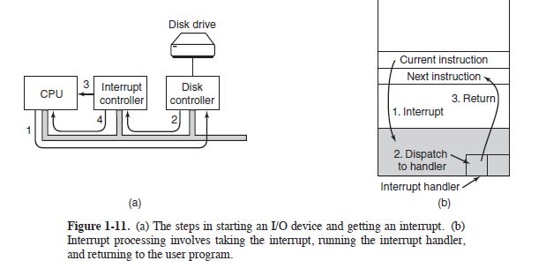
The third method for doing I/O makes use of special hardware: a DMA (Direct Memory Access) chip that can control the flow of bits between memory and some controller without constant CPU intervention. The CPU sets up the DMA chip, telling it how many bytes to transfer, the device and memory addresses
involved, and the direction, and lets it go. When the DMA chip is done, it causes an interrupt, which is handled as described above.

Interrupts can (and often do) happen at highly inconvenient moments, for example, while another interrupt handler is running. For this reason, the CPU has a way to disable interrupts and then reenable them later.

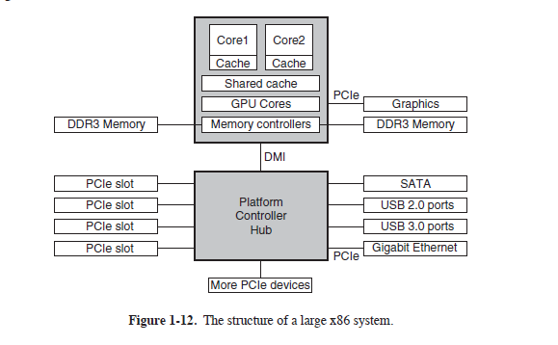
This system has many buses (e.g., cache, memory, PCIe, PCI, USB, SATA, and DMI), each with a different transfer rate and function. The operating system must be aware of all of them for configuration and management. The main bus is the PCIe (Peripheral Component Interconnect Express) bus.

In regular PCI buses, a single 32-bit number is sent over 32 parallel wires. In contrast to this, PCIe uses a serial bus architecture and sends all bits in a message through a single connection, known as a lane, much like a network packet. Parallelism is still used, because you can have multiple lanes in parallel. For instance, we may use 32 lanes to carry 32 messages in parallel.

The CPU talks to memory over a fast DDR3 bus, to an external graphics device over PCIe and to all other devices via a hub over a DMI (Direct Media Interface) bus. Each of the cores has a dedicated cache and a much larger cache that is shared between them. Each of these caches introduces another bus.

USB uses a small connector with four to eleven wires (depending on the version), some of which supply electrical power to the USB devices or connect to ground. USB is a centralized bus in which a root device polls all the I/O devices every 1 msec to see if they hav e any traffic

Booting the Computer

Every PC contains a parentboard (formerly called a motherboard before political correctness hit the computer industry). On the parentboard is a program called the system BIOS (Basic Input Output
System). The BIOS contains low-level I/O software, including procedures to read the keyboard, write to the screen, and do disk I/O, among other things
When the computer is booted, the BIOS is started. It first checks to see how much RAM is installed and whether the keyboard and other basic devices are installed and responding correctly. It starts out by scanning the PCIe and PCI buses to detect all the devices attached to them. If the devices present are different from
when the system was last booted, the new devices are configured.
The BIOS then determines the boot device by trying a list of devices stored in the CMOS memory.

The first sector from the boot device is read into memory and executed. This sector contains a program that normally examines the partition table at the end of the boot sector to determine which partition is active. Then a secondary boot loader is read in from that partition. This loader reads in the operating system
from the active partition and starts it.

OS queries the BIOS to get the configuration information. For each device, it checks to see if it has the device driver. Once it has all the device drivers, the operating system loads them into the kernel. Then it initializes its tables, creates whatever background processes are needed, and starts up a login program or GUI

OS concepts

A process is basically a program in execution. Associated with each process is its address space, a list ofmemory locations from 0 to some maximum, which the process can read and write. The address space contains the executable program, the program’s data, and its stack. Also associated with each process is a set of resources, commonly including registers (including the program counter and stack pointer), a list of open files, outstanding alarms, lists of related processes, and all the other information needed to run the program. A process is fundamentally a container that holds all the information needed to run a program.

In many operating systems, all the information about each process, other than the contents of its own address space, is stored in an operating system table called the process table, which is an array of structures, one for
each process currently in existence. Thus, a (suspended) process consists of its address space, usually called the core image and its process table entry, which contains the contents of its registers and many other items needed to restart the process later.

If a process can create one or more other processes (referred to as child processes) and these processes in turn can create child processes, we quickly arrive at the process tree structure.

Each person authorized to use a system is assigned a UID (User Identification) by the system administrator. Every process started has the UID of the person who started it. A child process has the same UID as its parent. Users can be members of groups, each of which has a GID (Group Identification).

Technique called virtual memory exists, as mentioned earlier, in which the operating system keeps part of the address space in main memory and part on disk and shuttles pieces back and forth between them as needed. In essence, the operating system creates the abstraction of an address space as the set of addresses a process may reference. The address space is decoupled from the machine’s physical memory and may be either larger or smaller than the physical memory.

To provide a place to keep files, most PC operating systems have the concept of a directory as a way of grouping files together. System calls are then needed to create and remove directories. Calls are also provided to put an existing file in a directory and to remove a file from a directory. Directory entries may be either files or other directories. This model also gives rise to a hierarchy—the file system. Every file within the directory hierarchy can be specified by giving its path name from the top of the directory hierarchy, the root directory. In Windows, the backslash (\) character is used as the separator instead of the slash (/) on unix.
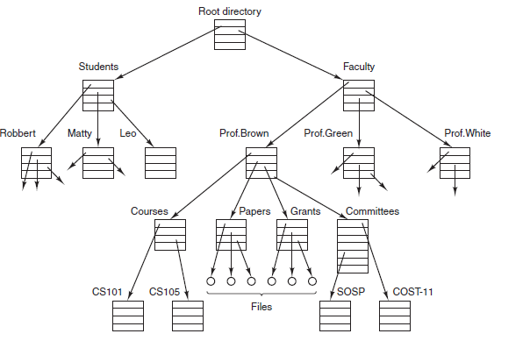

At every instant, each process has a current working directory, in which path names not beginning with a slash are looked for. For example, in Fig. 1-14, if /Faculty/Prof.Brown were the working directory, use of the path Courses/CS101

Mount system call allows the file system on the CD-ROM to be attached to the root file system wherever the program wants it to be.
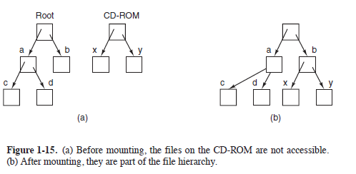

Block special files are used to model devices that consist of a collection of randomly addressable
blocks, such as disks. By opening a block special file and reading, say, block 4, a program can directly access the fourth block on the device, without regard to the structure of the file system contained on it. special files are used to model printers, modems, and other devices that accept or output a character stream. By convention, the special files are kept in the /dev directory.

A pipe is a sort of pseudofile that can be used to connect two processes. When process A wants to send data to process B, it writes on the pipe as though it were an output file. Process B can read the data by reading from the pipe as though it were an input file. Thus, communication between processes in UNIX looks very much like ordinary file reads and writes

Files in UNIX are protected by assigning each one a 9-bit binary protection code. The protection code consists of three 3-bit fields, one for the owner, one for other members of the owner’s group (users are divided into groups by the system administrator), and one for everyone else. Each field has a bit for read access, a bit for write access, and a bit for execute access. These 3 bits are known as the rwx bits.

When any user logs in, a shell is started up. The shell has the terminal as standard
input and standard output. GUI is just a program running on top of the operating system, like a shell

Changes in software industry
Each new species (mainframe, minicompute, personal computer) go throught the development that its ancestors did (in hardver and software) Personal compueters exist not beacues milions of people have a desire to own a computer, bet becaues it is now possible to manufacture them cheaply. Chane in technology renders some idea and then it quickly vanishers, then change in technology can revive it again. Example CPU became fast memory slow so caaches is introduced. If tehnology make memoty quick cahche will desapre.
it is important to understand why a concept is obsolete

System calls (kernl call, kernel mode)

operating systems have two main functions: providing abstractions to user programs and managing the computer’s resources.
System calls are mande throug interfaces/ abstractions.
mechanics of issuing a system call are highly machine dependent and often must be expressed in assembly code, a procedure library is provided to make it possible to make system calls from C programs and often from other languages as well

Any single-CPU computer can execute only one instruction at a time. If a process is running a user program in user mode and needs a system service, such as reading data from a file, it has to execute a trap instruction (user ro kernel mode) to transfer control to the operating system. The operating system then figures out what the calling process wants by inspecting the parameters. Then it carries out the system call and returns control to the instruction following the system call. In a sense, making a system call is like making a special kind of procedure call, only system calls enter the kernel and procedure calls do not.

The library procedure, possibly written in assembly language, typically puts the system-call number in a place where the operating system expects it, such as a register (step 5). Then it executes a TRAP instruction to switch from user mode to kernel mode and start execution

TRAP instruction also differs from the procedure-call instruction in two fundamental ways. First, as a side effect, it switches into kernel mode. Second, rather than giving a relative or absolute address where the procedure is located, the TRAP instruction cannot jump to an arbitrary address. Depending on the architecture, either it jumps to a single fixed location or there is an 8-bit field in the instruction giving
the index into a table in memory containing jump addresses

The kernel code that starts following the TRAP examines the system-call number and then dispatches to the correct system-call handler, usually via a table of pointers to system-call handlers indexed on system-call number (step 7). At that point the system-call handler runs (step 8). Once it has completed its work, control
may be returned to the user-space library procedure at the instruction following the TRAP instruction (step 9). This procedure then returns to the user program in the usual way procedure calls return (step 10). To finish the job, the user program has to clean up the stack, as it does after any procedure call (step 11).
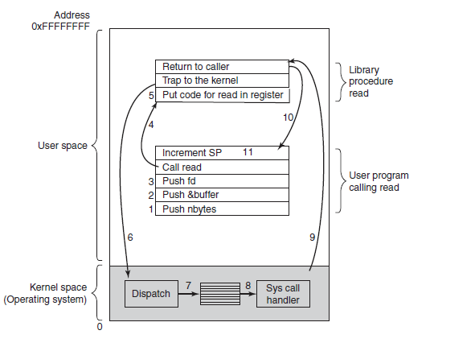
System calls are mande throug interfaces/ abstractions but interface dies not pecify whether they are syste, call lib vall or something else, so if call throught interface can be caried put wothout invoking system call (kernel call/kernen mode) it will be done in user space.

System calls form process management
Fork is the only way to create a new process in POSIX. It creates an exact duplicate of the original process, including all the file descriptors, registers—everything. After the fork, the original process and the copy
(the parent and child) go their separate ways. All the variables have identical values at the time of the fork, but since the parent’s data are copied to create the child, subsequent changes in one of them do not affect the other one. Using the returned PID, the two processes can see which one is the
parent process and which one is the child process

TODO 1.6 DIO DO 1.7

Operating system structure

On this point you have idea about s api (interfaces) No we are going to see how theay are implemented. Six commn used design options (arhitectures) : Monolithic, Layared, Microkernrlss. Client – Server. Virtual Machines and Exokernels.

Monolithic system
By far the most common organization, in the monolithic approach the entire operating system runs as a single program in kernel mode. The operating system is written as a collection of procedures, linked together into a single large executable binary program. When this technique is used, each procedure in the system is free to call any other one, if the latter provides some useful computation that the former needs. Being able to call any procedure you want is very efficient, but having thousands of procedures that can call each other without restriction may also lead to a system that is unwieldy and difficult to understand. Also, a crash in any of these procedures will take down the entire operating system.

To construct the actual object program of the operating system when this approach is used, one first compiles all the individual procedures (or the files containing the procedures) and then binds them all together into a single executable file using the system linker. In terms of information hiding, there is essentially
none—every procedure is visible to every other procedure (as opposed to a structure containing modules or packages, in which much of the information is hidden aw ay inside modules, and only the officially designated entry points can be called from outside the module).

Even in monolithic systems, however, it is possible to have some structure. The services (system calls) provided by the operating system are requested by putting the parameters in a well-defined place (e.g., on the stack) and then executing a trap instruction. This instruction switches the machine from user mode to kernel mode and transfers control to the operating system, shown as step 6 in Fig. 1-17. The operating system then fetches the parameters and determines which system call is to be carried out. After that, it indexes into a table that contains in slot k a pointer to the procedure that carries out system call k (step 7 in Fig. 1-17).

This organization suggests a basic structure for the operating system:
1. A main program that invokes the requested service procedure.
2. A set of service procedures that carry out the system calls.
3. A set of utility procedures that help the service procedures.

In this model, for each system call there is one service procedure that takes care of it and executes it. The utility procedures do things that are needed by several service procedures, such as fetching data from user programs. This division of the procedures into three layers is shown in Fig. 1-24. In addition to the core operating system that is loaded when the computer is booted, many operating systems support loadable extensions, such as I/O device drivers and file systems. These components are loaded on demand. In UNIX they are called shared libraries. In Windows they are called DLLs (Dynamic-Link Libraries). They hav e file extension .dll and the C:\Windows\system32 directory on Windows systems has well over 1000 of them.

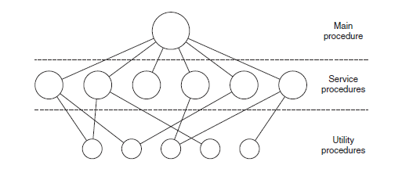
Layered System
organize the operating system as a hierarchy of layers, each one constructed upon the one below it
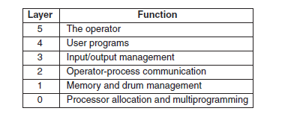
Layer 0 dealt with allocation of the processor, switching between processes when interrupts occurred or timers expired. Above layer 0, the system consisted of sequential processes, each of which could be programmed without having to worry about the fact that multiple processes were running on a single processor. In other words, layer 0 provided the basic multiprogramming of the CPU.

Layer 1 did the memory management. It allocated space for processes in main memory. Above layer 1, processes did not have to worry about whether they were in memory or on the drum; the layer 1 software
took care of making sure pages were brought into memory at the moment they were needed and removed when they were not needed.

Layer 2 handled communication between each process and the operator console (that is, the user). On top of this layer each process effectively had its own operator console.

Layer 3 took care of managing the I/O devices and buffering the information streams to and from them. Above layer 3 each process could deal with abstract I/O devices with nice properties, instead of real devices with many peculiarities.

Layer 4 was where the user programs were found. They did not have to worry about process, memory, console, or I/O management. The system operator process was located in layer 5.

Os: The THE system was a simple batch system for a Dutch computer, the Electrologica X8, which had 32K of 27-bit words (bits were expensive back then).

Microkernels
Various researchers have repeatedly studied the number of bugs per 1000 lines of code (e.g., Basilli and Perricone, 1984; and Ostrand and Weyuker, 2002). Bug density depends on module size, module age, and more, but a ballpark figure for serious industrial systems is between two and ten bugs per thousand lines of code.
This means that a monolithic operating system of fiv e million lines of code is likely to contain between 10,000 and 50,000 kernel bugs.

The basic idea behind the microkernel design is to achieve high reliability by splitting the operating system up into small, well-defined modules, only one of which—the microkernel—runs in kernel mode and the rest run as relatively powerless ordinary user processes. In particular, by running each device driver and file
system as a separate user process, a bug in one of these can crash that component, but cannot crash the entire system.

Many microkernels have been implemented and deployed for decades (Haertig et al., 1997; Heiser et al., 2006; Herder et al., 2006; Hildebrand, 1992; Kirsch et al., 2005; Liedtke, 1993, 1995, 1996; Pike et al., 1992; and Zuberi et al., 1999).
With the exception of OS X, which is based on the Mach microkernel (Accetta et al., 1986), common desktop operating systems do not use microkernels. However, they are dominant in real-time, industrial, avionics, and military applications that are mission critical and have very high reliability requirements.

MINIX 3, which has taken the idea of modularity to the limit, breaking most of the operating system up into a number of independent user-mode processes. MINIX 3 is a POSIX-conformant, open source
system freely available at www.minix3.org And we have mix of layared structrue
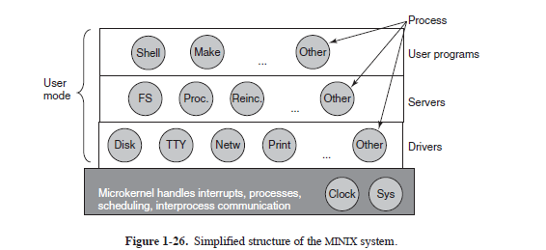
One interesting server is the reincarnation server, whose job is to check if the other servers and drivers are functioning correctly. In the event that a faulty one is detected, it is automatically replaced without any user intervention. In this way, the system is self healing and can achieve high reliability.

Client - server Model

A slight variation of the microkernel idea is to distinguish two classes of processes, the servers, each of which provides some service, and the clients, which use these services. This model is known as the client-server model. Often the lowest layer is a microkernel, but that is not required. The essence is the presence of client processes and server processes.

Communication between clients and servers is often by message passing. To obtain a service, a client process constructs a message saying what it wants and sends it to the appropriate service. The service then does the work and sends back the answer. If the client and server happen to run on the same machine, certain
optimizations are possible, but conceptually, we are still talking about message passing here.

An obvious generalization of this idea is to have the clients and servers run on different computers, connected by a local or wide-area network, as depicted in Fig. 1-27. Since clients communicate with servers by sending messages, the clients need not know whether the messages are handled locally on their own machines, or whether they are sent across a network to servers on a remote machine. As far as the client is concerned, the same thing happens in both cases: requests are sent and replies come back. Thus the client-server model is an abstraction that can be used for a single machine or for a network of machines.

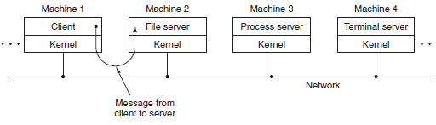
Virtual Machines (first in VM/370 OS)
The heart of the system, known as the virtual machine monitor, runs on the bare hardware and does the multiprogramming, providing not one, but several virtual machines to the next layer up, as shown in Fig. 1-28. However, unlike all other operating systems, these virtual machines are not extended machines, with
files and other nice features. Instead, they are exact copies of the bare hardware, including kernel/user mode, I/O, interrupts, and everything else the real machine has.

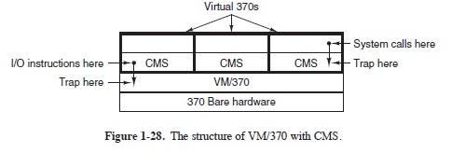
Because each virtual machine is identical to the true hardware, each one can run any operating system that will run directly on the bare hardware. Different virtual machines can, and frequently do, run different operating systems.

First the needs. Many companies have traditionally run their mail servers, Web servers, FTP servers, and other servers on separate computers, sometimes with different operating systems. They see virtualization as a way to run them all on the same machine without having a crash of one server bring down the rest.

Virtualization is also popular in the Web hosting world. Without virtualization, Web hosting customers are forced to choose between shared hosting (which just gives them a login account on a Web server, but no control over the server software) and dedicated hosting (which gives them their own machine, which is very
flexible but not cost effective for small to medium Websites). When a Web hosting company offers virtual machines for rent, a single physical machine can run many virtual machines, each of which appears to be a complete machine. Customers who rent a virtual machine can run whatever operating system and software they want to, but at a fraction of the cost of a dedicated server (because the same physical
machine supports many virtual machines at the same time).

Exokernels
Rather than cloning the actual machine, as is done with virtual machines, another strategy is partitioning it, in other words, giving each user a subset of the resources. Thus one virtual machine might get disk blocks 0 to 1023, the next one might get blocks 1024 to 2047, and so on. Each user-level virtual machine can run its own operating system,
The advantage of the exokernel scheme is that it saves a layer of mapping. The exokernel need only keep track of which virtual machine has been assigned which resource

The world according to C

Operating systems are normally large C (C++) programs. To build the operating system, each .c is compiled into an object file by the C compiler. Object files, which have the suffix .o, contain binary instructions for the target machine. They will later be directly executed by the CPU. The first pass of the C compiler is called the C preprocessor. As it reads each .c file, every time it hits a #include directive, it goes and gets the header file named in it and processes it, expanding macros, handling conditional compilation (and certain other things) and passing the results to the next pass of the compiler as if they were physically included.

Once all the .o files are ready, they are passed to a program called the linker to combine all of them into a single executable binary file. hen the linker is finished, the result is an executable program, traditionally called a.out.
